ID
CAPACITY BUILDING SUB-COMMITTEE
PROCEDURE 6
Part 2
EXAMPLE OF LOGISTICS INFORMATION

The 9th Hydrographic Commission on Antarctica Meeting
12 – 14 October 2009 – Cape Town, South Africa

Logistics Information
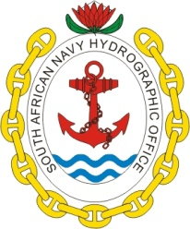
The South African Hydrographic Office, welcomes the 9th Hydrographic Commission on Antarctica to Cape Town, South Africa. The meeting venue is the Quayside Hotel, which is situated in the quaint seaside town known as Simon’s Town, adjacent to the historic Naval Dockyard.
GPS coordinates
34 deg 11 min 34.57 sec SOUTH
18 deg 25 min 55.68 sec EAST
Map Location
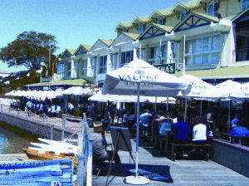

I. ACCOMMODATION
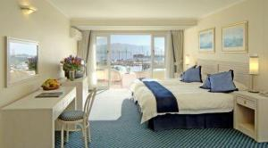  Set on the water's edge of the Simon's Town Yacht Basin, the Quayside Hotel offers views over False Bay, the Simon's Kloof mountains, and the Quayside Waterfront. The contemporary, three-storey hotel opens to a 24-hour front desk offering complimentary newspapers, and has wireless internet access throughout.  To make a booking please contact Gideon Le Roux on +27 21 7863838 or via email to conference@quayside.co.za with hydrosan@iafrica for information.  REMEMBER to mention that you  are a delegate of the HCA Meeting. | Special rates that includes room costs, the cost of the meeting room for the week, and morning/afternoon tees/coffees, has been negotiated with the hotel. This price also includes the 14% VAT charge and a 1% tourism tax), and is based on the present Rand / Euro exchange rate, for an estimated 30 attendees.  During Meeting dates 12 – 14 October:  En-Suite room Single R1015 (82 Euros*) per person / night.  With partner additional R200 (17 Euros*).  Before and after Meeting dates 12 – 14 October:  En-Suite room Single R740 (60 Euros*) per person / night.  With partner additional R200 (17 Euros*).  Note:  - The above rates include VAT and a 1%. tourism tax  - Rates are room only and exclude lunch and dinner.  - Exclude extras such as telephone calls and laundry.  - Breakfast included  - Based on an exchange rate of R12.50 to the Euro (*).  - Prices for conference days may be adjusted slightly subject to final attendance.  Please note that these prices do not include transportation between Cape Town International Airport and the hotel. (Please see II Transport below).
PLEASE SEND YOUR ATTENDANCE INFORMATION (see Annex A) BY NO LATER THAN 30 SEPTEMBER 2009. This is an extremely busy time in Cape Town so you are requested to confirm your accommodation bookings without delay.
II. TRANSPORT
Please note that transportation is not included in the hotel rate. We strongly recommend that you make use of the Way to Go Airport Shuttle Service to and from the hotel. Their rates per one-way trip are:
- R 280.00 for 1 person (about 23 Euros*)
Additional R 30 pp for every additional passenger on the same trip (about 3 Euros*)
If you wish to make use of this service please indicate this on the attached registration form and provide your arrival and departure times. The SAN HO will coordinate this to ensure that the transportation company is aware of all attendees’ arrival/departure times.
- VISA REQUIREMENTS
Depending on your nationality, and the purpose and duration of your visit, you may not need a visa to visit South Africa at all.
Countries exempt from South African visas
Countries subject to South African visa fees

IV. ELECTRICITY PLUGS
South Africa uses the “Old British 3-pin” plug so wherever you are travelling from (even Britain), you will need an adapter. The power voltage is 220 – 240 / 50 Hz | 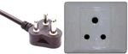
V. WEATHER

The South African Weather Site http:/weathersa.co.za is most useful for planning your suite case needs.

