HSSC11-05.3A

NIPWG report and recommendations
Submitted by: | NIPWG
Related Documents: | Minutes of the 6th NIPWG Meeting and Stakeholders‘ Forum, Rostock
Related Projects: | S-100 product specifications

Chair: | Jens SCHRÖDER-FÜRSTENBERG, BSH, GE
Vice-Chair: | Edward HOSKEN, UKHO, UK
Secretary (acting): | Tom LOEPER, NOAA, U.S.
Member States: | Argentina, Brazil, Denmark, Estonia, Finland, France, Germany, Japan, India, Italy, Republic of Korea, Netherlands, Norway, Poland, Russian Federation, South Africa, Spain, Sweden, UK, USA, (and IHB),
Expert Contributor Organisations: | CARIS, CIRM, IHMA; IIC, KRISO, NV Chats Germany, NTOU, NOVACO, Snowflake, University of New Hampshire, Anthropocene Institute, Portolan Sciences

Meetings Held During Reporting Period (Work Plan section K)
NIPWG Workshop XML Based Chart Corrections in NtM, 1–2 December 2018, Genoa, Italy
NIPWG6, 28 Jan–1 February 2019 Rostock, Germany
IHO Digital Nautical Publications Stakeholders' Forum, 29 January 2019, Rostock, Germany

Next Planned Meeting
NIPWG7, 25–29 November 2019, Saint-Petersburg, Russian Federation

Work Programme according to the HSSC Work Plan 2018-2019 for NIPWG and associated HSSC action items

Current work is on track against the HSSC Work Plan- All HSSC action items have been completed as scheduled.

Product Specifications development progress

S-122 (Marine Protected Area) and S-123 (Marine Radio Services) (Work Plan section F, HSSC 10 Action item 10/29)
The product specifications have successfully undergone the Member State approval process. They are ready for use and Hydrographic Offices are encouraged to develop their first products based on these Product Specifications.
Taking into account that S-100 compliant ECDIS systems are not available yet, these potential products could only be used in appropriate GIS applications.

S-125 (Navigational Services) (Work Plan section F, J)
Based on HSSC decision, work on S-125 is on hold. IALA ARM8 offered to support the S-125 development. That could be based on their S-201 development.
NIPWG provided an official IHO/HSSC response to IALA ARM9, welcoming the offer and specifying that S-125 should contain information in addition to those already covered by S-101. The scope of S-125 was described and it is expected that S-125 will be providing information which is of navigational significance.
Feedback of IALA ARM9 will be made early in April and will be reported to HSSC11 by the NIPWG presentation.

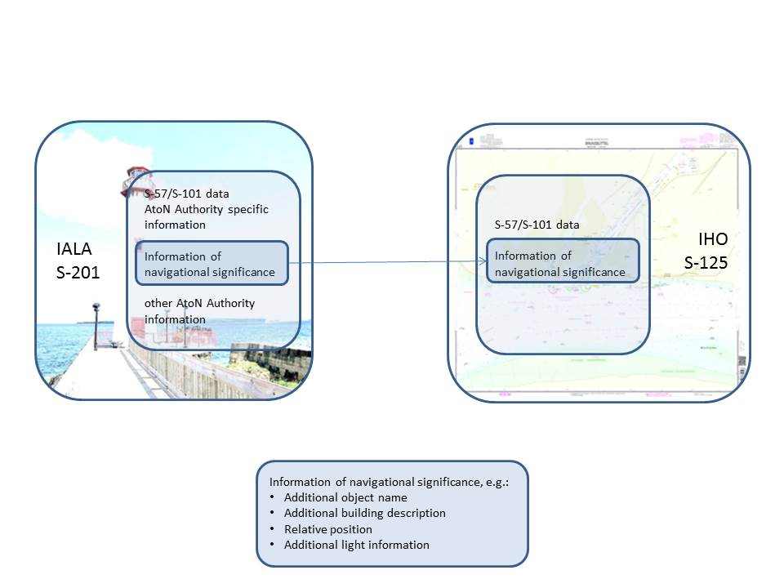

S-126 (Physical Environment) (Work Plan section F)
Following HSSC8’s advice, the group decided to put the further development of the S-126 (Physical Environment) Product Specification on hold. The status “on hold” remains until new HSSC advice. Independent from that status, NIPWG is aware of two small teams working
- on the description of S-126 product specification according to S-97 (under development),
- on the improvement of the current S-126 data model, and
- on the development of portrayal solutions.

S-127 (Marine Traffic Management) (Work Plan section F, HSSC 10 Action item 10/37)
Version 1.0.0 of the product specification was delivered as scheduled by the end of November 2018.
Two NIPWG reviews were conducted during the development process. Parts of the S-127 data model used S-101 components. That is the reason why some comments affect S-101. These comments will be forwarded as a separate submission to the S-101PT for consideration.
It is assumed that testing will deliver demand for further product specification improvement. Therefore, the release date for version 2.x.x has been estimated as 2021 at the earliest.

S-128 (Catalogue of Nautical Products) (Work Plan section F)
The work on S-128 is making good progress. Based on the current development status, HO’s are invited to test the product specification. In addition, the developer will check the S-128 appropriateness for use in e-navigation environment. The work is ongoing.

S-100 contributions (Work Plan section J)
The NIPWG proposal on incremental updates has been considered by the S-100WG and the possibility of such updates has been incorporated into S-100 Edition 4.
Testing incremental updates and work on drafting text to describe this function to S-100 in more detail is under contract. Results will be expected by the end of this year and will be reported to HSSC12.
If future development of NIPWG product specifications requires an S-100 amendment, this will be addressed in an appropriate format through the established channels.

S-100 Test Strategy Meeting required that a product specification feature catalogue (FC) should be built based on the S-100 feature catalogue builder (FCB). This was tried with the S-127 FC. A set of issues detected have been collected and provided to the S-100WG for further consideration.

Maintaining IHO Standards under NIPWG responsibility (Work Plan section D, E,), (HSSC10 Action item 10/27)

Maintain Publication S-12 “Standardization of List of Lights and Fog Signals”
No requests to amend S-12 were raised in 2018. The content provided in S-12 is considered as appropriate and as fit for purpose.

Maintain Publication S-49 “Recommendations concerning Mariners’ Routeing Guides”
A small team considered the appropriateness of the publication and provided proposals which were discussed by NIPWG.

One result was a proposal jointly developed together with the Underkeel Clearance Management Project Team (S-129PT) on revised definitions for:
- Underkeel Clearance Management System,
- “Static” Underkeel Clearance Management System, and
- “Dynamic” Underkeel Clearance Management System.
These definitions will be provided to the Hydrographic Dictionary Working Group (HDWG) for further consideration and implementation into the IHO Hydrographic Dictionary.
In addition, the list of ESSENTIAL, USEFUL and NOT APPROPRIATE items has been reviewed.

A redline version of S-49 will be discussed at NIPWG7 and will be provided to HSSC12.

Amendments to M-3
Following proposed M-3 amendments have successfully passed the Member State Approval process:
- 9/1932 as amended Uniform Sequence of Information
- 4/1982 as amended Arrangement of Information
- 4/1937 Population of Towns
- 6/1962 Density and Salinity of Water

Member States provided comments on the proposed revision of Resolution 7/2009 Time Reference. These comments have been considered and a revised version of the proposed amendment will be provided in a separate red line version to HSSC11 (Document HSSC 11-05B)

Any Other Items of Note

S-97 (Under development) product specification descriptions (Work Plan section J, HSSC 10 Action item 10/38)
Although the initial NIPWG product specification set was created to provide nautical publication information in future S-100 based ECDIS, discussions show potential use of such products for other users. It is imperative that the description of the intended use of products based on product specification should be described in more detail before the development of a product specification is initiated. The dependency on HSSC endorsement makes this description more urgent as the HSSC expectations and the NIPWG deliverables should match. Seeing the need to provide this information for all product specifications under HSSC’s remit, the implementation of such a description in S-97 (under development) has been considered as useful.
NIPWG discussed the set of information needed for a product specification description. The outcome of the discussions has been forwarded to the S-100WG for further consideration.

Supports of HOs survey (Work Plan section J)
NOAA initiated a survey to improve their Coast Pilot performance. NIPWG members were invited to participate. NIPWG letter 5/2018 informed on this survey.

Development of proposals to apply for budget for additional work with special expertise HSSC 10 Action item 10/33)
Based on HSSC decision, HSSC WGs were invited to provide potential work item which could be outsourced and which could be supported by IHO budget.
The outcome of the NIPWG list of proposals was that Council 2 accepted two items for 2019 and the third one was postponed for the 2020 list.
The two items are:
- to refine, test and evaluate the possible most feasible approaches to incremental updates for GML datasets,
- to develop an experimental production tool and viewer for S-100 based product speciation development on the web.

Contracts for both work packages are in the drafting phase at the time when this report was written.

NtM XML Development (HSSC 10 Action item 10/41)
The exchange of NTM chart corrections between HOs was discussed at NIPWG5. The application to conduct a workshop with XML experts was approved by HSSC10. This workshop was held in early October 2018. A White paper describing the intention of the results and associated files are on the NIPWG site/ miscellaneous section. Work is ongoing and first tests of the developed XML structure show that the team needs to meet one more time for a 1.5 days meeting. The place will probably be either Monaco or Genoa.
Due to the fact that an INT1 based symbol library is not available yet, the intended meeting date cannot be determined.

The custodian of INT1 symbols in each possible variation has been assigned to NCWG. Consequently, the development and maintenance of a symbol repository should be assigned to this working group. It would be necessary to provide for each symbol a textual description. This supports their further use for NtM chart correction exchange on XML basis.

IMO related work (Work Plan section G, HSSC 10 Action item 10/30, 10/31, 10/32, 10/52)
NIPWG continued the monitoring of the development of the IMO e-Navigation strategy.

NIPWG coordinated the IHO submission of the Maritime Services description under IHO remit to the HGDM (Harmonisation Group on Data Modelling). NIPWG Members participated the HGDM meeting October 2018.
Based on NCSR6 decisions, the term “Maritime Services” has been renamed to “Maritime Services in context of e-navigation”. Further, it was decided that the descriptions should be seen as “Initial Descriptions”.
Based on the experience made during the HGDM2 meeting, and in consideration of industry concerns that their contributions have not been considered at HGDM2, NCSR insisted to add IMO as Governmental Body to each maritime service description. That ensures that IMO can request amendments to the maritime service descriptions if appropriate.

Document HSSC11-05.3C discusses the results of the HGDM Meeting in detail.

HSSC should invite the responsible WGs to review the Maritime Service description under their remit and to provide it to NIPWG for further action.

NIPWG products specifications (Work Plan section F)

Naming conventions HSSC 10 Action item 10/39)
Naming conventions for product specifications have been discussed. To make the intended use or a product specification more clear and for consistency sake, it is proposed to add the term “marine” in front of each product specification name. Only S-128 (Catalogue of Nautical Products) is excluded. Thus, the names of the product specifications under the remit of NIPWG would be:
S-122 (Marine Protected Area)*
S-123 (Marine Radio Services)*
S-125 (Marine Navigational Services)
S-126 (Marine Physical Environment)
S-127 (Marine Traffic Management)*
S-128 (Catalogue of Nautical Products)

* Current product specification name contains the term “Mariner”

Life circle
A decision was made that NIPWG product specifications will undergo a review every two years.

Versioning
A decision was made that S-122 and S-123 should not be updated to be S-100 Edition 4.0.0 compliant. They remain on the S-100 Edition 3.0.0 level for conducting of feasibility studies on “Proof-of-Concept”. The S-100 concept expects that machines could handle product specifications, and consequently products, based on different S-100 editions and on different product specification levels.

Test of product specifications and production of data sets
S-122 (Marine Protected Area) data are available for US and DE waters for testing purposes. According to the software maintenance circle the product specification has passed the “Evolution” phase is now in the “Report” and “Request” phase. That needs active support from all HOs that intend to provide S-122 data in the future. NIPWG members from Spain, Canada and Netherlands indicated that they would develop data sets and report back to NIPWG7.

S-123 (Marine Radio Services) product specification will be tested by Spain, Canada, Netherlands and Germany. Same as for S-122, other Member States are invited to develop data sets and to report to NIPWG their findings.

HSSC should seek information from Member States which are not represented at NIPWG (possibly at IRCC level) to specify their intention to produce S-122 and S-123 based data.

Stakeholders’ Forum (HSSC 10 Action item 10/63)
The Stakeholder Forum attracted 8 Stakeholders of which 2 participated via Skype. 5 presentations were given. The main outcomes of the forum were:
- Stakeholders appreciate the IHO efforts on S-100 development;
- cooperation with Stakeholders is appreciated and they are keen to support IHO in the product specification development;
- standardization in isolation will fail;
- Parallel developments of services should be avoided. Connection of various projects deemed necessary to save time and money, e.g. Maritime Connectivity Platform.
- specifications should be aligned to support customising;
- no additional chart icons to portray NPUB information;
- product specifications should follow a platform agnostic approach;
- support user specific selection of individual chart items;
- CATZOC “unassessed” is not acceptable. Data coverage is vital especially in the advent of automated shipping,
- Order of display (in layers) should be discussed with stakeholder (CIRM; ICS, INTERTANKO, BIMCO, etc.),
- Integrated data need situation based data provision; and
- Vectorise data, No PDF.

Stakeholders raised attention to the fact that a replacement of S-101 data with bathymetric information will be reality soon. This bathymetric information will be additional data and not an S-101 content replacement. Only unmodified ENC data accord to IMO carriage requirement.

It shows that production system developers focus and support only a subset of S-100 product specifications, namely on S-101 and S-102. There is a simple reason why they are doing this. These are product they know. Support of all other product specifications should be addressed. .

It was mentioned that IHO should increase the efforts to produce S-100 based products and to establish routines for the provision of such products. Industry is ready to establish services for S-100 based products and to provide data on customers’ request outside the regulated market. They see the risk that IHO could become irrelevant in relation to the provision of S-100 based products.

Provision of S-100 Architecture
NIPWG discussed the presentation of the overarching architecture of S-100 based product specifications. First, it was necessary to define the scope. It was decided that only those product specifications would be included in the presentation which are either under the remit of IHO or which are already part of S-98 (Interoperability Specification). Next main limitation was to consider what is under IMO influence. That ensures that IHO keeps the widest possible control of their product specifications and that IHO is only addicted to IMO regulation where absolutely necessary.

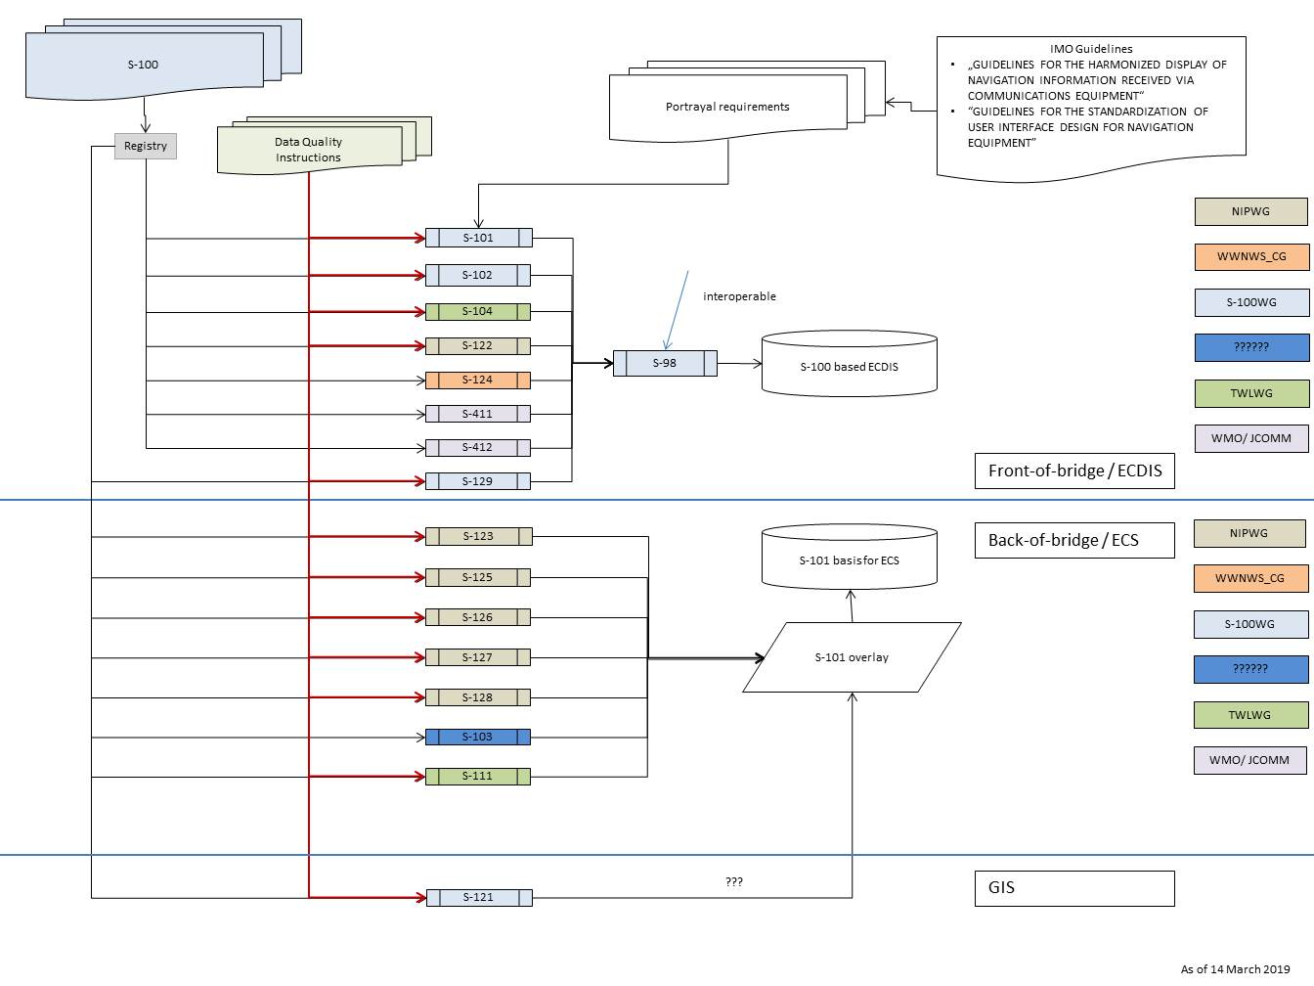

Meeting main discussion focus (Work Plan section H)
Before NIPWG6, the meeting’s focus was the development of product specifications on nautical information based on nautical publications. That changed at NIPWG6 were the main focus was to discuss and to assess how the products could be provided and which administrative, logistic and maintenance architectures of an S-100 based environment come within the remit of the IHO. That means the main focus was on the “P” in NIPWG which stands for PROVISION.

Conclusions and Recommended Actions
- The NIPWG activities are focussed
  - on making progress with the S-100 compliant NPUB Product Specifications development;
  - the development of test data sets for 100 compliant NPUB Product Specifications;
  - on developing proposals to amend the M-3 parts pertaining to nautical publications;
  - on assessing the appropriateness of IHO Standards that NIPWG is responsible for maintaining;
  - on the coordination of the IHO contributions to the IMO e-nav strategy;
  - on the assessment of proportionate S-100 based products management.

Action required of HSSC
HSSC11 is invited to endorse:
- the continued activity of NIPWG;
- the renaming of the product specification under the remit of NIPWG;
- the two years revision life circle for product specification under the remit of NIPWG.

HSSC11 is further invited to confirm:
- the assignment of the development and maintenance of an INT1 based symbol repository as defined in the appropriate section of this report to NCWG;
- the conduction of a final follow-up XML workshop as t.b.c.
- that responsible WGs should review the initial descriptions of “Maritime Services in context of e-navigation” under their remit and to provide them to NIPWG for further action.

HSSC11 is invited to
- initiate the M-3 amendment process by submitting a draft resolution revision to the Council-3 to seek the Member State approval
- seek information from Member States that are not represented at NIPWG (possibly at IRCC level) to specify their intention to produce S-122 and S-123 based data.

HSSC11 is further invited to note this report and to endorse:
- the continuance of the revised 2019-20 Work Plan as annexed.
Members List as of 7 February 2019

IHO MS | Name | email
Argentina | Alejandro Lucio José López | jsnautica@hidro.gov.ar
Brazil | Rogério Magalhães de Souza | souza@marinha.mil.br
 | Rafaela Castro | rafaela.castro@marinha.mil.br
Canada | Lynn Patterson | lynn.patterson@dfo-mpo.gc.ca
 | Eivind Mong | eivind.mong@dfo-mpo.gc.ca
Denmark | Allan Idd Jensen | alije@gst.dk
 | Simon Vammen | sitra@gst.dk
Estonia | Olavi Heinlo (Olavi.Heinlo@vta.ee) | Olavi.Heinlo@vta.ee
Finland | Stefan Engström | Stefan.Engstrom@traficom.fi
France | Yves Le Franc | yves.le.franc@shom.fr
Germany | Jens Schröder-Fürstenberg | jens.schroeder-fuerstenberg@bsh.de
Japan (JHOD) | Kenji Naito | ico@jodc.go.jp
 | Yuji Ono | ico@jodc.go.jp
India | Shyam Singh Chauhan | ia-inho@navy.gov.in
Italy | Carlo Marchi | carlo.marchi@marina.difesa.it
 | Elena Armanino | elena_armanino@marina.difesa.it
 | Ludovico Sturla | ludovico_sturla@marina.difesa.it
Korea (Republic of)(KHOA) | Eun Jung Seung | jse0515@korea.kr
 | Jimin Ko | jmko124@korea.kr
Netherlands | Wilfred den Toom | WF.d.Toom@mindef.nl
Norway | Anniken Puntervold Kvernstrom  Jon Leon Ervik | kveann@kartverket.no  jon.leon.ervik@kystverket.no
Poland | Radoslaw Magierek | r.magierek@mw.mil.pl
Russian Federation | Igor Bonakov | unio_main@mil.ru
South Africa | Alfons Vancraeynest | hydrosan@iafrica.com
Spain | Alejandro Herrero Pita | ihmesp@fn.mde.es
Sweden | Malin Liljenborg | Malin.Liljenborg@Sjofartsverket.se
UK | Edward Hosken | Edward.Hosken@UKHO.gov.uk
USA (NOAA) | Thomas Loeper | Thomas.Loeper@noaa.gov
 | Richard Powell | richard.powell@noaa.gov
USA (Coast Guard) | Dave Lewald | Robert.D.Lewald@uscg.mil
USA (NGA) | Mike Kushla  Jason Strom | Michael.S.Kushla@nga.mil  Jason.D.Strom@nga.mil
USA (US Army Corps of Engineers) | Brian Tetreault | Brian.J.Tetreault@usace.army.mil
IHO Secretariat | Yves Guillam | yves.guillam@iho.int
IHO MS | Name | email
Anthropocene Institute | Virgil Zetterlind | virgil@anthinst.org
CARIS (Teledyne-) | Jorge Sánchez Hernández | jorge.sanchez@caris.nl
CIRM | Michael Bergmann | michael.bergmann@bergmann-marine.com
IHMA | Ben van Scherpenzeel | BRJ.Scherpenzeel@portofrotterdam.com
IIC | Gerd Glang | gerd.glang@iictechnologies.com
KRISO | Sewoong OH | osw@kriso.re.kr
 | Hyunsoo Choi | troychoi@kriso.re.kr
NV Charts Germany | Hasko Scheidt | hscheidt@nvcharts.com
NV Charts Germany | Jeppe Scheidt | jscheidt@nvcharts.com
NOVACO | Yiorgos Palierakis | yiorgos.palierakis@novaco.co.uk
NTOU | Shwu-Jing Chang | sjchang@email.ntou.edu.tw
Portolan Sciences | Raphael Malyankar | raphaelm@portolansciences.com
Snowflake | Alexis Brooker | alex.brooker@snowflakesoftware.com
University of New Hampshire | Briana Sullivan | briana@ccom.unh.edu
University of New Hampshire | Steven Johnson | overcooked.lobster@ccom.unh.edu

Work Plan

NIPWG WORK PLAN 2019-20 2018-19(approved by HSSC10 and rRevised at NIPWG6 to be approved at HSSC11)

Tasks

D | Maintain Publication S-12 “Standardization of List of Lights and Fog Signals” (IHO Task 2.8.1)
E | Maintain Publication S-49 “Recommendations concerning Mariners’ Routeing Guides” (IHO Task 2.8.3)
F | Establish and monitor, in liaison with the S-100WG, the project teams required to specify and develop nautical information layers for use in ECDIS (IHO Task 2.3)
G | Develop high level specifications for a combined Mmaritimene Sservices as defined by IMO in the context of e-navigation Portfolio (MSP) covering the provision of hydrographic services to mariners in accordance with the IMO e-navigation strategy implementation plan (IHO Task 2.5.2)
H | Develop a test and implementation plan for the development of the maritime services as defined by IMO MSP “hydrographic services” (IHO Task 2.5.2)
I | Maintain IHO Resolutions in M-3 relating to Nautical Publications as required (IHO Task 2.1)
J | Liaise with other HSSC WGs and other IHO and international bodies (IHO Task 2.1.8)
K | Conduct the 20192017 and 20202018 meetings of the NIPWG and its sub-group(s) and project team(s) (IHO Task 2.1)

Work items

Work item |  | Title |  | Priority  H-high M-medium  L-low | Next Milestone | Start Date |  | End Date |  | Status  P-Planned  O-Ongoing  C-Completed S-superseded |  | Contact Person(s) |  | Related Pubs / Standard |  | Remarks
D.1 |  | Monitor and assess proposals for amending S- 12 |  | M | Next meeting | 2014 |  | Permanent |  | O |  |  |  | S-12 |  | In close liaison with IALA; see J.5.1
E.1 |  | Develop proposals for amending S-49 |  | M | Next meeting | 2019 |  | Permanent |  | O |  |  |  | S-49
F.1 |  | Assess the progress and perspectives of developing specifications for NP data layers in ECDIS and propose the way forward for consideration by HSSC |  | H |  | 2015 |  | Permanent |  | O |  |  |  |  |  | To be considered in the context of the IMO e-navigation strategy implementation.  NIPWG to consider establishing one or more project team(s) in liaison with S-100WG as required (see J.2), in particular to continue the development of Product Specifications currently assigned to the NIPWG.
F.2 |  | Investigate the interaction between Marine Protected Area Product and ENC in ECDIS |  | H | Draft Product Specification for Marine Protected Areas (S-122) released in 2018  Next meeting | 2015 |  | Permanent |  | O |  | Chair/Sec |  |  |  | In close liaison with the S-100 WG  On target for endorsement by Council - 2.  See action NIPWG 6/XX
F.3 |  | Model the NP data where required. |  | H | Next meeting | 2004 |  | Permanent |  | O |  | Chair/Sec |  |  |  | S-100 related.  To be included in Hydro domain of the FCD Register.
F.4 |  | Review of objects and attributes |  | H | Next meeting | 2004 |  | Permanent |  | O |  | Chair/Sec |  |  |  | S-100 related.
F.5 |  | Propose amendments to HYDRO domain of the FCD Register |  | H |  | 2005 |  | Permanent |  | O |  | Chair/Sec |  |  |  | S-100 related. To be included in the FCD register
F.8.1 |  | Develop S-12n - Nautical Information Product Specification
F.8.1.1 |  | For Marine Radio Services |  | H | next NIPWG meeting | 2012 |  | 2019 |  | OC |  | Chair/Sec |  | S-123 |  | Edition 1.0.0 endorsed by Member States 2018
F.8.1.2 |  | For Marine Navigational sServices |  | L | next NIPWG meeting | 2013 |  |  |  | P |  | Chair/Sec |  | S-125 |  | On Hold  IALA offers to develop draft, NIPWG accept; see Action item NIPWG 6/25
F.8.1.3 |  | For Marine Traffic Management |  | H | next NIPWG meeting  May 2019 for correction comments | 2013 |  | 2021 |  | O |  | Chair/Sec |  | S-127 |  | Edition 1.0.0 developed (is now under 2/2007 life cycle management)
F.8.1.3.1 |  | For Marine Protected Areas |  | H | next NIPWG meeting | 2011 |  | 2019 |  | OC |  | Chair/Sec |  | S-122 |  | Edition 1.0.0 endorsed by Member States 2018
F.8.1.4 |  | For Marine Physical eEnvironment |  | L | next NIPWG meeting | 2013 |  |  |  | PO |  | Chair/Sec |  | S-126 |  | On Hold  Investigatory work initiated, see action 6/07
F.8.1.5 |  | Catalog of nautical products |  | M | next NIPWG meeting | 2016 |  | 2021 |  | O |  | Chair/Sec |  | S-128 |  | Development continued by KHOA
F.8.2 |  | Monitor and Maintain NIPWG Product Specification |  | H | Next meeting | 2019 |  |  |  | O |  | Chair/Sec |  |  |  | S-122, S-123 and S-127 under 2 year revision cycle
 | G.1 |  | Monitor the requirements for, and provision of, nautical information in e-navigation test-beds  Produce NP1 sample data sets |  |  |  |  |  |  |  |  |  |  |  |  | According to the tasks assigned by HSSC4. Collection of information to be modelled
 | G.1.3 |  | For Marine Traffic mManagement | H | next meeting |  | 2012 |  | 2018 |  | C |  | Chair/Sec |  | S-127
 | G.1.4 |  | For Marine Physical environment | L | next meeting |  | 2013 |  |  |  | O |  | Chair/Sec |  | S-126 | On Hold  Investigatory work initiated, see action 6/07
 | G.3 |  | Rules and guidelines for displaying nautical information in ECDIS and in maritime services as defined by IMO combined Marine Service Portfolios
 | G.3.1 |  | Develop basic display principles for NP data intended for use in ECDIS (NP3) | M |  |  | 2008 |  |  |  | O |  | Chair/Sec |  | S-52 | Close co-operation with NCWG and S-100WG required. Interoperability Spec to be considered.
 | G.3.2 |  | Monitor and contribute to the development of IMO guidelines showing how navigation information received by communications equipment can be displayed in a harmonized way and what equipment functionality is necessary. | M |  |  | 2015 |  | 2019 |  | O |  |  |  |  | e-nav IMO Strategy Implementation Plan, Task T13 (HSSC6-07.1A refers)  Output number 5.2.6.2 of NCSR biennial agenda 2016-17  Completion date is unknown and dependent on the maturity of interoperability and portrayal frameworks  For HSSC consideration
 | G.5 |  | Contribute to considering the future of paper charts in the perspective of the establishment of MSPsmaritime services as defined by IMO | M |  |  | 2014 |  |  |  | O |  |  |  |  | Subject to request from NCWG
 | I.1 |  | Maintain and extend resolutions in M-3 relating to Nautical Publications | M | Next meeting |  | 2012 |  | Permanent |  | O |  | Chair/Sec NIPWG |  | M-3 | A review is required due for the harmonization of M-3 information and potential ProdSpecs content
 | J.0 |  | Liaise with the NCWG | M |  |  |  |  | Permanent |  | O |  | Chair/Sec NIPWG |  |  | Establish joint project teams as required and endorsed by HSSC.
 | J.1 |  | Liaise with the ENCWG | M |  |  |  |  | Permanent |  | O |  | Chair/Sec NIPWG
 | J.2 |  | Liaise with the S-100WG | H |  |  |  |  | Permanent |  | O |  | Chair/Sec NIPWG |  |  | Establish joint project teams as required and endorsed by HSSC.
 | J.2.1 |  | Draft Data Classification and Encoding Guides |  |  |  |  |  |  |  |  |  |  |  |  | Document for NPs similar to Use of the Object Catalog
 | J.2.3 |  | Draft Product Specification
 | J.2.3.2 |  | For Marine Navigational Services | L |  |  | - |  |  |  | P |  | Chair/Sec |  | S-125 | On hold
 | J.2.3.3 |  | For Marine Traffic management | H |  |  | 2011 |  | 2021 |  | O |  | Chair/Sec |  | S-127 | In progress
 | J.2.3.5 |  | For Physical eEnvironment | L |  |  | - |  | - |  | P |  | Chair/Sec |  | S-126 | On hold
 | J.2.3.6 |  | For Digital Catalog of Nautical Product |  | Next meeting |  | 2016 |  | 2021 |  | O |  | Chair/Sec |  | S-128 | In progress
 | J.3 |  | Liaise with other HSSC WG | M |  |  | 2004 |  | Permanent |  | O |  | Chair/Sec NIPWG
 | J.4 |  | Liaise with IRCC
 | J.4.1 |  | Liaise with WWNWS Sub-Committee |  |  |  |  |  |  |  |  |  |  |  | S-124 | Monitor developments of S-124 Correspondence Group
 | J.5 |  | Liaise with other international bodies which contribute to nautical information | H |  |  | 2015 |  | Permanent |  | O |  | Chair/Sec NIPWG
 | J.5.1 |  | Liaise with IALA e-Nav Committee | H |  |  | 2013 |  | Permanent |  | O |  | Chair/Sec NIPWG
 | J.5.2 |  | Liaise with International Harbor Masters’ Association (IHMA) | L |  |  | 2015 |  | Permanent |  | O |  | Chair/Sec NIPWG |  |  | See outcome HSSC8 Section 7.10 of the minutes  IHMA attended the NIPWG Stakeholder forum 2019
 | J.5.3 |  | Liaise with International Cable Protection Committee (ICPC) | ML |  |  | 2016 |  | Permanent |  | O |  | Chair/Sec NIPWG |  |  | MOU signed between IHO and ICPC
Meetings (Task K)
Date | Location | Activity
25–29 Nov 2019 | St. Petersburg, Russian Federation | NIPWG7
Sept 2020 | Brest (tbc), France | NIPWG8
June 2021 | India (invitation expected) | NIPWG9
March 2022 | Niteroi, Brazil | NIPWG10
Jan 2023 | Tallinn, Estonia | NIPWG11

Chair: Jens Schröder-Fürstenberg, BSH, GE Email: jens.schroeder-fuerstenberg@bsh.de
Vice Chair: Edward Hosken, UKHO, UK Email: Edward.Hosken@UKHO.gov.uk
Secretary: Thomas Loeper, NOAA, USA Email: Thomas.Loeper@noaa.gov

Top three work items:
- Initiate prototype implementation of existing S-12x products in an S-100 based environment to explore governance architecture and service delivery mechanism
- Develop S-12x nautical information Product Specifications
- Coordinate the IHO contributions to the definition and harmonisation of maritime services as defined by IMO within the remit of IHO

