The OGC Discrete Global Grid Systems core standard and its relevance to the hydrographic community
Researched by Andy Hoggarth (CARIS) and Trevor Taylor (OGC)
  - Introduction to DGGS
A Discrete Global Grid System (DGGS) is an earth referencing system that can be exploited for data processing, storage, discovery, transmission, visualization, computation, analysis and modelling. A Discrete Global Grid System (DGGS) is a series of discrete grids at progressively finer resolutions. A DGGS is not a navigation grid it is an information grid, it uses a hierarchical tessellation of equal area cells to partition and address the earth’s surface, each cell can be thought of as a spreadsheet containing a variety of information.
A tessellation of cells must meet a set of criteria to be considered as a DGGS, including global coverage, equal area cells, single point representation per cell, and multiple levels of granularity. There are several examples of tessellations that meet these criteria.
A DGGS uses solid polyhedrons e.g. tetrahedrons, cubes, octahedrons to model the earth, these tessellations are inversely projected to create the reference system. Many GIS and image processing systems assume a flat earth when calculating geometries and would therefore need to adapt to support this method of referencing.
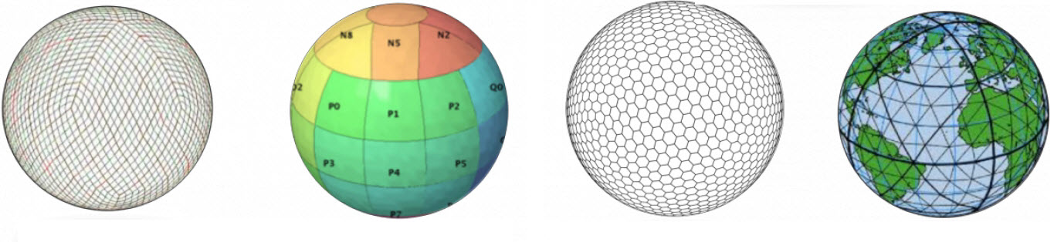
Examples of DGGS cell tessellations

Single resolution computational grids are not sufficient to constitute a DGGS, neither are spatial data structures used solely to organize map tiles or optimize spatial queries. The primary feature of a DGGS is the cell geometry not optimization of a spatial query although it is likely to utilize hierarchical indices to identify a cell.
The OGC does not intend to establish a single DGGS as a standard for geospatial applications but rather define the required criteria and core functional algorithms to support operations of a conformant DGGS.
  - Relationship to Coordinate Reference Systems
The standard anticipates that the creation of a registration system for a DGGS is analogous to the registration for a Coordinate Reference System (CRS). A conventional CRS addresses the globe with a continuous field of points suitable for repeatable navigation and analytical geometry a DGGS addresses the globe by partitioning it into a discrete hierarchical tessellation of progressively finer resolution cells.
One way to understand the important difference between a DGGS and a conventional CRS is to consider that a DGGS provides a digital framework for geospatial information, where geospatial information is a variable e.g. measurement (depth) which changes subject to another independent variable e.g. spatial location (seafloor trench). Conventional geospatial information is analogue as it typically references a continuous space e.g. geographic coordinates on an ellipsoidal datum.
  - Applications
A DGGS provides a uniform environment to integrate and visualize both vector geometry and raster coverages. It provides a fixed geospatial reference frame for the persistent location of measured Earth observations, feature interpretations, and modelled predictions.
A DGGS could be used to manage oceanographic measurements e.g. temperature and salinity over time, which could be used to create a predicted sound velocity correction model. This could then be used to correct sonar data being gathered by autonomous survey platforms in remote areas, where sound velocity casts are not possible.
Another example could be to manage bathymetric measurements, seafloor sediment type and currents over time to predict sand wave migration.
A DGGS could be used to manage hyperspectral imagery and satellite derived bathymetry data over time to determine when is a good time to conduct bathymetric LiDAR surveys based on lowest turbidity conditions for example.
A DGGS does not appear to be an ideal solution for indexing global ENC coverage as it is designed to be an information grid a DGGS uses conventionally referenced vector features and coverages to populate cells.
  - CUBE and Variable Resolution Surfaces
The CUBE (Combined Uncertainty and Bathymetric Estimator) surface technology has some similar properties to a DGGS. A CUBE surface can be visualized in such a way that the cube size is an indication of uncertainty and multiple observations (hypotheses) can exist for a single location. The next evolution of CUBE (CHRT) uses measurement density or changes in depth to create a resolution map, with higher resolution in areas with more measurements. The creation of a resolution map is prerequisite for creating a Variable Resolution surface. It would be interesting to explore how these types of data structures particular to bathymetry lend themselves to the DGGS core standard.
  - Big Data Potential
As hydrographic offices starts to utilize Big Data to develop the new products and services of the future, the need for global referencing systems to carry and process information from multiple sources will become important. Web Processing Services and Web Coverage Processing Services will be extended in order to utilize data referenced to a DGGS.
  - Conclusion
As a wide variety of data including vector and raster, observed and predicted can referenced to the same DGGS, the potential exists to save on costly data integration as the data is already aligned to the same grid as oppose to existing in separate databases or flat files with different CRS and metadata.
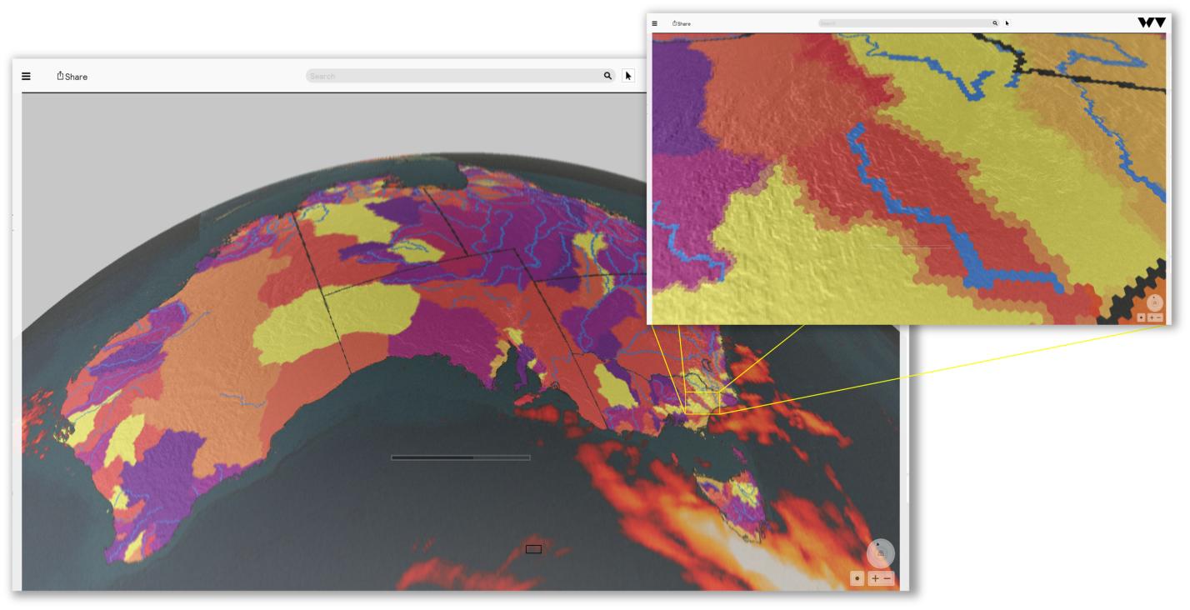
DGGS cells can hold data from raster and vector sources, in this image boundary, river, elevation and weather information is being referenced together, this makes analysis straight forward as the earth reference is common.

The MSDI WG through the IRCC should recommend that the IHO HSSC monitor progress with the emerging OGC DGGS core standard as it could be applicable to the way that hydrographic offices share data with wider stakeholders as they start to transition from product centric organizations to data centric ones. The DGGS core standard could be interesting for the evolution of S-102 especially as Variable Resolution surface technology becomes common for modelling source bathymetry. The emerging standard should also be brought to the attention of GEBCO, as the holders of a global dataset this could provide direct benefits around interoperability and wider usability. It should also continue to be monitored by the MSDI WG as a DGGS can provide an intuitive front end to browse and analyze hydrographic information for non-navigational uses; it is already being used in Canadian schools as part of the geography curriculum.
  - Further Reading
http://www.iho.int/mtg_docs/com_wg/MSDIWG/MSDIWG7/MSDIWG7-2.7A-GridRefSys-OGC.pdf
http://webpages.sou.edu/~sahrk/sqspc/pubs/gdggs03.pdf

