

INTERNATIONAL HYDROGRAPHIC ORGANISATION HYDROGRAPHIQUE
ORGANIZATION INTERNATIONALE

NAUTICAL CARTOGRAPHY WORKING GROUP
(NCWG)

[A Working Group of the Hydrographic Services and Standards Committee (HSSC)]

Chair: Jeff WOOTTON  Australian Hydrographic Service  8 Station Street, Wollongong, NSW, 2500  Australia | Secretary: Andrew HEATH-COLEMAN  United Kingdom Hydrographic Office  Admiralty Way, Taunton, Somerset  United Kingdom
Tel: +61 2 4223 6508 | Tel: +44 1823 337900 ext 3656
Email: jeff.wootton@defence.gov.au | Email: andrew.coleman@ukho.gov.uk

NCWG Letter: 13/2015
UKHO ref: HA317/010/031-12
AHS ref: fAA158960; fAA155722
Date 15 October 2015

Dear Colleagues

Subject: Covered Berths and Buildings In or Over the Water (follow-up to NCWG Letter 04/2015)
Thank you to the 19 Working Group members and ESRI who responded to NCWG Letter 04/2015. As usual, we have included a consolidated list of the responses, together with my (and for Australia, Secretary’s) comments, at Annex A.
Although you will see from the consolidated responses that there was almost unanimous agreement with the proposed additions and changes to S-4, there were some comments that we consider require further consideration of the Working Group. In summary (refer to additional comments at Annex A for a complete record of comments):
B-321.9: Australia has suggested some restructuring of the clause; France and Germany have noted an inconsistency in the graphics; and Germany has raised a question regarding the guidance for the depiction of a detached wharf.
B-370.9: Indonesia and US have suggested the inclusion of graphic examples to support the textual guidance; and US has questioned the line style to be used for the outer boundary (apparent coastline) of an area of buildings above water.
Annex B contains a “round 2” version of B-321.9 and B-370.9 addressing these comments. For your convenience, we have included a response form at Annex C with particular questions on which we would welcome your views; however, please feel free to comment on any other points as well.
In response to the suggestion of the inclusion of graphics at B-370.9, Working Group members are requested to provide any examples that they may have in support of the textual guidance to the Secretary in addition to their response to this Letter.
Please respond, using Annex C, by 12 November 2015.
Yours sincerely,
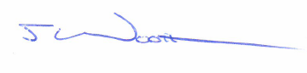
Jeff Wootton,
Chair NCWG.

Annex A: Consolidated response to NCWG Letter 04/2015
Annex B: Covered Berths and Buildings In or Over the Water: Revised additions and amendments to S-4
Annex C: Response form
Annex A to NCWG Letter 13/2015

Consistency of information on paper chart and ENCs
Consolidated Response Form

 | Question | Yes | No
1 | Do you agree with the revised wording and graphics for the new paragraph B-321.9? | BR, CA, DE, DK, ES, ESRI, FI, FR, GR, ID, IR, IT, JP, LV, NL, SE, UA, US, ZA | AU
2 | Do you agree with the draft new paragraph B-370.9? | AU, BR, CA, DE, DK, ES, ESRI, FI, FR, GR, ID, IR, IT, JP, LV, NL, SE, UA, US, ZA

Further comments

AUSTRALIA
B-321.9: The new example showing land tint over the covered berth indicates a (minimum) depth at the berth of 2.4 metres. However, the 2 metre contour encroaches into the berth area (and is indicated as such in the previous examples). Suggest the (minimum) depth be amended to a depth of 2 metres or less in the example.
Secretary: Agree. Will use 1.8m as in your version of the text

Australia also considers that the guidance is not clear as to whether the guidance for detached wharf is specific to transparent urban tint (and not appropriate for land tint); and similarly the guidance for depth at the berth is specific to land tint (and not appropriate for transparent urban tint). It may be clearer to re-organise the clause as follows (note that the depth at the berth in the land tint example (which we have amended to 1.8 metres in accordance with the above comment) would need to be moved to the detached wharf example):

B-321.9 A covered berth should be labelled by an appropriate descriptive legend or name, for example: ‘Covered wharf’; ‘Hull All-Weather Terminal’. Transparent urban tint (see B-370.4), representing the roof, may be inserted over the charted hydrography so that any shallow water tint shows through. A vertical clearance (see B-380.1-2) should be shown, if known. The urban tint should be surrounded by a black line, finer than coastline. If a transparent urban tint is not possible, then the building should be charted in accordance with national practice for buildings (D1) with land tint [Secretary: and/or solid urban tint – see DE comment below], associated legend and clearance height.

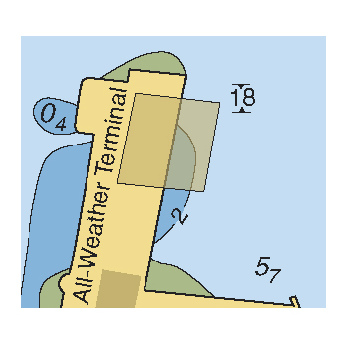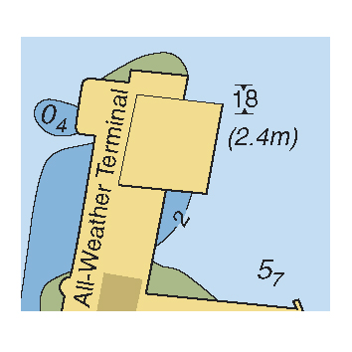

If it is required to show a detached wharf under the roof, this should be a black line, bolder than coastline (as F13, right hand example). If required, the depth of water at the berth should also be shown in parenthesis, for example (1.8m).

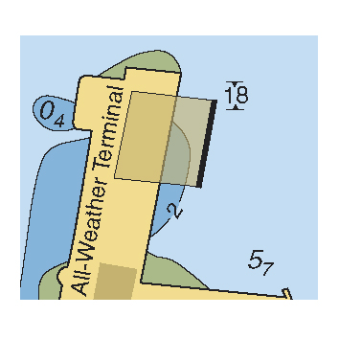
A profile diagram may be included if considered useful (see B-390).

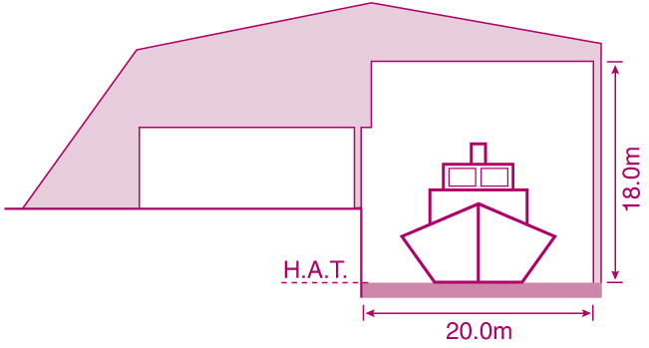

Secretary: I agree with your rearrangement. We also need to take account of DE’s comments about using a non-transparent (solid?) urban tint. Also the comment about moving the thick line set me thinking: as shown, it is extremely unlikely. A completely detached wharf would be fairly useless; how would you get goods for loading to/from it? Just about possible by a movable bridge perhaps, but unlikely, I think. See comment for Germany below.

FRANCE
Concerning the new paragraph B-321.9, in the 3rd example (after If required, the depth of water at the berth should be shown in parenthesis, for example (2.4m).) we have noted two inconsistencies:

Firstly, between the depth at the berth (2,4m) and the value of the contour: 2m.
Chairman: Agree. We will change to 1.8m (see Secretary comment for Australia above).

Secondly, regarding the depiction of the buildings: If a transparent urban tint is not possible, we should not find urban tint on this picture (difference between the covered berth and the building at the bottom of the graphic).
Chairman: The urban tint at the bottom of the graphic may well be possible; it is the transparency of urban tints that is not available to some HOs. However, the inconsistency is that if an HO is using urban tint at all, they would certainly include it on the terminal (see Germany’s comment below). We will amend the building at the bottom of the graphic to remove the urban tint and replace with shadowed outline as for the covered terminal so as to provide the greater contrast between the examples and also add an example with shadow-line and urban tint. We will also further clarify this in the text (see blue Secretary comment within the AU revised B-321.9 above).

GERMANY
1. If a transparent urban tint version is not possible to achieve a combination between the left and right hand example should be possible. In the right example the urban tint should be added for the roof area. A national practice example is not needed in S-4.
Chairman: Agree, see comment at France.

In the example where the wharf is shown as a bold line, the bold line should be moved to the coast side as on that side the ship is loaded and unloaded. The shown depth value should be changed according to the charted situation.
Chairman: See comment at Australia above. Given that this guidance and the accompanying graphics are an example of “composite” symbology, I suggest that all reference to a “detached wharf under the roof” be removed from this clause (and possibly replaced by reference(s) to other clauses in B-300). Specification for indicating berthing facilities are already included elsewhere within B-300.
INDONESIA
- The real coastline shown as normal in both cases and the outer limit of the built-up area delimited with a dashed line
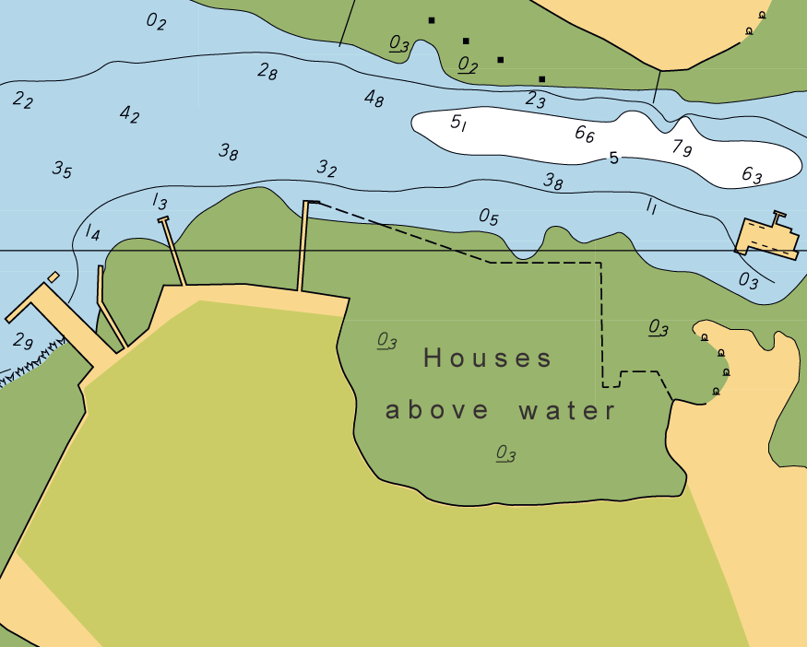

- Built up areas (by urban tint or ‘shadow-line’ building blocks)
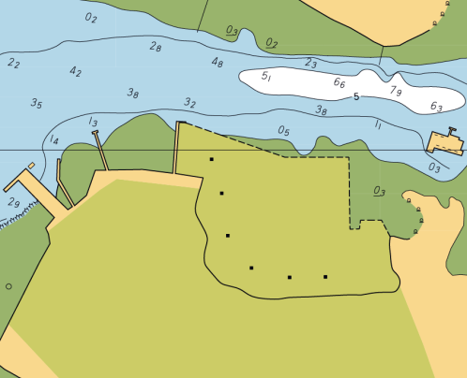

- Urban stipple, this should be over intertidal tint transparency
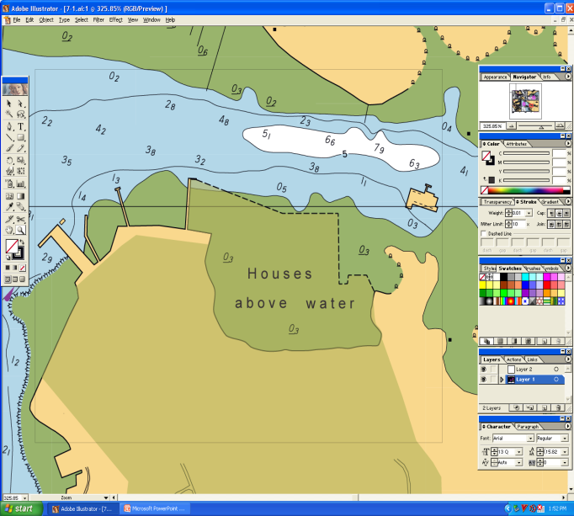

Chairman: Thank you for providing these examples; however the only one of the 3 that adequately supports the draft specification is example C. Example A does not contain any urban tint while example B includes a few isolated buildings in addition to the outer boundary and urban tint, and has no supporting text legend. I agree that example graphics would be helpful (see comment from US below), and will suggest that WG members supply any examples that they may have so as to include in S-4, similar to what was done for bridges at B-381.5. It would also be helpful to have the name of the settlement included, as would be expected when charted.

IRAN
In general showing more graphics of covered berth utilising urban tints will be very helpful for mariners to make safer decisions during berthing and unberthing.

JAPAN
We propose that Vertical clearance is encoding with information attribute (INFORM) in ENC because there is no attribute of Vertical clearance in Object Class (Building, single) expressing the roof.
Chairman: Thank you for this suggestion. This will be included in proposals to the ENCWG for guidance on encoding covered berths on ENCs.

US
Item # 2 – Draft of new S-4 ¶ B-370.9:
Adding simple graphics showing the various symbolization options would be very helpful.
Chairman: Agree. See comment at Indonesia.
We believe using an urban tint over water or intertidal tints will not be understood by mariners and that the only way to clearly describe the situation is to delineate it with a dashed black line with the appropriate label. We recommend that the second paragraph be changed as shown below:
Buildings in or over the water. Buildings are sometimes erected in or over the water, beyond the coastline. These may be individual buildings, sometimes of a specialized nature, such as a fort, or an extension of urban areas on piles or stilts. In the latter case, it may be possible for small vessels to navigate amongst (or even under) the buildings, while it represents an impenetrable mass for larger vessels and appears to the eye or on radar images as apparent coastline. This is similar, in some respects, to the situation with mangroves, see B-312.4, and merits similar treatment.

In general, the same principles as for buildings on land should be followed. Individual buildings should be charted in outline with land tint if scale allows, or by symbols if the chart scale is too small (D5 or an appropriate selection from E). Urban areas should be charted in the same way as urban areas on land, depending on national practice: that is as building blocks with ‘shadow line’ or using urban tint (see B-370.4). If using building blocks, they should be filled with land tint and an explanatory legend such as ‘houses above water’, or equivalent, should be inserted. If using urban tint, if possible it should be ‘transparent’ so that the intertidal or shallow water tint remains visible. When the density of buildings is too close to show individual symbols, the area shall be delimited by a fine black dashed line (N 1.1), appropriately labelled.

The high water line should be charted as coastline (C1 or C2, as appropriate) and the outer boundary of the urban area as a fine dashed line (similar to C32/33).

For covered berths, see B-321.9. For houseboats, see B-330.
Chairman: Nobody else has suggested that ‘transparent tint’ will not be understood and it seems to work well enough in the covered berth example. So I see no reason to remove the sentences you have struck through above. Your additional sentence is really the same as ‘urban areas’ where shadow-line or urban tint should be used. It may clarify to add ‘(when the density of buildings is too close to show by symbols)’ after ‘Urban areas’ in the 2nd sentence of the paragraph. The final sentence advises about the outer limit and is consistent with the practice for mangroves C32, however I can see an argument for delimiting the outer (seaward) boundary using N1.1. The type of dashed line was not specified during discussions at NCWG1, and I think this requires further NCWG deliberation.

ACTION NCWG1-30, ENC encoding:
It would seem that this action should call for making recommendations for ENC encoding of "Covered berths" too, not just "Buildings above the water." A few thoughts concerning possible ENC encodings for these features are included in Annex C.
Chairman: I agree that Action NCWG1-30 should be extended to include ENC encoding for covered berths, and will note this for inclusion in my report to the ENCWG and S-100WG (S-101 Project Team).
It should also be noted that the NCWG Terms or Reference call for the working group to
To provide expert and authoritative advice and guidance to relevant IHO bodies and non-IHO entities on the concepts of nautical cartography, including
(i) Its application to nautical charts existing in any physical or digital form;
The primary other "physical or digital form" being ENCs, shouldn't the NCWG also be recommending options for portraying these two features in ECDIS? The recommended encoding and existing ENC symbology alone may not be sufficient to render the desired effect in ECDIS. This could be an appropriate topic to address at NCWG-2 (specifically for these two features and as a general discussion on what role NCWG should have regarding the portrayal of features in ECDIS – especially since there is no longer an IHO working group devoted specifically to maintaining ECDIS portrayal.
Chairman: I agree that the NCWG has a role to play in the portrayal impacts of new/revised charting specifications in ECDIS as well as for the paper chart. An example of how a building encoded over water would be portrayed using S-52 Presentation Library Edition 3.4 was included in the paper submitted by Finland to the CSPCWG10 meeting (CSPCWG10-08.10A), which was further referenced in the paper submitted to CSPCWG11/NCWG1 (CSPCWG11-08.1A). While this was not discussed at either CSPCWG10 or CSPCWG11/NCWG1, I believe that the NCWG will transition to discussing the cartographic aspects of both the paper chart and ENC/ECDIS in its deliberations as more ENC/ECDIS expertise becomes involved in the Working Group. However, in relation to ENC/ECDIS, these discussions will need to be held in consultation with the ENCWG, which is responsible for the maintenance of S-52, including its Presentation Library. There is still much to be determined as to the relationships between Working Groups under the revised HSSC Working Groups structure, and from this perspective I agree that this should be a topic for discussion at NCWG2 (and also for the ENCWG and S-101 Project Team), perhaps with the initial intent of establishing an NCWG/ENCWG Project Team to address nautical cartography issues related to ENC/ECDIS. For impact of NCWG1 actions on ENC encoding and ECDIS portrayal, I will ensure that all the appropriate information is provided to the ENCWG and S-101 Project Team (scheduled to meet in March 2016) for discussion, and it may be that there will be actions from these meetings for further advice/action of the NCWG.
Annex B to NCWG Letter 13/2015

Covered Berths and Buildings In or Over the Water
(Revised for responses to NCWG Letter 04/2015)

B-321.9 A covered berth should be labelled by an appropriate descriptive legend or name, for example: ‘Covered wharf’; ‘Hull All-Weather Terminal’. Transparent urban tint (see B-370.4), representing the roof, may be inserted over the charted hydrography so that any shallow water tint shows through. The urban tint should be surrounded by a black line, finer than coastline. If a transparent urban tint is not possible, then the building should be charted in accordance with national practice for buildings (D1) with land tint and/or solid urban tint, associated legend and clearance height. If required, the depth of water at the berth should also be shown in parenthesis, for example (1.8m). A vertical clearance (see B-380.1-2) should be shown, if known. Examples:

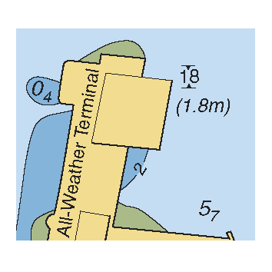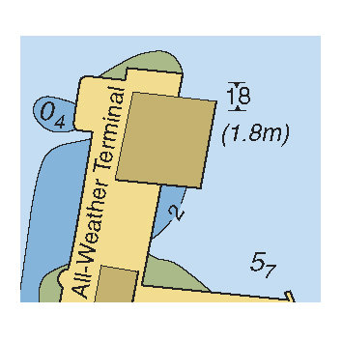

A profile diagram may be included if considered useful (see B-390).

B-370.9 Buildings in or over the water. Buildings are sometimes erected in or over the water, beyond the coastline. These may be individual buildings, sometimes of a specialized nature, such as a fort, or an extension of urban areas on piles or stilts. In the latter case, it may be possible for small vessels to navigate amongst (or even under) the buildings, while it represents an impenetrable mass for larger vessels and appears to the eye or on radar images as apparent coastline. This is similar, in some respects, to the situation with mangroves, see B-312.4, and merits similar treatment.

In general, the same principles as for buildings on land should be followed. Individual buildings should be charted in outline with land tint if scale allows, or by symbols if the chart scale is too small (D5 or an appropriate selection from E). Urban areas (when the density of buildings is too close to show by symbols) should be charted in the same way as urban areas on land, depending on national practice: that is as building blocks with ‘shadow line’ or using urban tint (see B-370.4). If using building blocks, they should be filled with land tint. If using urban tint, if possible it should be ‘transparent’ so that the intertidal or shallow water tint remains visible. An explanatory legend such as ‘houses above water’, or equivalent, should be inserted. The high water line should be charted as coastline (C1 or C2, as appropriate) and the outer boundary (apparent coastline) of the urban area as a fine dashed line (similar to C32/33).

Some examples are:

Example A (Source: Dinas Hidro – Oseanografi (Dishidros), Indonesia)

For covered berths, see B-321.9. For houseboats, see B-330.
Annex C to NCWG Letter 13/2015

Covered Berths and Buildings In or Over the Water
Response Form
(please return to CSPCWG Secretary by 12 November 2015)
andrew.coleman@ukho.gov.uk

 | Question | Yes | No
1 | Do you agree with the revised structure, wording and graphics for the new paragraph B-321.9?
2 | Do you agree with the revised new clause B-370.9 (noting further minor amendment may be required dependant on response to question 3 below)?
3 | What line style should be used for the outer boundary (apparent coastline) for an area of buildings above water (select a or b, not both):  - C32/33
3 | - N1.1

Further comments:

Name:
Member State:

IHO CSPCWG11-05C, paragraph 1.c)(i) at: http://www.iho.int/mtg_docs/com_wg/CSPCWG/CSPCWG11-NCWG1/CSPCWG11-05C_Annex%20to%20US_UK_AU_Proposal_to_Modify_CSPCWG_TOR.pdf

