General instructions for loading an S-100 application schema UML model for an S-100 4.0.0 product specification
Last updated 2019-NOV-18
The S-100 4.0.0 schemas and the master S-100 UML are available on GITHUB at <https://github.com/IHO-S100WG>.
Steps:
- Obtain the IHO S100 V4.0.0_FINAL file from the GitHub site mentioned above.
- Unpack and rename the EAP file to indicate the product specification and version.
E.g., S100_V4.0.0_S101_1_0_0.eap. Renaming the file will help keep track of product specification and version, and is preferable to all product specifications making application schemas using the same EAP file name.
- Add a Root Node named "IHO Application Schemas".
- If a file with Enterprise Architect “reference data” has been provided, import the “reference data” from that file using Enterprise Architect’s reference data import functionality.
- If a “Shared Packages” XMI file has been provided, import that file under the “IHO Application Schemas” root node (See steps 6-7 below for information on how to do this.)
- Import the product specification’s XMI file under the “IHO Application Schemas” root node. (In Enterprise Architect Version 14: Select the “IHO Application Schemas” root node -> Publish -> Import XMI -> Import Model XMI). Make sure the “Import Diagrams” box is checked and the “Strip GUI” box is NOT checked (Figure 1).
- When the dialog appears asking whether to place it at the root level (Figure 2), click No.
- After import is complete, the result should look like the attached Project Browser snapshot (Figure 3).

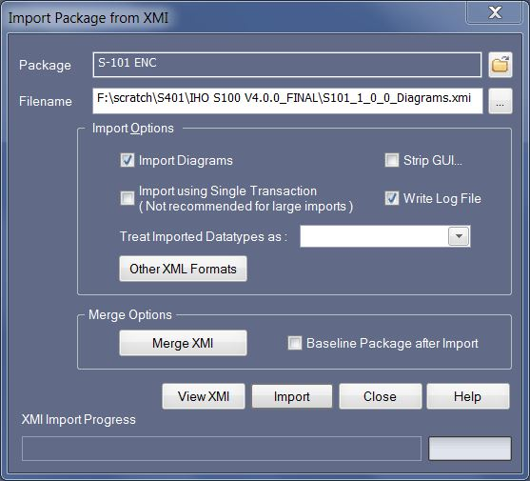
Figure 1. Import package dialog settings
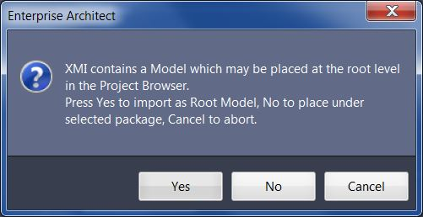
Figure 2. Model placement dialog
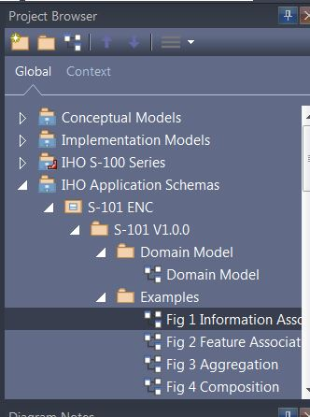
Figure 3. After successful import

