INTEROPERABILITY CATALOGUE FUNCTIONAL PRINCIPLES
OVERVIEW

Version 0.1 Draft 1
08 July 2018

Revision History
Changes to this white paper are coordinated by the IHO S-100 Working Group. New editions will be made available via the IHO web site. Maintenance of the Specification shall conform to IHO Technical Resolution 2/2007 (revised 2010).
Version Number | Date | Author | Purpose
0.1 | 2018-07-08 | EM, RM | First draft

Background
In S-57 ECDIS, a persistent issue has been the definition of how different data products should interact within the system. Interaction in this context means the manner in which the simultaneous display of data products affects the appearance of the combined display compared to the appearance of each product displayed in isolation. Interoperability of products includes issues such as ensuring that additional information overlay products do not obscure navigationally significant information, or managing the presence of same or similar feature instances in different products, which can leave the user questioning which instance is the most accurate. The IMO ECDIS Performance standard, MSC.232(82) paragraph 7.1 permits inclusion of other navigational information in an ECDIS, but gives little guidance to how this is done, nor does it define any principles of what constitutes interoperability. The result is that each implementor of ECDIS has done things slightly differently, and additional navigational information created for ECDIS has not been created in a harmonised manner. Within the S-100 paradigm, there are several products that are intended to work together in an ECDIS screen, and in order to not violate the requirement of additional navigational information not causing a degraded navigation screen and ensure a consistent display for all users, clear rules are required. The purpose of this Interoperability Catalogue Specification is to provide a framework for the specification of rules governing the interaction of data products in a machine-readable format that S-100 ECDIS systems can apply to the simultaneous display of S-100 data products.
The interoperability catalogue specification has been created using input from a survey by S-100WG of experts in ECDIS, government participants, and S-100-based product specification. The survey results were used to create the framework which was then validated by review by members of S-100WG. Subsequently the overall specification was created.

Principles of interoperability
The basic principles of interoperability in ECDIS center around information management for navigational safety. All data products intended for use in ECDIS provide some additional information within the scope of navigational safety. Chief among the products is the ENC, which is the basic information layer. All additional products complement the ENC in one way or another.
Two main categories of additional information are expected. The first one is additional information that does not already exist in the ENC, such as real-time water level. The second one is enhancements to information that already exist in the ENC, such as high definition bathymetry. In order to provide clear information to improve navigational safety, the ENC and the additional products must work together so as to avoid obscuring safety information (e.g., by high definition bathymetry overlapping aids to navigation) or cause the user to question which set of information is the most appropriate one to use in a given situation (such as navigationally significant regulations about protected areas that are encoded in both ENC and a marine protected area product).
The rules governing interoperability are not expected to be the same for all product interactions and therefore must be managed for groupings of products that are expected to be used together under specific circumstances, such as when performing specific navigational tasks. Rules that manage the information according to these principles, should be captured in a machine-readable format, so that ECDIS can be updated with new sets of rules if additional products become available or alterations to existing combinations are necessary.

Purpose
The interoperability specification is developed as a framework for capturing interoperability rules for use in ECDIS and includes a format that permits the exchange and machine reading of the interoperability rules. The specification includes an extensible list of products that are within the scope of this version of the interoperability specification. Should a need to include new version of an in-scope product arise, then a new version of the interoperability catalogue may be required to include the new or updated rules. If a new product is developed and should be included in the in-scope list, a new version of this specification may be required, such as if there is a need to extend the list of in-scope product specifications or include new functionality.
The principles described in this specification can be reused in any system using S-100 data. Although, should use be intended for a system other than ECDIS/ECS, a new specification of interoperability for that system may need to be developed to account for specific requirements versus those that apply to ECDIS.
Different products require different types of interoperability, such as turning off a feature in one product or placing one product in-between layers from another product. This specification has defined four levels of interoperability in addition to the current practice of overlapping and potentially obscuring overlays, which this specification regards as Level 0 interoperability. The four levels start out with simple interleaving at Level 1 and evolve to the use of spatial operations to virtually combine data at Level 4. Only Levels 1 and 2 are fully specified in this version of the specification. Full specifications of Levels 3 and 4 may be added in future editions.
Level 1
Interleaving
Level 2
Type-based selectivity and feature class replacement
Level 3
Feature hybridization
Level 4
Spatial operations

Figure 1 - Interoperability Levels

Level 1 – Interleaving
Feature types from different products are interleaved as specified by display plane and drawing priority information contained in the interoperability catalogue.
The ENC is the main product, but feature layers from other products may be interleaved with ENC feature layers to prevent ENC data from being obscured. There is no other interoperability-related processing of feature data at this level.

Level 2 – Type-based selectivity and feature class replacement
In Level 2 processing, Level 1 functionality is allowed as well as suppression of all features of a specified feature type in a specified product, with another feature type from a different product being displayed instead. Filtering by attribute values and geometry type is also possible. The output of interoperability processing is the same as Level 1 with certain feature types suppressed.

Level 3 – Feature hybridization
Level 3 extends interoperability functionality of Level 2 in that the ENC feature instance is either suppressed or replaced by the other feature instance (as in Level 2) or hybridized with it - i.e., their attributes are combined in some way. In Level 3, only thematic attributes can be combined for the purposes of hybridization. Hybridization may consist of adjustments to attributes of one of the ENC/other feature instances, such as re-calculation of values of numeric attribute or addition of listed values to an enumeration attribute. Hybridization may also result in an instance of a different feature type with an enhanced set of thematic attributes, some of which may be new attributes generated from attribute values of the original instances. The interoperability product will include a hybrid feature catalogue and portrayal catalogue defining the feature types and portrayals for new hybrid features.

Level 4 – Spatial operations
Level 4 extends Level 3 by permitting spatial queries (to determine related subsets) and operations (to define the interoperation result) that are explicitly defined using an adequate set of spatially-capable rules. This means that the ENC and other-product feature(s) need not be spatially equal, they need only be related to one another by the spatial query. For hybridization, in addition to thematic attributes, feature geometry can also be combined using spatial operations.
Support for Level 3 and 4 is not fully elaborated in this version of the Interoperability Catalogue Specification and Levels 3 and 4 should therefore not be implemented in interoperability catalogues created from this specification.

Functional overview
The interoperability concept envisions that interoperability is only required between specific subsets of available dataset types at any given time. These groupings are called predefined combinations and consist of pre-set combinations of products that are considered to be logically related for a specific navigation, route monitoring, or planning task (or set of tasks). Within each predefined combination rules are specified for how the products that are included shall interact. The predefined combinations are contained in an interoperability catalogue which is machine readable, permitting a regime that can respond to new requirements should such arise. The primary Interoperability Catalogue will be issued by IHO and contain the minimum set of Predefined Combination(s).
It is envisioned that users, service providers and system manufacturers can repackage and expand on the IHO issued Interoperability Catalogue as long as the functions of the minimum set of Predefined Combination(s) are not degraded.
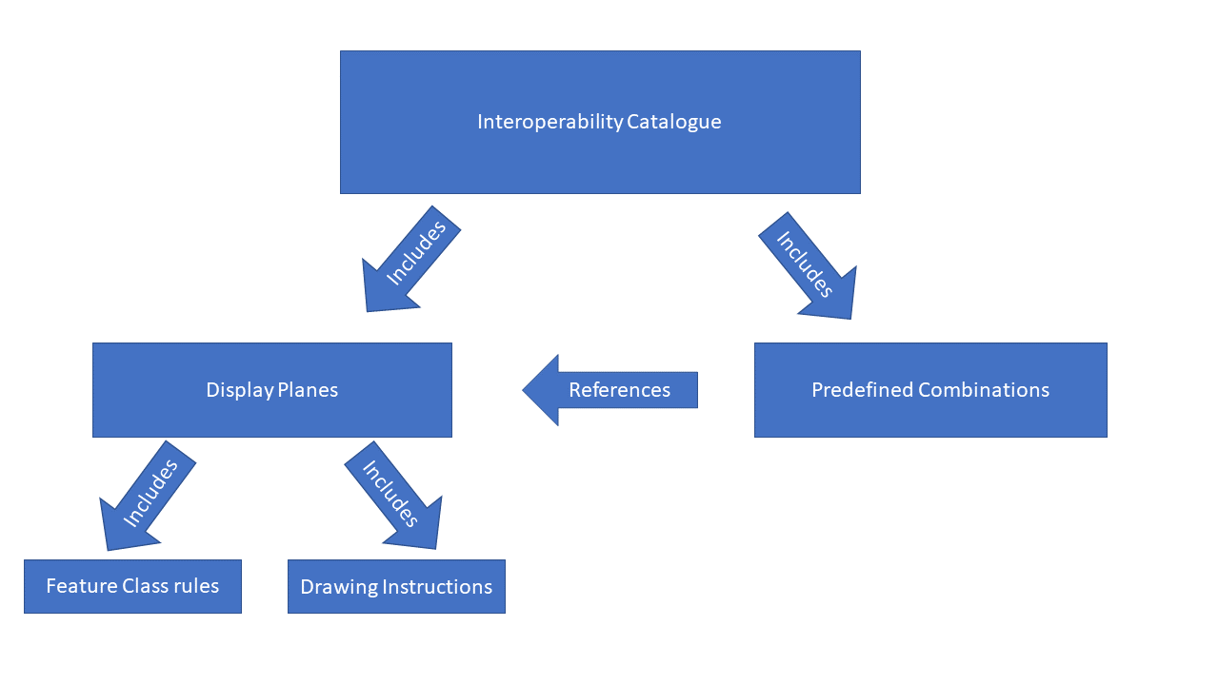
Figure 2 - High level Interoperability Catalogue Overview

The IHO issued Interoperability Catalogue is expected to be created using an interoperability catalogue builder software tool. The body of an interoperability catalogue consists of subsections encoding the rules for display planes, feature priorities, feature interleaving, and predefined combination. Each predefined combination provides its interoperability level as a level number, which indicates the types of available interaction rules that can be defined within the predefined combination. The predefined combinations can make use of the display planes to control the rendering (the drawing order or turning on or off visibility) for features from the products included in the individual predefined combination.

Administration aspects of interoperability
The interoperability specification concept requires that all product specifications that are in scope be harmonized, and therefore developed and maintained as part of a collection of product specifications. This means that it is a requirement for interactions between development teams of specifications to work together to ensure a harmonized approach to common elements. This collaboration is necessary to ensure the interoperability catalogue is configured to manage the interaction in predefined combinations correctly, to prevent potentially increasing safety risk by e.g. turning off a feature even though it is not present in another product, or inadvertently giving priority to less-detailed information in one product versus another when there is a domain overlap.
The development teams of product specifications that are in scope of the interoperability catalogue, become part of a common ecosystem where good communication and collaboration for the common goal is a necessity. The interoperability specification for ECDIS contains a number of guidelines of important issues that product specification teams should consider as they manage the lifecycle of in scope product specifications.

Data Encoding Guide
The interoperability catalogue also requires consistent content to reduce any processing issues. To aid in this, the interoperability specification includes encoding guidance for interoperability catalogue developers on syntax, content, and catalogue structure.

Implementation of interoperability support
The interoperability specification includes a high-level processing model in order to give implementors guidance for available options when choosing which implementation strategy works best in their system. Interoperability processing can either precede or follow portrayal processing (except rendering, which converts feature data into graphics and is necessarily the step just before actual display). A mixed processing model, where interoperability processing is done both before and after portrayal processing, is also possible.
Further normative implementation guidance is given for the provision of decluttering techniques by implementations, such as minimizing overlaps for both symbols and text, minimization of the number of colours on the display. Moreover, the specification includes requirements for software quality, human machine interface along with user requirements following the guidance in IMO MSC.1/Circ.1512.

Or drawing instructions corresponding to the feature instances.

