Example of encoded CATZOC differences in TSS encoded by 2 different producers.

ENC Country AA (AA3C3408), ENC Country BB (BB300923) and ENC Country BB (BB300036) have encoded individual parts of a common Traffic Separation Scheme.

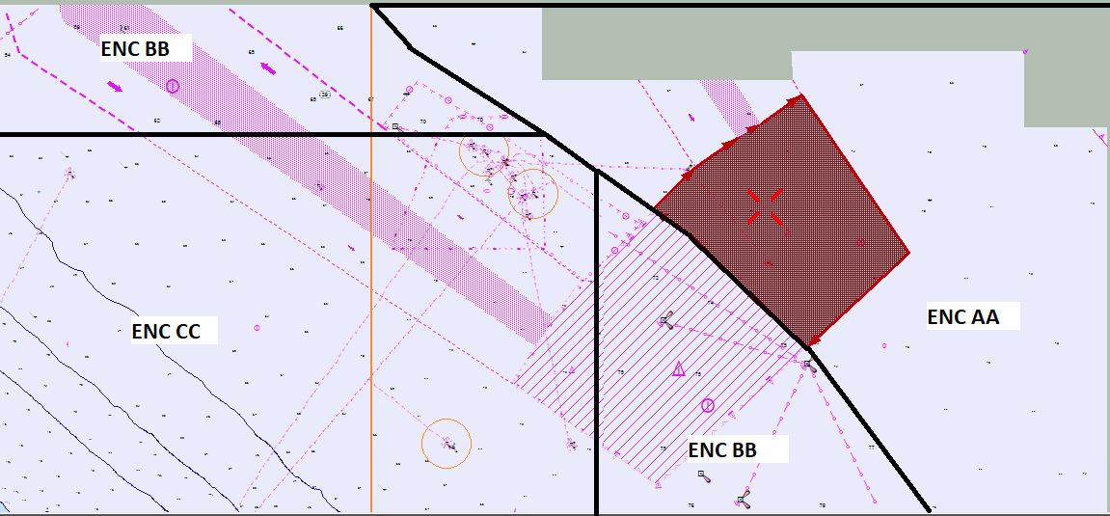

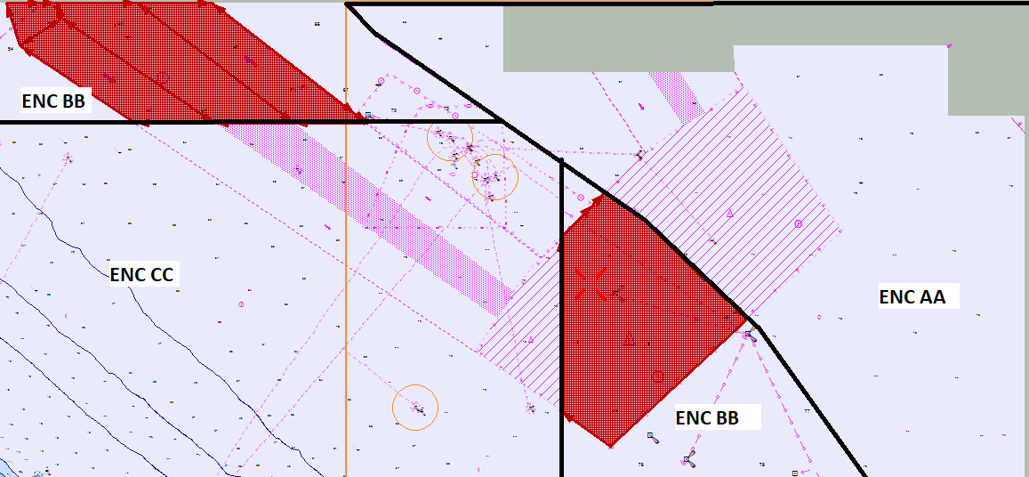

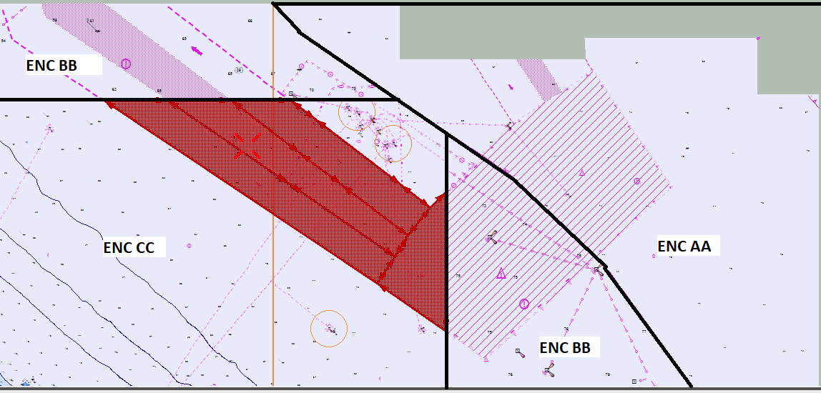

Checking CATZOC we can see ENC AA cell has M_QUAL area with CATZOC = B, ENC BB has M_QUAL areas with CATZOC =D and ENC CC has M_QUAL area with CATZOC = C:
