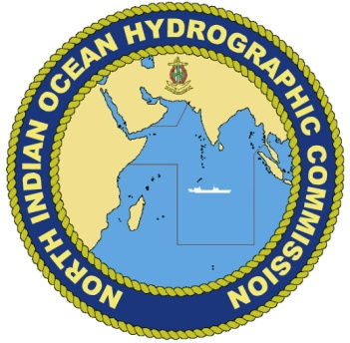
Annex B
NIOHC CL 04-2015
15th December 2015

16th NORTH INDIAN OCEAN
HYDROGRAPHIC COMMISSION MEETING
Chittagong, Bangladesh
14th to 16th March 2016

Delegate Registration Form

Please send the completed Registration Form to the NIOHC Secretariat, Directorate of Hydrography, Naval Headquarters, Banani, Dhaka 1213 via e-mail to dhydro@navy.mil.bd cc: bnhoc.bd@gmail.com or fax +88 02 9836270 before 16th February 2016.

Member State
Organization
- Contact Details
Head or Member of delegation
Rank or Title
Family Name
Given or Personal Name
Position / Job title / Role
Nationality
Telephone
Fax
E-mail
Special Dietary Requirements (Please State Type)

- Travel Details (For administrative purpose only). Participants are expected to make their own travel arrangements.
Your arrival in Chittagong | Date
 | Flight Number
 | Airline
 | Arrival Time

Your departure from Chittagong | Date
 | Flight Number
 | Airline
 | Departure Time

- Hotel Information (For administrative purpose only). Participants are expected to make their own accommodation arrangements.

Hotel at which booking has been made | Radisson Blu | Yes/No
 | Other | (Name)

Signature |  | Date

More information can be obtained from: Cdr Sheikh Shahid Ahmed, Deputy Director Hydrography, Naval Headquarters, Banani, Dhaka 1213, Phone: +88 (0)1769702172, Fax: +88 02 9836270, email:dhydro@navy.mil.bd

