CAPACITY BUILDING SUB-COMMITTEE

DRAFT PROCEDURE 11

ASSESSMENT OF CAPACITY BUILDING PHASE STAGE OF COASTAL STATES

PROCEDURE 11 provides guidance for the Assessment of Capacity Building Phase Stage of Coastal States.

Content:

Part 1 of this document contains the guidance procedure for the assessment of Capacity Building Phase stage of Coastal States by the CB Coordinators.

Part 2 of this document provides the templates to be used by the CB Coordinator to register the Capacity Building Phase stage of Coastal States.

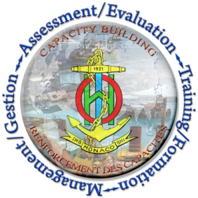
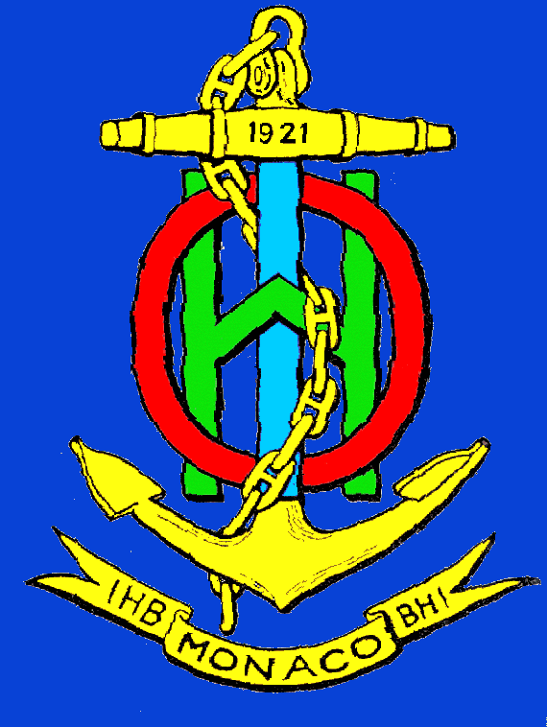
PART 1

GUIDANCE

Background
- Paragraph 4 of the TORs states that “CB Coordinators are expected to keep a record of the Capacity Building Phase Stage of all the countries and territories in their RHC region in accordance with the template in annex. This record will be part of the 3-year regional CB Work Plan”.
Description
- This CB Procedure provides guidance for the CB Coordinators to assess the phases of Capacity Building in each RHC using a consistent approach across the RHCs using a simple numerical grid in a database. This approach will allow the use of GIS tools to depict and analyze the status of the Capacity Building phases worldwide.
- The main objective of this database is to help the CB Coordinators to assess the global, regional and national needs for Capacity Building support, and to better measure the success of the IHO’s Capacity Building programme.
- The suggested numerical grid is represented below:
Value | Assessment
-1 | No information available
0 | The country is unaware of its national obligations
1 | The country is aware of its national obligations but does not have the means to do it
2 | The country has the ability to fulfil national obligations
3 | The country fulfils its national obligations through a third party
4 | The country fulfils its national obligations in a sustainable manner
Note: the assessment represented by 3 is an alternative to 4 as explained in the IHO Capacity Building Strategy.
- The assessment of the Capacity Building phase stage is complemented with the indication of whether the Coastal State has established a National Hydrographic Committee (NHC) or a National Hydrographic Coordination Committee (NHCC). Countries with an established NHC or NHCC will be given preferential status when capacity building submissions are considered. The assessment for the NHC/NHCC is:
Value | Assessment
-1 | No information available
0 | The country does not have a NHC/NHCC
1 | The country is in the process to establish a NHC/NHCC
2 | The country established a NHC/NHCC

- An example of the template with some representative assessments can be seen in the table below:
 | Coastal State | NHC or NHCC | CB Phase 1 | CB Phase 2 | CB Phase 3 | Last TV
1 | Country A | -1 | 1 | 1 | 3 | 2008
2 | Country B | 0 | 1 | 2 | 3 | 2012
3 | Country C | 2 | 4 | 4 | 4 | N/R
4 | Country D | 1 | 2 | 2 | 3 | 2013
5 | Country E | -1 | 1 | 1 | 3 | 2011

PART 2

TEMPLATE

INTERNATIONAL HYDROGRAPHIC ORGANIZATION

Assessment of Capacity Building Phase Stage of Coastal States

 | Coastal State | NHC or NHCC | CB Phase 1 | CB Phase 2 | CB Phase 3 | Last TV
1
2
3
4
5
6
7
8
9
10
11
12
13
14
15
16
17
18
19
20
21
22
23
24
25

Note: this template is available in Excel (xls) format from the IHO website.

