CAPACITY BUILDING SUB-COMMITTEE

DRAFT PROCEDURE 12

CERTIFICATE OF PARTICIPATION IN CB ACTIVITIES

PROCEDURE 12 provides guidelines for issuing a certificate of participation to those attending Capacity Building (CB) activities.

Explanation:

Part 1 of this document contains the standardized procedure for issuing the CB certificate that must be followed by the Project Leader. It provides guidance for the preparation, delivery and registration of the CB certificates.

Part 2 of this document provides the template to be used by the Project Leader when preparing/coordinating the CB certificates.

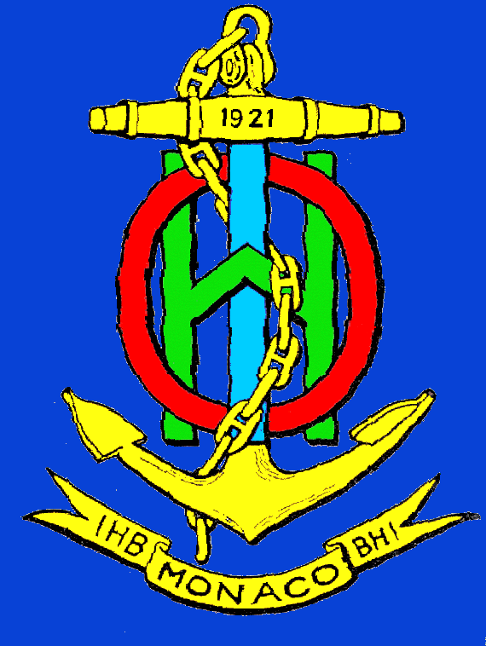
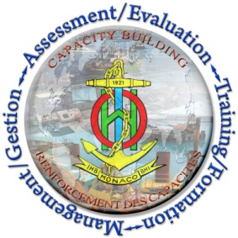
PART 1

STANDARDIZED PROCEDURE

Participants to IHO Capacity Building activities will receive a certificate for their attendance to Courses, Trainings, Seminars, Workshops and other CB provision approved in the annual CB Work Programme (CBWP). The certificate will be issued according to the following rules:
- The Project Leader is responsible for the delivery of the certificates to the participants and will coordinate the task with the RHC Chair, the RHC CB Coordinator, the hosts and other contributing organizations.
- The participant will be entitled to a certificate when the frequency of attendance is higher than 85%. For example, if the trainee fails to attend one day out of five the certificate will not be issued.
- Certificates will be numbered according to the following rule of formation:
YYYY-CBWP-P-NN-mm/MM,
where YYYY is the year of the CBWP
P-NN is the identification of the CB activity in the CBWP
NN is the individual number of CB activity
mm is the sequential number of the certificates, from 01 to MM
MM is the number of participants entitled to receive a certificate
- The above unique number will be used as a reference in the Students' database. A list of attendees and the certificates' numbers shall be sent to the IHB with the final report and with digital copies of the certificates to cba@iho.int (copy to adcc@iho.int and to the CB Coordinator).
- The certificate will be prepared utilizing the template in Part 2. In the case of unforeseen circumstances and the approved template is not appropriate, the Project Leader will coordinate with the CB Coordinator and the IHB for guidance in amending the wording of the approved template.
- The successful completion of a Category A or Category B programmes in Hydrography or Nautical Charting will enact the recognized institution to issue a certificate in accordance with the IHO Publications S-5 (A/B) and S-8 (A/B) and thus no certificate will be issued as established in this Procedure.

PART 2

CERTIFICATE TEMPLATE

A template is shown on the next page to help the Project Leader to issue the certificate of participation in coordination with the hosting institution. The parts in brackets will be edited in accordance with this procedure.

Note: this template is available in Microsoft Word format in the CB web pages

[XX]RHC
[OTHER INSTITUTION]
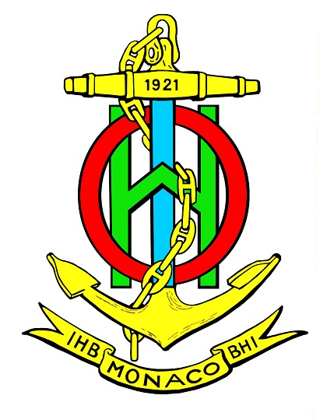

CERTIFICATE Nº [YYYY]-CBWP-P-[NN]-[mm]/[MM]
This is to certify that
has participated in the
jointly organized by
the International Hydrographic Organization (IHO)

Name
Director
International/Regional Organization

Name
Chair
[_______] Regional Hydrographic Commission
Name
Director
International Hydrographic Organization

