CSPCWG3-10.3A

3rd CSPCWG MEETING
Monaco, 22-24 November 2006

Paper for Consideration by CSPCWG

International Chart Titles

Submitted by: | DE
Executive Summary: | Language of INT chart titles in charts and for Part B M11
Related Documents: | M4 B-241, M11 part B, BSICC correspondence
Related Projects: | none

Introduction / Background
- Introduction / Background
Up to now the chart titles in M11 are all in English, but the real titles are mostly in national language – see examples below.
For the BSICC catalogue which is updated every year, members have already been encouraged to fill the real titles, that means in the national languages.

- Analysis / Discussion
The chart titles in M11 Part B are not the real titles. They are mostly translations.
Because of space limitation it is not really possible to show both national and English (French or Spanish) titles. Are there examples for printing the translation on the back of the chart?
There are examples for additional English titles but there are in smaller size and not following INT2.

3. Conclusions
It is necessary to decide if we keep to the English translations in M11 or if we change to the original titles.

- Recommendations
It is shorter to show only the national titles on charts and also in M11-part B. The most used geographical names (endonyms) are well known. Non-Latin fonts should be transliterated or translated.

- Justification and Impacts
M11-changes:
- additions to Part A concerning language?
- Part B (not high priority or before Internet version?)

- Action required of CSPCWG
The WG is invited to discuss and endorse the recommendations.

ES_B 4_INT1081
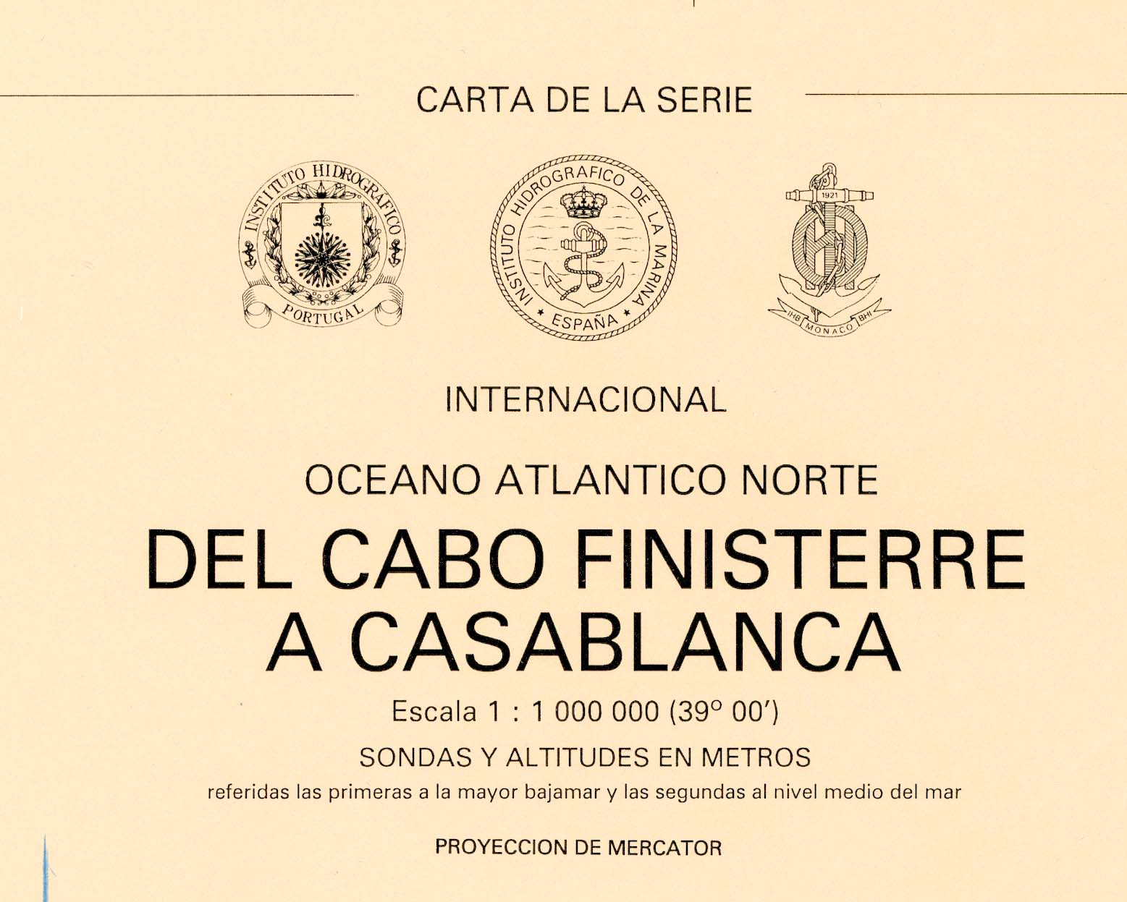

EE_507_INT 1267
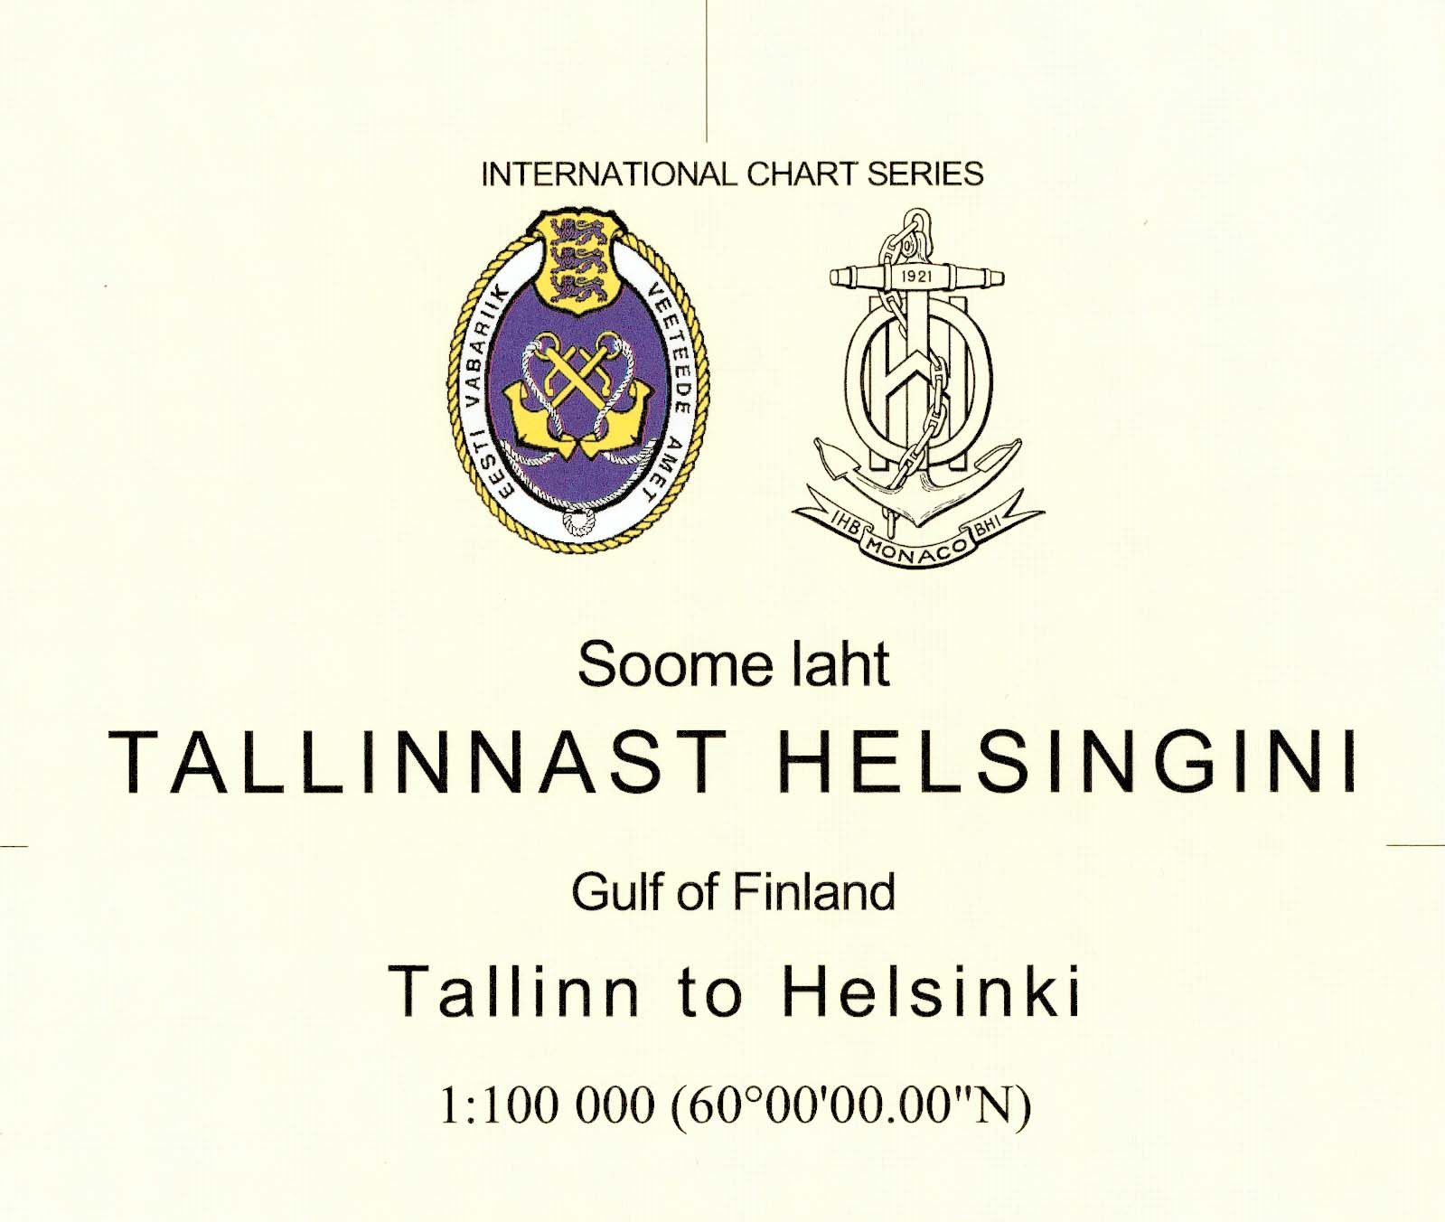

FI_28_INT1191
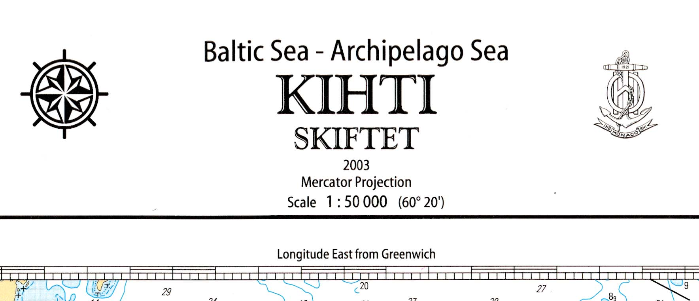

GB_1481_INT1543
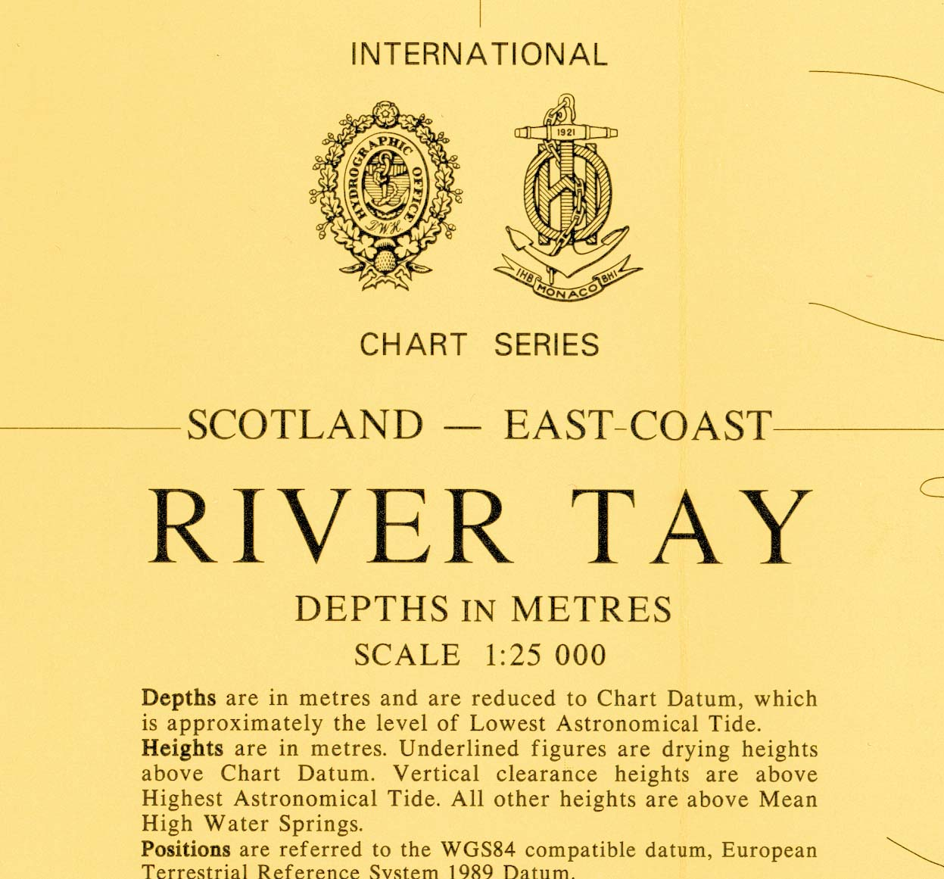

DE_146_INT1293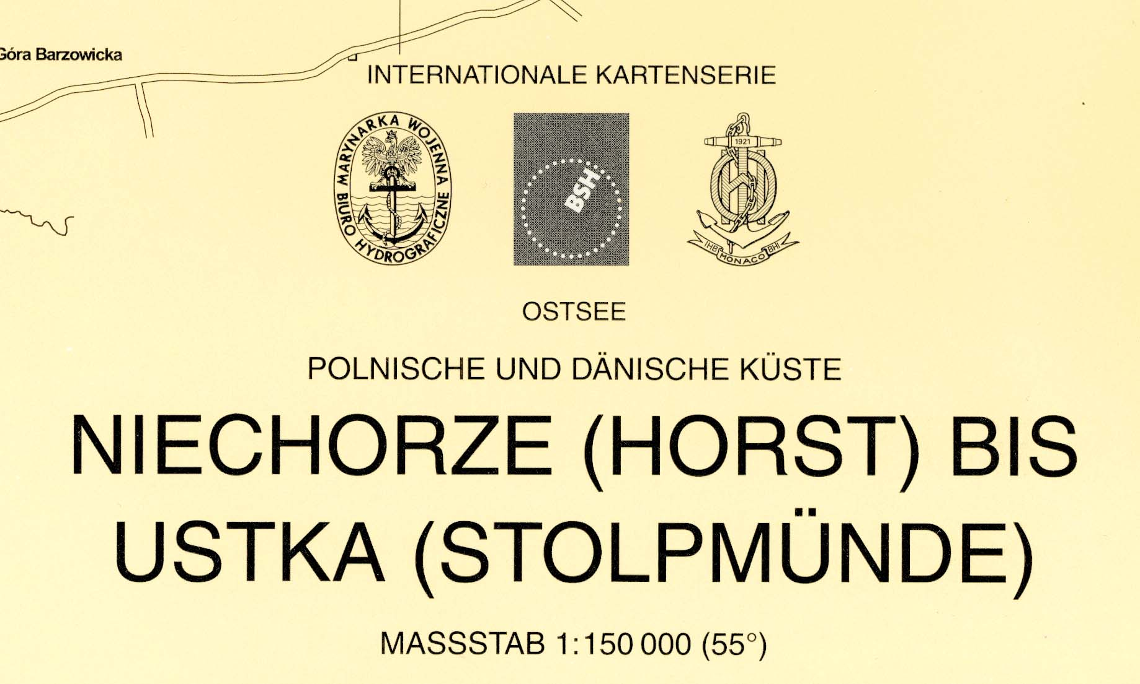

DE_40_INT1201 (Title out of chart limits)
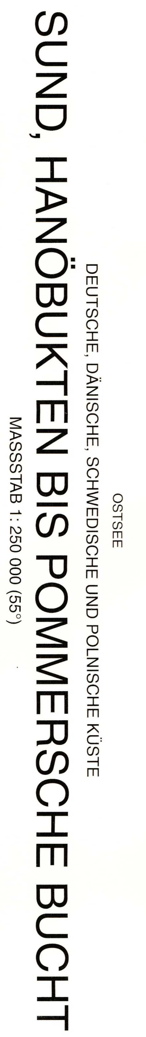

LV_1012_INT1273
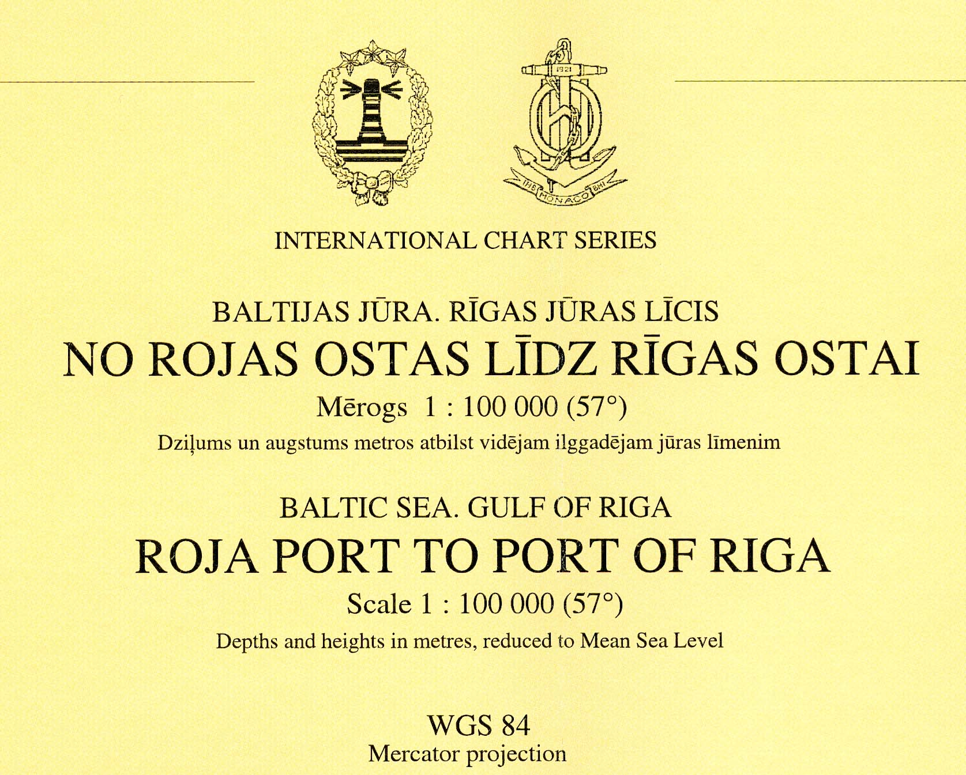

PL_37_INT1297
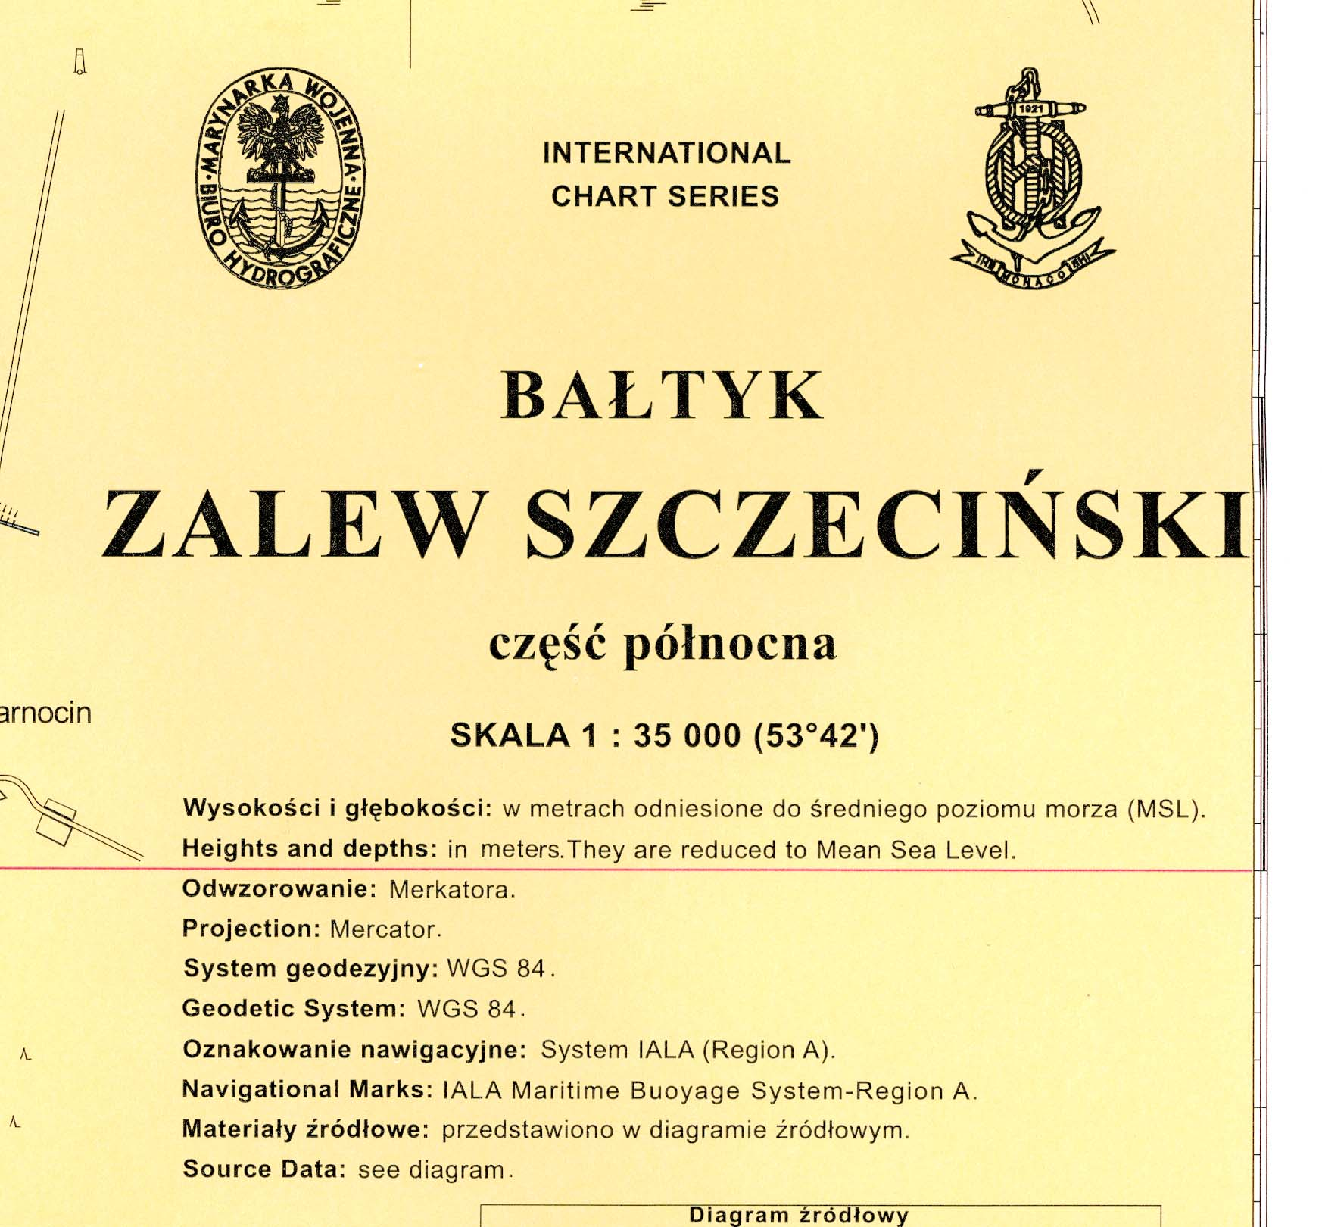

PT_23204_INT1812
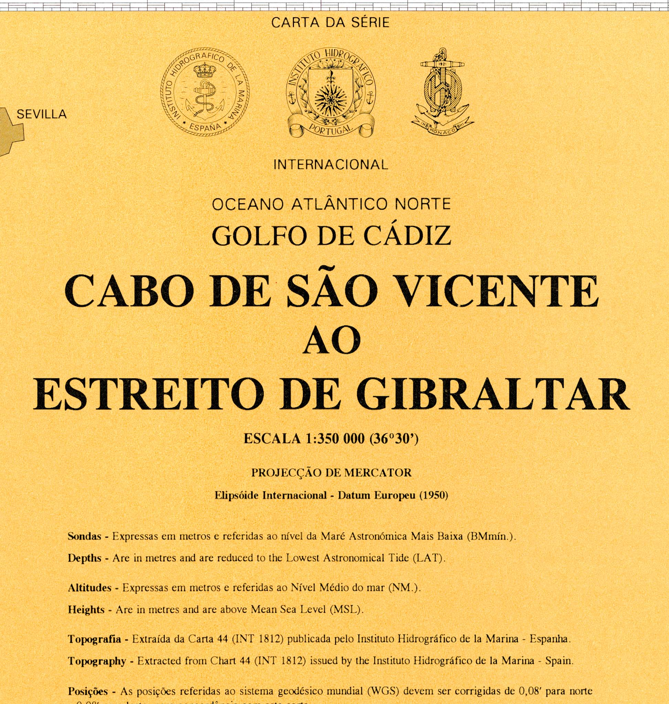

RU_21001_INT1023_Russland


