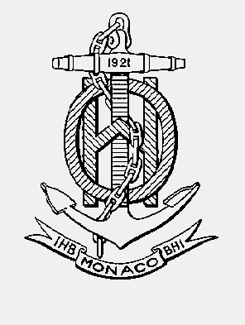

INTERNATIONAL HYDROGRAPHIC ORGANISATION HYDROGRAPHIQUE
ORGANIZATION INTERNATIONALE

CHART STANDARDIZATION & PAPER CHART WORKING GROUP
(CSPCWG)

[A Working Group of the Hydrographic Services and Standards Committee (HSSC)]

Chairman: Jeff WOOTTON  Australian Hydrographic Service  8 Station Street, Wollongong, NSW, 2500  Australia | Secretary: Andrew HEATH-COLEMAN  United Kingdom Hydrographic Office  Admiralty Way, Taunton, Somerset  United Kingdom
Tel: +61 2 4223 6508 | Tel: +44 1823 337900 ext 3656
Email: jeff.wootton@defence.gov.au | Email: andrew.coleman@ukho.gov.uk

CSPCWG Letter: 10/2014
UKHO ref: HA317/010/032-13
AHS ref: fAA143547
Date: 9 October 2014

Dear Colleagues

Subject: CSPCWG10 Actions 15 and 18-21.
Here is another group of actions from CSPCWG10. The details are at Annex A, with specific questions at Annex B.
Please note that Action 16 (Light vessel symbol) is currently being further researched, following questions from IHB.
Please respond, using Annex B, not later than 4 December 4014.

Yours sincerely,
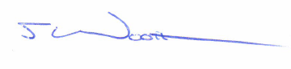
Jeff Wootton,
Chairman

Annex A: CSPCWG10 Actions 15 and 18-21
Annex B: Response form
Annex A to CSPCWG Letter 10/2014

CSPCWG10 ACTIONS 15 and 18-21

Actions in blue
Comments and explanations in green
Extracts from S-4 in black with:
- Proposed additional words in red
- Proposed deletions crossed through.

ACTION 15

Italy’s paper ‘CSPCWG10-08.3A’ gives background.

Extract from CSPCWG10 Record

8.3 Maintained Depth, Dredged and Unsurveyed areas in the source diagram (IT)
Docs: CSPCWG10-08.3A Maintained Depth, Dredged and Unsurveyed areas in the source diagram
The Chairman presented IT’s paper. The meeting agreed that it is acceptable, although not necessary, to letter unsurveyed, maintained and dredged areas on traditional Sources diagrams. However, it was decided that the guidance should be included at B-296.2, rather than B-297 [as suggested by IT], as the latter only deals with ZOC diagrams. The meeting also decided that it is unnecessary to include MD, DA and UNS as INT abbreviations. These abbreviations were originally included on AU ZOC diagrams and always included in a key; however, AU no longer use these abbreviations and it is unlikely that any other HO does.

ACTION 15: Secretary to draft amendment to B-296.2 to allow (ie use ‘may’) indication of dredged / maintained / unsurveyed areas in Sources diagrams.

Proposed amended B-296.2:

B-296.2 The sources in each category of similar origin and type should be listed chronologically, preferably with the most recent first. Hydrographic surveys should normally precede references to charts, and in some cases the relative importance of a major survey may require it to be placed first. Sources of topographic detail, if included, should appear last. Maintained, dredged and unsurveyed areas may be labelled separately, if considered useful, for example:
a Maintained channel
e Unsurveyed area

Other consequential amendments:

B-291.1 The purpose of Source diagrams is to guide navigators, and those planning ‘navigational operations’ (including the planning of new routes and official routeing measures), on the degree of confidence they should have in the adequacy and accuracy of charted depths and their positions. A Source diagram should ideally give details of the survey data from which each part of the chart has been compiled. See B-417 for a summary of the ways in which the inadequacy of surveys may be indicated on charts.

B-418.1 Areas delimited by a bold line. In unsurveyed areas which are considered dangerous for vessels to enter, a very positive form of warning is required. Such areas must be shown by bold dashed black or magenta limits, with the legend either:
- ‘Unsurveyed ’ (which may be accompanied by a note) or
- ‘Depths (see Note)’.
A reference to the Source or ZOC Diagram may be inserted instead of a note. See B-296.2 and B-297.7.

ACTIONS 18 & 19

Netherland’s paper ‘CSPCWG10-08.6A’ gives background.

Extract from CSPCWG10 Record

8.6 Dangerous cargo berth (NL)
Docs: CSPCWG10-08.6A Proposed symbol for dangerous cargo berth
The meeting agreed that the proposed symbol should be used for a dangerous cargo berth (although it should utilize existing symbols in its make-up). It should be located at INT1 F19.3. By extension, the current term at N12.7 should be extended to include dangerous cargo.

ACTION 18: Secretary to draft S-4 specification for dangerous cargo berth.
ACTION 19: INT1 subWG to add symbol for dangerous cargo berth at F19.3.

Proposed revised specification:

B-321.8 Berths for particular purposes should be indicated by a legend or by the following symbols, if appropriate.

A visitors’ berth (for example in a marina) may be indicated by the magenta symbol (diameter about 2.5mm):
F19.2

A dangerous cargo berth may be indicated by the magenta symbol (diameter about 2.5mm)

 F19.3

If the dangerous cargo berth also has a berth number, the ‘flame’ symbol should be inserted within the oval (see B-321.7), adjacent to the number.

Other consequential amendments:

B-431.3 Amend term at N12.7 to ‘Dangerous cargo anchorage area’

INT1 Add new symbol at F19.3

Amend term at N12.7 to ‘Dangerous cargo anchorage area’

Ben Timmerman (NL) also supplied . He wrote ‘Although we didn’t really talk about it I also included a symbol for dangerous anchorage berth.’ There is logic to this, but does it need to be in INT1? Anchor berths containing the quarantine cross (from N12.8) and DW (from N12.4) have already appeared on charts and there are other possibilities. These are certainly intuitive and arguably are composite symbols, so do not need to be shown separately in INT1. B-431.2 could be revised as follows:

B-431.2 Designated anchor berths must be shown, normally by means of a magenta anchor with a circle superimposed. The number, or letter or possibly symbol (for example dangerous cargo ‘flame’, quarantine cross) assigned to the berth must be inserted within the circle. If necessary, to contain a 3-figure (or longer) designation, the circle may be extended to an oval:

ACTION 20

UK’s paper ‘CSPCWG10-08.7A’ gives background.

Extract from CSPCWG10 Record

8.7 Wind farms under construction (UK)
Docs: CSPCWG10-08.7A Wind farms (including under construction)
The Chairman described the problems UK was experiencing with the establishment of very large wind farms in UK waters, with construction sometimes taking several years. He explained the interim solution that UK used to show wind farms under construction, with example charts displayed. The meeting agreed that this solution is appropriate. It also considered that it is unnecessary to chart the associated air obstruction lights which should be covered by a legend or note. It invited UK to consider strengthening its wind turbine symbol to make it more prominent.
[Note: UK has strengthened its symbol, which will appear on future new editions]

ACTION 20: Secretary to draft S-4 specification for wind farms under construction.
Proposed revised specifications:

B-445.8 Wind turbines are generally tall, multi-bladed structures, usually with two or three blades, often visible over long distances. Their purpose is to generate electricity for large communities, or to feed a national grid. They are often in groups (known as wind farms) and may be sited on-shore (see B-374.6). Individual wind turbines must be shown by the symbol:
L5.1
If a navigational light is attached to the wind turbine, a flare should be added to the base, and the light description placed alongside. Air obstruction lights may be charted as ‘(RLts)’ if required, in accordance with B-476.2. No attempt should be made to describe the characteristic of the obstruction light other than its colour, as the visible character is likely to vary according to weather conditions and the angle at which it is viewed. Where numerous turbines are shown, it is often better to avoid chart clutter by either:
- adding a note (similar to the oil/gas field note – B-445.2) to state that all (or specified) turbines in the wind farm may exhibit air obstruction lights, or
- adding a legend under the wind farm name, eg ‘(Red lights on turbines)’.

Where vessels may navigate close to the structure, it is appropriate to show the minimum clearance height (in accordance with the datum for vertical clearances – see B-380.1) under the blade on large-scale charts, using symbol D20.

B-445.9 …
Note: Individual wind turbines which have navigational lights attached should be charted, even within a wind farm, if scale permits. For charting air obstruction lights on turbines, see B-445.8.

If all the turbines in a wind farm are floating, the symbol in the centre of the circle must be sloping 15°:

L5.2

Wind farms under construction may be indicated by the legend ‘Under construction’ with year date (F32), within or adjacent to the charted area or symbol. However, large wind farms may take years to construct. Where navigation through such areas is permitted and it is possible to show individual turbines, it may not be practicable to continually update the chart to show new turbines when their construction is completed. Also, those under construction may be at different stages, below or above water; all stages may be hazardous to navigation. In such cases it may be useful to mark the planned location of the turbines (which usually conform to a regular pattern), to assist the mariner in navigating safely between the rows, as follows:

The symbol F22 (Minor post or pile) should be used to indicate the pattern of planned turbines.

A [black] note should be added to explain the use of the symbol, for example:

WIND FARM UNDER CONSTRUCTION
The symbols [insert F22] within the wind farm construction area show the planned positions of the turbines. A safety zone of 50m becomes operational around each turbine as it is being installed, with a safety zone of 500m around the installation vessel; unauthorized navigation is prohibited in these zones. The symbols [insert L5.1] show the positions of any turbines that have been installed before the edition date of this chart.
Consult local notices to mariners issued by the wind farm developer for details of installation progress.
Periodically, the turbines that have been fully installed should be added by NM Block or New Edition, using symbol L5.1.

Example:

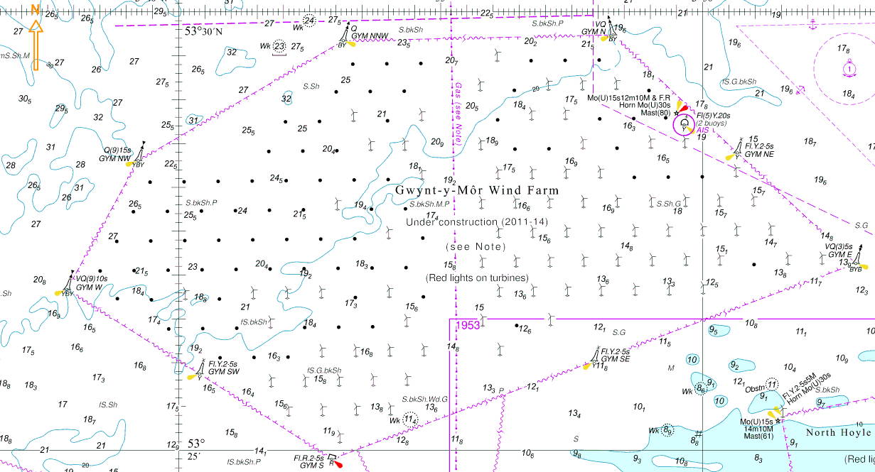

When the wind farm (or a significant section of it) becomes operational and confirmation is received that the permanent aids to navigation are operating correctly, charts should be updated to include all features appropriate to the chart scale.

ACTION 21

Finland’s paper ‘CSPCWG10-08.10A’ gives background.

Extract from CSPCWG10 Record

8.10 Covered berths (FI)
Docs: CSPCWG10-08.10A Covered berths
M Hovi (FI) briefed on the method FI had used for charting a covered berth, i.e. extending the building tint across the quay and water area, while retaining the blue tint in the water. The meeting agreed this solution worked well, although accepted it could not be used if an HO used open line style without tint for built-up areas.

ACTION 21: Secretary to draft S-4 specification for covered berth.

Proposed new specification B-321.9:

B-321.9 A covered berth should be labelled by an appropriate descriptive legend or name, for example: ‘Covered wharf’; ‘Hull All-Weather Terminal’. Transparent urban tint (see B-370.4) may be inserted over the charted hydrography so that any shallow water tint shows through. A vertical clearance (see B-380.1-2) should be shown, if known.
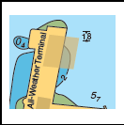
A profile diagram may be included if considered useful (see B-390).

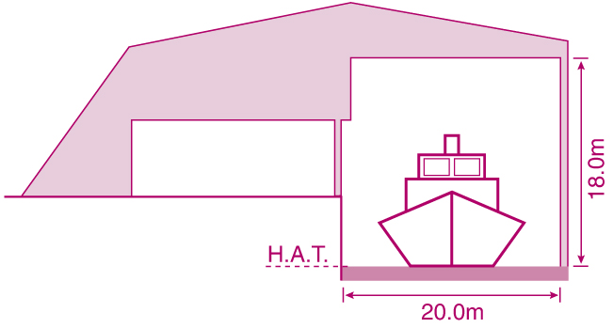

Annex B to CSPCWG Letter 10/2014
CSPCWG10 Actions 15 and 18-21

Response Form
(please return to CSPCWG Secretary by 4 December 2014)
andrew.coleman@ukho.gov.uk

WG10  Action | Question | Yes | No
15 | Do you agree with the proposed changes to B-296.2?
15 | Do you agree with the consequential change to B-291.1?
15 | Do you agree with the addition of cross references at B-418.1?
18 & 19 | Do you agree to adopt the proposed new symbol F19.3?
18 & 19 | Do you agree with the proposed changes to B-321.8?
18 & 19 | Do you agree to amend the term for N12.7 in B-431.3 and INT1 to ‘Dangerous cargo anchorage area’?
18 & 19 | Do you agree that a separate symbol for a dangerous cargo anchor berth is not needed in INT1?
18 & 19 | Do you agree with the proposed changes to B-431.2?
20 | Do you agree with the proposed changes to B-445.8?
20 | Do you agree with the proposed changes to B-445.9?
21 | Do you agree with the proposed new specification B-321.9?

Comments:

Name:
IHO Member state:

