TSMAD Meeting, 5-7 May 2008
Combined TSMAD and CSMWG Meeting, 7 May 2008
CSMWG Meeting, 7-9 May 2008

Cape Town, South Africa
Logistics Information

The South African Hydrographic Office, welcomes the 16th TSMAD and 18th CSMWG to Cape Town, South Africa. Whereas past Working Group meetings have taken place at the Silvermine naval complex, with delegates staying at the coastal village of Simons Town, this meeting will take place in the heart of the Cape Town city at the Breakwater Hotel. This hotel is situated adjacent to the Victoria and Alfred waterfront area, which provides easy access to the shops, restaurants, and a variety of tourist activities/ attractions. It is also very close to the central city area. | 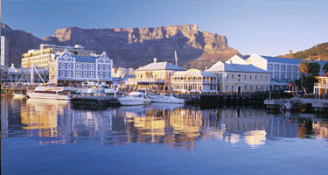

I. ACCOMMODATION

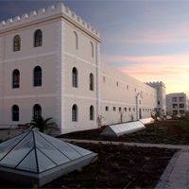 | Special rates that includes room costs, the cost of the meeting room for the week, an evening function and morning/afternoon tees/coffees, has been negotiated with the Breakwater hotel. This price also includes breakfast and the 14% VAT charge, (but not the 1% tourism tax), and is based on the present Rand / Euro exchange rate, for an estimated 30 attendees.  - Single room R900 (78 Euros) per person / night.  - Limited double rooms are available at R1200 (105 Euro) per night for those attendees who will be accompanied by a partner.  Please note that these prices do not include transportation between Cape Town International Airport and the hotel. (Please see II Transport below).

PLEASE SEND YOUR ATTENDANCE INFORMATION (at Annex A) BY NO LATER THAN 14 MARCH 2008.

II. TRANSPORT
Please note that transportation is not included in the hotel rate. Several waterfront hotels do however make use of a reputable minibus taxi transportation company to convey their clients between Cape Town Airport and the waterfront. Their standard prices are as follows:
Airport Transfers (per trip)

R 190.00 for 1 person (about 17 Euro), R 110 pp for 2 passengers, R 83 pp for 3 etc …
If you wish to make use of this service please indicate this on the attached registration form. The SAN HO will coordinate this to ensure that the transportation company is aware of all members’ arrival/departure times.
- VISA REQUIREMENTS

Depending on your nationality, and the purpose and duration of your visit, you may not need a visa to visit South Africa at all.
Countries exempt from South African visas
Countries subject to South African visa fees
IV ELECTRICITY PLUGS
South Africa uses the “Old British 3-pin” plug so wherever you are travelling from (even Britain), you will need an adapter. The power voltage is 220 – 240 / 50 Hz | 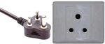

Annex A

TSMAD and CSMWG Meetings Registration Form

IMPORTANT Note: All members must please complete the information requested in this form, and forward it to the SAN Hydrographic Office (Sidney Osborne) by no later that the 14th of March 2008.

SANHO Contact Information:
Sidney Osborne
Email: hydrosan@iafrica.com
Phone: +27 (21) 78 72231 or + 27(21) 78 72408
Fax: +27 (21) 7872233

Personal details

First name: …………………………………………..
Surname (given name) …………………………………………..
Name of partner (if applicable) …………………………………………..
Organization …………………………………………..
Nationality …………………………………………..

Accommodation
Arrival date: ……………………………. Departure date: …………………….
Room type - single or double (for those accompanied by partners) …………….
Smoking / non-smoking ……………………………

Travel Information

Your Arrival at C.T. International Airport | Your Departure from C.T. International Airport
Flight No: ………………………………..  Airline: ………………………………..  Arrival time: ……………………………….  Please book transportation from CTI Airport to the Breakwater Hotel (Yes / No) …………………  (See section II above) | Flight No: ……………………………………  Airline: ……………………………………  Departure time: …………………………………..  Please book transportation from the Breakwater Hotel to CTI Airport (Yes / No) ……………  (See section II above)

Comments or additional information: ……………………………………………………………………..

Date: ……………………

