INTERNATIONAL HYDROGRAPHIC ORGANIZATION

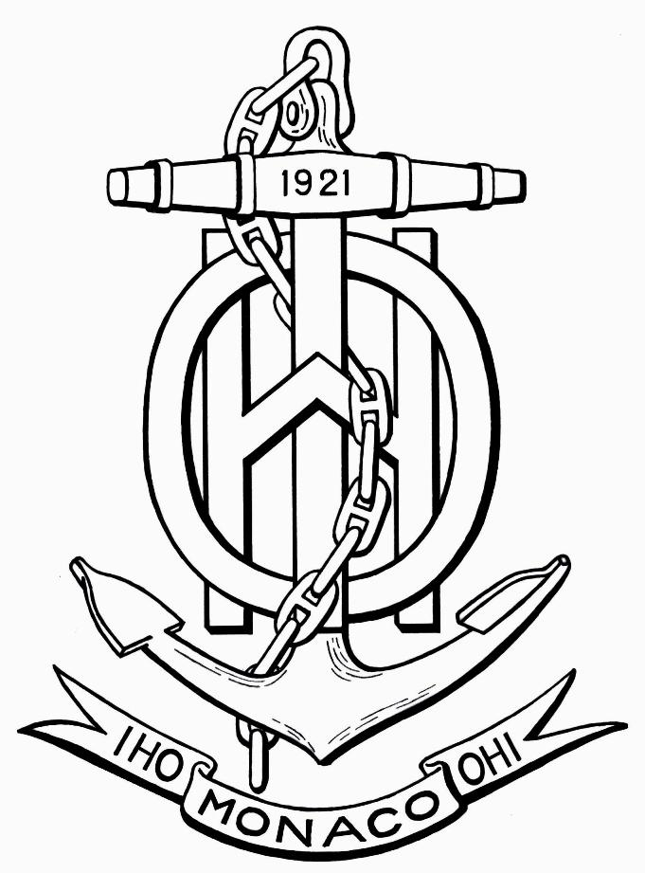
S-67
MARINERS’ GUIDE TO
ACCURACY OF DEPTH INFORMATION IN
ELECTRONIC NAVIGATIONAL CHARTS (ENC)

Edition 0.7
September 2018

© Copyright International Hydrographic Organization 2018

This work is copyright. Apart from any use permitted in accordance with the Berne Convention for the Protection of Literary and Artistic Works (1886), and except in the circumstances described below, no part may be translated, reproduced by any process, adapted, communicated or commercially exploited without prior written permission from the International Hydrographic Organization (IHO) Secretariat. Copyright in some of the material in this publication may be owned by another party and permission for the translation and/or reproduction of that material must be obtained from the owner.

This document or partial material from this document may be translated, reproduced or distributed for general information, on no more than a cost recovery basis. Copies may not be sold or distributed for profit or gain without prior written agreement of the IHO and any other copyright holders.

In the event that this document or partial material from this document is reproduced, translated or distributed under the terms described above, the following statements are to be included:

“Material from IHO publication [reference to extract: Title, Edition] is reproduced with the permission of the International Hydrographic Organization (IHO) Secretariat (Permission No ……./…) acting for the IHO, which does not accept responsibility for the correctness of the material as reproduced: in case of doubt, the IHO’s authentic text shall prevail. The incorporation of material sourced from the IHO shall not be construed as constituting an endorsement by IHO of this product.”

“This [document/publication] is a translation of IHO [document/publication] [name]. The IHO has not checked this translation and therefore takes no responsibility for its accuracy. In case of doubt the source version of [name] in [language] should be consulted.”

The IHO Logo or other identifiers shall not be used in any derived product without prior written permission from the IHO Secretariat.

S-67
MARINERS’ GUIDE TO
ACCURACY OF DEPTH INFORMATION IN
ELECTRONIC NAVIGATIONAL CHARTS (ENC)

Edition 0.7

September 2018

Published by:

The International Hydrographic Organization
4b, quai Antoine 1er
B.P. 445
Monaco, MC 98011 Cedex
MONACO
<info@iho.int>
<www.iho.int>

Foreword

This publication is intended to illuminate the accuracy and reliability of the bathymetry in an Electronic Navigational Charts (ENC) through an understanding of the Data Quality indicators in an ENC. The intended audience for the is publication are mariners and those wishing to improve their knowledge of how to determine which parts of the bathymetry in an ENC are accurate and reliable, and which parts require caution.

Contents

Section | Content | Page
1 | Accuracy of Nautical Charts | 5
2 | Zones of Confidence | 5
3 | ENC ZOC Symbols | 6
4 | The components of an assessment | 7
…4.1 | Typical survey characteristics | 8
…4.2 | Seafloor coverage | 9
…4.3 | Position accuracy | 10
…4.4 | Depth accuracy | 12
5 | Impact of ZOC categories upon mariners | 12
…5.1 | An alternative way to understand ZOC (using the star symbols) | 13
…5.2 | ZOC A1 (6 stars) | 14
…5.3 | ZOC A2 (5 stars) | 15
…5.4 | ZOC B (4 stars) | 16
…5.5 | ZOC C (3 stars) | 17
…5.6 | ZOC D (2 stars) | 18
…5.7 | ZOC U (U) | 19
6 | Summary | 19
Annex A | Zones Of Confidence Categories | 20
Annex B | Dangerous effects of over-scale ECDIS display near  ‘Isolated dangers’ | 22

1. Accuracy of Nautical Charts

All charts, whether paper or electronic, contain bathymetric data which varies in quality due to the age, accuracy and completeness of the individual surveys that were used to develop the charted depths. A chart can be considered as a jigsaw of individual surveys pieced together to form a single image. Most charts contain a mixture of surveys of differing quality.

In general, remote areas away from shipping routes tend to be surveyed less frequently, less accurately, and with lower confidence that all features have been detected. Areas of high commercial traffic are re-surveyed frequently to very high levels of accuracy and completeness, particularly where under-keel clearances are small. However, the vast majority of coastal and international shipping routes fall somewhere between these two examples, where risks in the form of dangers to navigation are less well defined.

To assess these risks, mariners have traditionally relied upon familiar but often ambiguous indicators used on paper charts, usually in a source diagram. The details and interpretations often varied widely between nations, like establishing how old a survey was, rather than how good. The variations in method, detail and interpretation render this type of quality information unsuitable for use in an electronic system such as ECDIS, as it prevents use of automated checking routines to look along a planned route to confirm suitability.

To address this, the International Hydrographic Organization developed and published the international system to be used by all nations within their S-57 Electronic Navigational Charts (ENC). This is the “Zones Of Confidence” system, often referred to as “ZOC”. The degree of reliance which can be placed in the depth information within an ENC can be consistently determined by understanding the Zone of Confidence assessment for an area, then applying a common-sense approach.

2. Zones of Confidence

All S-57 ENCs use the Zones Of Confidence (ZOC) system. There may be several different ZOC areas within each individual ENC. These assessments enable mariners to consider the limitation of the bathymetric data from which the ENC was compiled, and to assess the associated level of risk to navigate in a particular area.

The ZOC system only applies to the bathymetry (depths, contours, submerged rocks and reefs, etc) – it does not apply to the accuracy of charting the high water line, wharves, navigation aids, pipelines and so on.

There are five basic levels within the ZOC system. Each differing level of quality is referred to as a ‘category’ within the overall ZOC system. Each category is therefore labeled as ‘CATZOC’ when queried within the ENC. The categories range from ‘very high confidence’ to ‘very low confidence’. There is an additional category for ‘Unassessed’. The impact upon mariners of the various categories is discussed in Section 5.
The various ZOC categories are:

Category | Confidence level | General description - survey characteristics
A1 | Significant seafloor features detected and depths measured | High position and depth accuracy achieved using DGPS and a multi-beam, channel or mechanical sweep system.
A2 | Significant seafloor features detected and depths measured. | Position and depth accuracy less than ZOC A1, achieved using a modern survey echo-sounder and a sonar or mechanical sweep system.
B | Uncharted features, hazardous to surface navigation are not expected but may exist. | Similar depth accuracy as ZOC A2 but lesser position accuracy than ZOC A2 (generally pre-dating DGPS), using a modern survey echo-sounder, but no sonar or mechanical sweep system.
C | Depth anomalies may be expected. | Low accuracy survey, data collected on an opportunity basis such as soundings on passage or low accuracy given due the passage of time.
D | Large depth anomalies may be expected. | Poor quality data or unsurveyed.
U | Unassessed. | The quality of the bathymetric data has yet to be assessed. (Mariners should assume poor data quality until the area has been assessed).

The full version of this Table may be found in Section 7 at the end of this publication.

3. ENC ZOC Symbols

In the ENC the different ZOC quality levels are denoted by a series of symbols containing a varying number of stars, enclosed within a triangle or ellipse. This symbol is repeated throughout each area of equal quality. The symbols can be made visible or be hidden on the ECDIS screen depending upon the mariner’s needs at any particular time. The various categories range from six stars down to two stars. There is an additional category for areas which are ‘Unassessed’.

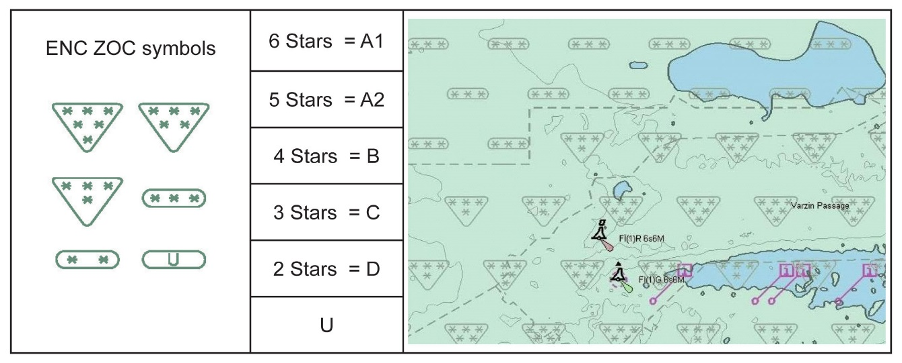
Zones Of Confidence symbols, categories and depiction on an ENC.

4. The components of an assessment

Assessments are made based upon four criteria, following which a single ZOC rating is derived for each area of differing quality. The lowest rating for any individual component within that area determines which ZOC category is assigned.

Individual assessment criteria are:

- typical survey characteristics;

- seafloor coverage (this relates to the possibility that something may have been missed and is therefore not on the chart);

- position accuracy;

- depth accuracy (this relates only to what has been detected and is therefore charted, not what might remain undetected).

The first criteria considered is the typical survey characteristics. The planning of the survey, the techniques used and the datum used are considered initially when assigning ZOC. A well planned and conducted survey has much greater potential than a poor one.

The most important criteria for mariners is seafloor coverage. For over 95% of the world’s coastal waters this determines the sensible clearance that should be maintained between a ship’s keel and the seabed and where any additional precautions may be needed. In the majority of coastal waters, and many oceanic areas, the potential size of an undetected seabed anomaly lying between the charted depths may be equal to or larger than any uncertainty indicating how good the charted depths may be.

The next most important criteria is position accuracy. As there will always be shoals and other features either too shallow or too risky to steam over, the sensible approach is to avoid them. The position accuracy for each category gives some idea of how far away from a hazard a ship should remain.

The least important criteria is depth accuracy, simply because it is the controlling factor in only a small proportion of the world’s coastal waters. It only assumes greater relevance where full seabed coverage has been achieved, such as within or near ports, or in certain channels. In areas where full seabed coverage has not been achieved, the safety margin allowing for the possibility of uncharted hazards is much larger than the allowance for the accuracy of charted depths.

Mariners should not require a detailed understanding of survey characteristics, as long as they understand the implications for shipping explained within each different ZOC category. These four major contributing factors are discussed further in the following paragraphs, with the implications for shipping in each ZOC area discussed in Section 5.

One limitation of the ZOC system is the lack of information about when a survey was conducted, or whether the seabed is stable. While the date can be provided in an additional data field within an ENC, this is rarely done, doesn’t form part of the chart ’image’, and may be difficult to find. In areas where the seabed is subject to change, national hydrographic offices should be downgrading the assigned ZOC category, restoring it only once a replacement survey is incorporated. However, this isn’t always done, so it’s wise to note areas of sand-waves, dates within dredged channels, and any other notes advising that channels may have changed.

4.1 Typical survey characteristics

Typical survey characteristics are the first considerations and generally overlap with the other three assessment criteria. The completeness of the survey with regard to the known nature of the seafloor is the first factor for assessment. Are there any holes in area of the survey that may have been important to survey? Are the techniques used for positioning and depth measurement modern? Finally the systematic nature of the survey; does the survey comprise planned survey lines on a known geodetic datum that can be transformed to WGS 84.

In this example, a single beam survey conducted in 1963 is very complete. Developments (more survey lines) were made around the shoal areas and crosslines were conducted to see if any shoals existed between survey lines. Due to this completeness of this survey no uncharted features, hazardous to surface navigation are expected. The resulting charted depth data would be given CATZOC of B. The area could not be given a CATZOC of A1 or A2 because full seafloor coverage was not achieved. | 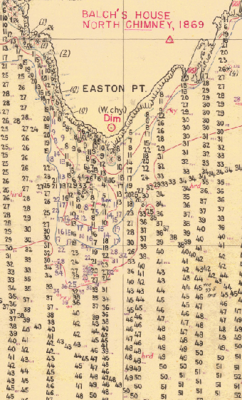

4.2 Seafloor coverage

This is the most important factor in assessing and categorizing a survey. What is in the gaps between charted depths? Did the surveyor miss anything? Was it potentially small or very large? The question of whether there are any undetected dangers in an area affects the majority of the world’s coastal and oceanic waters – it is only when there is confidence that nothing has been missed (and therefore nothing left off the chart) that the question of how close a ship can pass to the charted seabed becomes relevant.

The possibility of dangers being missed typically arises from older surveys, which simply were not as effective as using modern systems.

In this example, the older handwritten survey was completed in 1899. It was done by leadline measurements (recorded in fathoms)*. These measurements are actually quite accurate. However, they are only isolated measurements, with no guarantee of finding any hazard between one leadline depth and the next. This old survey only includes hazards seen by the surveyors at or above the sea surface. It was assessed as ZOC C – depth anomalies may be expected.  In contrast, depths taken from the modern metric survey shows a significant 2.1 metre shoal not found during the original survey. It proves that the 1899 survey, if it was the only survey in this area, could not be trusted, and that precautions should be taken.  (* 1 fathom equals 1.8 metres.) | 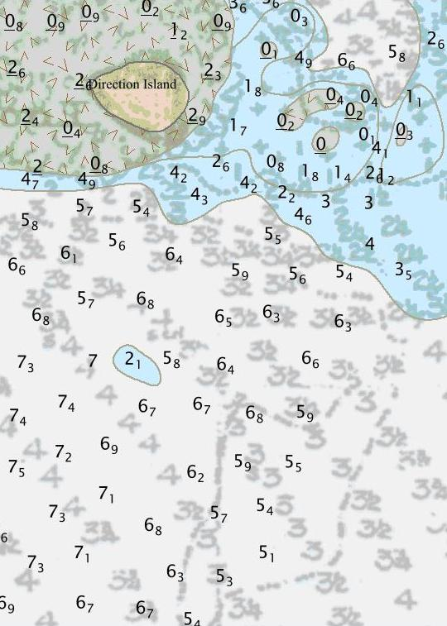

It is only in ZOC areas A1 and A2 where full seafloor coverage has been achieved. It is therefore only in these areas that the accuracy of the charted depths directly defines where a ship can go, and how deep the draft of that ship can be.

Even then, according to the ZOC system, there is a very small possibility that small features may remain undetected (less than a maximum size of 2 cubic metres for depths less than 40 metres). More information is available in the ZOC A1 and A2 sections of this publication.

ZOC B, C and D areas result from surveys that were progressively less detailed. In these areas there is an increasing possibility of undetected features absent from the chart (ranging from a small rock or shoal through to a submerged reef).

In a ZOC B area there is unlikely to be anything undetected affecting surface navigation, though it remains possible. The hydrographic office responsible for the chart will have (or should have) made their assessment based upon the quality of the survey, the depth of water and the size of vessels using the area. More information is available in the ZOC B section of this publication.

In a ZOC C area there is a strong possibility of undetected features (or charted features significantly out of position). These areas can be considered inadequately surveyed. More information is available in the ZOC C section of this publication.

In a ZOC D area there is a very strong likelihood of large undetected features absent from the chart (or charted features even further out of position). As these areas either have no systematic survey, or are completely unsurveyed, these features may well be as large as an entire submerged reef rising to just below the surface. If contemplating entering a ZOC D area, extensive precautions should be taken, in order to ensure there is sufficient time to react to dangers as they are revealed. More information is available in the ZOC D section of this publication.

4.3 Position accuracy

The next important factor in most circumstances is accuracy of position of the bathymetry. This includes depth contours, charted depths, reef edges or other charted seabed features. Positioning accuracy is typically determined by the positioning systems used during the hydrographic survey, as well as any loss of accuracy transferring older data from the survey to the chart, or between older datums and WGS84.

Most ships using modern satellite based navigation systems can be navigated with much greater accuracy than most of the surveys still used in charts. While some parts of a chart will be based upon modern surveys, away from the most critical areas most charts still rely upon surveys done with progressively older survey systems. While they were on the forefront of technology and science for their time, few of these systems were as good as Global Navigation Satellite System (GNSS) of today.

It is only since the 1990s that satellite based navigation systems for survey ships have been widely available. These give a positioning accuracy of seabed features somewhere in the range of 2 to 20 metres. (Determining the position of a feature on the seabed can be much harder than just positioning the survey ship itself.)

From the late 1940s to the 1990s survey ships depended upon shore-based electronic positioning systems transmitting their signal over short or medium ranges, giving accuracy of around 20 to 100 metres. In coastal areas, this means that anything the ship found could be up to 100 metres from where it was thought to be. Much of this depended upon how accurately the transmitter ashore was positioned, as well as the accuracy of the transmitted ranges to generate the ‘fix’.

Prior to this, survey ships used sextants to measure angles between a system of prominent marks, or flag poles built on towers established ashore, with surveyors ‘angling’ for hours at a time. A second row of towers could be built in shallow water or on reefs to extend the network further offshore, but with a further reduction in accuracy. Depending upon how accurately the towers were placed, accuracy of 50 to 500 metres was possible for the survey ship. So again, when something was found, particularly offshore, the true position could quite easily be up to 500 metres from where it was surveyed to be.

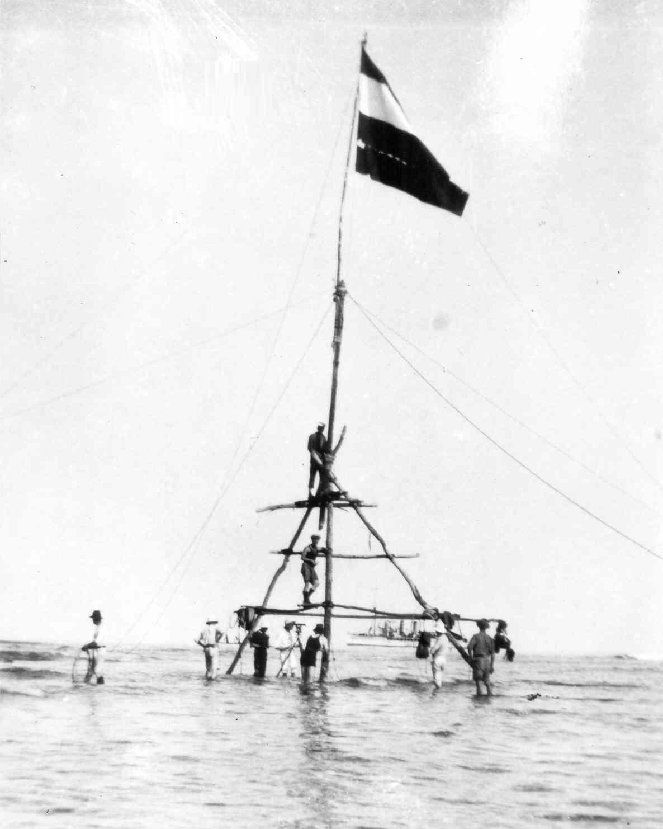
Up to early 1940s: Survey flag on an offshore reef to extend horizontal sextant control further offshore could achieve accuracy typically between 50 – 500 metres compared to GNSS. | Late 1940s to mid 1990s: Shore based electronic position fixing systems could achieve accuracy typically between 20 – 100 metres compared to GNSS.

Further offshore, where information was collected by ships relying entirely upon celestial navigation, positions could be considerably less accurate, typically no better than 1 to 2NM, and frequently worse.

While modern satellite imagery can be used to correct the position of many isolated visible offshore features, such as islands, reefs or perhaps shoals breaking in rough weather, anything more than a few metres below the surface is likely to remain unseen, and therefore possibly well out of its true position.

However, the quoted positional accuracy of a charted features is only part of assessing how far to stay clear of a potential danger.

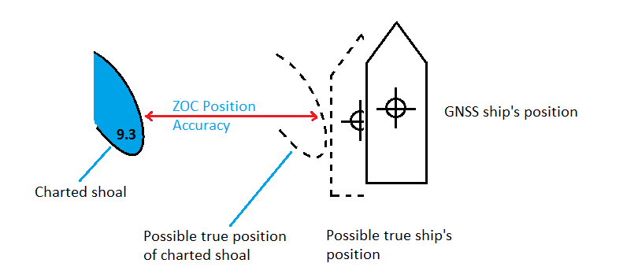
- A planned route should allow for both chart accuracy and ship’s positioning accuracy, as well as other factors.

Using the example of a shoal surveyed to a 50 metre positional accuracy in a coastal area, the Master also needs to consider the size of the vessel, the accuracy of the ship’s navigation system, and possibly other vessel parameters. The more correct safe distance in this example is likely to be over 80 metres:

50m | Positional accuracy of charted seabed feature, plus
15m | GNSS accuracy, plus
15m | half ship’s beam, plus
5m | ship orientation / motion =
85m | Total safe distance to clear hazard

4.4 Depth accuracy

Depth accuracy refers to how well the depth of a known feature has been measured below chart datum – it clearly does not refer to the accuracy of something which remains undetected. The margin allowed by a ship’s Master for the possibility that something remains undetected within a survey is a separate concern influenced by the seafloor coverage.

The three biggest factors affecting depth accuracy in relatively shallow coastal waters are the accuracy of the tidal observations, the motion of the survey ship and the setup of the echo sounder. Old leadline surveys actually contain very accurately measured depths, however they have a high risk of not detecting shoaler depths nearby. In contrast, a modern multibeam echo sounder misses very little, but requires careful setup and use to deliver accurate results.

5. Impact of ZOC categories upon mariners

Put in simple terms, mariners should be able to navigate with confidence in areas with ZOC A1 and A2 classifications. It is also unlikely that an uncharted danger affecting surface navigation exists in ZOC B areas. In ZOC C areas mariners should exercise caution since hazardous uncharted features may be expected, particularly in or near reef and rocky areas. A very high degree of caution is required for areas assessed as ZOC D, as these contain either very sparse data or may not have been surveyed at all. Finally, it is good practice to treat ZOC U areas with the same degree of caution as ZOC D areas.

To put this in perspective, the following table is an overall analysis of over 14 million square kilometers of coastal ENC from 32 nations:

Category | % area of English Channel | % area of Singapore & Malacca Straits | % area of world’s coastal ENC (32 nations) | Confidence
A1 (6 stars) | 3.6% | 1.4% | 0.7% | Very Good
A2 (5 stars) | 9.4% | 0.2% | 1.0% | Very Good
B (4 stars) | 62.9% | 2.5% | 30.5% | Good
C (3 stars) | 21.3% | 76.2% | 21.8% | Fair
D (2 stars) | 2.8% | 1.1% | 20.5% | Low
Unassessed (U) | 0.0% | 18.5% | 25.4% | Low

5.1 An alternative way to understand ZOC (using the star symbols)

An alternative way to understand the basic concept of confidence levels might be to think about the number of stars symbolizing each area. Even if the specifics are not considered, most people understand that if something is given more stars in an assessment than another, the one with more stars is considered to be ‘better’.

A good example that works similarly to ZOCs might be choosing a hotel from listings on a website. Everyone knows that a six star hotel is better than a three star hotel. Equally, when a listed hotel hasn’t been assessed, most people are unsure so tend to assume it isn’t very good.

Zones Of Confidence work exactly the same way. Wherever possible ships should be kept in those areas rated with a higher number of stars (preferably four or more, and three stars only with caution). Those areas with only two stars, or unassessed, should be considered very carefully and avoided if circumstances permit.

5.2 ZOC A1 (6 stars)

Surveys within this category have met the requirements for full seabed search. ZOC A1 is only achievable with recent technology.

ZOC A1 surveys generally only cover those areas of minimal under-keel clearance in harbours and shallow channels. The likelihood of any remaining undetected features is extremely low, and is most likely to be the result of undetected silting, or a channel which moves as a result of storms or seasonal changes. A very high degree of confidence can be had that there are no uncharted features between the charted depths or other features already shown on the chart.

The positions of charted seabed features should be better than 5 metres.

In practical terms, mariners should only require a relatively small allowance for an under-keel clearance in a ZOC A1 area. For a 10-20m draft ship this would be an allowance of at least 0.6 to 0.8m for the accuracy of charted depths, plus allowances for squat, settlement, ship motion and the accuracy of tidal predictions (if real-time tides are unavailable).

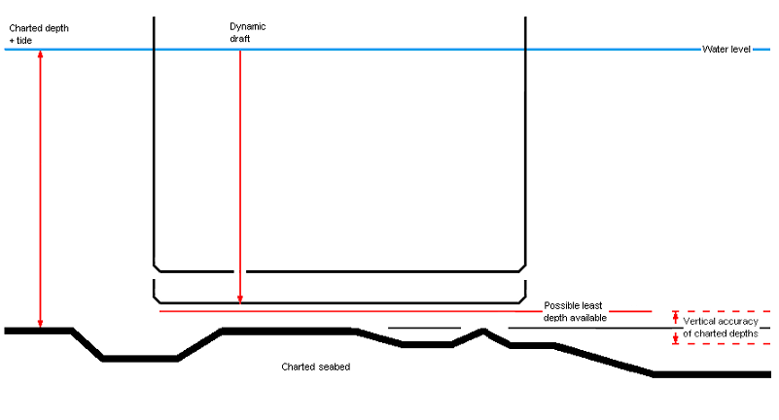
- ZOC A1 – Full area search undertaken. Significant seafloor features detected (Annex A, note 4) and depths measured.
- Position accuracy (uncertainty) better than 5 metres.
- Depth accuracy (uncertainty) approximately 0.6 – 0.8m (Annex A, table).

If the Master considers that there is the possibility of undetected features, such as in an area where depths may have recently changed, it may be wise to allow another 2m safety margin.

Conversely, the Harbour Master or pilot may advise that a smaller under-keel margin is possible. This will be the result of what is known as a ‘Special Order’ survey. While still within the overall ZOC A1 category, these surveys have achieved vertical accuracy better than +/- 0.25m. Under-keel margins this small should only be considered on the specific advice of the Harbour Master or Pilot, supported by real-time tidal observations, or with the benefit of excellent, and very recent, local knowledge. Without this knowledge or advice, under-keel margins as small as these should not be considered.
5.3 ZOC A2 (5 stars)

Surveys within this category have also met the requirements for full seabed search. They have the same level of confidence as ZOC A1 that there are no uncharted features lying between the charted depths or other features already shown on the chart. However, the safety margins the Master should allow in a ZOC A2 area are larger than those in a ZOC A1 area.

Surveys meeting ZOC A2 requirements are generally undertaken in those port areas used by smaller vessels (such as outside the dredged channel), as well as port approach areas and coastal shipping routes. ZOC A2 areas may be subject to a program of periodic re-survey but this is likely to be less frequent.

The positions of charted seabed features should be better than 20 metres.

In practical terms, mariners should only require a relatively small allowance for an under-keel clearance in a ZOC A2 area, approximately twice as much as for ZOC A1. For a 10-20m draft ship this would be an allowance of at least 1.2 to 1.4m in a ZOC A2 area, plus allowances for squat, settlement, ship motion and the accuracy of tidal predictions (if real-time tides are unavailable).

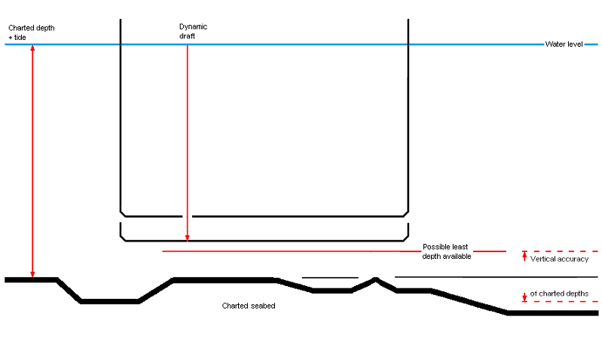
- ZOC A2 – Full area search undertaken. Significant seafloor features detected (Annex A, note 4) and depths measured.
- Position accuracy (uncertainty) better than 20 metres.
- Depth accuracy (uncertainty) approximately 1.2 – 1.4m (Annex A, table).

If the Master considers that there is the possibility of undetected features, such as in an area where depths may change due to silting, it may be wise to allow an additional 2m safety margin.

5.4 ZOC B (4 stars)

ZOC B typically includes well conducted coastal surveys prior to the late 1990s. Many sea lanes regarded as adequately surveyed carry a ZOC B classification, and have proven entirely suitable over time. Some surveys are still conducted to this standard away from shipping routes.

While the vertical accuracy of charted depths (the ‘known’ depths) is the same as for ZOC A2, the difference is in the size of seabed objects which may not have been detected and therefore are not charted. The size of possible undetected features is not specified.

However, in assigning ZOC B to an area, the national hydrographic office responsible for the ENC has assessed that ‘undetected features hazardous to surface navigation are unlikely but may exist’. In making that assessment, they are likely to have considered ‘surface navigation’ as shipping that draws no more than 15 metres when underway (even though vessels with greater draft now exist). This draft estimate is likely to vary from one hydrographic office to another.

The positions of charted seabed features should be better than 50 metres.

As a general recommendation, it would be prudent to allow at least an additional 5 metres under-keel margin in ZOC B areas covering well used shipping routes, and more in other ZOC B areas. These margins should be increased in or near reef or rocky areas or in areas subject to change (such as a sand-wave area).

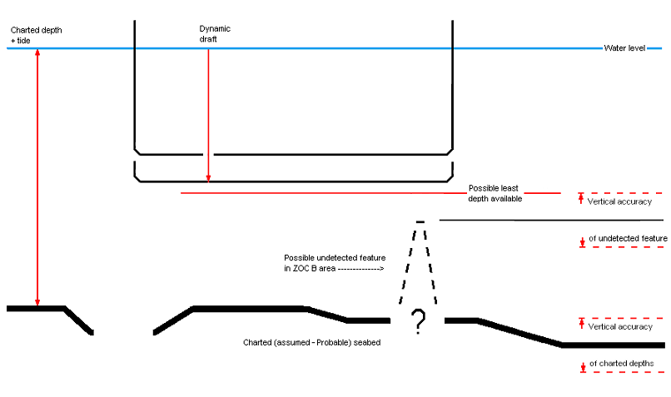
- ZOC B – Full area search not achieved; uncharted features, hazardous to surface navigation are not expected but may exist.
- Position accuracy (uncertainty) better than 50 metres.
- Depth accuracy (uncertainty) of surveyed features approximately 1.0m (Annex A, table). However, the potential size of undetected features is not specified.

5.5 ZOC C (3 stars)

It is the expectation that uncharted features hazardous to surface navigation are likely to exist that is the key difference between this category and ZOC B. ZOC C covers a broad range of surveys, including:

- relatively modern surveys which may be very thorough but just fail to meet the higher position accuracy ZOC B standard;

- older systematic surveys best described as ‘historic’ and likely to have either missed shoals, or did not fully investigate shoals that have become significant over time as the size of ships has increased;

- passage sounding (as long as they are not just isolated tracks).

The positions of charted seabed features should be better than 500 metres.

A typical ZOC C area is unlikely to have included a comprehensive sonar sweep to cover the gap between adjacent survey lines. As the distance between survey lines may be from 250m to as much as a kilometre (0.6NM), it is highly likely that seabed features may remain undetected between those lines. A ZOC C survey may be considered ‘inadequately surveyed’, particularly for depths of 30 to 40 metres or less.

Caution is therefore advised when navigating close to shore or adjacent reefs or rocky areas, where depths may rise rapidly from the sea floor, or where the seabed appears subject to change.

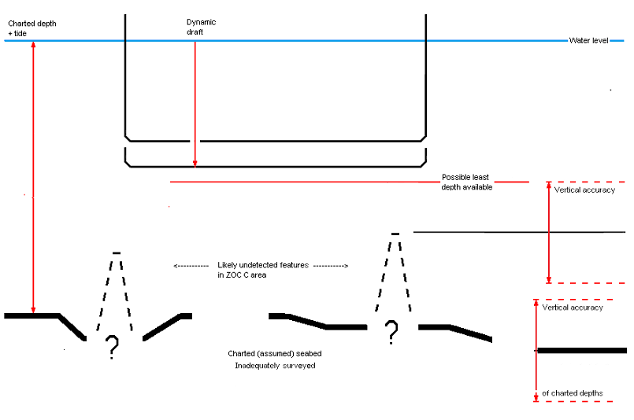
- ZOC C – Full area search not achieved, depth anomalies may be expected.
- Position accuracy (uncertainty) better than 500 metres.
- Depth accuracy (uncertainty) of surveyed features approximately 2.0m (Annex A, table). However, the potential size of undetected features is not specified and may be significantly larger than the accuracy of known features.

5.6 ZOC D (2 stars)

Soundings in ZOC D areas are similarly sourced from historic surveys, but in this case those conducted with large distances between adjacent survey lines, or simply soundings collected on an opportunity basis by ships undertaking routine passage.

Large depth anomalies may include:

- Uncharted features rising from the seafloor to the surface in coastal areas – 20 and 50 metre high pillars rising to a metre below the surface have been found in former ZOC D areas;

- Uncharted seamounts or very poorly positioned coral atolls in oceanic areas;

- Uncharted shoals rising several hundred metres from the seafloor, with gradients too steep for a vessel at sea speed to stop or turn away in time.

The positions of charted seabed features are likely to be worse than 500 metres.

Although many ZOC D areas will appear blank (unsurveyed), some may show a few broken depth contours or isolated depths. These should not be considered an invitation to disregard the ZOC D assessment.

In attempting to navigate a ZOC D area, while following a line of depths on the chart may be better than navigating the white space between, it remains a very poor precaution. Passage soundings typically come from low accuracy and often very old sources – the earlier ship may have passed close to, but not detected, a significant shoal. Equally, the true track followed by the original ship may be well over 500 metres from where they reported it to be.

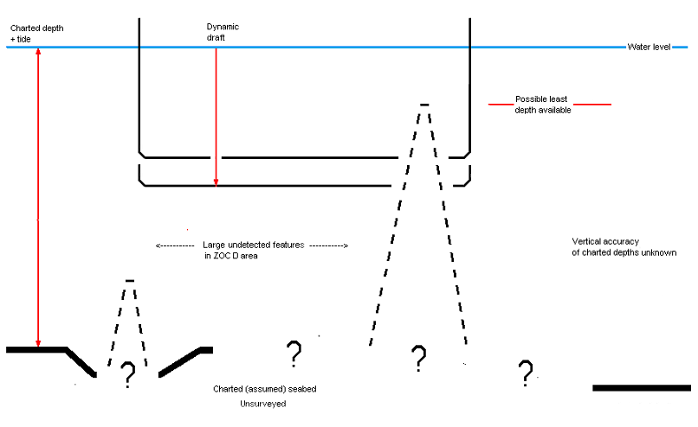
- ZOC D – Full area search not achieved, large depth anomalies may be expected.
- Position accuracy (uncertainty) worse than 500 metres.
- No quoted Depth accuracy (uncertainty). Undetected features may potentially rise to or near the sea surface.

5.7 ZOC Unassessed (U)

This category is used to indicate areas where survey information included has not been assessed for accuracy. This may occur when:

- newly received information has been included, as an urgent precaution, prior to the data being fully assessed;

- the national hydrographic office has only limited resources, so has initially published a large number of their first-generation ENCs faster than their survey assessment teams can complete assessments;

- the area depicted is on a small scale ENC, (smaller than 1:500,000 – a carry-over from some nations’ paper charts), though the same area may be covered by one of the other categories within an overlapping larger scale ENC. In these cases mariners should refer to the larger scale ENC for precise detail.

6. Summary

Put in simple terms, mariners should be able to navigate with confidence in areas with ZOC A1 and A2 classifications. It is also unlikely that an uncharted danger affecting surface navigation exists in ZOC B areas. In ZOC C areas mariners should exercise caution since hazardous uncharted features may be expected, particularly in or near reef and rocky areas, or areas of mobile seabed. A very high degree of caution is required for areas assessed as ZOC D, as these contain either very sparse data or may not have been surveyed at all. Finally, it is good practice for mariners to treat ZOC U areas with the same degree of caution as ZOC D areas.

Within ports, the Pilot or Harbour Master may advise that higher accuracy surveys have been conducted that allow for smaller under-keel clearances (subject to tides, weather, speed, and maneuvering margins). In the absence of this advice, smaller under-keel safety margins should not be assumed.

In coastal shipping areas the most common assessments likely to be encountered are:

- ZOC B – around 30% of the world’s coastal waters,

- ZOC C – around 20% of the world’s coastal waters,

- ZOC D – around 20% of the world’s coastal waters, and

- ZOC U – around 25% of the world’s coastal waters.

While these percentages may vary from place to place, the key point to note is that the standards of surveying in port are only very rarely encountered outside those ports. Ships are therefore at greatest risk away from ports, even though depths may be deeper. An understanding of how much confidence can be placed in the data within an ENC is therefore most important.
Annex A to S-67

Zones Of Confidence Categories

ZOC Category  (note 1) | Position  Accuracy  (note 2) | Depth Accuracy  (note 3) |  | Seafloor Coverage | Typical Survey Characteristics  (note 5)
A1 | ± 5 m + 5% depth | =0.50 + 1%d |  | Full area search undertaken. Significant seafloor features detected (note 4) and depths measured. | Controlled, systematic survey (note 6) high position and depth accuracy achieved using DGPS and a multi-beam, channel or mechanical sweep system.
 |  | Depth (m)  10  30  100  1000 | Accuracy (m)  ± 0.6  ± 0.8  ± 1.5  ± 10.5
A2 | ± 20 m | = 1.00 + 2%d |  | Full area search undertaken. Significant seafloor features detected (note 4) and depths measured. | Controlled, systematic survey (note 6) achieving position and depth accuracy less than ZOC A1 and using a modern survey echo-sounder (note 7) and a sonar or mechanical sweep system.
 |  | Depth (m)  10  30  100  1000 | Accuracy (m)  ± 1.2  ± 1.6  ± 3.0  ± 21.0
B | ± 50 m | = 1.00 + 2%d |  | Full area search not achieved; uncharted features, hazardous to surface navigation are not expected but may exist. | Controlled, systematic survey (note 6) achieving similar depth but lesser position accuracies than ZOCA2, using a modern survey echo-sounder (note 5), but no sonar or mechanical sweep system.
 |  | Depth (m)  10  30  100  1000 | Accuracy (m)  ± 1.2  ± 1.6  ± 3.0  ± 21.0
C | ± 500 m | = 2.00 + 5%d |  | Full area search not achieved, depth anomalies may be expected. | Low accuracy survey or data collected on an opportunity basis such as soundings on passage.
 |  | Depth (m)  10  30  100  1000 | Accuracy (m)  ± 2.5  ± 3.5  ± 7.0  ± 52.0
D | Worse than ZOC C | Worse than ZOC C |  | Full area search not achieved, large depth anomalies may be expected. | Poor quality data or data that cannot be quality assessed due to lack of information.
U | Unassessed - The quality of the bathymetric data has yet to be assessed
Column: 1 | 2 | 3 |  | 4 | 5
Source: IHO S-57 Ed3.1 Supp 3 (Jun 2014), pp 13-14

Remarks:

To decide on a ZOC Category, all conditions outlined in columns 2 to 4 of the table must be met.

Explanatory notes quoted in the table:

Note 1. The allocation of a ZOC indicates that particular data meets minimum criteria for position and depth accuracy and seafloor coverage defined in this Table. ZOC categories reflect a charting standard and not just a hydrographic survey standard. Depth and position accuracies specified for each ZOC category refer to the errors of the final depicted soundings and include not only survey errors but also other errors introduced in the chart production process.

Note 2. Position accuracy of depicted soundings at 95% CI (2.45 sigma) with respect to the given datum. It is the cumulative error and includes survey, transformation and digitizing errors etc. Position accuracy need not be rigorously computed for ZOCs B, C and D but may be estimated based on type of equipment, calibration regime, historical accuracy etc.

Note 3. Depth accuracy of depicted soundings = a + (b*d)/100 at 95% CI (2.00 sigma), where d = depth in metres at the critical depth. Depth accuracy need not be rigorously computed for ZOCs B, C and D but may be estimated based on type of equipment, calibration regime, historical accuracy etc.

Note 4. Significant seafloor features are defined as those rising above depicted depths by more than:

Depth Significant Feature
a. <40m: 2 m
b. >40m: 10% depth

A full seafloor search indicates that a systematic survey was conducted using detection systems, depth measurement systems, procedures, and trained personnel designed to detect and measure depths on significant seafloor features. Significant features are included on the chart as scale allows. It is impossible to guarantee that no significant feature could remain undetected, and significant features may have become present in the area since the time of the survey.

Note 5. Typical Survey Characteristics - These descriptions should be seen as indicative examples only.

Note 6. Controlled, systematic surveys (ZOC A1, A2 and B) - surveys comprising planned survey lines, on a geodetic datum that can be transformed to WGS 84.

Note 7. Modern survey echo-sounder - a high precision single beam depth measuring equipment, generally including all survey echo-sounders designed post 1970.

Annex B to S-67

Dangerous effects of over-scale ECDIS display near ‘Isolated dangers’

Use of over-scale display of an ENC may dangerous in certain circumstances. There is a mistaken belief that zooming in allows for greater accuracy – however, this is not the case. In reality, zooming in beyond the intended maximum display scale may be misleading and dangerous, particularly for ‘Isolated dangers of depth less than the safety depth’.

Every ENC is compiled at an intended maximum scale. At this scale the maximum level of detail is revealed, while zooming out will progressively reduce the level of detail. None of this affects the accuracy of the chart. Zooming in may reveal a new, larger scale ENC, but this too has limits, and a point will be reached where there is no point zooming in further.

At the intended maximum compilation scale, details which are too small to chart, but which still present a hazard to navigation, are typically replaced by a symbol larger than the charted size of the feature (such as a very small reef). Zooming in to over-scale destroys the relationship between the size of the (now larger) hazard and the size of the symbol.

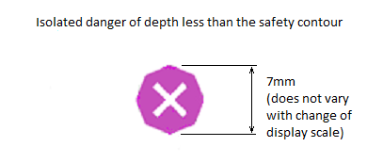

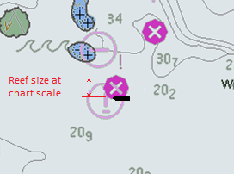 | 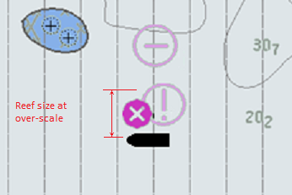
When the ENC is displayed correctly, the danger to a ship close to an isolated danger is clear. | However, when displayed at over-scale, a ship the same unsafe distance from the isolated danger incorrectly appears to be safe because the isolated danger symbol is still the same size.  This is not more accurate, and is definitely not safe.

Remember, the positioning accuracy of the isolated danger may be worse than 500 metres. Routes should be planned to clear these dangers by at least as far as the ZOC category immediately around the danger dictates.

This page
intentionally blank

From Navigation Purpose 3 and 4 ENC in 2015, covering 14,218,244 SQ KM. The analysis did not include ports.

