Principles of presentation of center symbols are described in clause 8.5 (Area Symbolization by a centered Symbol) of the presentation library.

Center symbols can be (roughly speaking) divided into two groups:

* Symbols designed with a shifted pivot point (relatively far and out of the boundary box)
* Symbols with the pivot point inside or very near of the boundary box

The first group of symbols (with a shifted pivot point) supposedly permits to avoid clattering.

However, in practice such design results in that many center symbols (sufficiently important for navigation) are not shown in the corresponding area object. Such objects are often presented with some generic (identical for many objects) complex line for the symbolized presentation and with a dashed line for the plain presentation. Consequently such objects become visually indistinguishable for the mariner. It is the most common case for the screen plots of new S-64: center symbols are not shown because they are located outside the object.

Moreover, such shifted center symbols look nice only in case of the strict rectangle geometry, e.g., in ECDIS CHART1 screen plots, but they look worse on more complex shapes.

On concave polygons (e.g., L-shape), presentation of such center symbols becomes absolutely incalculable.

Furthermore, a center symbol designed with a shifted pivot point is useless on a ship-centred display mode (see clause 8.5.2 of Presentation library). In this mode, manufacturers *must keep any centred area symbols a minimum of 20 mm from the own-ship symbol to avoid a potentially dangerous and confusing display*: the symbol in any case must be shifted from its origin (pivot point).

The following center symbols are designed with a shifted pivot point:  
SY(ACHRESnn), SY(CTNARE51), SY(CTYAREnn), SY(DWRTPT51), SY(ENTRESnn), SY(FSHRESnn), SY(INFARE51), SY(PRCARE51), SY(RSRDEF51), SY(TSSCRS51), SY(DIRBOYnn), SY(LOCMAG51), SY(MAGVAR51)

*Remark:*

*In the addendum to Presentation Library (EDITION 4.0.0 (2014)), the design drawings show the pivot point for the symbols SY(DIRBOYnn) in the centre of the bounding box. See, e.g., SY(DIRBOY01):*



*However, in the description for the pivot point, the vertical shift is far lower:  
Pivot Point Column: 6.50*

***Pivot Point Row: 30.43***

*Width of Bounding Box: 13.12*

***Height of Bounding Box: 8.27***

*The corresponding screen plots (CHART 1 and S-64) do not show these symbols because they are located outside the objects (at rational presentation scale).*

We can imagine the purpose of such symbols design (with a shifted pivot point) for the areas where special conditions exist with a possible RESTRN attribute (SY(ACHRESnn), SY(CTNARE51), SY(CTYAREnn), SY(DWRTPT51), SY(ENTRESnn), SY(FSHRESnn), SY(INFARE51), SY(PRCARE51), SY(RSRDEF51), SY(TSSCRS51)).

However we can’t see a practical reason why such shifted pivot point had been introduced (from the earliest editions of presentation library) for the symbols SY(DIRBOYnn), SY(LOCMAG51), SY(MAGVAR51).

In any case, the M_NSYS, LOGMAR, and MARVAR objects no any connection with the above-mentioned areas. And in any case, to avoid clattering between such symbols, it is necessary to implement much more complex program decisions than the corresponding clause of Presentation library suggests.

Especially obscured it looks when objects with LINE geometry are concerned. Please examine the picture below. Displayed is a MAGVAR object with the LINE geometry (example from S-64).

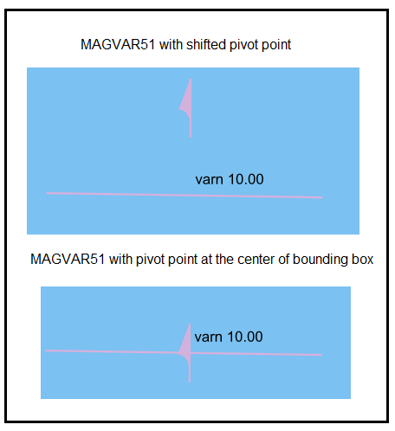

Such location of the centre symbol looks very strange: the text for the CURVEL attribute is located directly above the line presentation of MAGVAR. But the centre symbol SY(MAGVAR51) is shown at a considerable distance from the object and the corresponding text. In our opinion, such presentation is confusing for the mariner. The SY(MAGVAR51) symbol as displayed in the upper plot is indistinguishable in the information pick-up mode.

*Remark 1:*

*The Presentation library provides no rule for locating such centre symbols for objects with LINE geometry for Look-up tables. There are only some words (‘show centre symbol at the middle point of the line’ (?)) in some Conditional procedures. Also there is the requirement (S-52 Chart Presentation Bulletins - PB8) about equal placement of depth contour labels.***of depth contour labels Equal placement of depth contour labels**

*Remark 2:*

*Two different SHOWTEXT instructions are used for presentation of the VALMAG value for objects with the POINT and LINE geometry.*

*Point geometry:*

*"MAGVAR","","SY(MAGVAR01);****TX(VALMAG,3,1,2,'15110',1,-1,CHBLK,27)****","4","O","OTHER","31080"*

*LINE geometry:*

*"MAGVAR","","LS(SOLD,2,CHMGF);SY(MAGVAR51);****TE('varn %3.2f','VALMAG',3,1,2,'15110',1,-1,CHBLK,27)****","4","O","OTHER","31080"*

*In our opinion, the use of TX(…) instruction for numeric and formatted strings is incorrect (see, for example, clause 9.1 of Presentation Library). In this case, it is impossible to guarantee the necessary resolution of the printed value.*

**Suggestions**

1. In our opinion, it is necessary to add the permission to locate center symbols with modern and more complex own OEMs algorithms to the clause 8.5 of the presentation library. For example:  
     
   *“It is permitted to use own algorithms for locating the center without taking into account the predefined shift of the pivot point in the S-52 addendum. Center symbol should not be shown if it is wholly located outside the object”*Such remark should also be added to the test of S-64 3.6.9 (Display of objects affected by CSPs).  
   In the corresponding screen plot, some center symbols are shown without the offset.
2. In our opinion, the TE(…) SHOWTEXT instruction should be used for point geometry:  
   "MAGVAR","","SY(MAGVAR01);**TE('varn %3.2f','VALMAG',3,1,2,'15110',1,-1,CHBLK,27)**","4","O","OTHER","31080"
3. It is necessary to add a description of how the SY(…) symbol should be shown in case of the LINE geometry to the clause 9.3 of Presentation library (SHOWLINE instruction).