Remarks from NAVTOR – Discrepancy between Edit 3.4 and 4.0 (CSP for CS DEPVAL02)

SC DEPVAL02 had not been mentioned as reviewed. But in spite of this we have found the difference between the previous version (PL 3.4) and new one published in Presentation Library, edition 4.0.1
In our opinion UML diagram provided for the loop for underlying group 1 object is wrong

- Problem description
In previous version of this CSP all group 1 objects (DEPARE, DRGARE, UNSARE) which are intersecting with the calling object should be processed and the least value of DRVAL1 attribute should be set to local variable LEAST_DEPTH
See screen plot below (CS DEPVAL02, Presentation library, Edition 3.4)

In UML diagram in the Presentation Library 4.0.1 for the same analysis it is suggested to break this loop in case of underlying UNSARE object
See screen plot CS DEPVAL02, Presentation library, Edition 4.0.1

In our opinion such break is wrong:
Nobody can guarantee the order of group 1 objects in ENC. Therefore in case of intersecting of several TG1 objects the value LEAST_DEPTH can be different and fortuitous:
- In case if UNSARE is the first in processing variable LEAST_DEPTH always will be set to ‘Unknown’
- In other cases (e.g., sequence DEPARE – UNSARE- etc., see for example S-64 test 5.1) LEAST_DEPTH can be set to the wrong value

Suggestion:
It is necessary to change FlowFinal ‘Break’ to ‘Continue’ in case underlying UNSARE object

- CS DEPVAL02, Presentation library, Edition 3.4
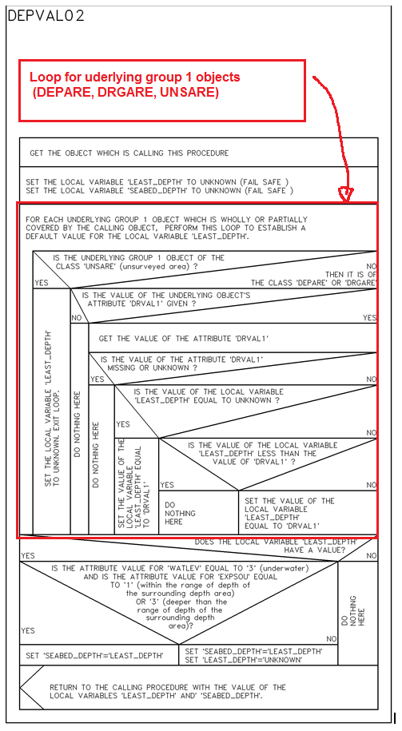

- CS DEPVAL02, Presentation library, Edition 4.0.1
