HSSC-CG2016-xx
HSSC Chair Group Workshop

Report and Recommendations of the Hydrographic Dictionary Working Group

Submitted by: | Chairman, HDWG
Related Documents: | N/A
Related Projects: | None

Chair: | Jean Laporte, France
Vice-Chair: | Vacant
Secretary: | David Wyatt, IHB
Annex 1  Annex 2 | Revised Terms of Reference_V5  Business Rules_rev1.0

Foreword / Background
After three years of management by the present team, and the rather depressing feeling that the HD activities were about to end, the WG disbanded and the IHO most consulted document dumped on the scrap heap of indifference, a breakthrough seems at last to have materialised with the recent contribution made by the Wikimedia Foundation.
The Working Group hopes to be able to present a working demonstrator of the new Hydrographic Dictionary at the 8th HSSC (Monaco 14 – 18 November 2016).

- Revision of the HDWG Terms of Reference
The WG has attempted to modernise its ToRs in order to reflect the need for simplification, improved reach to the International Community, the contribution of the Wikimedia Foundation and value for money.

Some tentative revised TORs and Business Rules are annexed to this report.

- HD Operating principles

The main changes envisaged in the future Hydrographic Dictionary are as follows:

- Unique IHO definition.
- Reintroduction of identifiers to facilitate cross-comparisons.
- Unique multilingual HD format defined by the IHO, but national content developed under the responsibility of Member States.at their own expense.
- Inclusion of unambiguous terms proposed by the custodians of the IHO GII Registry.
- Progressive implementation of new format with the assistance of the Wikimedia-Foundation.

- Work Programme and next developments

Apart the development of a HD demonstrator in time for the HSSC 8, the work programme defined at HSSC 7 remains unchanged.

Action Required of HSSC
The HSSC is invited to:
- note this report
- provide a budget to assist in developing the HD demonstrator mentioned in the foreword above.
- review the current Terms of Reference and Business Rules revised by the HDWG subgroup, with a view to have the new ToRs approved at HSSC 8.
- develop a simple procedure to exchange information between the Hydrographic Dictionary and the IHO GII Registry.
- re-appoint the HDWG to continue its work under this new set of rules

Annex 1 to the HDWG Report to HSSC-CG-xx of 29 May 2016

IHO WORKING GROUP ON THE HYDROGRAPHIC DICTIONARY (HDWG)
Terms of Reference
Ref: 1st HSSC Meeting (Singapore, October 2009)

- Objectives

- To provide to all users a unique definition of hydrographic terms validated by the IHO.
- To review and update systematically the hydrographic definitions which fall within the IHO technical and scientific domain.
- To incorporate all unambiguous terms contained in the IHO Geographical Information Items (GII) registry for the digital use by nautical cartographers
- To facilitate the consultation of the Hydrographic Dictionary by IHO Member States, regardless of language issues by use of unique identifiers (ID).
- To offer the dictionary users additional definitions of technical terms that do not fall within the IHO technical and scientific domain, but are nonetheless relevant to hydrographic sciences and activities.
2. Authority

The HDWG is a subsidiary of the Hydrographic Services and Standards Committee (HSSC) and its work is subject to HSSC approval.

3. Operating principles

- Each hydrographic definition should be unique and expressed in one of the IHO languages from which other language versions will be derived.
- Unambiguous definitions used in digital cartography are provided under the responsibility of the custodians of the IHO GII registry.
- Additional non-hydrographic definitions are provided as a convenience and are only the result of the HDWG best effort, without guaranteeing exhaustivity either of the definition or of the sources.
- Each hydrographic term will be associated with a unique identifier to facilitate further multilingual cross-comparisons.
- Whilst the format of multilingual versions of the HD dictionary is defined by the HDWG, the content and details of translations, either complete or simplified, shall remain under the responsibility of the Member States wishing to develop their national versions at their own expense.
- Member states will be encouraged to liaise with the Wikimedia-Foundation to contribute to the Wiki worldwide hydrographic database with their national definitions based on the translation of IHO reference terms and definitions.
- HD national versions will comprise a table of cross-comparisons between the following entries: Identifier, IHO reference term and definitions, National term.
- These principles will be implemented progressively with the assistance of the Wikimedia-Foundation. In the meantime, the existing Wiki versions will continue being used and maintained.
1st Example (Spanish Hydrographic Dictionary – future version):
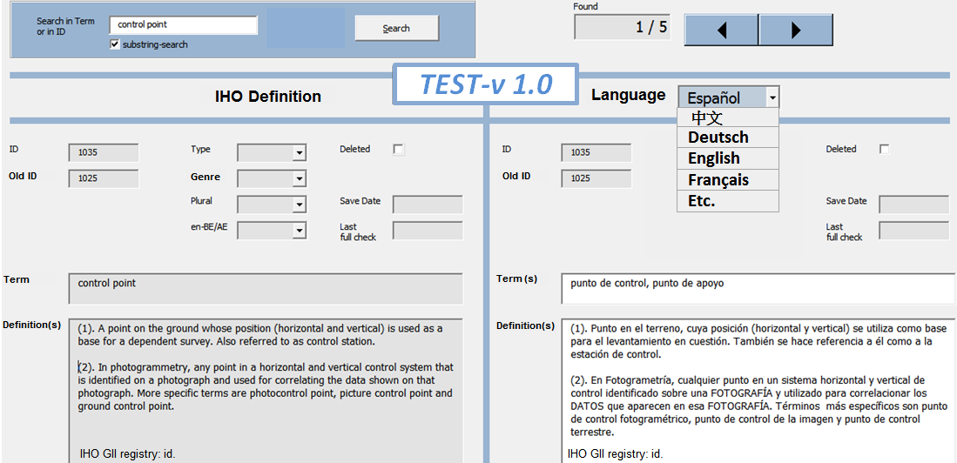
2nd Example (Chinese Hydrographic Dictionary – future version):
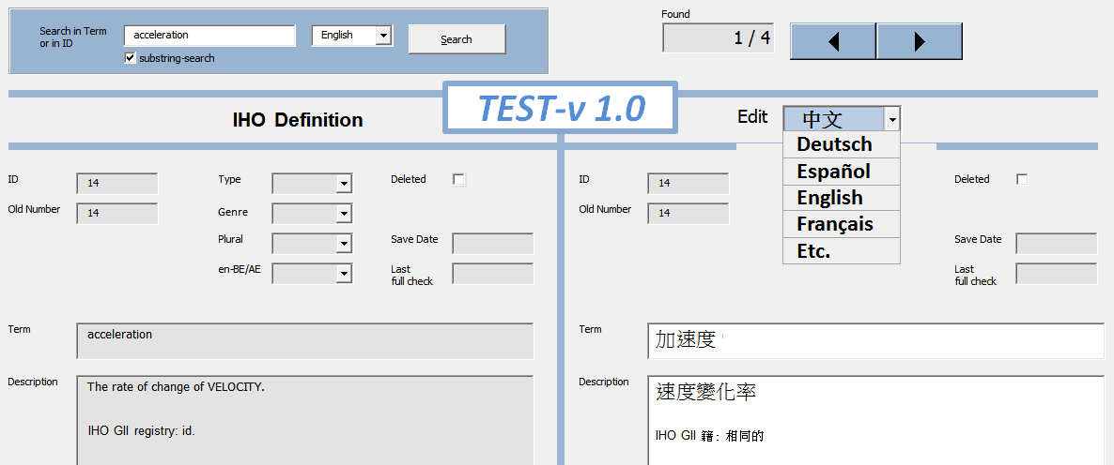
4. Procedures

a. The HDWG should conduct its business mainly by correspondence. Meetings will be held whenever deemed necessary by the HSSC but should be at least once between Conferences (Conference to be replaced by Assembly when established). When meetings are scheduled, and in order to allow any WG submissions and reports to be submitted to HSSC on time, WG meetings should not normally occur later than nine weeks before a meeting of the HSSC.
b. The HDWG may establish individual language sub-groups as necessary. These sub-groups should work by correspondence only and their work will be coordinated by a leader appointed by the HDWG.
c. The HDWG should liaise with other IHO bodies developing publications containing glossaries to ensure consistency. ‘Terms and Definitions’ should be a standing agenda item for meetings of all HSSC subordinate bodies.
d. The WG should liaise as appropriate with other organisations developing dictionaries and/or glossaries.
e. The WG should develop a work programme for each year that includes target completion and dates where appropriate.

4. Composition and Chairmanship

a. Membership of the HDWG is open to all Member States wishing to participate. The International Hydrographic Bureau (IHB) (“the International Hydrographic Bureau (IHB)” to be replaced by “the IHO Secretariat” when the Secretariat is established) will maintain a list of nominated members. The HDWG should have one representative from each HSSC subordinate body.
b. The HDWG may invite expert contributors to participate in its deliberations during and between meetings. Accredited Non-Governmental International Organizations (NGIO) may also participate as observers in the work and meetings of the HDWG.
c. Expert Contributor membership is open to entities and organisations that can provide a relevant and constructive contribution to the work of the WG. These may include, in particular, the Wikimedia-Foundation in a position of permanent consultant.
d. The Chair and vice-Chair shall be representatives of Member States and be independent of any HSSC subordinate body. The election of the Chair and vice-Chair should normally be decided at the first meeting following each ordinary session of the Conference (“Conference” to be replaced by “Assembly” when the revised IHO Convention enters force) and, in such case, shall be determined by vote of the Member States present and voting. If no qualified candidates are members of the HDWG, the IHB will call for suitable volunteers from Member States and submit the list to HDWG members for election.
e. Decisions should generally be made by consensus. If a vote is required, only Member States may cast a vote. Votes shall be on the basis of one vote per Member State represented.
f. If a secretary is required it should normally be drawn from a Member State representative of the HDWG.
g. If the Chair is unable to carry out the duties of the office, the Vice-Chair shall act as the Chair with the same powers and duties.
h. Expert Contributors shall seek approval of membership from the Chairman.
i. Expert Contributor membership may be withdrawn in the event that a majority of the M/S represented in the WG agree that an Expert Contributor’s continued participation is irrelevant or unconstructive to the work of the WG.
j. All members shall inform the Chairman in advance of their intention to attend meetings of the WG.
k. In the event that a large number of Expert Contributor members seek to attend a meeting, the Chairman may restrict attendance by inviting Expert Contributors to act through one or more collective representatives.

Annex 2 to the HDWG Report to HSSC-CG-xx of 29 May 2016

Business Rules for International Hydrographic Organization (IHO) Publication S-32
(See IHO Resolution 7/1929, as amended)

- S-32 is maintained by the Hydrographic Dictionary Working Group (HDWG), a subsidiary body of the Hydrographic Services and Standards Committee (HSSC) of the IHO.
- IHO Publication S-32 – “The Hydrographic Dictionary” provides definitions for terms commonly encountered within the areas of competence of the IHO.
- Definitions included in S-32 are intended to cover:
- Hydrography and Marine Cartography – extensively
- Geodesy, Land Surveying, Law of the Sea, Mathematics, Navigation and Physics – to the extent required for clarity and to avoid ambiguity. Where possible duplication should be avoided and reference made to the relevant responsible organization.
- Cartography – to the extent required for the digital use by nautical cartographers. Terms are provided under the responsibility of the custodians of the IHO Geographical Information Items (GII) registry.
- Terms for inclusion in S-32 may be proposed by IHO Member States, IHO Committees and subordinate bodies and the IHB. Following consideration by the HDWG, proposals for the inclusion of new definitions or the amendment / deletion of existing definitions will be passed to the HSSC for endorsement prior to circulation to IHO Member States for adoption.
- Where IHO Member States have adopted an IHO Publication which includes definitions (for example, S-53 – “Joint IMO/IHO/WMO Manual on Maritime Safety Information” these definitions may, at the discretion of the HSSC, be included in S-32 without further reference to IHO Member States.
- To be revised in due time: Since January 2010, S-32 has been available as an on-line “WIKI” dictionary in English and French. The preparation of a Spanish version and the interlinking of the three languages remain to be done. The English and French WIKIs contain those definitions previously published in the printed 5th Editions of S-32.
- To be revised in due time: Where a definition has been added or amended since the establishment of the WIKI versions, the IHB Circular Letter reference or IHO Conference decision number is recorded under the WIKI “Discussion Tab”. This information is only accessible via a username and password login. This password and login is restricted to HDWG members and IHB staff. However any user of the WIKI can see the date on which an entry was last amended.

