10th MEETING OF THE IHO MARINE SPATIAL DATA INFRASTRUCTURES
WORKING GROUP (IHO-MSDIWG10)

Busan, Republic of Korea (4-5 March 2019)

MSDIWG10 Groupwork.
Pinpoint the three most important UN Sustainable Development Goals from a MSDI perspective.
Describe how we as the IHO MSDIWG can support these three important goals and present it at the meeting.

About the Sustainable Development Goals
The Sustainable Development Goals are the blueprint to achieve a better and more sustainable future for all. They address the global challenges we face, including those related to poverty, inequality, climate, environmental degradation, prosperity, and peace and justice. The Goals interconnect and in order to leave no one behind, it ís important that we achieve each Goal and target by 2030.
Read more on https://www.un.org/sustainabledevelopment/sustainable-development-goals/

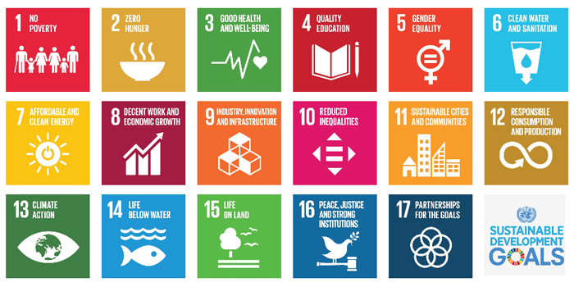
The three most important UN Sustainable Development Goals from a MSDI perspective. | Description of how we as the IHO MSDIWG can support these three important goals and present it at the meeting.
1.

2.

3.

