INTERNATIONAL HYDROGRAPHIC ORGANIZATION  4b, quai Antoine Ier  B.P. 445  MC 98011 MONACO CEDEX  PRINCIPAUTE DE MONACO | 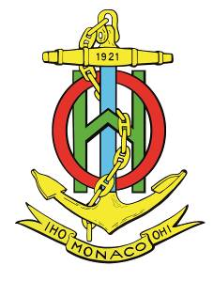 | ORGANISATION HYDROGRAPHIQUE INTERNATIONALE  Tel. : +377 93 10 81 00  Fax : +377 93 10 81 40  Email : info@iho.int  Web : www.iho.int

NAUTICAL CARTOGRAPHY Working Group

Chair: Mikko HOVI  Finnish Transport Agency  Opastinsilta 12 A  00520 Helsinki  Finland | Secretary: Andrew HEATH-COLEMAN  United Kingdom Hydrographic Office  Admiralty Way, Taunton, Somerset  United Kingdom
Tel: +358 29 5343463 | Tel: +44 1823 483218
Email: mikko.hovi@liikennevirasto.fi | Email: andrew.coleman@ukho.gov.uk

NCWG Letter: 04/2017
UKHO ref: HA317/010/031-14
Finnish ref:
Date 17 October 2017

Subject: NCWG3 – Secretary actions (Group 2)
Dear Colleagues

The following NCWG Actions propose revisions to S-4 (and in some cases to INT1) which will need approval by HSSC, the Council and eventually Member States, in accordance with Resolution 2/2007 (as amended by IA-1). However, first NCWG members need to agree on what changes we want to make.

- ACTION NCWG3/18: Secretary to draft letter explaining the proposals to extend the use of the yacht/small craft symbol in more detail and allow WG members to consider and vote as appropriate.
NCWG3-08.2A proposed extending the use of the ‘yacht’ symbol (F11.2) for small craft in general. Initially the suggestion (from a UK compiler) was to use it with an ‘anchor’ symbol (N12) to represent a small craft anchorage symbolically where space was limited, instead of using a text legend with the anchor. Following on from this, it seemed possible to extend this usage to other composite symbols. At the NCWG3 meeting, it was decided that to work through all the possible options for a comparatively minor change would take up too much meeting time, so the Secretary was tasked to take it forward by correspondence.
The first and most basic question to consider is whether it would be appropriate to extend the use of F11.2 to mean ‘small craft in general’, instead of limiting it to sailing vessels (yachts).
Although F11.2 means ‘yacht berths without facilities’, F11.1 contains the same graphic enclosed in a circle and means ‘Boat harbour, Marina’. It can therefore be argued that the symbol has already been extended to include other small craft such as ‘boats’, which would include motorboats and other leisure craft. Note that we extended the meaning of the explosives ‘flame’ symbol (N12.7) to include any dangerous cargo in a similar way.
If the agreed answer to this basic question is ‘No’, then the rest of this subject becomes irrelevant. However, if the agreed answer is ‘Yes’ then further questions and possible extensions of use arise. These could allow some space saving on charts in harbour areas which are often cluttered. They would also conform to the convention of using intuitive symbols rather than words wherever possible. Various options are detailed on the response form at Annex, for your consideration.
- ACTION NCWG3/22: Secretary to draft amendments to S-4 for islet/above water rock symbol and circulate to WG members for review.
The background to this proposal is in NCWG3-08.6A (submitted by Italy) and a counter proposal NCWG3-08.6B (submitted by US). After discussing various options, the NCWG3 meeting agreed that there should be a paper chart equivalent to the S-52 LNDARE point symbol, and that it should be a small circle of coastline thickness filled with land tint.
However, it should be noted that converting all existing ‘dot’ islets on paper charts to small circles filled with land tint would be a very long term project, and would also result in overcrowding in complex areas, in a similar way to that demonstrated for ECDIS displays in NCWG3-08.8A. For a paper chart, small black islets amongst other rock symbols within a danger line are useful to show that an area is encumbered by a mixture of underwater, drying and above water rocks. For isolated islets, the proposed larger land tint filled circle is useful (although a ‘dot’ can be effectively emphasised by a danger circle and associated text).
Draft revised text is at Annex for your consideration.
- ACTION NCWG3/27: Secretary to prepare revision consequent on Res 3/1919 (2017) for next edition of S-4 for HSSC10 and note possible changes to H20 for INT1subWG to consider.
The draft text changes for S-4 provided in NCWG3-09.1A were approved by the NCWG3 meeting and will be submitted to HSSC10 in preparation for the next expected edition of S-4. If anyone who did not get a chance to comment at NCWG3 has any concerns, please let me know as soon as possible.
There does not seem to be any consequent change necessary to INT1 H20. Although this diagram shows clearances and heights/elevations referred to HW datum (as generally applicable to the national charts in accordance with INT1subWG principle 7), there is also a note explaining that planes of reference may not always be as shown but will usually be defined on the chart. (I presume ‘usually’ is stated to cover the fact that charts smaller than 1:500 000 do not require a statement about tidal datum, see B-405.1).
- ACTION NCWG3/28: Secretary to prepare deletion of ‘LORAN’ section [B-480.2] for next edition of S-4 for HSSC10.
If anyone who did not get a chance to comment at NCWG3 has any concerns, please let me know as soon as possible.
- ACTION NCWG3/29: Secretary to draft change to S-4 to allow use of decimals of degrees for magnetic variation and circulate to WG members for review.
Draft revised text is at Annex for your consideration.
Please respond using the response form at Annex not later than 12 December 2017.
Yours sincerely,
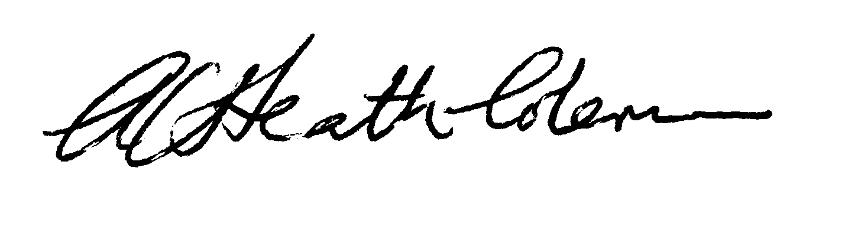
Andrew Heath-Coleman
Secretary NCWG
Annex to NCWG Letter 04/2017
NCWG3 – Secretary actions (Group 2)

Response Form
(please return to NCWG Secretary by 12 December 2017)
andrew.coleman@ukho.gov.uk

If you vote ‘No’ to any of the following questions, please explain in the ‘Comments’ section.
No. | Question | Yes | No
1 | Action 18:  Do you agree with the proposal to allow the use of the ‘yacht’ symbol F11.2 to include ‘small craft’ in general (for example motorboats and pleasure craft)?  (Note: if your answer is ‘no’, you should still answer the following questions, as the WG’s overall vote on this question may be ‘yes’)
1.1 | If the agreed answer to 1 is ‘yes’:  Should the term at INT1 F11.2 be amended to read ‘Yacht/small craft berth without facilities’?
1.2 | If the agreed answer to 1 is ‘yes’:  Do you agree to use F11.2 with an anchor to mean ‘small craft anchorage?
1.3 | If the agreed answer to 1.2 is ‘yes’:  Should there be an ‘N12.10’ INT1 entry for small craft anchorage?  (Note: You may consider that the note under N12.9 is sufficient)
1.3.1 | If the agreed answer to 1.3 is ‘no’, should S-4 B-431.3 be clarified by addition of the symbol F11.2 in lieu of ‘small craft’ after (Ref) in the second paragraph?
1.3.2 | If the agreed answer to 1.3 is ‘yes’, should B-431.3 be clarified by deleting ‘small craft’ as above and including the new N12.10 at the end of the graphics?
1.4 | Do you agree the F11.2 symbol could be used inside an anchor berth symbol N11.1?  (Note: It would be very unusual to chart individual anchor berths for small craft, but combined with an anchor it would be distinct from the mariner symbol F11.1 and therefore intuitive as a small craft anchor berth.)
1.4.1 | If the agreed answer to 1.4 is ‘yes’, should B-431.2 be clarified by adding ‘small craft’ in the parenthesis.  (Note: B-431.2 already allows use of symbols, i.e. flame, quarantine cross, which are not shown in INT1 as they are intuitive.)
1.5 | Would it be useful to allow the use of F11.2 within the berth circles at Q42? (Note: as 1.4, it would be very unusual to have a space on a charted mooring trot designated for a small craft, but the symbol would be intuitive.)
1.6 | Should the example of ‘small craft moorings’ at INT1 Q44 be replaced by the F11.2 symbol?  (Note: the limit and ‘moorings’ legend is black, as these are shown primarily because they are physical obstructions, like mooring buoys.)
1.6.1 | If the answer to 1.6 is ‘yes’:  Should the symbol F11.2 be black (to match the area limit and legend)?
2.1 | Action 22:  Do you agree with the following revised text at B-310.2?  The coastline must be generalized as necessary according to chart scale, but its essential characteristics must be preserved. An islet too small to be shown true to scale should be shown as a small circle of coastline thickness filled with land tint or may be shown as a black dot, if within a danger line, with no dimension less than 0.5mm.
2.2 | Do you agree with the following revised text at B-421.1?  Rocks (or large boulders) which do not cover must be shown as islets (that is: using the coastline symbol and, where the size permits, land tint). Where the height is shown, it must be in metres, or metres and decimetres for heights of less than 5m, above the height datum for the chart as stated in the explanatory notes. The same style of numeral as used for land spot heights must be used (see B-352.2). If there is not sufficient space to insert the numeral within the rock it must be inserted adjacent to it, in brackets (see also B-302.3). An islet too small to be shown true to scale should be shown as a small circle of coastline thickness filled with land tint or may be shown as a black dot, if within a danger line, with no dimension less than 0.5mm. Islets may be landmarks; for the charting of landmarks and conspicuous objects, see B-340.
3.1 | Action 27:  Do you agree with draft changes to S-4 detailed in NCWG3-09.1A?
3.2 | Do you agree that no changes are necessary to H20 consequent on the revision of IHO Resolution 3/1919?
4 | Action 28:  Do you agree that B-480.2 can be deleted from S-4 (if agreed by HSSC)?
5.1 | Action 29:  Do you agree to add the following text to B-260?  Variation on the arrows may be expressed in degrees and decimals (to one decimal place) or in degrees and minutes to the nearest 5′ and rate of change in decimals of degrees (up to two decimal places) or in minutes.
5.2 | Do you agree to amend B-272.1b and c as follows?  b. The magnetic variation must be shown in degrees followed by the letter E or W as appropriate. Where the isogonal of 0° is charted, it must be so labelled. The annual rate of change, expressed in up to two decimals of degrees or in minutes and followed by the letter E or W as appropriate, must immediately follow the variation, in brackets….  c…..  MAGNETIC VARIATION LINES ARE FOR (YEAR)  The Magnetic Variation is shown in degrees, followed by the letter W or E, as appropriate, at certain positions on the lines. The annual change is expressed in [decimals of degrees / minutes] with the letter W or E and is given in brackets, immediately following the variation.
5.3 | Do you agree to amend B-272.3 as follows?  The Magnetic North arrow must be labelled with the value of the variation, the year to which the value applies and, in brackets, the rate of annual change of variation. Variation must be given to the nearest 0.1° or 5′, change to the nearest 0.01° or 1′. To both, values E or W must be added as appropriate. Where the increase or decrease in the rate of annual change is 0.01° or 0.5′ or less, it must be shown as (0.0° or 0′).
5.4 | Do you agree to amend B-273 as follows?  If a hydrographic office finds the values based on its national data differ by more than 0.75° 45’ for variation or more than 0.05° 3’ for annual change…

Further comments:

Name:
Organization:

