INTERNATIONAL HYDROGRAPHIC ORGANISATION HYDROGRAPHIQUE
ORGANIZATION INTERNATIONALE
NAUTICAL INFORMATION PROVISION
WORKING GROUP
(NIPWG)
[A Working Group of the Hydrographic Services and Standards Committee (HSSC)]

Chairman: | Jens SCHRÖDER-FÜRSTENBERG | jens.schroeder-fuerstenberg@bsh.de
Vice-Chairman: | Edward HOSKEN | edward.hosken@ukho.gov.uk
Secretary: | Thomas LOEPER | thomas.loeper@noaa.gov

NIPWG Letter: 01/2015
To NIPWG Members Date 05 October 2015
Dear Colleagues,
Subject: Provision of fuzzy areas examples

References: NIPWG Action Item 1/12
http://www.iho.int/mtg_docs/com_wg/NIPWG/NIPWG1/NIPWG_Minutes_final.pdf

It is commonly agreed and accepted that NPUB data will be GML data. According to a SNPWG initiative, the use of GML is supported by the S-100 Edition 2.0.0 and it is assumed that this support will be retained.
The group discussed during the NIPWG1 meeting the existence of areas with undefined borders. The problem becomes pressing when using GML data. Although supporting GML, the S-100 Edition 2.0.0 is not capable to cover an uncertain extend of a feature spatial.
NIPWG1 decided to initiate a further extension to the S-100 by introducing methods to define areas with uncertain extension, called fuzzy areas.
The usual procedure with suggestions to S-100 is to provide the request accompanied with use cases.
Thus, action item 1/12 is on the chair to seek feedback from the group on the existence of fuzzy areas in the areas of your HO’s responsibility. These areas will be the basis to develop use cases which are needed to be forwarded as an extension request of S-100.

I would like to invite you to investigate the existence of fuzzy areas and to provide examples by the 13 November 2015 at the latest.

Yours sincerely,
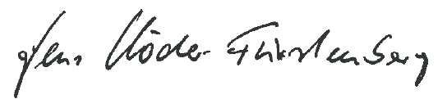
Jens Schröder-Fürstenberg, Chairman

