NIPWG Letter 5/2017 14 March 2017

CHECK OF APLICABILITY OF S-128, ACTION ITEM NIPWG 3/14

References:
A. NIPWG3 action item 3/14
B. Document NIPWG3/29.3 http://www.iho.int/mtg_docs/com_wg/NIPWG/NIPWG3/NIPWG%203-29.1%20S-128%20development%20status.pdf
Dear colleagues,
During the NIPWG3 meeting the development status of the S-128 Product Specification was presented. It was agreed that each HO should check whether the S-128 data model would support the definitions of their products and that the current S-128 data model would be enhanced based on HOs’ feedback.
This work is important to enable HOs to exchange catalogue information very easily and in a harmonised structure. S-128 could also support the presentation of HO products on a platform provided by the IHO.

This NIPGW letter is accompanied by several files; the Enterprise Architect UML, various diagrams to support NIPWG members who have no access to Enterprise Architect, and the data model description.
We could discuss the results of your investigations during the NIPWG4 meeting. But having considered the need to assess the feedback and to provide a proportionate discussion basis, I would appreciate your feedback by the 28 April at the latest.

Please note that this is not a tacit approval letter. Your response on this letter is requested.
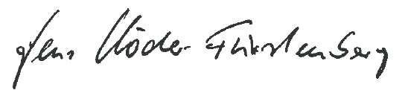
Jens Schröder-Fürstenberg,
Chair, NIPWG

