C:\Documents and Settings\julia.powell\My Documents\IHO TSMAD\S100-0 main\IHO S-100 Main Oct 1 2007.doc © ISO/IEC 2007 – All rights reservedISO-IEC_ 63Complementary elementIntroductory element — Main elementÉlément introductif — Élément central — Élément complémentaireIntroductory element — Main element — Complementary elementE2007-10-2 ISO/IECISO/IEC 2007 ISO/IEC ISO/IEC _(E). 2Heading 2Heading 1 02 STD Version 2.1c20 4 INTERNATIONAL HYDROGRAPHIC ORGANIZATION

MARITIME LIMITS AND BOUNDARIES
PRODUCT SPECIFICATION

IHO Publication S-121

Edition 1.0.0 – February 2019
Proposed revision as per comments
29 July 2019

Published by the
International Hydrographic Organization
4b quai Antoine 1er
Principauté de Monaco
Tel: (377) 93.10.81.00
Fax: (377) 93.10.81.40
E-mail: info@iho.int
Web: www.iho.int

© Copyright International Hydrographic Organization 2019
This work is copyright. Apart from any use permitted in accordance with the Berne Convention for the Protection of Literary and Artistic Works (1886), and except in the circumstances described below, no part may be translated, reproduced by any process, adapted, communicated or commercially exploited without prior written permission from the International Hydrographic Organization (IHO). Copyright in some of the material in this publication may be owned by another party and permission for the translation and/or reproduction of that material must be obtained from the owner.
This document or partial material from this document may be translated, reproduced or distributed for general information, on no more than a cost recovery basis. Copies may not be sold or distributed for profit or gain without prior written agreement of the IHO Secretariat and any other copyright holders.
In the event that this document or partial material from this document is reproduced, translated or distributed under the terms described above, the following statements are to be included:
“Material from IHO publication [reference to extract: Title, Edition] is reproduced with the permission of the IHO Secretariat (Permission No ……./…) acting for the International Hydrographic Organization (IHO), which does not accept responsibility for the correctness of the material as reproduced: in case of doubt, the IHO’s authentic text shall prevail. The incorporation of material sourced from IHO shall not be construed as constituting an endorsement by IHO of this product.”
“This [document/publication] is a translation of IHO [document/publication] [name]. The IHO has not checked this translation and therefore takes no responsibility for its accuracy. In case of doubt the source version of [name] in [language] should be consulted.”
The IHO Logo or other identifiers shall not be used in any derived product without prior written permission from the IHO Secretariat.

Document Control
Changes to this Product Specification are coordinated by the IHO S-121 Project Team (S-121PT) which is a subsidiary group of the S-100 Working Group (S-100WG). New editions will be made available via the IHO web site.
Edition Number | Date | Author | Purpose
Draft 1 | April 2014 | GA Australia | Initial Draft.
Draft 2 | 7 Nov 2016 | CHS Canada | Revise BAUnit relationship.
Draft 2.2 | 23 Nov 2016 | CHS Canada | Revise spatial relationships.
Draft 2.3.7 | 27 Nov 2016 | CHS Canada | Overall review.
Draft 3 | March 2017 | CHS Canada | Restructuring as recommended by S-121 Project Team meeting Dec 16.
Draft 4 | November 2017 | CHS Canada | Restructuring as recommended by S-121 Project Team meetings.
Draft 5 | March 2018 | CHS Canada | Restructuring as recommended by S-121 Project Team meeting Dec 17 and editorial meetings.
Draft Edition 1.0.0 | April 2018 | S-121PT | Approved by HSSC 10 under the new review cycle for testing. (Reference; HSSC10/16)
Draft Edition 1.0.0 | January 2019 | S-121PT | Minor revision after S-121 Project Team meeting December 2017, including alignment with S-100 Spatial Attribute, changes of optionality on some attributes and acceptance of Encoding Document by UN DOALOS.
Edition 1.0.0 | February 2019 | IHO Sec | Revised format and structure.
Proposed revision  Edition 1.0.0 | Jul 2019 | S-121PT | Proposed revision as per comments

TABLE OF CONTENTS

1 Overview 2
1.1 Scope 2
1.2 Conformance Clause 2
1.3 Normative References 2
1.4 Terms, Definitions and Abbreviations 2
1.4.1 Use of Language 2
1.4.2 Terms and Definitions 3
1.4.3 Abbreviations 3
1.5 S-121 General Data Product Description 4
1.6 Data Product Specification Metadata 5
1.7 Product Specification Maintenance 6
1.7.1 Introduction 6
1.7.2 New Edition 6
1.7.3 Revision 6
1.7.4 Clarification 7
1.7.5 Version numbers 7
2 Specification Scope 7
3 Dataset Identification 7
4 Data Content and Structure 9
4.1 Introduction 9
4.2 Application Schema 9
4.2.1 Feature Catalogue 9
4.2.2 Dataset types 9
4.2.3 Object identifiers 10
4.2.4 Geometry 10
5 Coordinate Reference System (CRS) 12
5.1 Horizontal reference system 12
5.2 Vertical coordinate reference system 12
5.3 Temporal reference system 12
5.4 Coordinate reference system registry 12
6 Data Quality 13
6.1 Introduction 13
6.2 Completeness 13
6.2.1 Redundant or oversampled data 13
6.2.2 Omission 13
6.3 Logical consistency 14
6.3.1 Conceptual consistency 14
6.3.2 Domain consistency 14
6.3.3 Format consistency 14
6.3.4 Topological consistency 14
6.4 Positional accuracy 14
6.4.1 Absolute external positional accuracy 14
6.5 Temporal accuracy 15
6.6 Thematic accuracy 15
6.6.1 Thematic classification correctness 15
6.6.2 Non-quantitative attribute accuracy 15
6.6.3 Quantitative attribute accuracy 15
6.7 Dataset Validation checks 15
7 Data Capture and Classification 15
8 Maintenance 16
8.1 Maintenance and Update Frequency 16
8.2 Data Source 16
8.3 Production Process 16
9 Portrayal 16
10 Data Product Format (encoding) 16
11 Data Delivery 17
12 Metadata 17
Appendix A. Abstract Test Suite and Conformance Classes 19
A 1. Test case for attribute assignment to feature classes 19
A 2. Test case for attribute domains 19
A 3. Test case for UUID 19
A 4. Test case for data completeness 19
A 5. Test case for feature commission 20
A 6. Test case for omission 20
A 7. Test case for domain consistency 20
A 8. Test case for format consistency 21
A 9. Test case for topological consistency 21
A 10. Test case for data accuracy 21
Appendix B. Use Case Description 23
B 1. Overview 23
B 2. Use Cases 24
Appendix C. Application Schema 27
C 1. Overview 27
C 2. Feature and Attribute Structure from S-100 27
C 2.1. Application Schema General Model 27
C 2.2. Basic Administrative Unit Package 28
C 2.3. Feature Unit 29
C 2.4. Geometry / Additional Spatial Information 31
C 2.5. Party Unit Package 39
C 2.6. Rights, Responsibilities and Restrictions (RRR) Administrative Package 39
C 2.7. Governance Object 40
C 2.8. Versioned Object 42
C 2.9. Implementation Model 43
Appendix D. Bibliography 47

Page intentionally left blank

Introduction
This Product Specification provides a conceptual description of the real world entities (both physical and social) that constitute Maritime Limits and Boundaries (MLB). The MLB conceptual schema is based on S-100 Part 1 - Conceptual Schema Language. The MLB Product Specification also documents the features, attributes, code lists and enumerated lists (and their relationships) required to encode MLB objects for use in geospatial information systems.
This product specification is optional. No state is required to use this product specification in whole or in part.

S-121 Annex 1 - Explicit Text Encoding Format and Implementation Specification documents the default encoding for deposit to the UN Division of Ocean Affairs, Law of the Sea (DOALOS).
The principle purpose for S-121 is to provide a mechanism for deposit of a nation’s Maritime Limits and Boundaries to the UN DOALOS in accordance with the United Nations Convention on the Law of the Sea (UNCLOS). The MLB data submitted by coastal States does not imply official recognition by other countries, nor does it affect the maritime rights and related positions advocated by States in accordance with international law.
Disclaimer
This product specification has been developed in response to paragraph 6 of United Nations, General Assembly resolution 59/24 of 17 November 2004 which
“requests the Secretary-General to improve the existing geographic information system for the deposit by States of charts and geographical coordinates concerning maritime zones, including lines of delimitation in particular by implementing, in cooperation with relevant international organizations technical standards for the collection, storage and dissemination of the information deposited, in order to ensure compatibility among the Geographic Information System, electronic nautical charts, and other systems developed by these organizations.”
Nothing in this product specification amends or modifies a State's obligations under UNCLOS.
The boundaries, names, designations and other information inputted in databases developed in conformity with S-121 standards do not imply official endorsement or acceptance by the IHO.
Information contained in, or derived from, databases developed in conformity with S-121 standards do not imply the expression of any opinion whatsoever on the part of the IHO concerning the status of any country, territory, city or area or of its authorities, or concerning the delimitation of its frontiers or boundaries

Overview
The S-121 is a product specification for Maritime Limits and Boundaries for the administration of the marine domain. Its data model allows for the description of marine zones, as defined by the UN Convention on the Law of the Sea (UNCLOS), while also allowing States to represent generic objects as necessary. Its exchange formats are compatible with other S-100 based products. The standard is based on S-100 and its model on the ISO standard 19152 Land Administration Domain Model.

Scope
This document describes a product specification for the administration of Maritime Limits and Boundaries in support of the deposit by States Parties of the geographical coordinates of points identifying their baselines and outer limits of maritime zones in accordance with UNCLOS,. This Product Specification complies with the IHO S-100 Universal Hydrographic Data Model.

Conformance Clause
Any data set claiming conformance with this Product Specification shall pass the requirements described in the abstract test suites in Appendix A.

Normative References
The following referenced documents are indispensable for the application of this document.
S-100 IHO Universal Hydrographic Data Model, Edition 4.0.0
ISO 3166-1:2013 Codes for the representation of names of countries and their subdivisions – Part 1: Country codes
ISO 19107: 2003 Geographic Information – Spatial Schema
ISO 19108: 2002 Geographic Information – Temporal Schema
ISO 19115: 2003 Geographic Information – Metadata
ISO 19152: 2012 Geographic Information – Land Administration Domain Model (LADM)

Terms, Definitions and Abbreviations

Use of Language
Within this document:
- “Must” indicates a mandatory requirement.
- “Should” indicates an optional requirement, that is the recommended process to be followed, but is not mandatory.
- “May” means “allowed to” or “could possibly”, and is not mandatory.

Terms and Definitions
For the purposes of this document, the following terms and definitions apply.
Attribute
Named property of an entity. For example, number of lanes or pavement status. [ISO 19115-2:2009 from ISO/IEC 2382-17:1999]
In UML “a classifier that describes a range of values that instances of the classifier may hold.” [ISO/TS 19103:2005 – adapted from ISO/IEC 19501]
Class
Description of a set of objects that share the same attributes, operations, methods, relationships, and semantics. [ISO/TS 19103:2005 – adapted from ISO/IEC 19501]
NOTE A class does not always have an associated geometry (for example, address range class).
Dataset
Identifiable collection of data. [ISO 19101:2002 from ISO 19115-1:2014, 4.3]
Feature
Abstraction of real-world phenomena. [ISO 19101-1:2014 from ISO 19101:2002]
Object
An object is an instance of a class.
In UML “entity with a well-defined boundary and identity, which encapsulates state and behaviour.” [ISO/TS 19103:2005 – adapted from ISO/IEC 19501]

Abbreviations
CEDA Category of Estimated Data Accuracy
CMAS Circular Map Accuracy Standard:
CRS Coordinate Reference System
DOALOS Division for Ocean Affairs and the Law of the Sea, Office of Legal Affairs, United Nations
EEZ Exclusive Economic Zone

GIS Geographic Information System
GML Geography Markup Language (ISO standard 19136:2007)
ID Identifier
IHO International Hydrographic Organization
ISO International Organization for Standardization

LADM Land Administration Domain Model
MLB Maritime Limits and Boundaries
MSDI Marine Spatial Data Infrastructure
UNCLOS United Nations Convention on the Law of the Sea
UML Unified Modeling Language
UUID Universal Unique Identifier
WMS Web Mapping Service

S-121 General Data Product Description
Title: IHO S-121 - Maritime Limits and Boundaries Product Specification
Abstract: This document describes a product specification for Maritime Limits and Boundaries (MLB) data as part of the suite of IHO S-100 standards. The purpose is to establish a framework of sourced and versioned objects for communicating in a digital form the geographic extents of some maritime zones . This product specification is also compatible with the ISO 19152 Land Administration Domain Model (LADM) structure and optionally the associated rights, responsibilities and restrictions that apply to them within the scope of UNCLOS. This integration bridges both the land and maritime domain structurally and provides to the S-100 series a product specification which effectively supports the description of objects defined in national legislation.

.
Spatial Extent:
Description: This product specification applies to the maritime area, described below: The area of applicability are the global maritime areas.
East Bounding Longitude: 180°
West Bounding Longitude: -180°
North Bounding Latitude: 90°
South Bounding Latitude: -90°
Content Description
The IHO S-121 - Product Specification for Maritime Limits and Boundaries contains a set of MLB expressed as set of features compliant with the IHO S-100 Universal Hydrographic Data Model. A number of new feature types and attributes have been defined with their definitions taken from UNCLOS. The features and attributes used in this product specification are described in the Data Classification and Encoding Guide (DCEG) and are registered in the IHO Geospatial Information Registry.
The product specification also includes metadata derived from both S-100 and from ISO 19115:2003 Geographic Information – Metadata. In addition to general discovery metadata and descriptive metadata, there are metadata elements used to describe the quality of the data.
Specific Purpose

This product specification has been developed in response to paragraph 6 of United Nations, General Assembly resolution 59/24 of 17 November 2004 which “requests the Secretary-General to improve the existing geographic information system for the deposit by States of charts and geographical coordinates concerning maritime zones, including lines of delimitation in particular by implementing, in cooperation with relevant international organizations technical standards for the collection, storage and dissemination of the information deposited, in order to ensure compatibility among the Geographic Information System, electronic nautical charts, and other systems developed by these organizations.”

Built on top of the data model structuring the information, there is a need for several encodings to support:
(1) Exchange of complete MLB features between parties.
(2)
A structured text record oriented exchange format that is readable and comprehensible by both the human eye and a computer.

Data Product Specification Metadata
This information uniquely identifies this Product Specification and provides information about its creation and maintenance.
 | Item Name | Description | Content
1 | Title | Title of the data Product Specification. | IHO S-121 - Product Specification for Maritime Limits and Boundaries
2 | S-100 version | The version of S-100 upon which the product is based. | Version 4.0.0
3 | Product specification version | Version of the Product Specification. | Version 1.0.0
4 | Date | Date the Product Specification was created / last updated. | May 2019
5 | Language | Language(s) of the data Product Specification, for example translations. | English (this does not exclude instances of data being encoded in multiple languages).
6 | Classification | Security classification code on the data Product Specification. | The default value is “unclassified” however any value from the code list MD_ClassificationCode may be used, see clause 3.
7 | Contact | Party responsible for the data Product Specification. | International Hydrographic Organization  4b quai Antoine 1er  B.P. 445  MC 98011 MONACO CEDEX  Telephone: +377 93 10 81 00  Telefax: + 377 93 10 81 40  Email: info@iho.int
8 | URL | Online-address where the resource is downloadable. | http://www.iho.int
9 | Identifier | Persistent unique identifier for a published version of the Product Specification. | S-121
10 | Maintenance | Description of the maintenance regime for the Product Specification. | Changes to the Product Specification S-121 are coordinated on a needs basis by the S-121 Project Team (S-121PT), a Project Team under the IHO S-100 Working Group (S-100WG), and must be made available via the IHO web site. Maintenance of the Product Specification must conform to IHO Technical Resolution 2/2007, as amended.
Table 1-1 – Data Product Metadata

Product Specification Maintenance

Introduction
Changes to S-121 will be released by the IHO as a New Edition, a revision, or as a document that includes clarifications. These are described below.

New Edition
New Editions introduce significant changes. New Editions enable new concepts, such as the ability to support significant new functionality. New Editions may have a significant impact on users. All cumulative revisions and clarifications must be included with the release of approved New Editions.

Revision
Revisions are defined as substantive semantic changes. Typically, revisions will introduce change to correct factual errors; introduce necessary changes that have become evident as a result of practical experience or changing circumstances. A revision must not be classified as a clarification. Revisions could have an impact on either existing users or future users of this specification. All cumulative clarifications must be included with the release of approved corrections revisions.
Changes in a revision are minor and ensure backward compatibility with the previous versions within the same Edition. Newer revisions, for example, introduce new features and attributes. Within the same Edition, a dataset of one version could always be processed with a later version of the feature and portrayal catalogues. In most cases a new feature or portrayal catalogue will result in a revision of this specification.

Clarification
Clarifications are non-substantive changes. Typically, clarifications: remove ambiguity; correct grammatical, spelling and punctuation errors; amend or update cross references; and insert improved graphics. A clarification must not cause any substantive semantic changes to S-121.
Changes in a clarification are minor and ensure backward compatibility with the previous versions within the same Edition. Within the same Edition, a dataset of one clarification version could always be processed with a later version of the feature and portrayal catalogues, and a portrayal catalogue can always rely on earlier versions of the feature catalogues.
Changes in a clarification are minor and ensure backward compatibility with the previous versions.

Version numbers
The associated version control numbering to identify changes (n) to S-121 must be as follows:
New Editions denoted as n.0.0
Revisions denoted as n.n.0
Clarifications denoted as n.n.n

Specification Scope
This Product Specification describes the S-121 data model for Maritime Limits and Boundaries
Scope ID: Global
Level: 006- series
Level name: S-121 Dataset

Dataset Identification
A dataset that conforms to this product specification may be identified by its discovery metadata. The information identifying the data product may include the following items from S-100 Part 11, clause 11-6 (as adapted from ISO 19115).
Title IHO S-121 - Maritime Limits and Boundaries
Alternate Title S-121
Abstract This document describes a Product Specification for Maritime Limits and Boundaries (MLB).
Topic categories Boundaries (ISO 19115-1 MD_TopicCategoryCode 003)
Inland waters (ISO 19115-1 MD_TopicCategoryCode 012)
Location (ISO 19115-1 MD_TopicCategoryCode 013)
Oceans (ISO 19115-1 MD_TopicCategoryCode 014)
Geographic description The extent element of MD_DataIdentification is conditional; either the EX_GeographicBoundingBox or EX_GeographicDescription subclass of extent’s geographicElement Role must be included if the dataset is spatially referenced. If necessary both may be used. If a code is used then the following applies:
Code: Code of the geographical region covered by the product according to the ISO 3166-1:2013.
Any code from ISO 3166-1 may be used to identify different national areas of interest. This IHO standard is suitable for addressing Maritime Limits and Boundaries for the whole world.
Spatial resolution Maritime limits and boundaries are normally calculated to a high accuracy based on control points that themselves are normally determined to a high accuracy. The Product Specification does not require high precision, but allows for it.
Data elements represent either locations or limits or derived elements as defined in national legislation and/or bilateral and multilateral treaties. Positions defined in such a manner have an absolute accuracy. Derived elements, such as a transformed point, or a densified line or a calculated limit based on a rule, such as 12 nautical miles seaward from a straight baseline, bear the accuracy of the calculation. An accuracy and precision statement may accompany a derived element or group.
Purpose The description of a specific set of maritime locations, boundaries, limits and/or zones as described in related legislation. MLB features may be considered as an independent data set, or the data may serve as a foundation for the production of other S-100 based data products. The conformance class used by the dataset is indicative of its intended usage and purpose.
Language Data sets for exchange internationally will be in English. Nations may also optionally maintain data sets in any other language.
Classification The default value for Maritime Limits and Boundaries data is “For Official Use Only”; however, any value from the code list MD_ClassificationCode may be used.
Certain types of data may be “Unclassified’, “Sensitive but Unclassified”, “Protected” or of “Limited Distribution”.
Spatial Representation Type: 001 - Vector
Point of Contact: Producing Agency
Use Limitation: The allowed uses of the data are defined in clause 4.1 in accordance with conformance classes as defined in Appendix B.

Data Content and Structure

Introduction
The S-121 Maritime Limits and Boundaries product specification is based on the S-100 General Feature Model. The feature types, attribute types and attribute values used in S-121 are registered in the IHO Geospatial Information Registry.
S-121 makes use of elements derived from the ISO standard 19152 Land Administration Domain Model used within the scope of UNCLOS.
Spatial geometry makes use of the spatial objects defined in S-100 and use Level 3a topology structures (shared spatial objects with no overlap - planar graph topology). In addition S-121 allows for spatial geometry to carry additional geometry elements that may be defined in other spatial referencing systems, such as historical points that are defined in the coordinate reference system used in the treaty, proclamation or other document that established the data element. There is also a capability to define spatial geometry using a "Location by Text" capability, derived from ISO 19152 that allows for a textual description of a spatial element. Many historical treaties use such textual descriptions.

Application Schema
The conceptual model of the S-121 Product Specification is provided in Appendix C. S-121 conforms to the General Feature Model (GFM) from S-100 Part 3. The implementation is defined in the Feature Catalogue. The S-121 Application Schema is realized in the Feature Catalogue.

Feature Catalogue
The S-121 Feature Catalogue describes the feature types, information types, attributes, attribute values, associations and roles which may be used in an S-121 data product.
The S-121 Feature Catalogue is available in an XML document (S-121 Annex D) which conforms to the S-100 XML Feature Catalogue Schema and can be downloaded from the IHO website. S-121 Annex A – Data Classification and Encoding Guide, constitutes a human readable interpretation of the Feature Catalogue.

Dataset types
The S-121 Product Specification contains a specific set of features related specifically to MLB. This is a scale independent set of data. It is not necessarily a complete set of data and it may be combined with other data.
S-121 contains geographic features, information types and both feature relationships and information associations fully documented within the Feature Catalogue.

Geometry
The S-121 product is based on the S-100 General Feature Model (GFM), and is a feature-based vector product. All S-121 features and information classes are derived from one of the abstract classes FeatureType and InformationType defined in the S-121 application schema, which realize the GFM meta-classes S100_GF_FeatureType and S100_GF_InformationType respectively.
The S-121 Product Specification is constrained to level 3a which supports 0, 1 and 2 dimensional features (points, curves and surfaces) as defined by S-100 Part 7 – Spatial Schema.
Level 3a is described by the following constraints:
  - Each curve must reference a start and end point (they may be the same).
  - Curves must not self intersect. See Figure 4-1
  - Areas are represented by a closed loop of curves beginning and ending at a common point.
  - In the case of areas with holes, all internal boundaries must be completely contained within the external boundary and the internal boundaries must not intersect each other or the external boundary. Internal boundaries may touch other internal boundaries or the external boundary tangentially (that is at one point) as shown in Figure 4-2.
  - The outer boundary of a surface must be in a clockwise direction (surface to the right of the curve) and the curve orientation positive. The inner boundary of a surface must be in a counter-clockwise direction (surface to the right of the curve) and the curve orientation negative. See Figure 4-3.
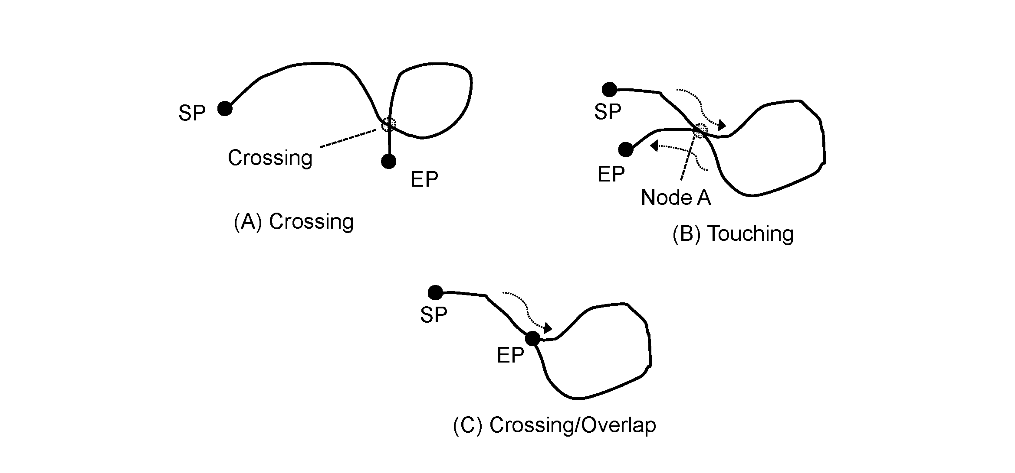
Figure 4-1 - Self Intersect Example

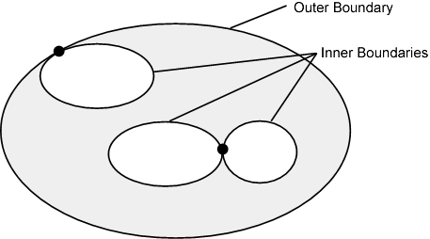
Figure 4-2 - Area Holes

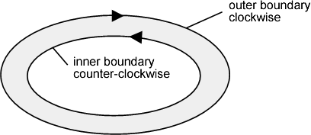
Figure 4-3 - Boundary Direction

Each feature type is independent and Maritime Boundaries may cross other Maritime Boundaries or zones (areas). Different features may be a zone represented by a geometric surface, a limit represented as curves or a location represented by a point.
The relationship of the geometric primitives used to represent a feature are described in Appendix C, clause C 2.4.

Although S-121 data may use the full palette of S-100 Level 3a geometry there is a distinction between the geospatial locations represented in the implicit geometry of each feature and any documented positions (and line interpolations) associated with individual features required for documentation of the source data. Alternate descriptions of locations represented in other coordinate reference systems and Location by Text do not participate in the geometric complex defined by the Level 3a topology.

Coordinate Reference System (CRS)

Horizontal reference system
Spatial data are expressed in latitude and longitude geographic coordinates in reference to a horizontal reference system.
The longitude is stored as a negative number to represent a position west of the prime meridian (0°). Latitude is stored as a negative number to represent a position south of the equator.
Latitude and Longitude may also be stored as textual strings. This is required so that positions may be described in the exact format that they are described in the source document (treaty or national legislation) they were extracted from. If a position is described in a source document in degrees, minutes and seconds then this description must be retained in the textual string as degrees, minutes and seconds because a conversion to decimal degrees would constitute a change in format from its defined value. The same latitude and longitude position may also be stored as a set of real numbers within a GIS system so that it can be used digitally. That is, the values used in a source documents must be preserved, but points and other geometric primitives may have multiple representations.
Different reference systems are used by various nations. Since data may come from different sources such as different treaties, multiple coordinate reference systems may be used in the same dataset.
MLB data is geographic data and therefore is not projected.

Vertical coordinate reference system
Vertical position is expressed in meters above or below a vertical reference.
The IHO Geospatial Information (GI) Registry includes vertical datums as registered concepts, although IHO also indicates that the IHO GI Registry is not an exhaustive or authoritative definition.

Temporal reference system
Time is measured by reference to Calendar dates and Clock time in accordance with ISO 19108:2002 Temporal Schema clause 5.4.4.

Data Quality

Introduction
Data quality allows users and user systems to assess fitness for use of the provided data. Data quality measures and the associated evaluation are reported as metadata of a data product. This metadata improves interoperability with other data products and provides usage by user groups that the data product was not originally intended for. The secondary users can make assessments of the data product usefulness in their application based on the reported data quality measures.
For S-121 the following data quality elements have been included;

- Completeness of the data product in terms of coverage;
- Logical Consistency;

- Positional Uncertainty and Accuracy;

- Temporal accuracy;
- Thematic Accuracy;

- Validation checks

Completeness
An S-121 product contains a quality geometric and attributive description (current, accurate, consistent), homogeneous and standardised of the entire set of MLB managed by the organization which issued the data set.

Redundant or oversampled data
MLB data is official data and therefore redundant and oversampled data elements are not permitted. It is up to the data producer to ensure consistency with official source documentation and correct attribution as such in the S-121 dataset.
Duplicate instances of features (defined by equal geometric realization, feature and attribute definition and temporal validity) are not permitted. Multiple instances of feature classes must be differentiated by means of attributes or metadata. Different versions of a feature instance are permitted using the versioning attributes to distinguish which is valid and any particular time.

Omission
The description of jurisdictional zones through the definition of MLB is often done through conceptual descriptions which may be complete or incomplete. For the sake of clarity features defined in the Feature Catalogue have very strict geometric primitives to ensure their geometries match the feature’s definition in related legislation.
In order to also support conceptual description, these features also may be described textually or by reference to other features. Certain features such as geodetic lines or loxodromes, may have densification requirements (which may be separately documented).

Logical consistency

Domain consistency
Attribute values must be validated to ensure they are within the defined range. The allowed ranges are defined in the Feature Catalogue.

Format consistency
Data encoded in one of the S-121 data formats, either the Explicit Text Format defined in Annex B should be validated in accordance with the format specification..

Topological consistency
The dataset validation tests the geometric consistency of a dataset should reflect S-100 Level 3a geometry.

Positional accuracy

Authoritative data has by definition absolute accuracy because it represents an defined position without qualification. Authoritative data may be described in treaties, national legislation and/or deposits in compliance with UNCLOS. These absolute accuracy positions may be included in a data set along with derived data.
Official data has by definition absolute accuracy because it depicts a determination of a state’s Maritime Limits and Boundaries where no legal process exists to make it authoritative or where a technical process has been required to realize the data; although errors may exist in the data no disadvantage will apply to a user that acts in good faith. Official data may be described in treaties, national legislation and/or deposits in compliance with UNCLOS and become authoritative data. These absolute accuracy positions may be included in a data set along with derived data. Official data may be normalized to a single spatial reference system.
Data derived from authoritative or official data has the accuracy of the transformation or other process used to generate the data. A location may be represented by a point that has an absolute accuracy in one Coordinate Reference System, but has a different transformed value in another CRS. Since multiple treaties may have been agreed at different times there may be multiple locations with absolute accuracy in a MLB data set that use different CRS. If all of these points are transformed to a common CRS, so that they can be managed in a GIS and used, then each point may have an error resultant from the transformation process. The transformation source and the resultant error may be referenced in a source reference within the structure for each transformed point.
The accuracy of derived lines, such as transformed or densified lines shall also carry an accuracy statement in a referenced source for the transformation process.

Temporal accuracy
Constituent of data features may be established at different dates. A validity attribute is mandatory for all features. A single creation date may be assigned to a component feature derived from different sources. The source description shall be used to describe the difference between the actual establishment date of a feature and any date assigned to a group.

Thematic accuracy

Thematic classification correctness
Each of the standardized features will have an IHO code to serve as a linkage to proper depiction based on the IHO S-100 Feature Concept Dictionary. When a feature type will be realised into a specific instance the corresponding IHO code shall be linked to the object to ensure that the proper thematic classification is used. Through such automation, no further verification is needed.

Non-quantitative attribute accuracy
The method used for evaluating the accuracy of the non-quantitative attribute values with respect to reality is determined by the type of data and its method of acquisition, and thus rely on the metadata information and data description provided at the time of the dataset integration.

Quantitative attribute accuracy
The method used for evaluating the accuracy of the quantitative attribute values with respect to reality is determined by the type of data and its method of acquisition, and may be calculated in accordance with clause 5.3 or may rely on the metadata information.
The presence of inconsistencies or discrepancies in information provided by different states does not indicate the existence of a dispute among the relevant states.

Dataset Validation checks
A comprehensive set of dataset validation checks are included as Annex C to this Product Specification. These form a minimum set of data validation tests and do not provide assurance that features meet an intended level of logical or topological consistency.. This section of the Product Specification contains guidance to ensure a minimum level of consistency is achieved across all S-121 datasets.

Data Capture and Classification
Maritime Limits and Boundaries data is primarily acquired from multiple external and internal sources. Critical points may be defined in treaties and other agreements. The S-121 source feature is designed to support references to official sources.
The S-121 Data Classification and Encoding Guide (DCEG) describes how data defining Maritime Limits and Boundaries should be captured using the features defined in the S-121 Feature Catalogue. This Guide is located at Annex A.

Maintenance
There is no mechanism for maintenance defined in this product specification.

Portrayal
No specific portrayal implementation is included within this Product Specification.

Data Product Format (encoding)
The data format for the data provided is dependent upon its use.
- Deposit – Data is provided as official deposit of MLB objects to the UN in accordance with UNCLOS.
- Exchange – A set of MLB data may be provided as a dataset encoded as GML, in accordance to S-100 part 10b.

See Annex B for a complete description of the data encoding for S-121.

Data Delivery
Multiple encodings and product delivery mechanisms for the data are permitted. The Explicit Text Encoding Format (S-121 Annex B) is recommended for depositing MLB to the UN DOALOS, and the GML (per S-100 part 10b) encoding is identified as a neutral encoding for other requirements.
This section needs to be expanded in a future version of this product specification to support dataset discovery metadata (e.g. in section 1.6) and how features are aggregated into datasets as per S-100 (particularly Part 4a).

Metadata
The S-121 Product Specification makes use of IHO S-100 and ISO 19115:2003 metadata. The Metadata in this dataset complies with S-100 Part 4a. The metadata for an entire data product dataset is defined in Table 1-1, clause 1.6 in this document. Additional metadata may be defined to be associated with any feature instance in a dataset.

Currently metadata addressing the product specification is described in Table 1-1, clause 1.6 in the document. There will need to be some restructuring to include dataset metadata in this section and rewrite clause 1.6 in a future version of this product specification.

Page intentionally left blank

- Validation Tests
(Normative)
- Test case for attribute assignment to feature classes
- Test purpose: Verify that all mandatory attributes associated with feature classes are provided.
- Test method: Check that all mandatory attributes that are defined for each feature class in the Feature Catalogue are provided.
- Reference: Appendix C, clause C 2.3
- Test type: Basic.
- Test case for attribute domains
- Test purpose: Verify that attribute domains respect Feature Catalogue definition.
- Test method: Check that all attribute domains defined in the Feature Ccatalogue are respected.
- Reference: Appendix C, clause C 2.3
- Test type: Basic.

- Test case for feature duplication
- Test purpose: Verify that a feature is not duplicated (that is, with identical geometry, feature definition and attribution) with another feature in the same dataset.
- Test method: Check that each feature is not duplicated with itself. If two instances of a feature class exist they must be differentiated by means of attributes such as the versioning attribute or metadata.
- Reference: Clause 6.2.1
- Test type: Basic.
- Test case for data omission
- Test purpose: Verify that data is not missing.
- Test method: Check that geometrically defined linear features are logically continuous and that geometrically defined area features are bounded by as set of boundary objects.
- Reference: Clauses 6.2.2 and 6.3.1
- Test type: Basic.
- Test case for domain consistency
- Test purpose: Verify that attribute values are within specified ranges.
- Test method: Check that attribute values are within range by means of test software.
- Reference: Clause 6.3.2
- Test type: Basic.
- Test case for format consistency
- Test purpose: Verify that the encoding is compliant with the encoding specified by this Product Specification.
- Test method: Conformance with encoding specification.
- Reference: Clause 6.3.3
- Test type: Basic.
- Test case for topological consistency
- Test purpose: Verify that the dataset geometry is in line with S-100 Level 3a geometry.
- Test method: The object topology consistency test is done by the GIS software.
- Reference: Clause 6.3.4
- Test type: Basic.
- Test case for data accuracy
- Test purpose: Verify that objects and attributes are represented to the accuracies specified in the metadata or associated source objects associated with the data types within the data set.
- Test method: Verify that all data elements are either of absolute accuracy or associated with metadata elements or source objects that describe the accuracy.
- Reference: Clause 6.4
- Test type: Basic.

Page intentionally left blank

- Application Schema
(Normative)
- Overview
The S-100 Universal Hydrographic Model allows for the representation of many aspects of the marine environment. Marine resources maps, fisheries maps, a marine cadastre and Maritime Limits and Boundaries use concepts defined in UNCLOS. The theme behind some of these types of marine data is rights, restrictions and responsibilities.
This Appendix describes an Application Schema model for managing rights, restrictions and responsibilities within the context of S-100. The high level conceptual model is based on the General Feature Model defined in ISO 19109 and the conceptual model defined in IHO S-100. The model is similar to that defined for any S-100 compliant feature based data model. The major distinguishing characteristic is the introduction of the Rights, Restrictions, Responsibilities and Parties structure derived from the ISO 19152 Land Administration Domain Model within the scope of UNCLOS.
The conceptual model for managing rights, restrictions and responsibilities is described in this Appendix to S-121. S-121 features are shown with class names beginning "S121" followed by the name of the class.
- Feature and Attribute Structure from S-100
The S-121 Application Schema uses the same Feature and Attribute model as defined in IHO S-100. Feature types, attribute types and listed values for code lists and enumerations have their definitions recorded in the Feature Concept Dictionary Register within the IHO Geospatial Information Registry.
Attributes provide detail that establish context for a feature. S-100 defines attributes that may be associated with a feature. Types of geometry are limited by the Spatial Primitive Types defined in S-100. Thematic attributes have their definitions recorded in the Feature Concept Dictionary Register and Feature Catalogue.
The ISO 19152 Standard defines a structure to represent Rights, Restrictions and Responsibilities, Parties and Sources. This structure also acts as a set of attributes by reference. These attributes may be shared. For example, several of the features in a MLB data set may describe sovereign rights, or have common sources. The structure inherited from ISO 19152 is implemented using S-100 Information types. These Information types, their attributes and enumerations of listed values are also recorded in the Feature Concept Dictionary Register and the Feature Catalogue.
Another attribute structure inherited from ISO 19152 is the capability to version features. Versioning allows for individual features to be revised using a start and end date. An alternative approach is to version entire datasets using metadata. Both versioned features and versioned datasets can be used together.
  - Application Schema General Model
Figure C-1 shows the overall S-121 Application Schema model. The S-121 Feature Unit derives directly from S-100 and takes on attributes defined in the Feature Catalogue. The S-121 Spatial Attribute Type takes on the spatial attribute types of S121_Point, S121_Curve, S121_Surface or S121_Volume. These spatial attributes take their geometry from S-100 Part 7.
This Feature and Attribute structure has a relationship to S121_Source so that source information can be provided on any feature or spatial attribute. Zone (or Space) features may also have a relationship to a Basic Administrative Unit type feature, which is an Information type. This allows Rights, Restrictions and Responsibilities to be described and associated to Parties or Group Parties. These may also be sourced.
All of the Information types are defined in the S-121 Feature Catalogue.
The S121_Party and S121_GroupParty are non-spatial objects. Individual parties are identified by the attribute values of the party features.
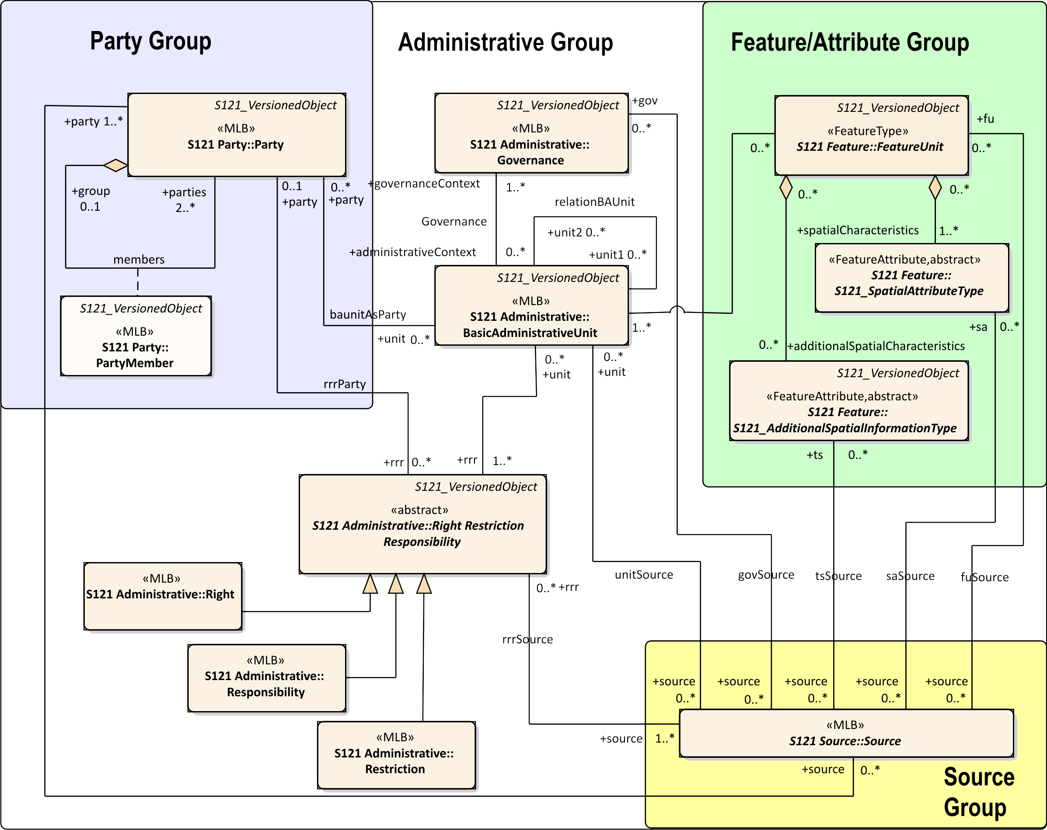
Figure C-1 – Application Schema Model
  - Basic Administrative Unit Package
The Basic Administrative Unit is an information type to “which (one or more) unique and homogeneous rights, responsibilities or restrictions are associated”. This class does not take on spatial attributes itself, but is associated with a FeatureUnit, which corresponds to a feature and has its own spatial attributes. The rights, restrictions and/or responsibilities and parties structure is thus shared through the BasicAdministrativeUnit. That is, a Basic Administrative Unit is an attribute by reference for a Feature Unit. The BasicAdministrativeUnit feature is also a Versioned Object which allows the duration of validity for an object to be described. The BasicAdministrativeUnit is illustrated in Figure C-2.
The attribute basicAdministrativeUnitType is taken from the code list basicAdministrativeUnitType and describes the types of the administrative unit.
BasicAdministrativeUnit realizes attributes from the metaclass S121_GF_ThematicAttributeType. The memberName attribute is inherited and is renamed as basicAdministrativeUnitName. It establishes a name for an instance of a BasicAdministrativeUnit.
The feature component of the Application Schema model is derived from IHO S-100 allowing direct compatibility with other IHO Product Specifications. Features defined in S-121 can thus be imported into other S-100 based products.
The attribute uID is used in relationships between instances of the BasicAdministrativeUnit and Rights, Restrictions and/or Responsibilities and parties (Party) information objects.
The attribute basicAdministrativeUnitContext allows the context for an instance of a BasicAdministrativeUnit to be described. This would include other information that would be included with a logical administrative unit in a document.
Both the attribute basicAdministrativeUnitName and basicAdministrativeUnitContext support multilingual character strings in accordance with the ISO TC211 PT_Locale structure.
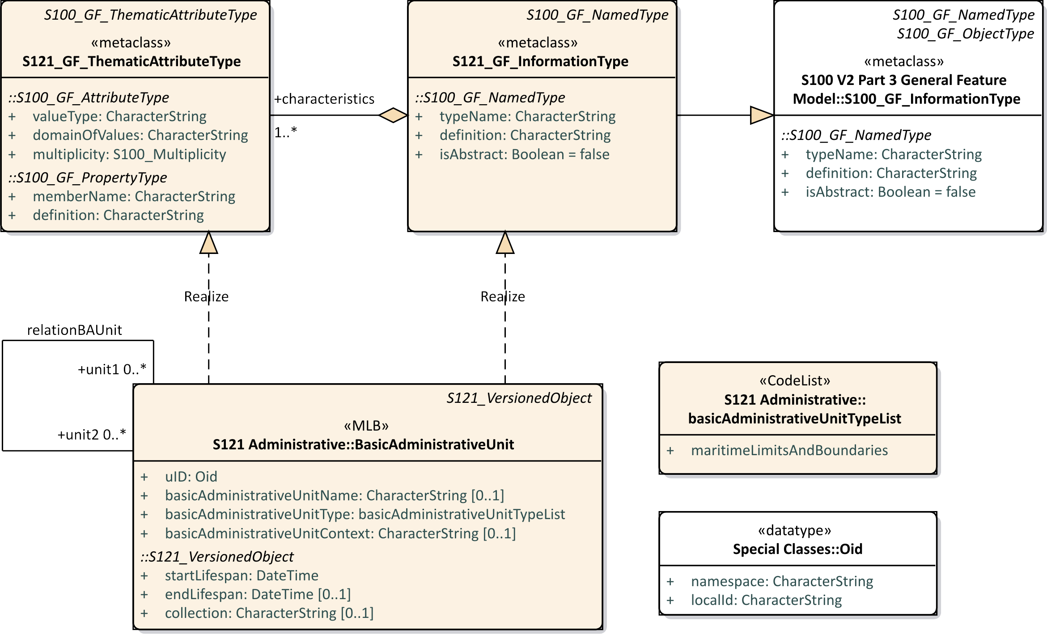
Figure C-2 – S-121 Basic Administrative Unit
  - Feature Unit
The class Feature Unit realizes S121_GF_FeatureType. The definition, code and other aspects are recorded in the Feature Concept Dictionary Register. A Feature Unit would be associated to a BasicAdministrativeUnit information type to take on rights, responsibilities and restrictions and party administrative attributes.
The name of a feature is optionally defined in the attribute name. The attribute name is realized from the attribute typeName from the metaclass S121_GF_FeatureType. The definition, and isAbstract of the feature are recorded in the Feature Concept Dictionary Register so do not need to be included in attributes.

The attribute context optionally describes the administrative aspects of the feature object.
The attribute context is of type CharacterString and may support PT_Locale from ISO 19139 (or ISO 19115-3) in order to support multi-language data description.
The attribute releasability is optionally used to differentiate between releasability status for particular features. It makes use of the enumeration releasabilityTypeList.
Shared geometry is provided through the implementation of S-100 Level 3a geometry
All FeatureUnit Features are versioned.
Only one spatial primitive (Point, Curve or Surface) may be associated with a defined feature.
A name or label will uniquely identify the feature.
***** Legal Status to be removed from the Model and all diagrams regenerated ****

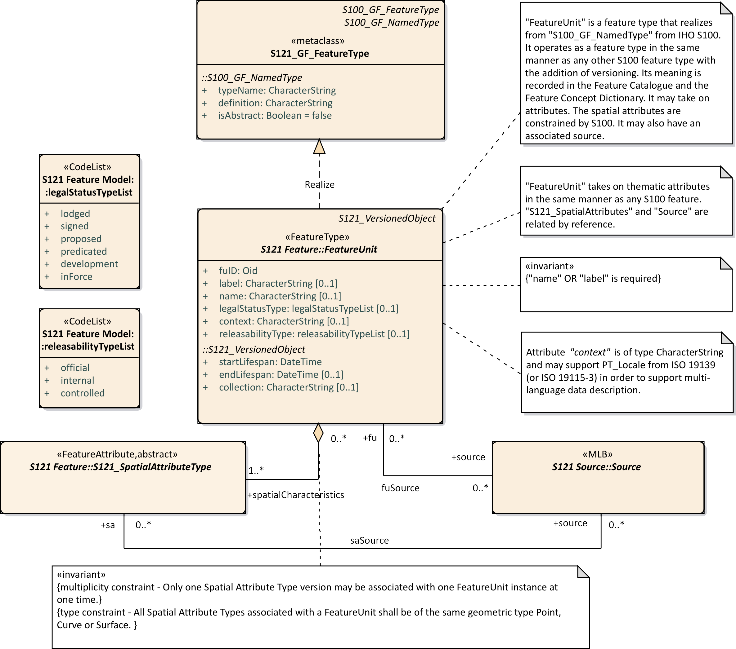
Figure C-3 – S-121 Feature Unit
  - Geometry / Additional Spatial Information
The approach to geometry in S-121 is different from that used in ISO 19152 which is based on a surveying model. S-100 allows one geometry per feature and composition is handled at the feature level through feature associations. It is straightforward to convert from ISO 19152 to the S-100 geometry model because both are based on the ISO 19107 spatial schema. They differ only in how composition is done. S-121 uses the IHO S-100 approach.
S-121 includes additional ways of describing position inherited from the ISO standard 19152. These are the description of a spatial attribute textually called “location by text” and the description of a position in a coordinate reference system different from that used to describe other positions in the same dataset. Both cases occur in real data. A treaty or law may describe a position as “an extension of a line from …” or by some other descriptive means. Also the reference system used in a treaty or law may be in a coordinate reference system that was used at the time the treaty or law was written. Since this textual description or position in a unique coordinate reference system are what is described in the treaty or law they are the correct position and must be included as is in the S-121 data. However, for an implementing production system to work, and for it to be possible to calculate and display geometries it is necessary for all the spatial primitives to be within the same coordinate reference system. A new information type carrying additional information has been defined, “AdditionalSpatialInformation”.
ISO19152 also allows for per object versioning. All of the feature and thematic attributes in S-121 may optionally be versioned. Versioning in the other S-100 based Data Products is done at the dataset level. If an S-121 Spatial is revised then the version of all the Features that reference that attribute as a component will need to be revised.
In S-100 spatial components may be shared. Under S-100 Level 3a geometry there may be several Feature instances that share the same spatial component by reference. For example a curve may be the spatial component referenced by a limit, a boundary or an adjacent zone. Similarly in S-121 the additional spatial information type with its attributes may be shared. A constraint is defined that locks the additional spatial information object to the corresponding S-121 Spatial Attribute object. Since the additional spatial information object and the S-121 Spatial component are locked together they must handle versioning in the same manner. Since geometry components are not versioned versioning is done at the feature level only.
The attributes and relationships of S-121_SpatialAttributeType and S-121_AdditionalSpatialInformationType are shown in Figure C-4 below. The attributes of SpatialAttributeType are the same as for any spatial attribute from S-100. The additional information type AdditionalSpatialInformation contains the additional attributes required to support the alternate coordinate reference system based positions and “Location by text” aspects.
The attribute saID is the spatial attribute identifier that is referenced by the FeatureUnit.The attribute siID is the additional spatial attribute object identifier that is referenced by the FeatureUnit
The attribute locationByText allows additional spatial information to be a textual description. This allows locations, limits, zones or spaces that are not fully described geometrically to be included.
A CoordinateReferencingSystem (CRS) may optionally be textually described using the attribute referenceSystem. Some treaties points or lines may come from different sources and it is possible in one dataset to make use of more than one CRS.
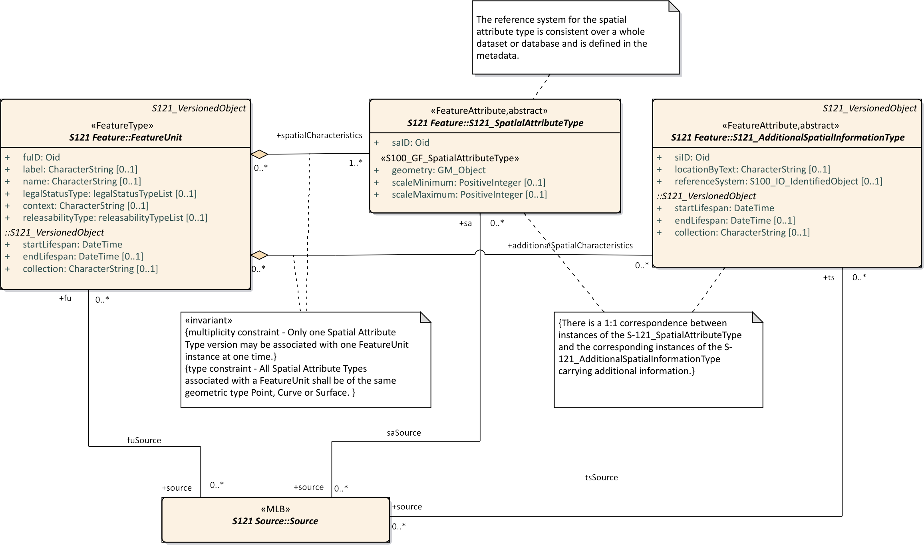
Figure C-4 – S-121 Spatial Attribute Type
The attribute referenceSystem references the class S100_IO_IdentifiedObject. This in turn references a series of other classes shown in Figure C-5 below that identify the CRS. This includes an optional reference to an authority that makes use of the metadata class CI_Citation. This is complex way of duplicating the role of S121_Source, so a constraint is applied to make use of the S121_Source approach.
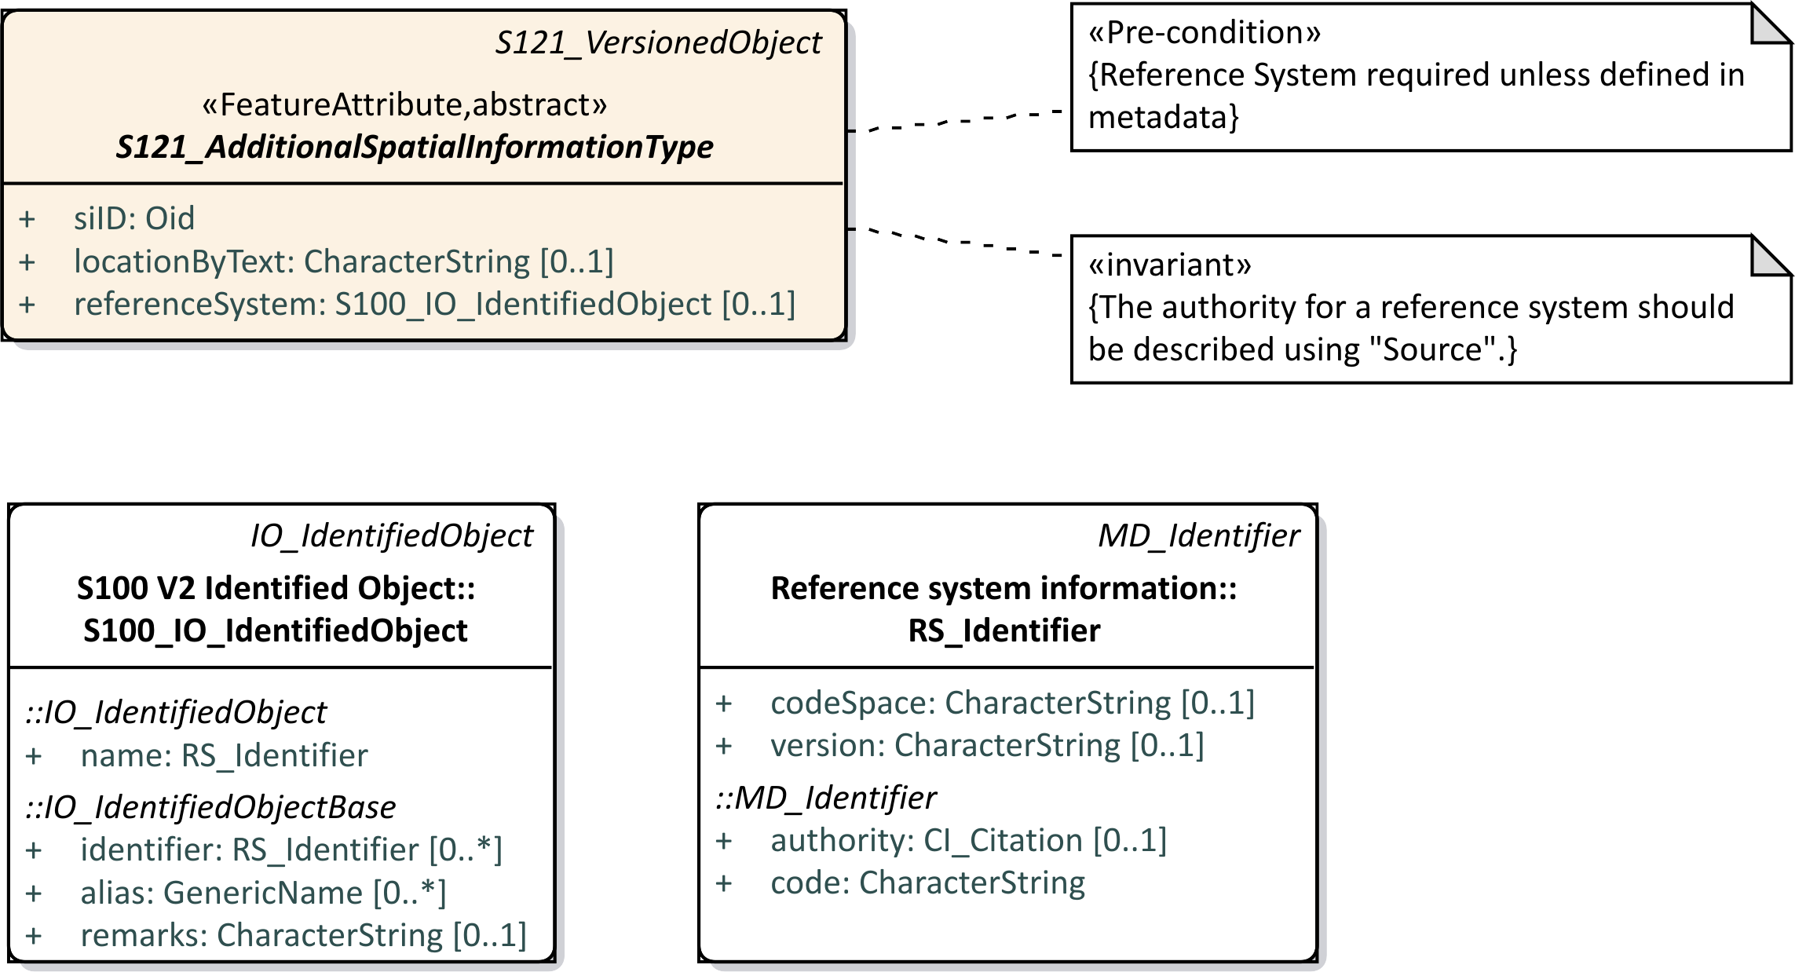
Figure C-5 – S-121 Reference System Attribute
Since the domain of rights for some of the UNCLOS feature instances have different vertical extents it is necessary to address the third dimension. This is done by using an optional height description attribute on 2D features to establish a volume. 3D space type features that support volume therefore have the same geometric primitives as 2D zone type features.
Figure C-6 below shows spatial geometry for each of four feature categories Location, Limit, Zone and Space.
The locationByText attribute is an attribute that allows a textual description. There are some situations where MLB authoritative documents do not geometrically describe all boundaries of a zone. If both spatial geometry and text are both provided then the geometry may be considered as an approximation and the text as the authoritative description. With respect to locationByText, the presence of inconsistencies or discrepancies in information provided by different states does not indicate the existence of a dispute among the relevant states.
Feature to feature relations are allowed between the Location, Limit, Zone and Space type features. This will allow one to associate particular treaty or control points to delimit curves and particular curves to bound zones. Since administrative attributes such as Rights only apply to Zones and Spaces it is necessary to have a mechanism to relate a Zone or a Space to Limits and Location points when the geometric elements are not described.

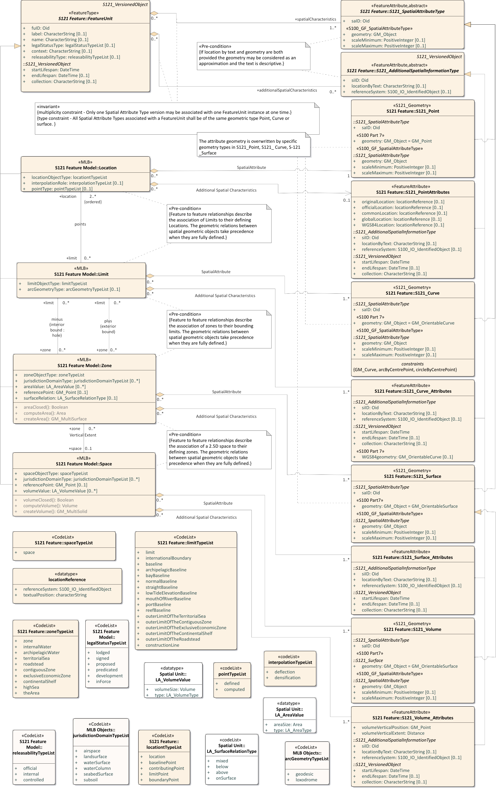
Figure C-6 – Spatial Geometry

The Basic Administrative Unit (BasicAdministrativeUnit) information type acts as an attribute by association to provide administrative attributes of Rights, Restrictions or Responsibilities to the Zone and Space features. This is shown in Figure C-7 below.
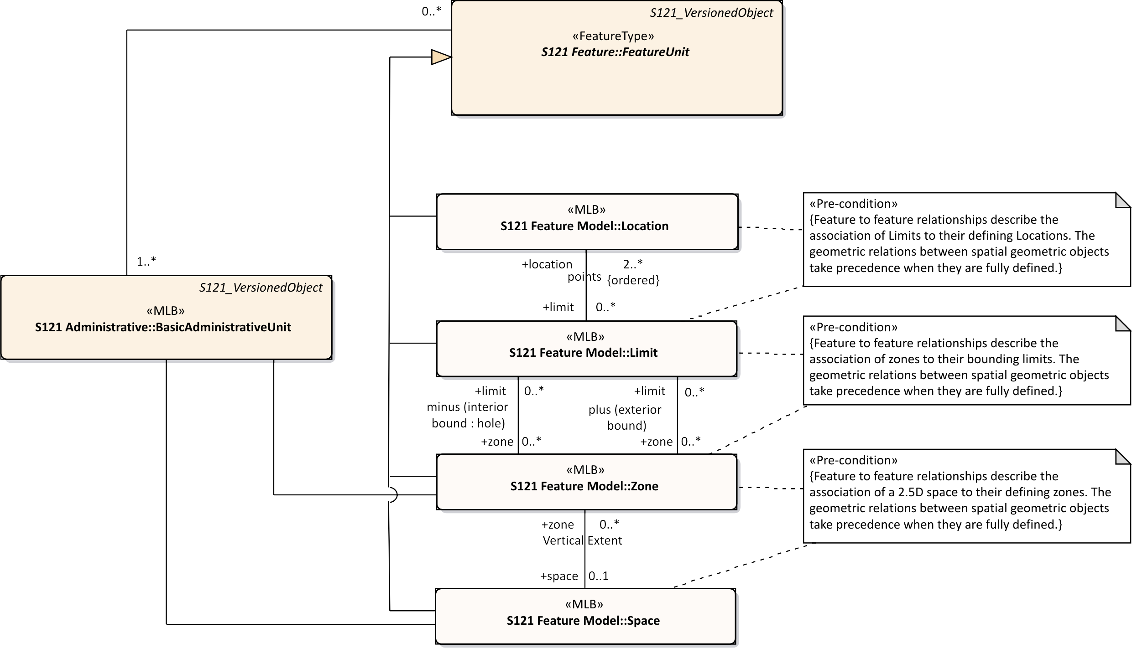
Figure C-7 – Relation of Administrative Structure to Feature Unit
Source is described by reference to the Source information object. In the ISO 19152 standard the two subtypes of Source are a SpatialSource and an AdministrativeSource. In S-121 this has been consolidated into one Source Information Object with two conditional attributes. The attributes spatialSourceType and administrativeSourceType that identify different enumerations. This is shown in Figure C-8 below.
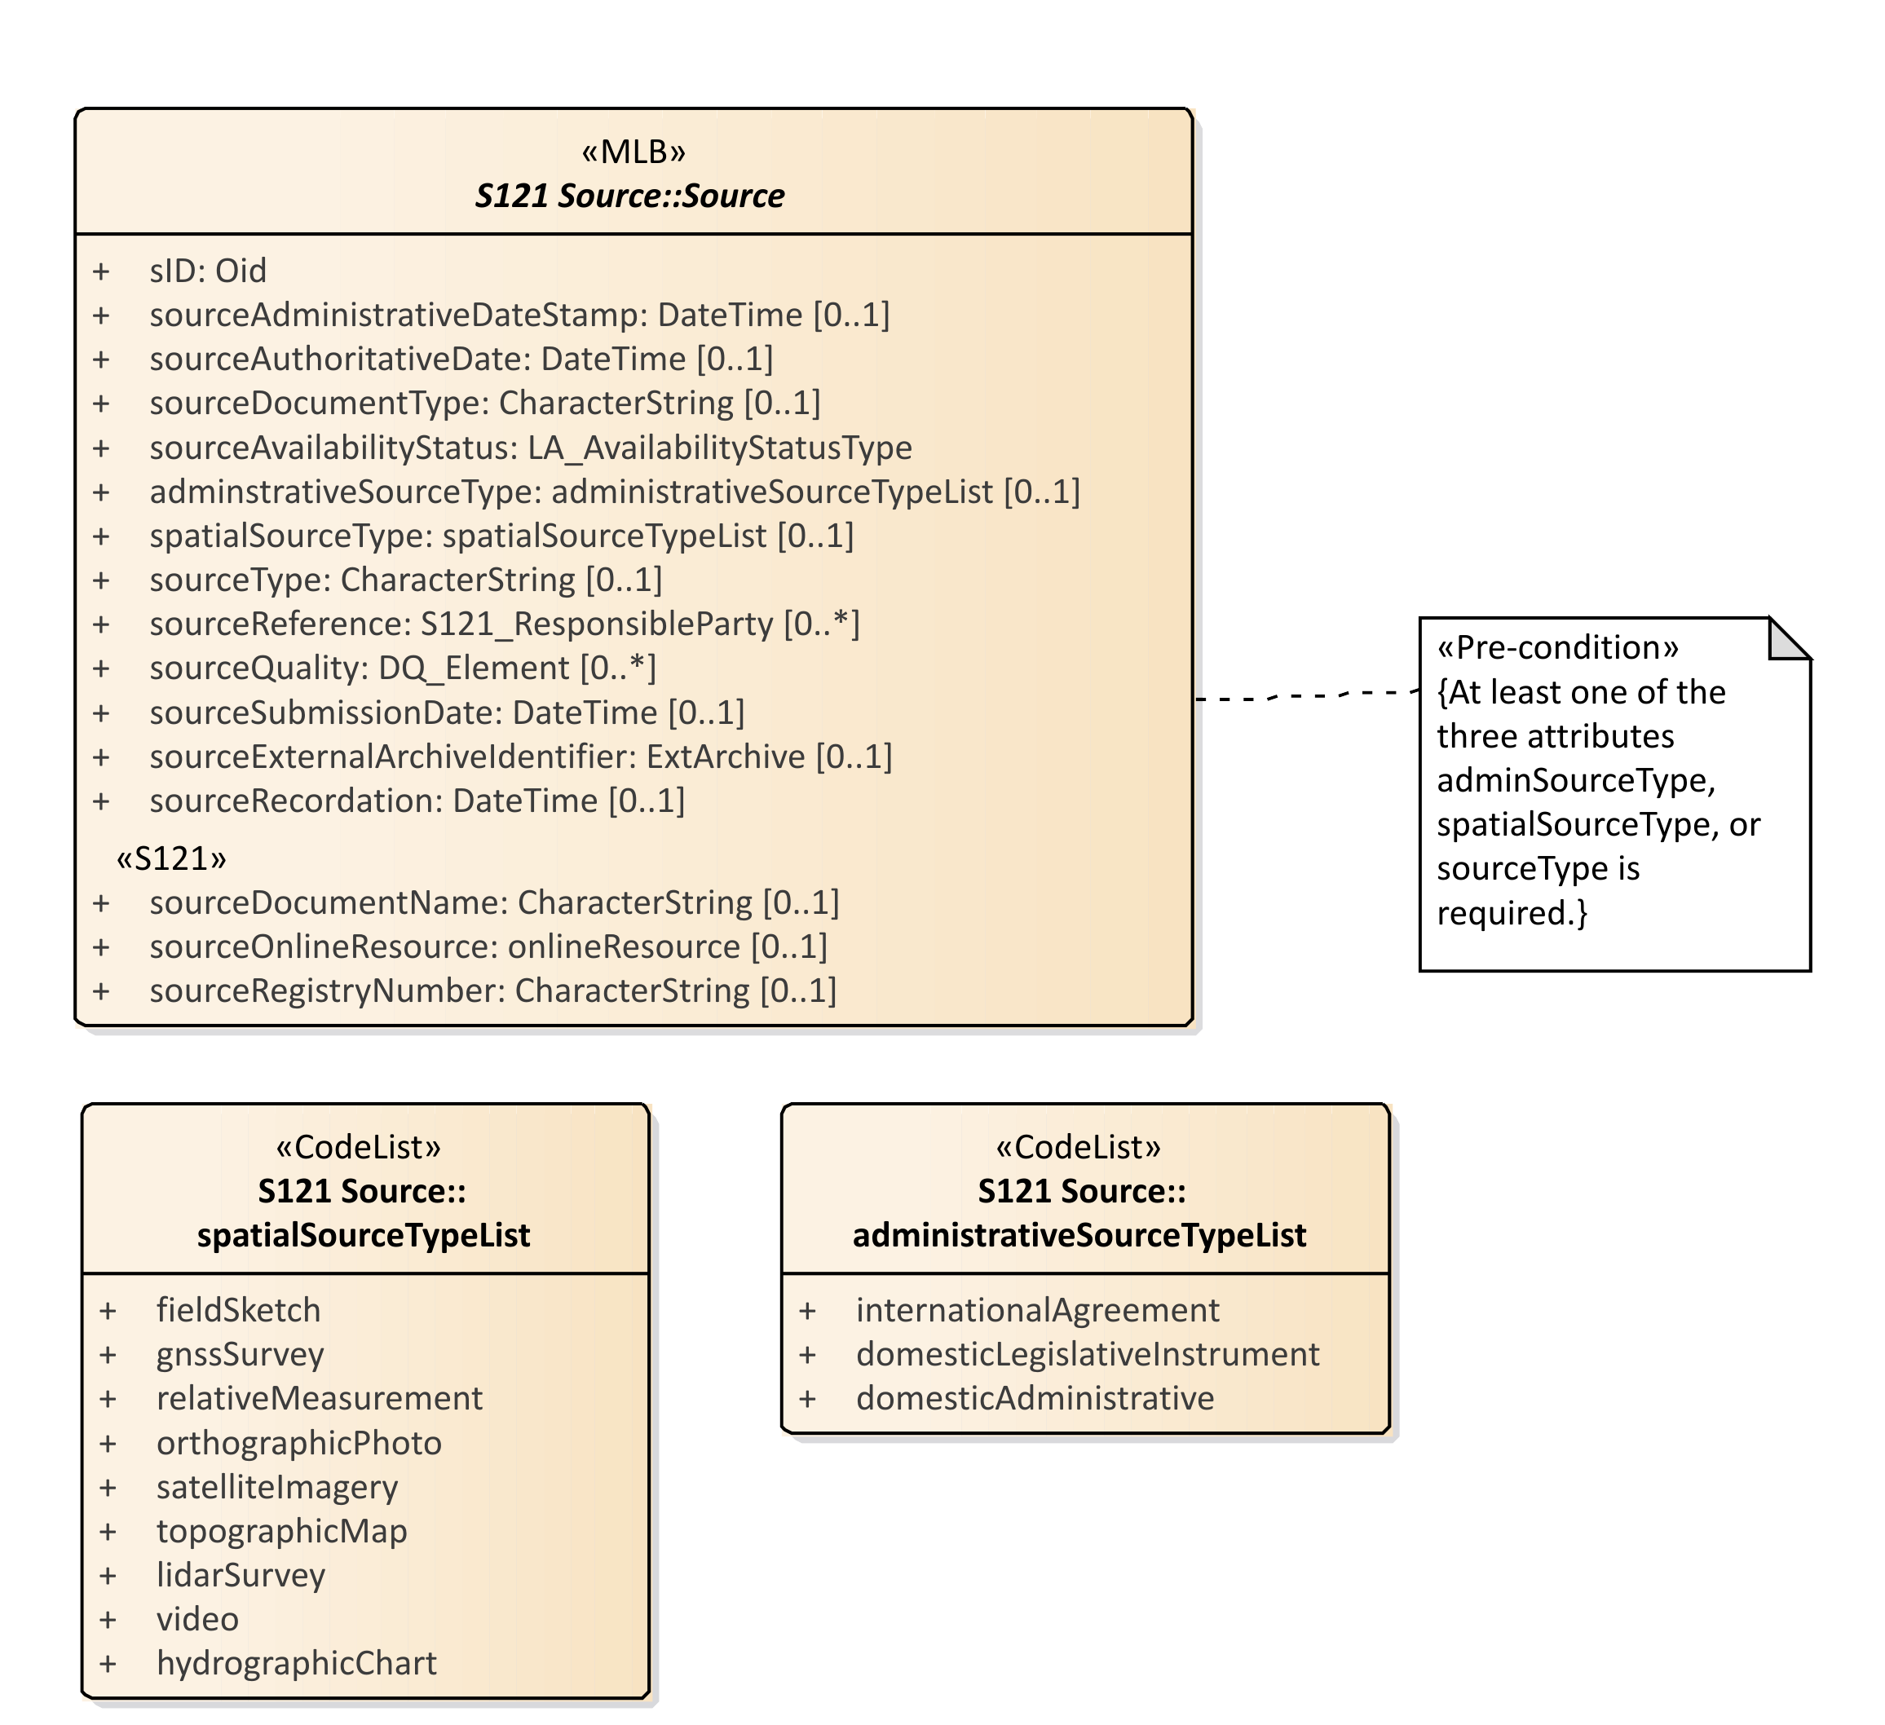
Figure C-8 – Source
Figure C-9 below shows the Source object with all of the associated enumerations and associated support classes. A set of attributes explicitly describe the information pertinent to source documents. These are:
- sourceDocumentName – Document name - for example the document (legislation, treaty, title) that defines the object;
- sourceOnlineResource – Official URL (or equivalent online resource) where the document is distributed;
- sourceregistryNumber – Unique official identifier of the record in a registry. For example, in states with registers of legislative instruments, versioning is controlled by the registry ID;
The other S-121 Source attributes are:
- sID – the identifier of the source;
- sourceAdministrativeDateStamp – The moment that the event represented by the instance of S-121_Source is further processed;
- sourceAuthoratitiveDate – The date of force of law of the source by an authority;
- sourceDocumentType – The type of document;
- sourceAvailibilityStatus – The status of document from the enumeration LA_AvailabilityStatusType;
- administrativeSourceType – Descriptive documentation that supports, complement or describes the associated object;
- spatialSourceType – The type of spatial "Source" document;
- sourceType – The type of "Source" document Reference;
- sourceReference – Reference to source through the class S121_ResponsibleParty;
- sourceQuality – Data Quality description through the metadata class DQ_Element;
- sourceSubmissionDate – The date of submission of the source by a party;
- sourceExternalArchiveIdentifier – The identifier of a source in an external registration;
- sourceRecordation – The date of registration (recordation) of the "Source" by registering authority.
The code lists and classes referenced are:
- DateTime – A data type for recording clock time;
- LA_AvabilityStatusType – An enumeration identifying the status of a source archive;
- SpatialSourceTypeList – Category of "spatialSourceType" (from ISO 19152:2012);
- AdministrativeSourceTypeList – Category of "administrativeSourceType" (from ISO 19152);
- responsibleParty – The responsible party of the "Source";
- CI_RoleCode – Responsible Party Role;
- EX_Archive – Metadata about an external archive;
- DQ_Element – A metadata class describing data quality of the source data;
- DQ_EvaluationMethodTypeCode – A code list of the method used to evaluate data quality;
- DQ_Result – Results of the data quality evaluation;
- CI_RoleCode – A code list of information about the function performed by the responsible party for the source data;
- CI_OnlineFunctionCode – A code list of the online function performed by an online resource as part of a contact for a responsible party for a source;
In addition the ISO metadata class CI_ResponsibleParty has been realized in S-121 to be ResponsibleParty. This includes the classes Contact, OnlineResource and Address that are realizations of the ISO classes CI_Contact, CI_Address and CI_OnlineResource. The attributes and inheritance of S121_Source are shown in Figure C-9.
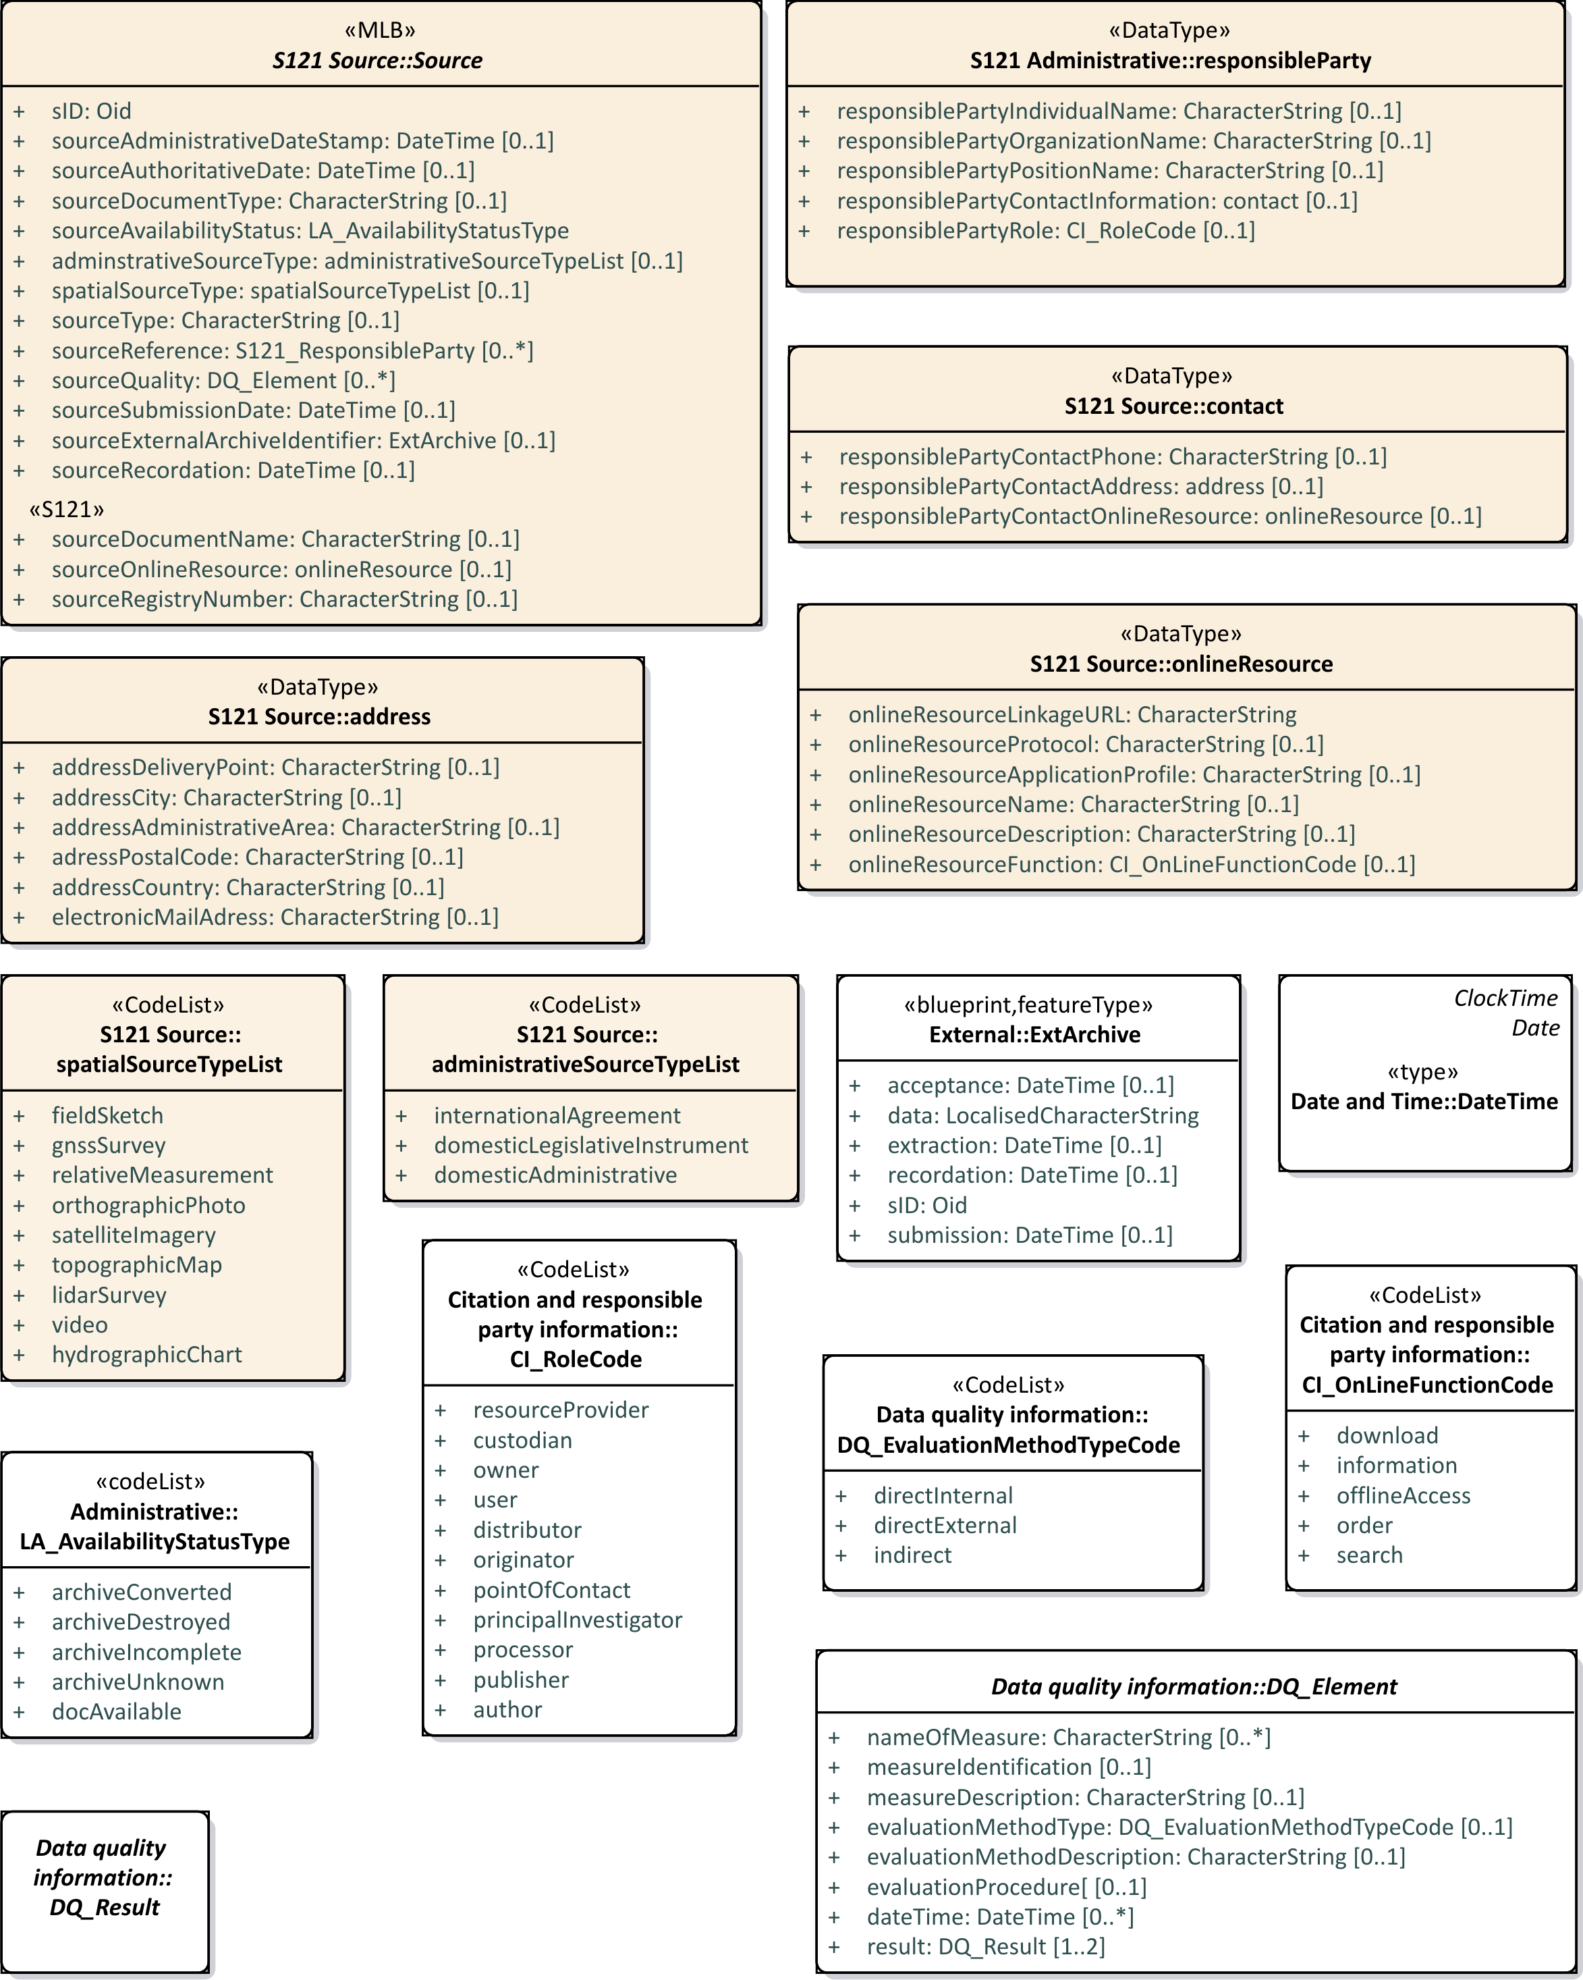
Figure C-9 – S121_Source Attributes
  - Party Unit Package
A party is “a person or organization that plays a role in rights”. A Party is considered as an object which allows it to be shared. That is, a party may be part of several different rights, responsibilities and restrictions. A Group Party is also a Party that consists of several individual parties. The PartyMember class provides an attribute on the composition attribute that forms a group out of several party members. This optional attribute allows parties to have different shares within a group. The types of Parties and Group Parties are described by partyType and partyGroupType. Figure C-10 below shows the Party structure.
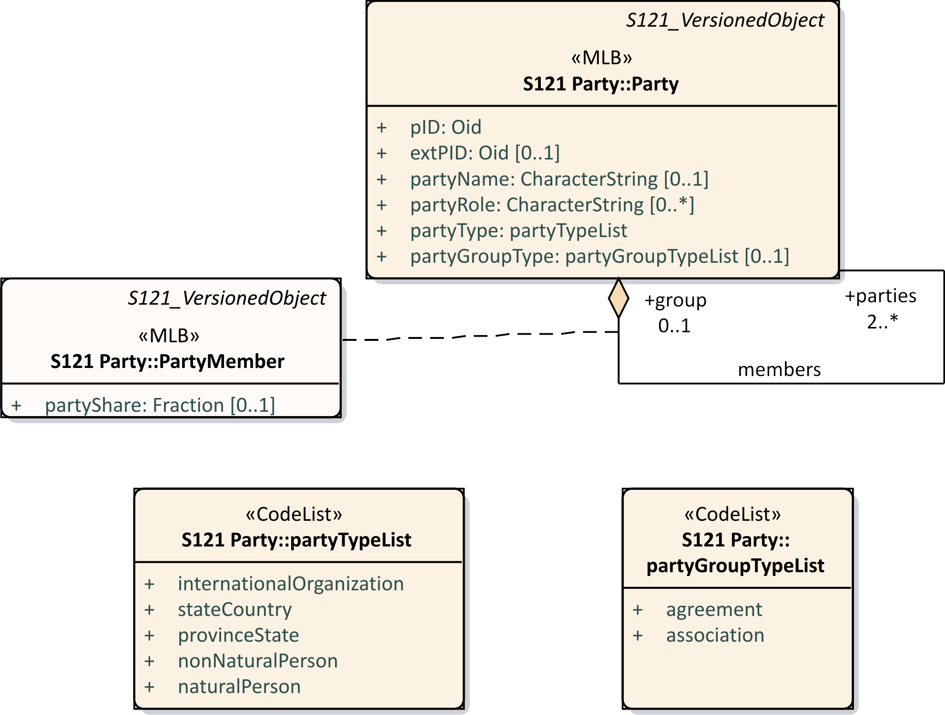
Figure C-10 – S121_Party Package
The relationship between Parties, Group Parties, Rights, Restrictions and Responsibilities and feature instances (BasicAdministrativeUnit) is by named associations.
The S121_Party is structured in an equivalent but simpler manner than ISO 19152.
  - Rights, Responsibilities and Restrictions (RRR) Administrative Package
The RRR administrative package associates parties with Basic Administrative Units (BasicAdministrativeUnit). There are three subtypes realised as information types.
1. Right, with rights as instances..
2. Responsibility, with responsibilities as instances.
3. Restriction, with restrictions as instances. Restrictions usually apply to features independent of the rights; that is, the related party can change and the restriction remains.
Rights, Responsibilities and Restrictions are information types associated by reference to BasicAdministrativeUnit features.
*** Remove code list for rightTypeList ***
These features are stand-alone entities associated by reference. They are Information types and do not carry geometry. Feature objects therefore point to an appropriate information type. If the restriction is changed it only needs to be changed once, not through the attributes in possibly hundreds of feature objects.
Figure C-11 below shows the S-121 Administrative Rights, Responsibilities and Restrictions.
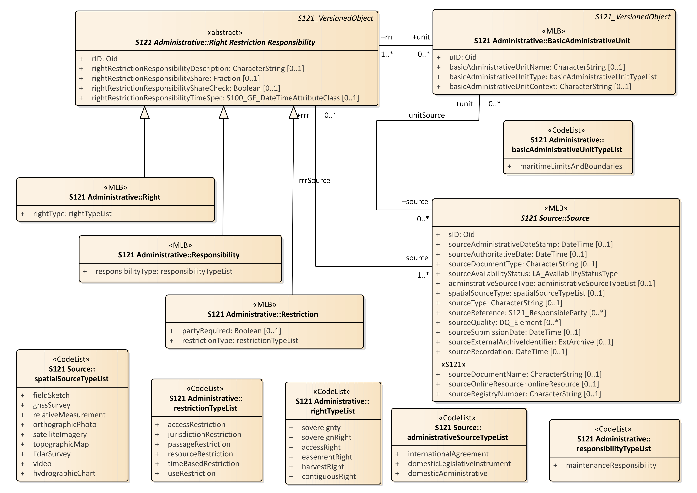
Figure C-11 – S-121 RRR Administrative Package
  - Governance Object
Treaties and other descriptive documents normally contain a textual preamble that contains information specific to the status of the data, or exchange data set (such as a deposit in compliance with the depositary obligations of UNCLOS). This information requires another type of Information Type. This information type is called a governance object. This information is not metadata, it is an integral part of the dataset containing specific text, but it may duplicate some metadata elements such as title. The governance data object may be versioned and can reference a source or sources.
All of the attributes of the governance object are optional except for a unique identifier attribute: govID. There may be zero or more (0..*) governance objects associated with a BasicAdministrativeUnit. When generating a data set from data held in the S-121 data model the governance objects associated with the Basic Administrative Units selected for output would be included with the output data.
There are several optional attributes that may be used to carry specific aspects of the textual preamble such as the title (governanceTitle), or the reference number (referenceNumber) of the data. The textual preamble would be carried as a character string in the governance description (governanceDescription) attribute.
The attributes are:
- govID – A unique character string and a namespace identifier which is also a unique character string;
- referenceNumber – The reference number of the source reference;
- label – A short textual identifier of the governance object;
- name – The name of the governance object;
- governanceTitle – The title of the reference;
- governanceDescription – A character string containing the governance statement;
- releasibilityType – Optionally used to differentiate between releasability status for particular features;
- dateApproved – The date at which the statement or document was approved by the appropriate governing body;
- dateConsidered – The date at which the statement or document was considered by the appropriate governing body;
- dateIntroduced – The date at which the statement or document was introduced.
Figure C-12 below shows the Governance Object structure.
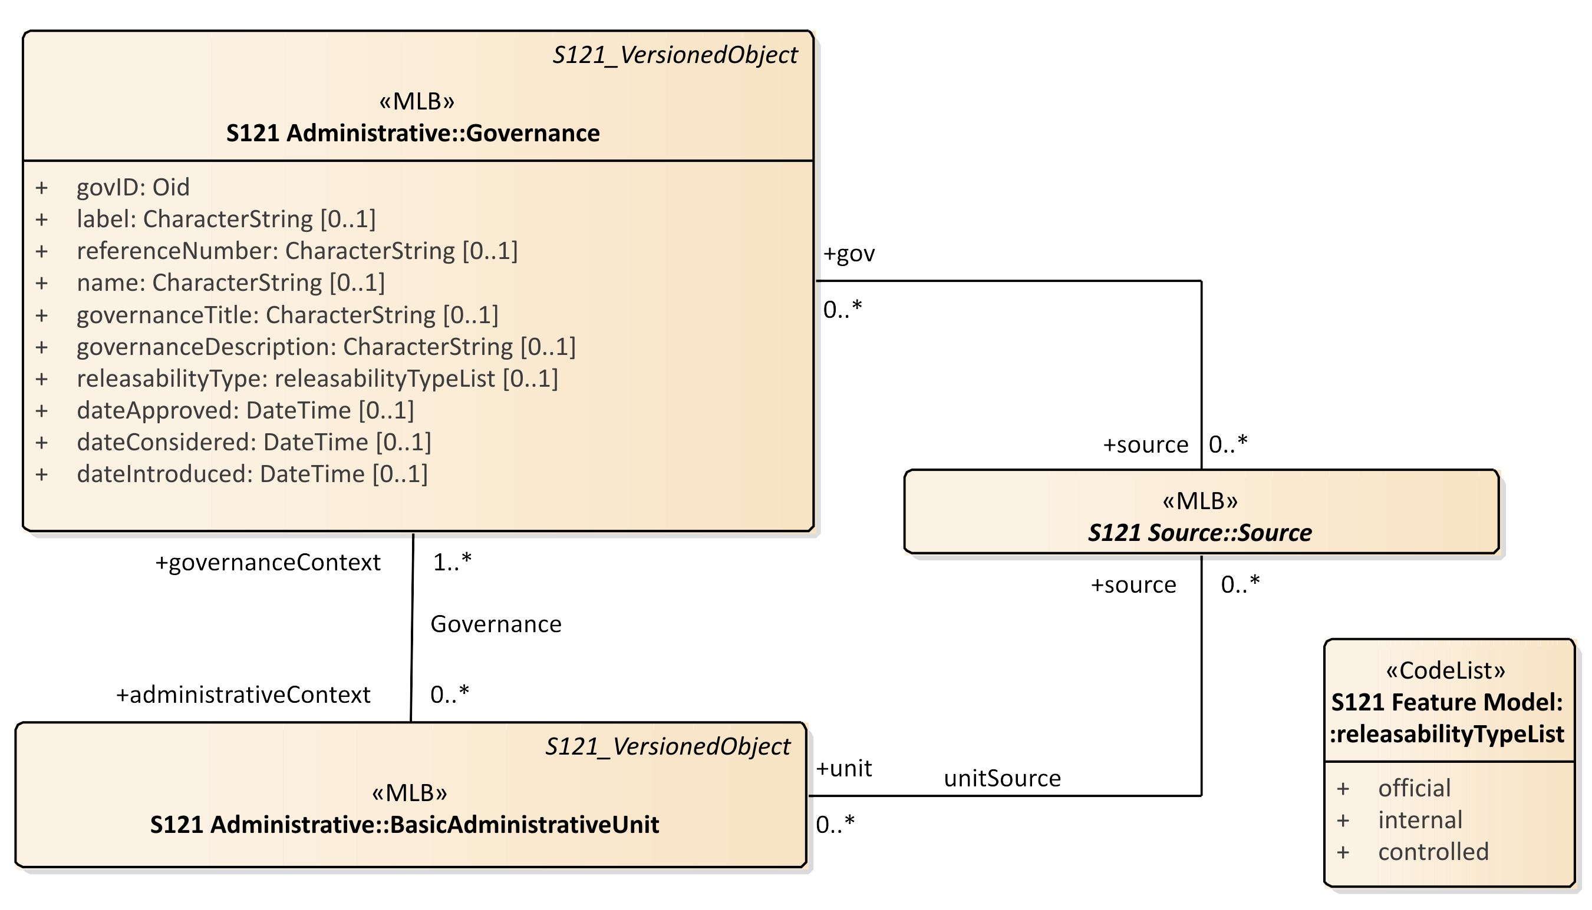
Figure C-12 – Governance Object
  - Versioned Object
Versioning is a critical aspect for data. Each feature and information object can be separately versioned. This is done by including two attributes in each of these features that define the beginning and end dates of validity.
Versioned and non-versioned features may be combined in a dataset. Non-versioned objects are then implicitly versioned by the metadata date stamp on the whole dataset. Versioning is particularly important when data is extracted from an online database. Figure C-13 below shows the S-121 versioning attributes for S-121 features.
The VersionedObject attributes also contains an attribute collection. This attribute allows one to describe several different collections of data. For example the UN may hold data from Canada, France and other countries in the same database. There may be a unique numbering or naming system for feature and information object instances in Canada and another one in France, but there is no assurance that the two namespaces do not conflict. The collection attribute identifies which “collection” a data element is a member of. Effectively it ensures a unique namespace. This attribute is conditional. It is required in a database that contains information from different suppliers. The attribute is not required in a country’s national database (if the country has a unique and unambiguous name or numbering system, and it is not required in an exchange data set because the metadata of the entire dataset uniquely identifies the dataset).
With respect to versioning, the presence of inconsistencies or discrepancies in information provided by different states does not indicate the existence of a dispute among the relevant states.
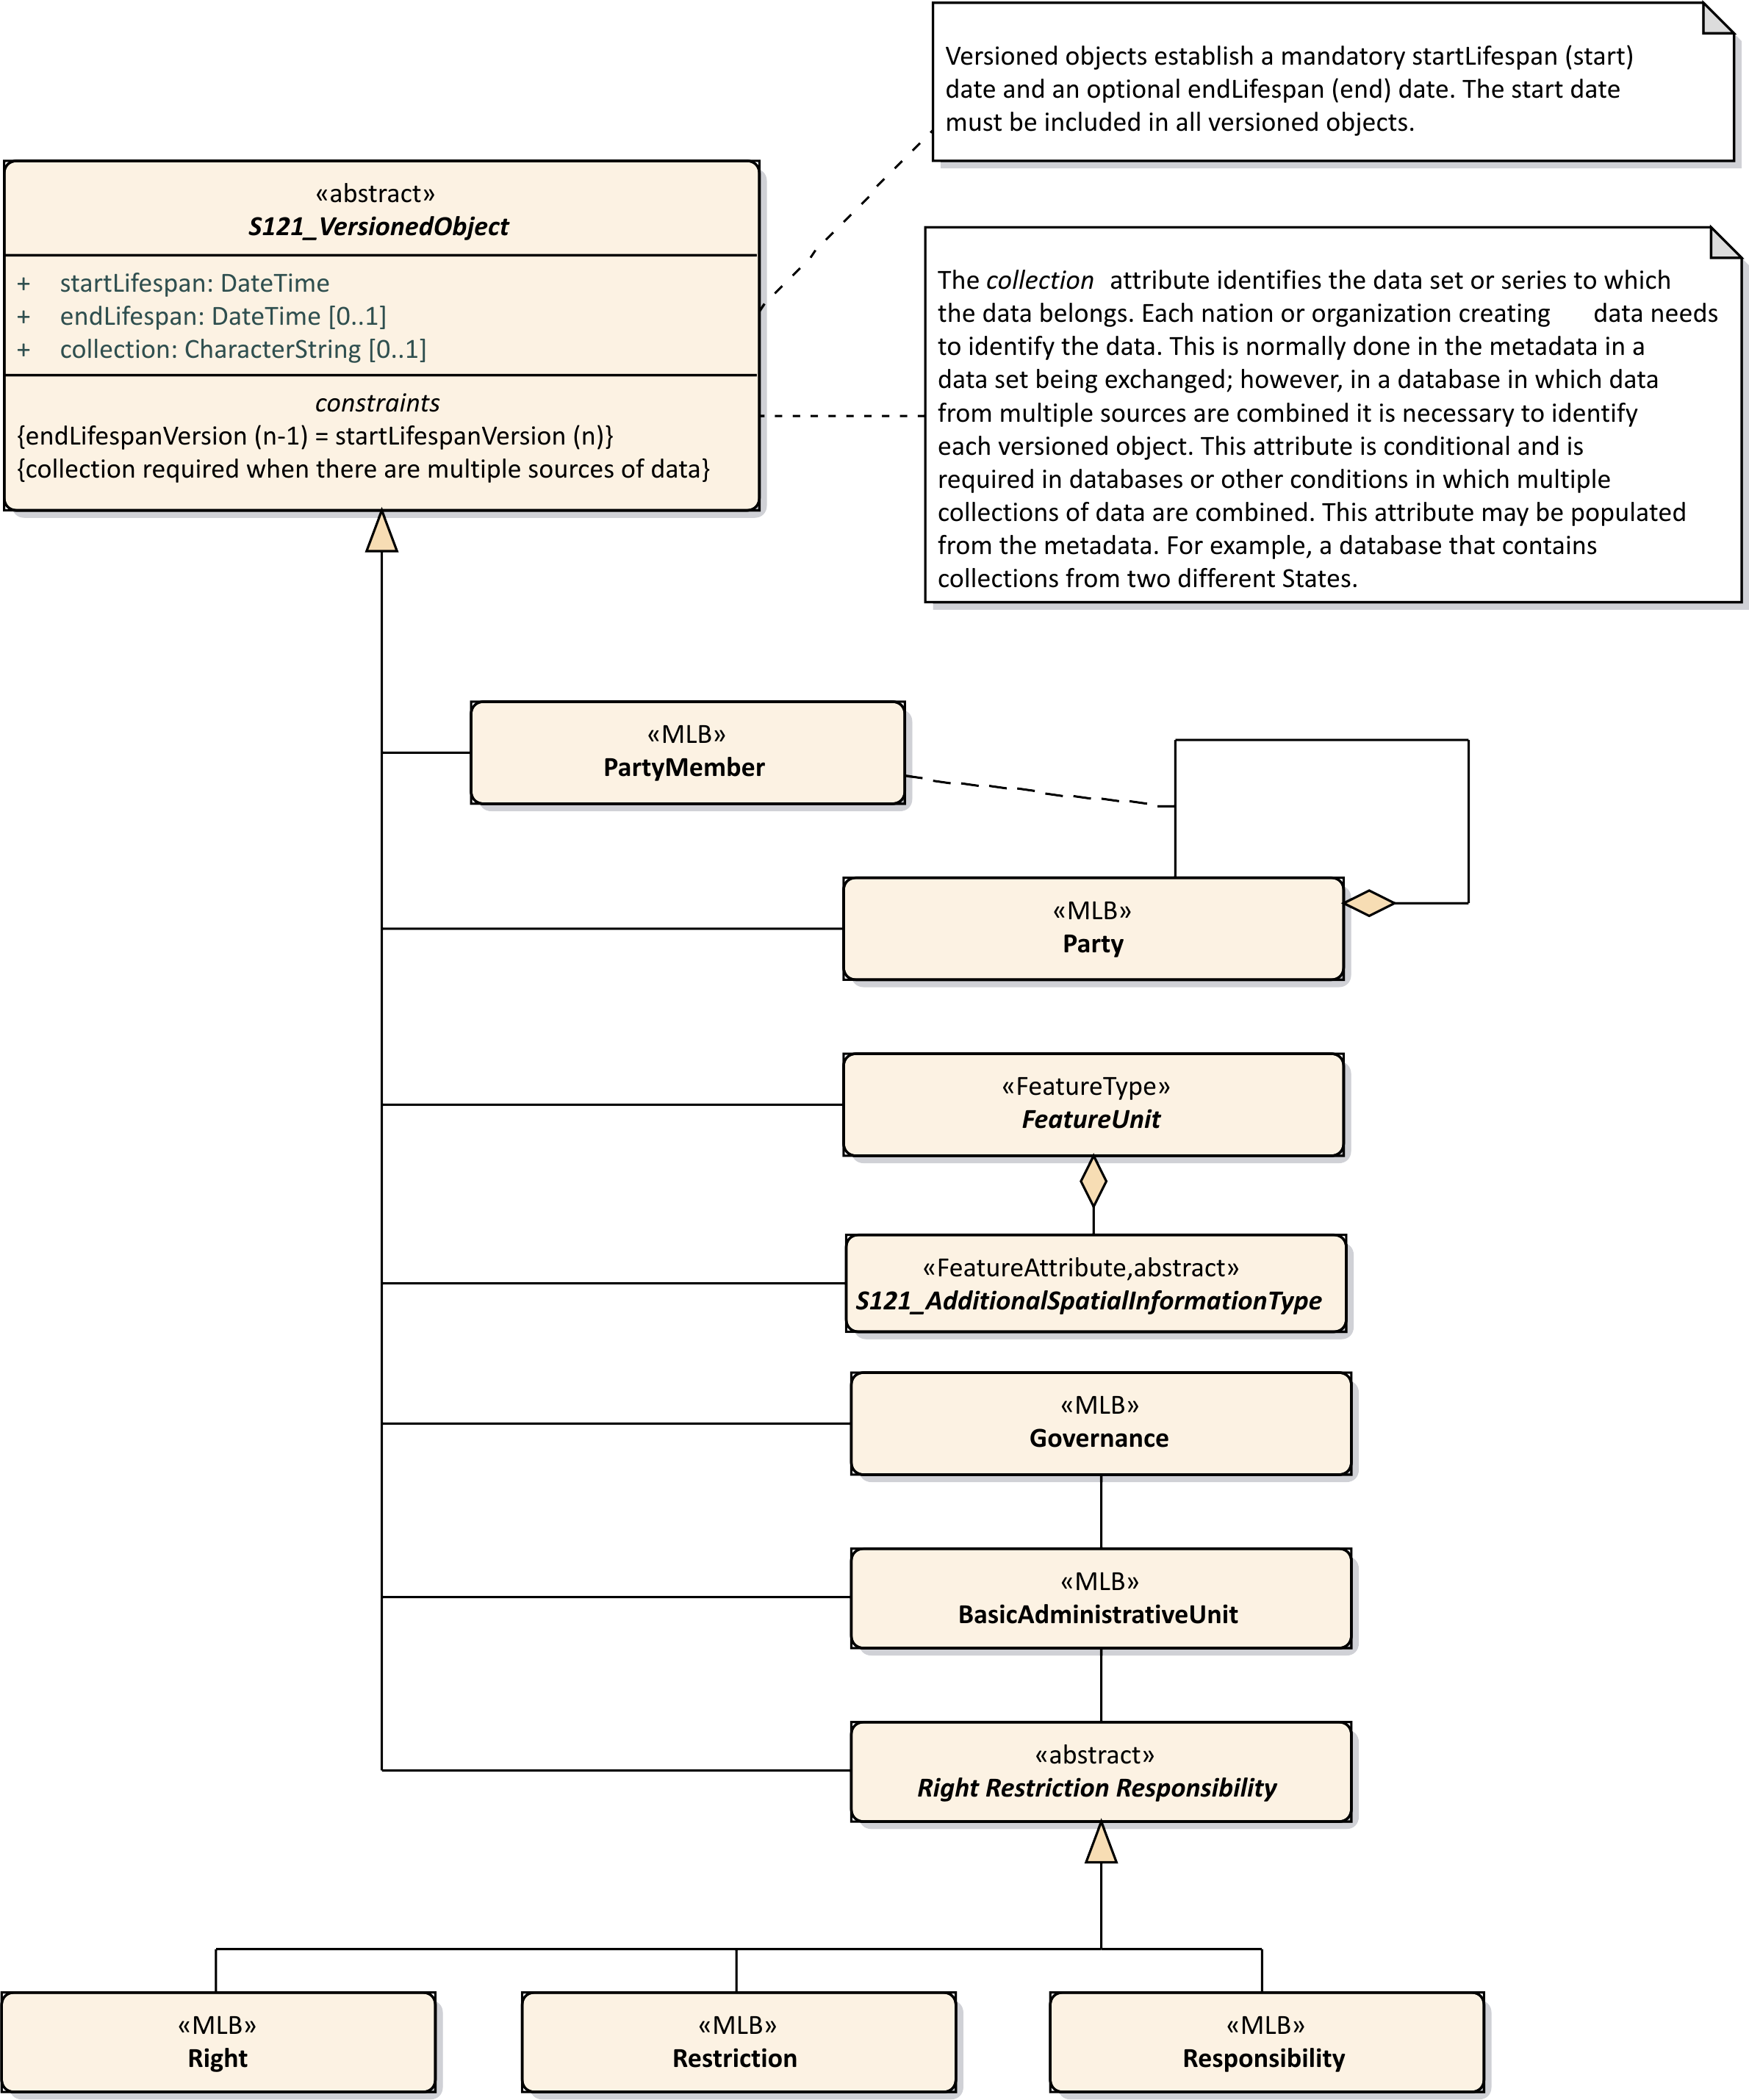
Figure C-13 – Versioned Objects
  - Implementation Model
The implementation model for the S-121 Administrative Group is shown in Figure C-14 below. It shows four groups of features, the Feature/Attribute Group which is derived directly from S-100 and the three additional groups implemented by S-121. There are only 7 instantiable classes. These additional groups are the Administrative Group that defines the Basic Administrative Unit and the Rights, Restrictions and Responsibilities. The Party group defines Parties and the Source Group defines Source references. The governance object is also part of the Administrative Group.
The structure is conceptually simple. There is a link from a Feature Unit to an Administrative Group BasicAdministrativeGroupUnit for Zone type features and Space type features. The Administrative and Party structure simply behaves as an attribute by association describing the Rights, Responsibilities and Restrictions and the Parties involved for that Feature.
The Administrative group and the spatial primitives associated with a feature may also reference the S121_Source in the Source group. This is also by reference and it allows source references to be shared.
The Feature, Administrative and Party groups are versioned objects. If a source changes a new source reference instance should be generated.
The implementation model shown in Figure C-14 has resolved many of the relations to be navigable in one direction meaning that they can be implemented as pointers in an encoding structure. The pointers emanate from the FeatureUnit making the feature the central object in alignment with the philosophy of the underlying S-100 GFM.

The structure of the party group has been transformed in the implementation model. Since the GroupParty class inherited from ISO 19152 is a subtype of the Party class with an extra attribute, these two classes have been combined with the inclusion of a constraint that indicates that the additional attribute party group type (partyGroupType) is to only be used in a group party. The Party Member class then becomes a related feature. This simplifies the implementation for those systems that cannot support a relationship class used for the purpose of carrying an association attribute.
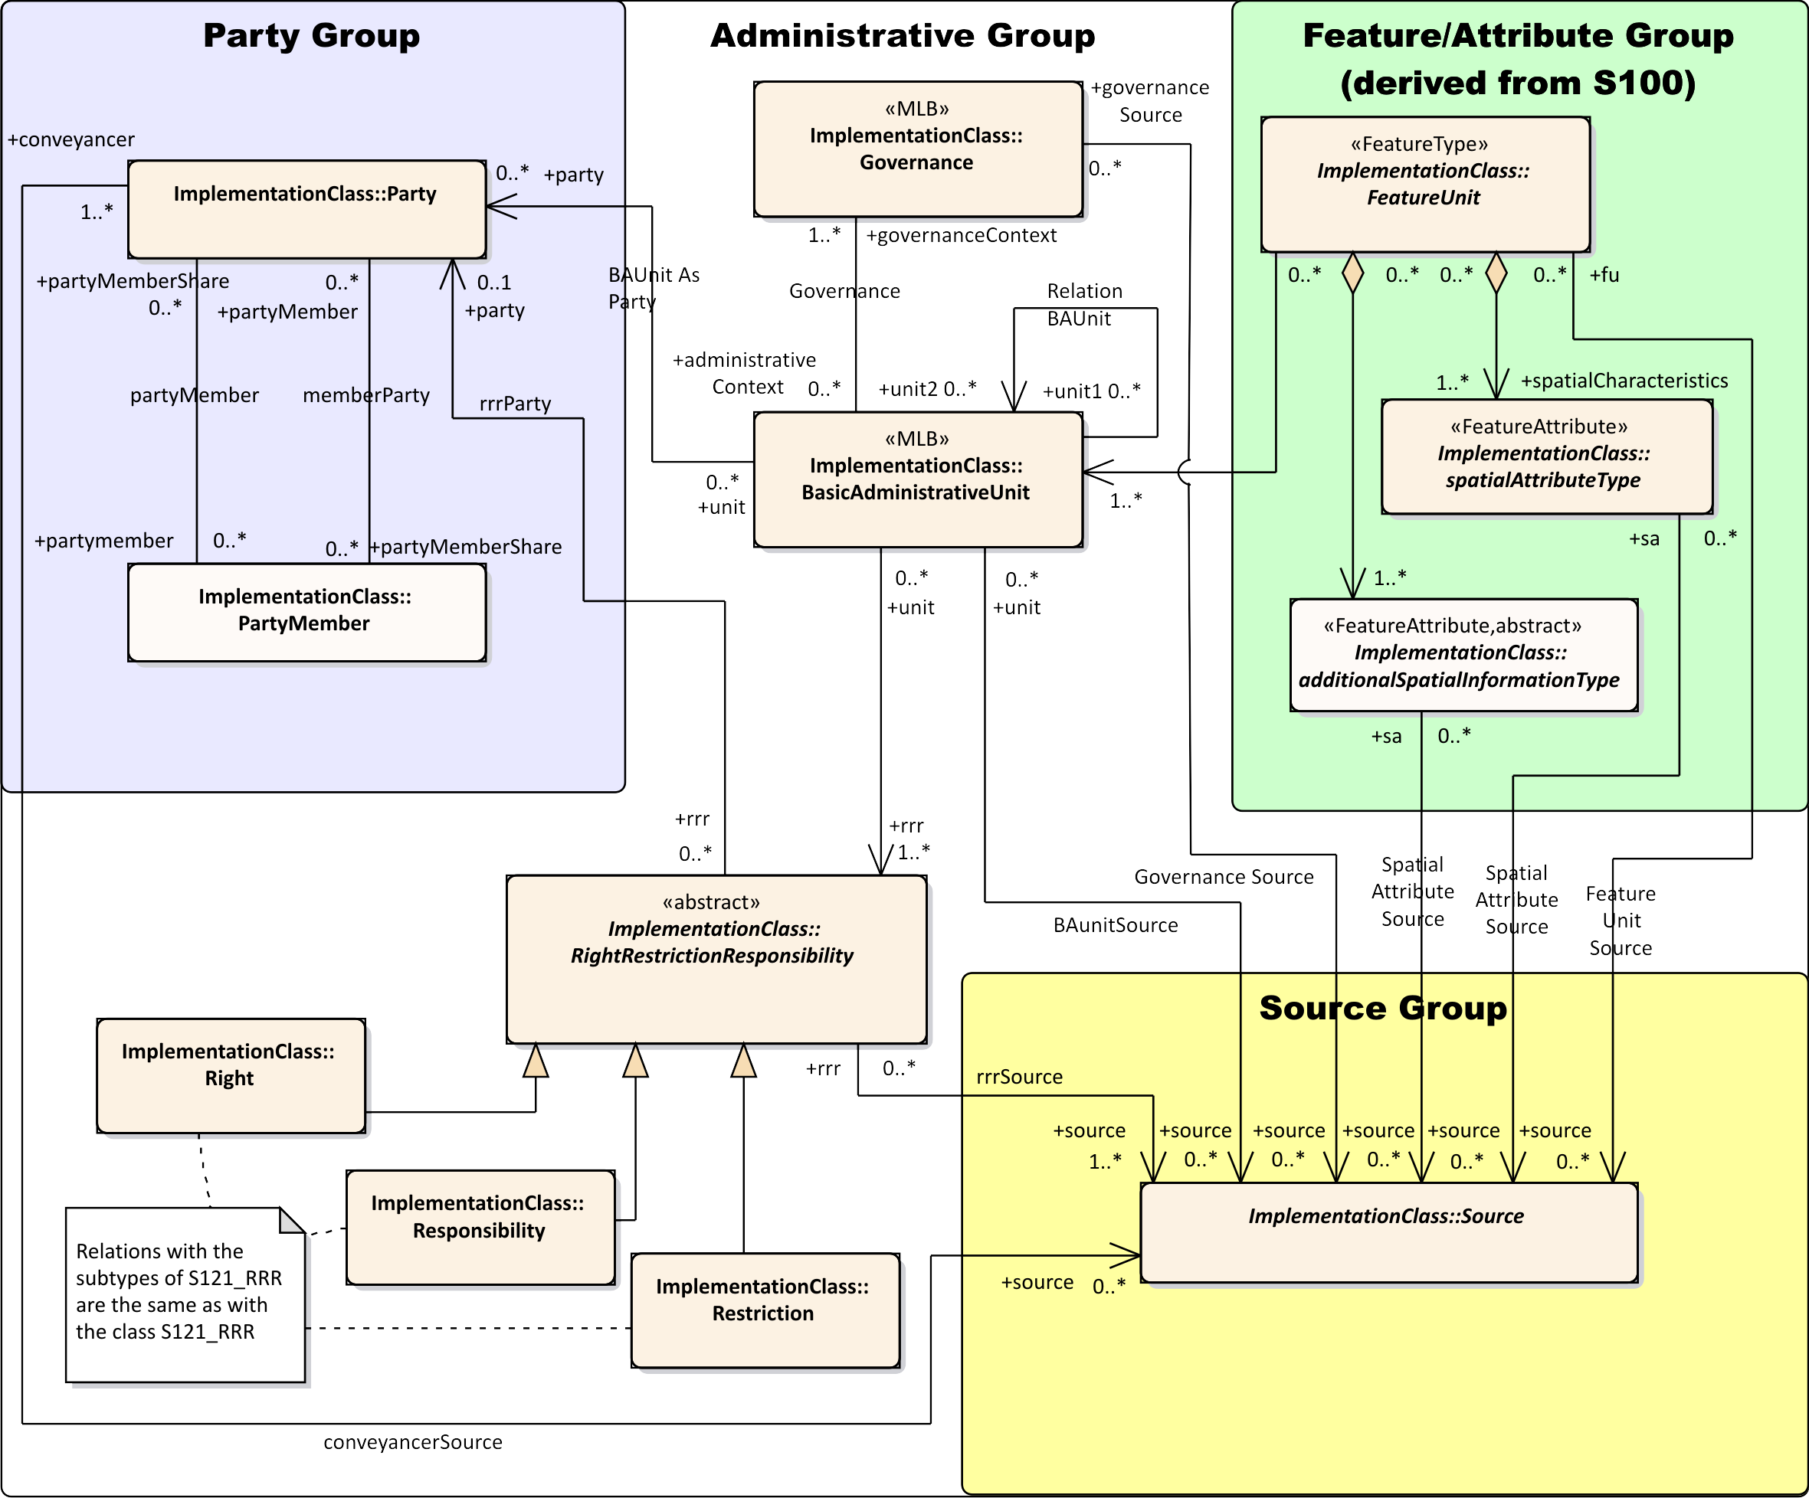
Figure C-14 – S-121 Implementation Model

Page intentionally left blank

- Bibliography
(Informative)
- IHO S-100 IHO Universal Hydrographic Data Model (June 2015)
- ISO 3166-1:2013 - Codes for the representation of names of countries and their subdivisions -- Part 1: Country codes,
- ISO 19101:2003 - Geographic Information – Reference model,
- ISO 19103:2003 - Geographic Information – Conceptual schema language,
- ISO 19107:2003 - Geographic Information – Spatial Schema,
- ISO 19110:2005 - Geographic information – Methodology for feature cataloguing,
- ISO 19115:2003 - Geographic information – Metadata

- ISO 19136:2007 - Geographic Information – Geography Markup Language,
- ISO 19152 - Geographic Information – Land Administration Domain Model (LADM)

- NIMA Technical Report TR8350.2 Department of Defense World Geodetic System 1984, Its Definition and Relationships with Local Geodetic Systems, Third Edition, National Geospatial-Intelligence Agency.

- WC3 Extensible Markup Language (XML) https://www.w3.org/XML/

Page intentionally left blank

The normative reference is to the base ISO 19115:2003 metadata standard because IHO S-100 references this version of the ISO standard. The revised standard ISO 19115-1:2014 is backward compatible with ISO 19115:2003 with respect to the metadata elements used in this S-121 Product Specification.
ISO 19152
PT_Locale is defined in ISO 19139 and ISO 19115-3 which are the XML encodings for metadata, although the structure allows any text string to include an identifier of language and text in that language..
ISO 19152 LADM clause 4.1.13

