4th S-129 Under Keel Clearance Project Team (UKCPT) and
6 th S-100 Testbed Strategy Meeting (TSM)

Busan, Republic of Korea, 17-20 September 2018
LOGISTICS INFORMATION

Venue

The UKCPT(17-18 September) and S-100TSM(18-20 September) meetings will take place at the Paradise Hotel, Busan, Republic of Korea. The meetings are scheduled between 9am to 5pm which is subject to changes.

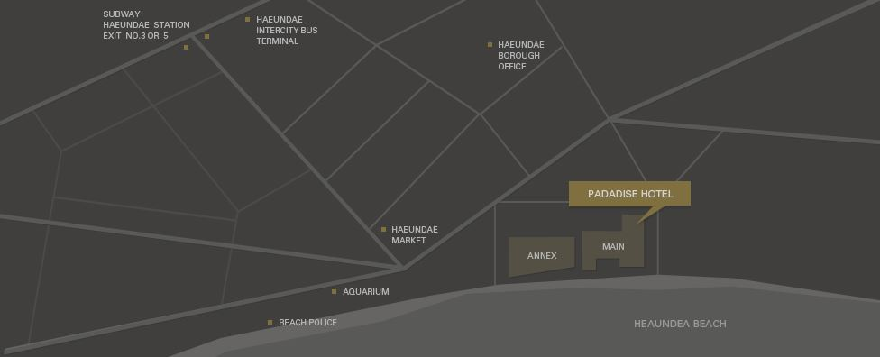

Accommodation

Participants are expected to make their own accommodation arrangements. However, assistance can be provided as needed. Anyone requiring assistance is invited to contact Mr. Martin PARK (martin.park@korea.kr) and Ms. Boram JANG (jangbbo89@korea.kr). The block reservation for the meeting will be available by the end of the September 2018 with special rates as described below.

- PARADISE HOTEL BUSAN

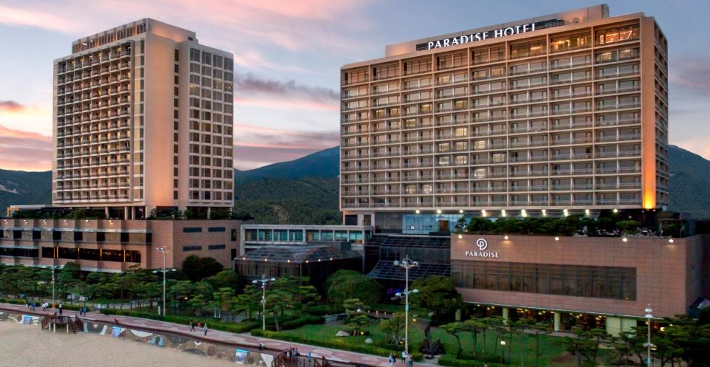
Address: 296, Haeundaehaebyeon-ro, Haeundae-gu, Busan, Republic of Korea
Tel: +82-51-749-2111~4
Fax: +82-51-749-2004
E-mail for reservations: res@paradisehotel.co.kr
Website: www.busanparadisehotel.co.kr

Rate: There are various room types available.
- US$155 (City View), US$220 (Ocean View) per room per night. (This is a negotiated rate)
- 10% service charge and 10% tax are included.
- Breakfast buffet is NOT included. If you wish to have it, please tick the box in the registration form. The rate is US$30.

Reference for booking: Please indicate “S100 Meeting 17-20 September 2018 Special Rate US$155”
Note: All meetings will be held at the Paradise Hotel Busan.

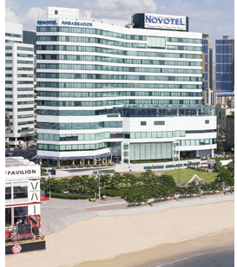
2. NOVOTEL AMBASSADOR BUSAN

Address: 292, Haeundaehaebyeon-ro, Haeundae-gu Busan, Republic of Korea
Tel: +82-51-743-1234
Fax: +82-51-743-1250
E-mail for reservations: rsvn@novotelbusan.com
Website: https://novotel.ambatelen.com/busan/main.amb

Rate: There are various room types available.
- KRW 133,100 (City View), KRW181,500 (Ocean View) per room per night. (This is a negotiated rate)
- 10% service charge and 10% tax are included.
- Breakfast buffet is NOT included. If you wish to have it, please tick the box in the registration form. The rate is KRW24,200.

Reference for booking: Please indicate “S100 Meeting 17-20 September 2018 Special Rate US$121”
Note: This hotel is 5 minutes walking distance from the Paradise Hotel.

NOTE: There are other hotels but only these two are offering special rates.

Transportation

To and From airport

The Gimhae International Airport is located at Daejeo 2-dong, Gangseo-gu, Busan. (http://www.airport.co.kr/gimhaeeng/main.do)

While there are several transportation options to travel from the Airport to Paradise Hotel Busan, we recommend considering:

- Limousine Bus (Cost : Adult KRW7,000, Child KRW4,500)
Route name: Haeundae Limousine (Get off at ‘Novotel Ambassador’ or ‘Paradise Hotel’)
Boarding location: Domestic/International Terminal 1st Floor Bus Stop 2

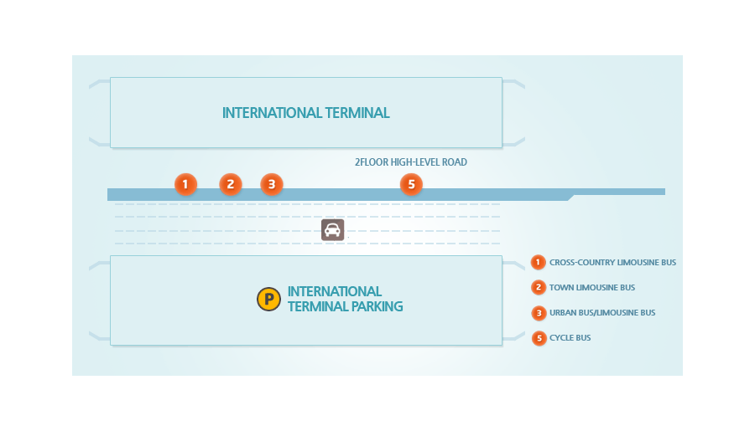
Interval: about 30 min.
(06:50, 07:15, 07:40, 08:05, 08:30, 08:55, 09:20, 09:50, 10:20, 10:45, 11:10, 11:35, 12:00, 12:30 13:00, 13:30, 14:00, 14:30, 15:00, 15:30, 16:00 16:30, 17:00, 17:30, 18:00, 18:30, 19:00, 19:30 20:00, 20:30, 21:00, 21:30, 22:00, 22:20)

- Bus (Cost : Adult KRW1,500, Kid KRW4,500)
307 (Get off at the Novotel Ambassador)

- Taxi
General 30,000KRW, Black Cab 45,000KRW or less (Approx. 40 mins)

Weather

Korea has four seasons, with a wet monsoon/summer season in the middle of the year, and a cold winter from November to March. Autumn is from September to November, and it is the transition period to winter. Average temperature of September in Busan is approximately 21℃. Please check the latest weather information prior to your departure for Korea. (http://web.kma.go.kr/eng/index.jsp)

Official Language

The official language of the Republic of Korea is Korean. However, most of the street and road signs are written in both Korean and in English. Services are available in English at airports and hotels.

Tourist Information

Busan is the Republic of Korea’s second largest metropolis after Seoul, the capital. It has Korea’s longest beach and the world’s fifth busiest seaports by cargo tonnage. It is one of the most famous tourist locations in Korea and you can find traditional and historic sites as well as lots of modern shopping and entertainment districts. More information can be found at: http://www.tripadvisor.com/Tourism-g297884-Busan-Vacations.html.

Travel Documents & Visa

You can check the required travel documents by country at: https://bit.ly/2KKjYPy

Electrical Power

The standard voltage in Korea is 220 volts. The outlet has two round holes and is the same type used in France, Germany, Austria, Greece, Turkey, and many other countries. If you do not have a multi-voltage travel adapter, you can borrow one from your hotel’s front desk.
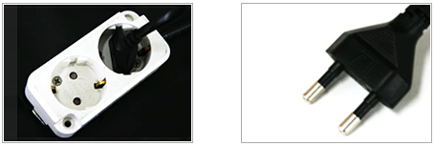

Contact and Additional Information

Mr. Martin PARK Ms. Boram JANG
Email: martin.park@korea.kr Email: jangbbo89@korea.kr
Phone: +82-(0)51-400-4340~4344 Phone: +82-(0)51-400-4340~4344
Mobile: +82-(0)10-9139-1717 Mobile: +82-(0)10-9179-6226

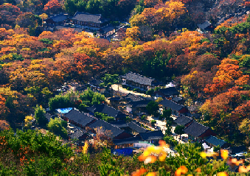 | 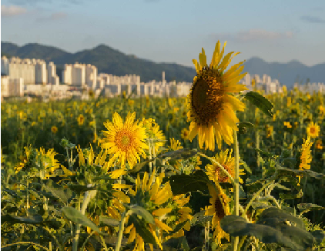 | 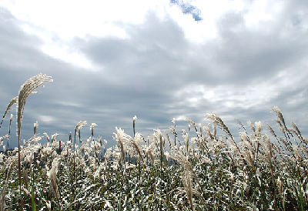
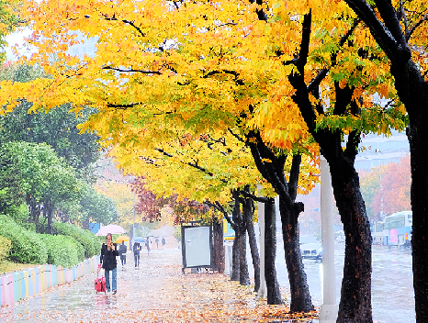 |  | 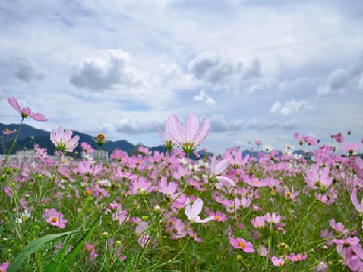

[Annex A. Reservation form for Paradise Hotel Busan]
PARADISE HOTEL BUSAN  RESERVATION REQUEST |  | UKCPT & S-100TSM meeting  KHOA(국립해양조사원) |  |  |   
*Check In : |  |  | *Check out : |  | Remarks
*No. of Persons:
*Guest Name: □ Mr. □ Ms.

*Last Name:

*First Name:
*Country:
*Telephone: |  |  | *Email:
 |  |  | Fax:
PAYMENT
*Credit Card Type: □Etc. □Visa □Masters □Amex(4Digit-number Amex: )
*Expiry Date:
*Credit Card Number:
*Card Holder’s Name:
ROOMS CATEGORY | Weekday |  |  | Weekend (Saturday) | OTHERS RATE
Deluxe  City View | □ USD 155 (double)  □ USD 155 (twin) |  |  | □ USD 220 (double)  □ USD 220 (twin) | Breakfast  □ USD 30 / Person
Deluxe  Ocean View Terrace | □ USD 220 (double)  □ USD 220 (twin) |  |  | □ USD 285 (double)  □ USD 285 (twin) | Breakfast  □ USD 30 / Person
* The rates above are non-commissionable, and they are includes of 10% Service Charge and 10% Government Tax.
* The rates above are the special rate only for Conference attendees.
* Full Buffet breakfast will be served at the’ On the Plate Restaurant’ at the Main Building Lobby Floor
* Free Access : Fitness center, Swimming pool, Plat station zone, Internet Wi-fi
* 50% Special Discount on admission to Sauna and Outdoor hot spring ‘Cimer’
Cancellation Policies: Cancellation or No Show after the room reservation is being charged as below;
* From 7days to 4days prior to Arrival date : 30% of the Room charge
* From 3days to 2days prior to Arrival date : 50% of the Room charge
* From 1days or less prior to Arrival date : no refund
Please send reservation to: res@paradisehotel.co.kr
[Annex B. Reservation form for Novotel Ambassador Busan]

국립해양조사원
NOVOTEL AMBASSADOR BUSAN
RESERVATION FORM
Thank you for choosing Novotel Ambassador Busan.
Reservation should be made through the hotel directly.
Please complete this Accommodation Form and send it to the Novotel Ambassador Busan via fax (+82-51-743-1250) or e-mail (rsvn@novotelbusan.com)

1. Personal Information & Reservation Details
First Name | □ Mr. □ Ms. | Last Name
Passport No. |  | Nationality
Telephone |  | E-mail
Check-In |  | Check-Out
Estimate time of arrival at Hotel :

2. Room Requirements
Room Type | Special Rate | Bed Type / No. of Rooms | Breakfast
Deluxe City | KRW 133,100 | □ Twin □ Double ( Rm) | □ Yes □ No ( PAX)  KRW 24,200 (per person)
Deluxe Ocean | KRW 181,500 | □ Twin □ Double ( Rm) | □ Yes □ No ( PAX)  KRW 24,200 (per person)
- All room rates are inclusive of the 10% service charge and 10% tax.
- Room reservation might not be available depends on room occupancy.
- Special Rates are only offered for the stay from 10th of September to 14th of September 2018
- There will be 48,400KRW surcharge per 1 night for staying on Saturday
- Cancellation Policies: 1) From the agreement date to 6days prior to Arrival date: 30% of the Room charge.
2) From 5days to 2days prior to Arrival date: 50% of the Room charge.
3) From 1day or less prior to Arrival date: No refund
3. Deposit
Credit Card | □ VISA □ Master □ JCB □ Others ( )
Card No. |  | Expiration Date (mm/yy)
Holder’s Name |  |  | Signature
I agree that my reservation in guaranteed with my credit card information described above and I will settle all hotel charges when checking out. |  |  | Signature

- Please note that the credit card information will be used to guarantee your hotel room reservation ONLY.
- Total hotel fee will be settled upon check out.
- Please contact the hotel for more information on the cancellation policy.

- Please send a fax or E-mail for reservation ASAP with application form due to limited room volume.

 | NOVOTEL AMBASSADOR BUSAN  292, Haeundaehaebyeon-ro,  Haeundae-Gu, Busan KOREA | Tel : +82-51-743-1234  Fax : +82-51-743-1250  rsvn@novotelbusan.com | www.novotelbusan.com  www.novotel.com

