APPENDICES

Page intentionally left blank

Appendix A

IHO MEMBER STATES’ RESERVATIONS

- NORTH ATLANTIC OCEAN

No reservations.

- BALTIC SEA

No reservations.

- MEDITERRANEAN REGION

No reservations.

- SOUTH ATLANTIC OCEAN

No reservations.

- INDIAN OCEAN

Reservation by Australia. Australia issues charts and publications depicting Australia's limits of the Indian Ocean, as shown in the diagram below.

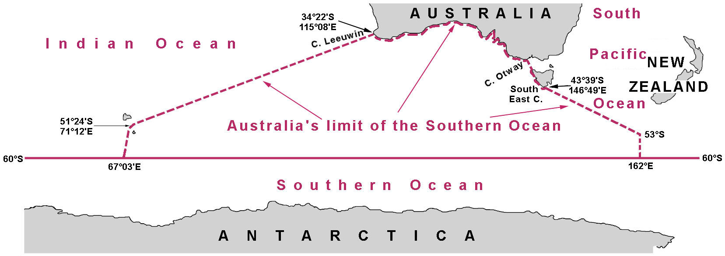

- SOUTH CHINA AND EASTERN ARCHIPELAGIC SEAS

No reservations.

- NORTH PACIFIC OCEAN

No reservations.

- SOUTH PACIFIC OCEAN

Reservation by Australia. Australia issues charts and publications depicting Australia's limits of the South Pacific Ocean, as shown in paragraph 5 above.

- ARCTIC OCEAN

9.1 EAST SIBERIAN SEA

Reservation by the USA. The USA has proposed that the northern limit be defined by a line from the northern most point of Ostrov Vrangelya to the northern sides of Ostrava Dehong, following the definition provided in the 3rd Edition of S-23 in 1953, as shown in the diagram below (green).

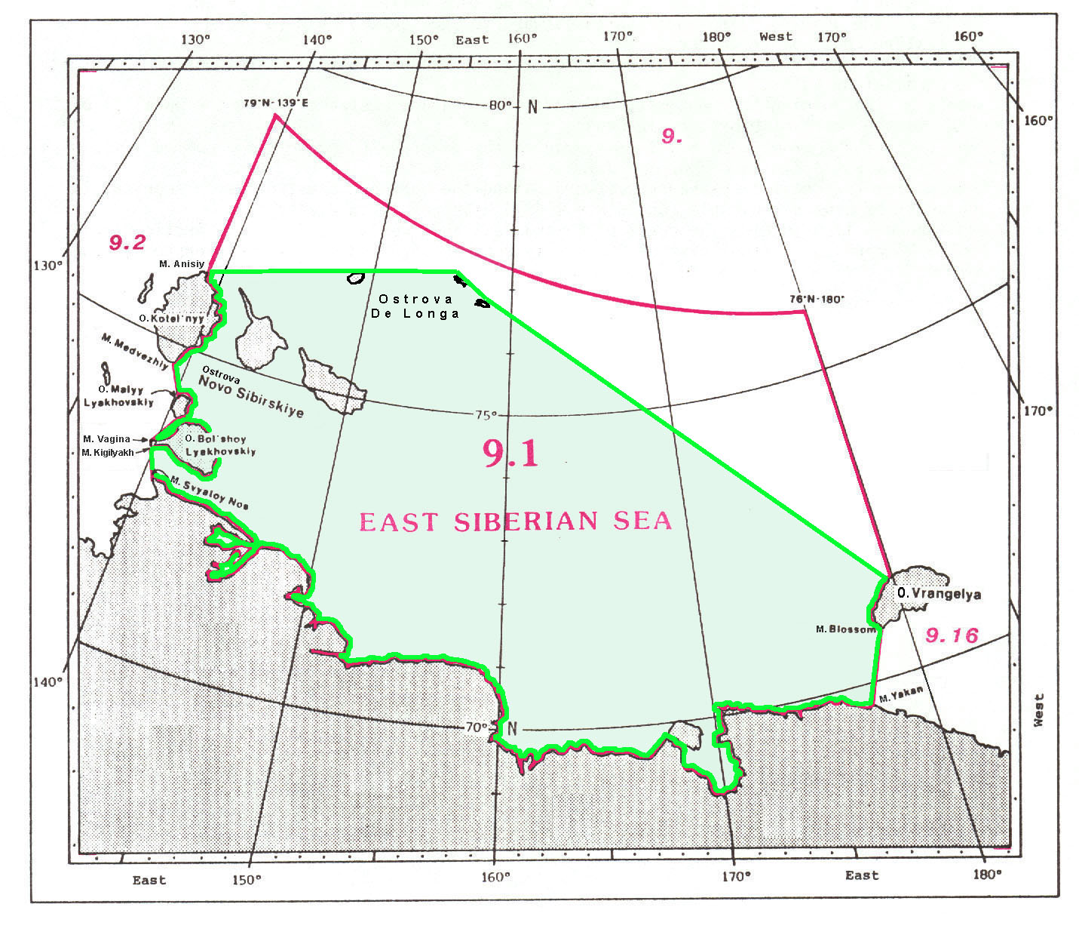

9.2 LAPTEV SEA

Reservation by the USA. The USA has proposed that the northern limit be defined by a line from Mys Molotov to the northern extremity of Ostrov Kotel'nyy, following the definition provided in the 3rd Edition of S-23 in 1953, as shown in the diagram below.

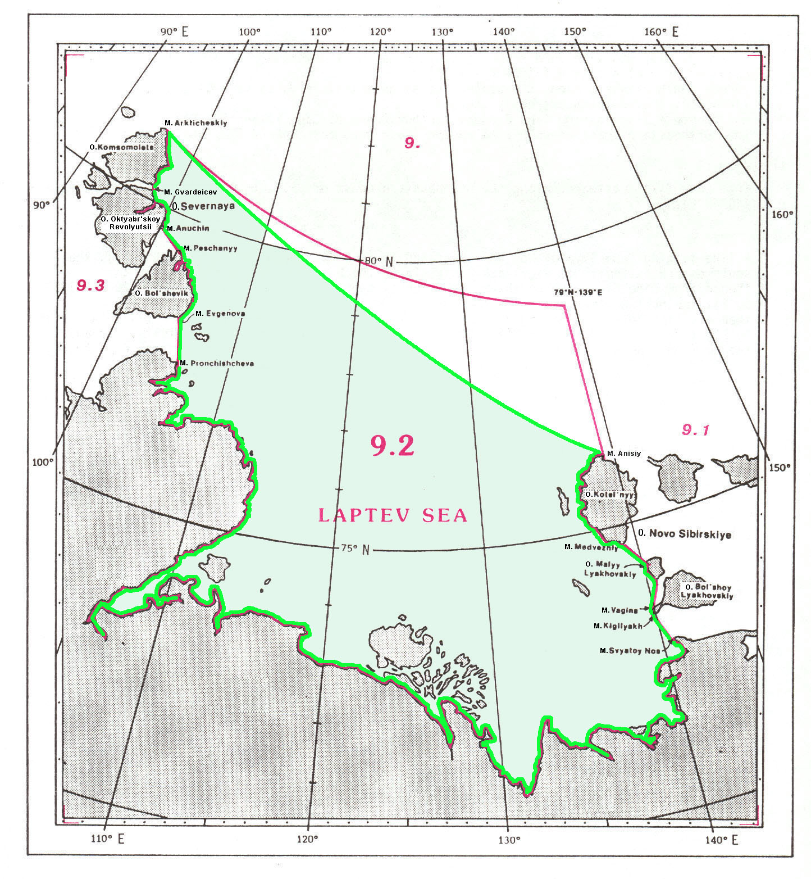

9.9 DAVIS STRAIT

Reservation by Russian Federation. In Russia, the Davis Strait is referred to being in the Atlantic Ocean.

9.16 CHUKCHI SEA

Reservation by Russian Federation. Russian usage supports a northwestern limit of Chukchi Sea extending to the position 76°N - 180°W, as shown in the diagram below (green).

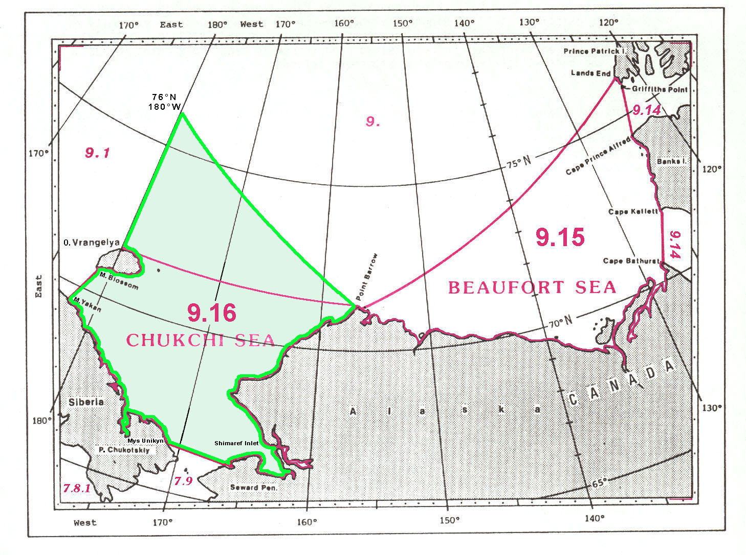

10. SOUTHERN OCEAN

Reservation by Australia. Australia issues charts depicting Australia's limits of the Southern Ocean north of 60°, as shown in paragraph 5 above.

10.2 LAZAREV SEA

Reservation by Norway. Norway recognizes the name Kong Håkon VII Hav which covers the sea area adjacent to Dronning Maud Land and stretching from 20°W to 45°E. The southern limit is the ice edge and the northern limit is the 60°S parallel, as shown in the diagram below (green).

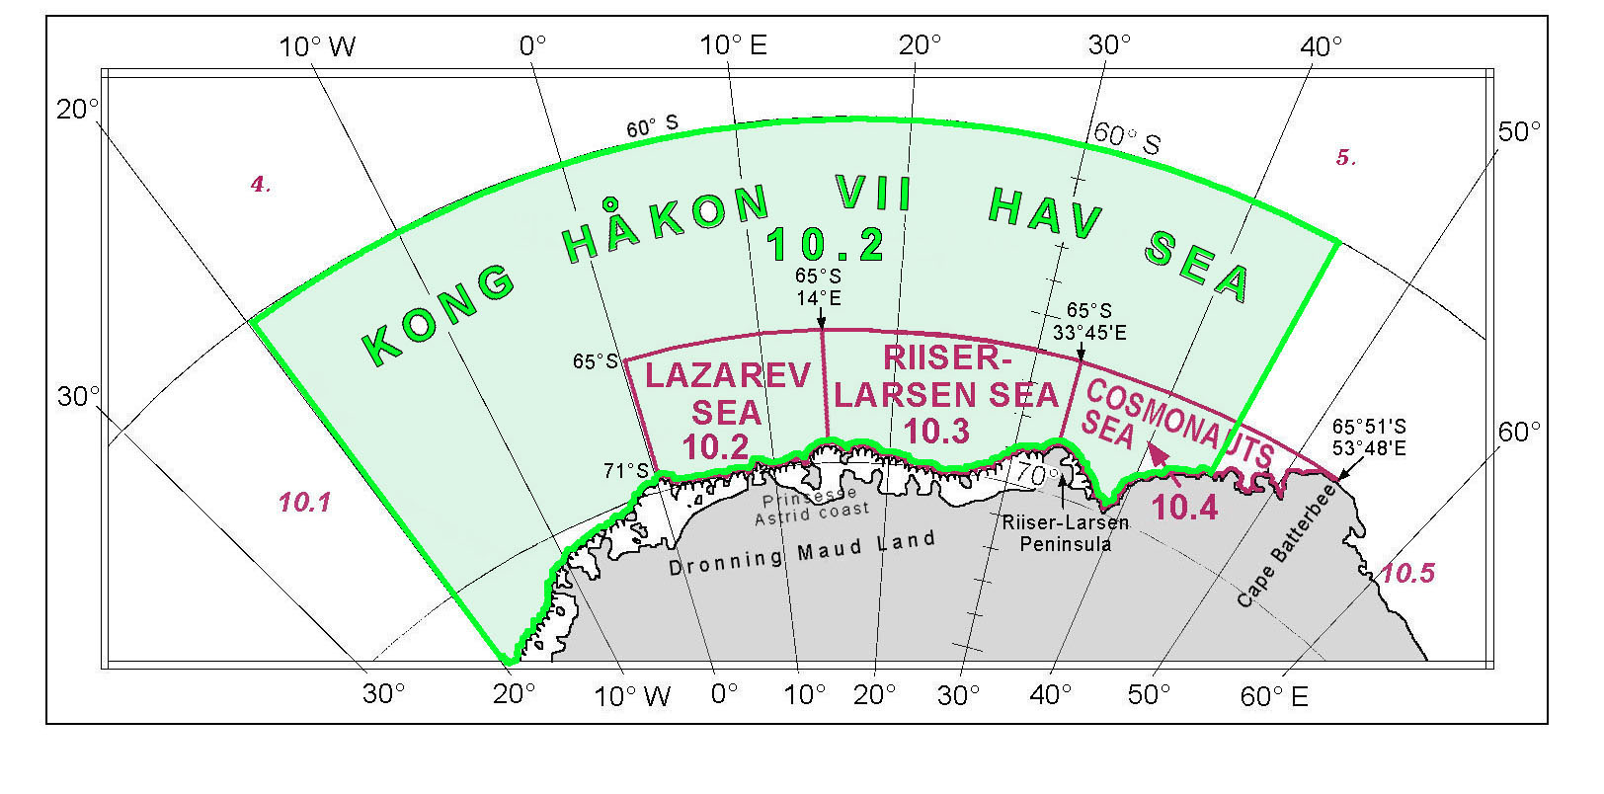

__________

Appendix B

NAMES OF OCEANS & SEAS IN ENGLISH AND FRENCH

ENGLISH VERSION | FRENCH VERSION
1)North Atlantic Ocean & subdivisions  Bay of Biscay (Golfe de Gascogne)  Bay of Fundy  Bristol Channel  Carribbean Sea  Celtic Sea  Dover Strait (Pas de Calais)  English Channel (La Manche)  Gulf of Guinea  Gulf of Mexico  Gulf of St.Lawrence  Inner Seas off the West Coast of Scotland  Irish Sea  Labrador Sea  North Atlantic Ocean  North Sea  Skagerrak  Straits of Florida  2)Baltic Sea & subdivisions  Baltic Sea  Bay of Bothnia  Bothnian Sea  Central Baltic Sea  Gulf of Bothian  Gulf of Finland  Gulf of Riga  Kattegat  Lillebælt  Sound Sea  Storebælt  The Sound  3)Mediterranean Sea & subdivisions  Adriatic Sea  Aegean Sea  Alboran Sea  Balearic Sea  Black Sea  Ionian Sea  Ligurian Sea  Mediterranean Sea  Mediterranean Sea, Western Basin  Mediterranean Sea, Eastern Basin  Sea of Azov  Sea of Marmara  Strait of Gibraltar  Strait of Sicily  Tyrrhenian Sea  4) Southern Atlantic Ocean & subdivisions  Drake Passage  Rio de la Plata  Scotia Sea  South Atlantic Ocean  5)Indian Ocean & subdivisions  Andaman Sea  Arabian Sea  Arafura Sea  Bay of Bengal  Great Australian Bight  Gulf of Aden  Gulf of Aqaba  Gulf of Carpentaria  Gulf of Mannar  Gulf of Oman  Gulf of Suez  Indian Ocean  Joseph Bonaparte Gulf  Lakshadweep Sea  Mozambique Channel  Palk Bay  Palk Strait  Persian Gulf  Red Sea  Strait of Hormuz  Timor Sea  6)South China & Eastern Archipelagic Seas  Aru Sea  Bali Sea  Banda Sea  Celebes Sea  Ceram Sea  Flores Sea  Gulf of Thailand  Gulf of Tonkin  Halmahera Sea  Jawa Sea  Malacca Strait  Molucca Sea  Natuna Sea  Sawu Sea  Selat Sumba  Selat Makasar  Selat Sunda  Singapore Strait  South China Sea  Sulu Sea  Teluk Berau  Teluk Bone  Teluk Tomini  7) North Pacific Ocean & subdivisions  Anadyrskiy Zaliv  Bering Sea  Bering Strait  Bo Hai  Coastal Waters of Southeast Alaska and British Colombia  East China Sea  Gulf of Alaska  Gulf of California  Gulf of Panama  Liaodong Wan  North Pacific Ocean  Phillippine Sea  Sea of Okhotsk  Seto Naikai  Tai-Wan Strait  Tatarskiy Proliv  Yellow Sea  8) South Pacific Ocean & subdivisions  Bass Strait  Bismark Sea  Coral Sea  Great Barrier Reef (Coastal Waters)  Gulf of Papua  Solomon Sea  South Pacific Ocean  Tasman Sea  Torres Strait  9) Arctic Ocean & subdivisions  Arctic Ocean  Baffin Bay  Barents Sea  Beaufort Sea  Chukchi Sea  Davis Strait  East Siberian Sea  Greenland Sea  Hudson Bay  Hudson Strait  Iceland Sea  Kara Sea  Laptev Sea  Lincoln Sea  Northwestern Passages  Norwegian Sea  White Sea  10) Southern Ocean & Subdivisions  Amundsen Sea  Bellingshausen Sea  Bransfield Strait  Cooperation Sea  Cosmonauts Sea  Davis Sea  Drake Passage  Dumont d’Urville Sea  Lazarev Sea  Mawson Sea  McMurdo Sound  Ross Sea  Riiser-Larsen Sea  Somov Sea  Southern Ocean  Tryoshnikova Gulf  Weddell Sea | 1) Océan Atlantique Nord et ses subdivisions  Golfe de Gascogne (Bay of Biscay)  Baie de Fundy  Canal de Bristol  Mer des Antilles ou Mer des Caraïbes  Mer Celtique  Pas de Calais (Dover Strait)  La Manche (English Channel)  Golfe de Guinée  Golfe du Mexique  Golfe du Saint-Laurent  Mer côtière de la côte ouest de l’Écosse  Mer d'Irlande  Mer du Labrador  Océan Atlantique Nord  Mer du Nord  Skagerrak  Détroit de Floride  2) Mer Baltique et ses subdivisions  Mer Baltique  Baie de Botnie  Mer de Botnie  Mer Baltique centrale  Golfe de Botnie  Golfe de Finlande  Golfe de Riga  Kattegat  Petit Belt  Mer du Sound  Grand Belt  Öresund  3) Mer Méditerranée et ses subdivisions  Mer Adriatique  Mer Égée  Mer d'Alboran  Mer des Baléares  Mer Noire  Mer Ionienne  Mer de Ligurie ou Mer Ligurienne  Mer Méditerranée  Mer Méditerranée, Bassin Ouest  Mer Méditerranée, Bassin Est  Mer d'Azov  Mer de Marmara  Détroit de Gibraltar  Détroit de Sicile  Mer Tyrrhénienne  4) Océan Atlantique Sud et ses subdivisions  Passage de Drake  Rio de la Plata  Mer de Scotia  Océan Atlantique Sud  5) Océan Indien et ses subdivisions  Mer des Andaman  Mer d'Arabie  Mer d'Arafura  Golfe du Bengale  Grande Baie Australienne  Golfe d'Aden  Golfe d'Aqaba  Golfe de Carpentarie  Golfe de Mannar  Golfe d'Oman  Golfe de Suez  Océan Indien  Golfe de Joseph Bonaparte  Mer des Laquedives  Canal du Mozambique  Baie de Palk  Détroit de Palk  Golfe Persique  Mer Rouge  Détroit d'Hormuz  Mer de Timor  6) Mer de Chine Méridionale et mers des archipels orientaux  Mer d'Aru  Mer de Bali  Mer de Banda  Mer de Célèbes  Mer de Céram  Mer de Florès  Golfe de Thaïlande  Golfe du Tonkin  Mer de Halmahera  Mer de Java  Détroit de Malacca  Mer des Moluques  Mer des Natuna  Mer de Sawu  Détroit de Sumba  Détroit de Macassar  Détroit de la Sonde  Détroit de Singapour  Mer de Chine Méridionale  Mer de Sulu  Golfe de Berau  Golfe de Bone  Golfe de Tomini  7) Océan Pacifique Nord et ses subdivisions  Golfe de l’Anadyr  Mer de Béring  Détroit de Béring  Bo Hai  Eaux côtières d'Alaska du sud-est et de la Colombie-Britannique  Mer de Chine Orientale  Golfe d'Alaska  Golfe de Californie  Golfe de Panama  Golfe du Liaodong  Océan Pacifique Nord  Mer des Philippines  Mer d'Okhotsk  Seto Naikai  Détroit de Taïwan  Détroit de Tatarie  Mer Jaune  8) Océan Pacifique Sud et ses subdivisions  Détroit de Bass  Mer des Bismarck  Mer de Corail  Récif de la Grande Barrière (Eaux côtières)  Golfe de Papouasie  Mer des Salomon  Océan Pacifique Sud  Mer de Tasman  Détroit de Torres  9) Océan Arctique et ses subdivisions  Océan Arctique  Baie de Baffin  Mer de Barents  Mer de Beaufort  Mer des Tchouktches  Détroit de Davis  Mer de Sibérie Orientale  Mer du Groenland  Baie d'Hudson  Détroit d'Hudson  Mer d'Islande  Mer de Kara  Mer des Laptev  Mer de Lincoln  Passages du Nord-Ouest  Mer de Norvège  Mer Blanche  10) Océan Austral et ses subdivisions  Mer d'Amundsen  Mer de Bellingshausen  Détroit de Bransfield  Mer de la Coopération  Mer des Cosmonautes  Mer de Davis  Passage de Drake  Mer Dumont d'Urville  Mer de Lazarev  Mer de Mawson  Détroit de McMurdo  Mer de Ross  Mer de Riiser-Larsen  Mer de Somov  Océan Austral  Golfe de Tryochnikova  Mer de Weddell

__________

Appendix C

IHO TECHNICAL RESOLUTION A 4.2

International Standardization of Geographical Names

1.- It is resolved that the IHB should maintain continuous contact with the United Nations Organization and specifically with the United Nations Group of Experts on Geographical Names, for all studies or actions relating to geographical names involving or affecting hydrographic publications. The Bureau should insure that actions previously taken on hydrographic matters, with respect to names, within the IHO are brought to the attention of appropriate United Nations Conferences or working groups. The Bureau should also promulgate to Member States information on all significant developments on this subject as they occur.

2.- It is recommended that, since national standardization of geographical names is an essential preliminary to international standardization, Hydrographic Offices encourage and support the establishment of national names authorities, following the principles and procedures recommended by the resolutions on this subject adopted by the United Nations Conferences on Geographical Names.

3.- It is recommended that the IHB co-operate with the United Nations Group of Experts on Geographical Names with the object of achieving international standardization of names of maritime and undersea features.

4.- It is further recommended that co-operation should, in particular, be extended in the under-mentioned activities of the United Nations Group of Experts:

a) Study of existing national and international practices concerning the delineation and naming of oceans and seas, including their integral subdivisions, beyond the limits of national jurisdiction, with a view to recommending improvements in current nomenclatural practices and procedures.

b) Drawing up a system for naming undersea features beyond a single sovereignty and proposing it as a basis for preparing an international convention on the subject.

c) Standardizing the definitions of undersea feature "terms and definitions" in order to promote their acceptance and use by names authorities.

d) Developing procedures for international standardization of naming new undersea features as they are discovered, defined and identified in the future.

5.- It is recommended that when Hydrographic Offices produce gazetteers or geographical dictionaries, these publications be standardized as far as possible in accordance with resolutions on the subject adopted by the United Nations.

6.- It is recommended that where two or more countries share a given geographical feature (such as, for example, a bay, strait, channel or archipelago) under a different name form, they should endeavour to reach agreement on fixing a single name for the feature concerned. If they have different official languages and cannot agree on a common name form, it is recommended that the name forms of each of the languages in question should be accepted for charts and publications unless technical reasons prevent this practice on small scale charts. e.g. English Channel/La Manche.

__________

