CHAPTER 3

MEDITERRANEAN REGION
AND ITS SUB-DIVISIONS

CHARTLET-INDEX
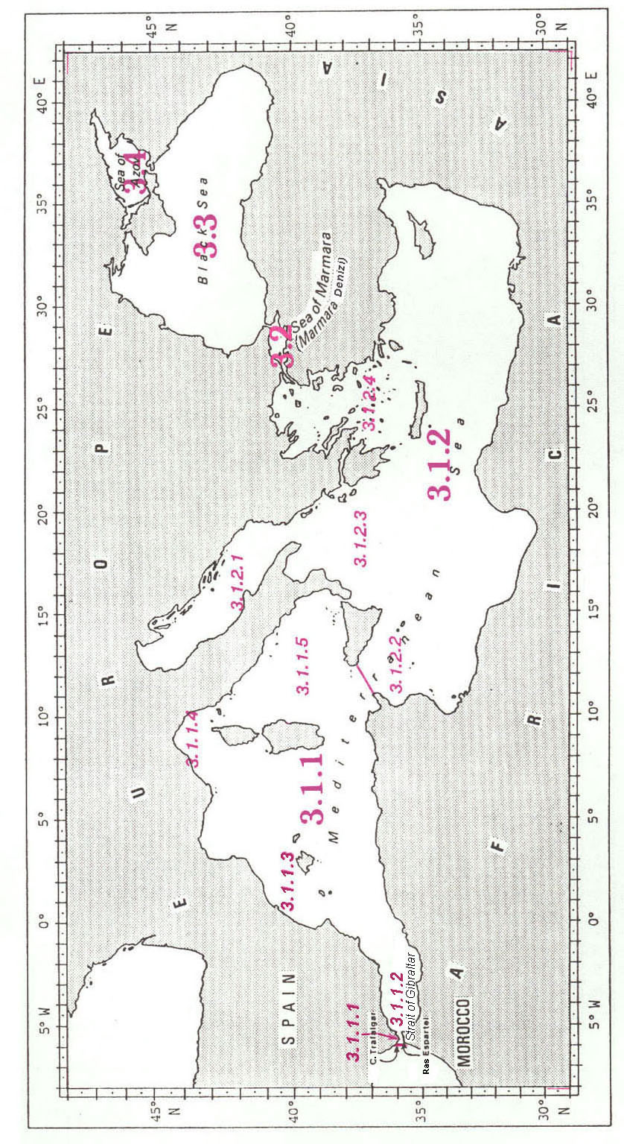
MEDITERRANEAN REGION

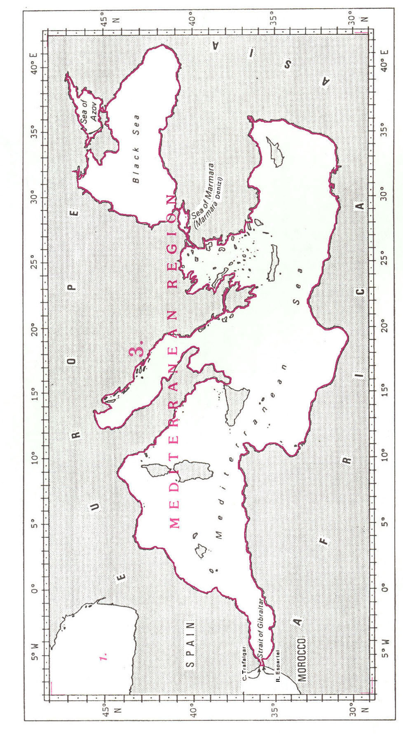
3. MEDITERRANEAN REGION

The Mediterranean Region includes the Mediterranean Sea (see 3.1), the Sea of Marmara1 (see 3.2), the Black Sea ((see 3.3) and the Sea of Azov (see 3.4).

It is bounded by the coasts of Southern Europe, West Asia and North Africa, and forms an enclosed body of water opening only, in the West, to the North Atlantic Ocean through the Strait of Gibraltar (see 3.1.1.1).

The limit between the Mediterranean Region and the North Atlantic Ocean (in the western entrance of the Strait of Gibraltar) is the following:

A line joining Cabo2 Trafalgar (36°11’N - 6°02’W), on the southern coast of Spain, southward to Ras3 Espartel (35°48’N - 5°55’W), on the northern coast of Morocco.
MEDITERRANEAN SEA

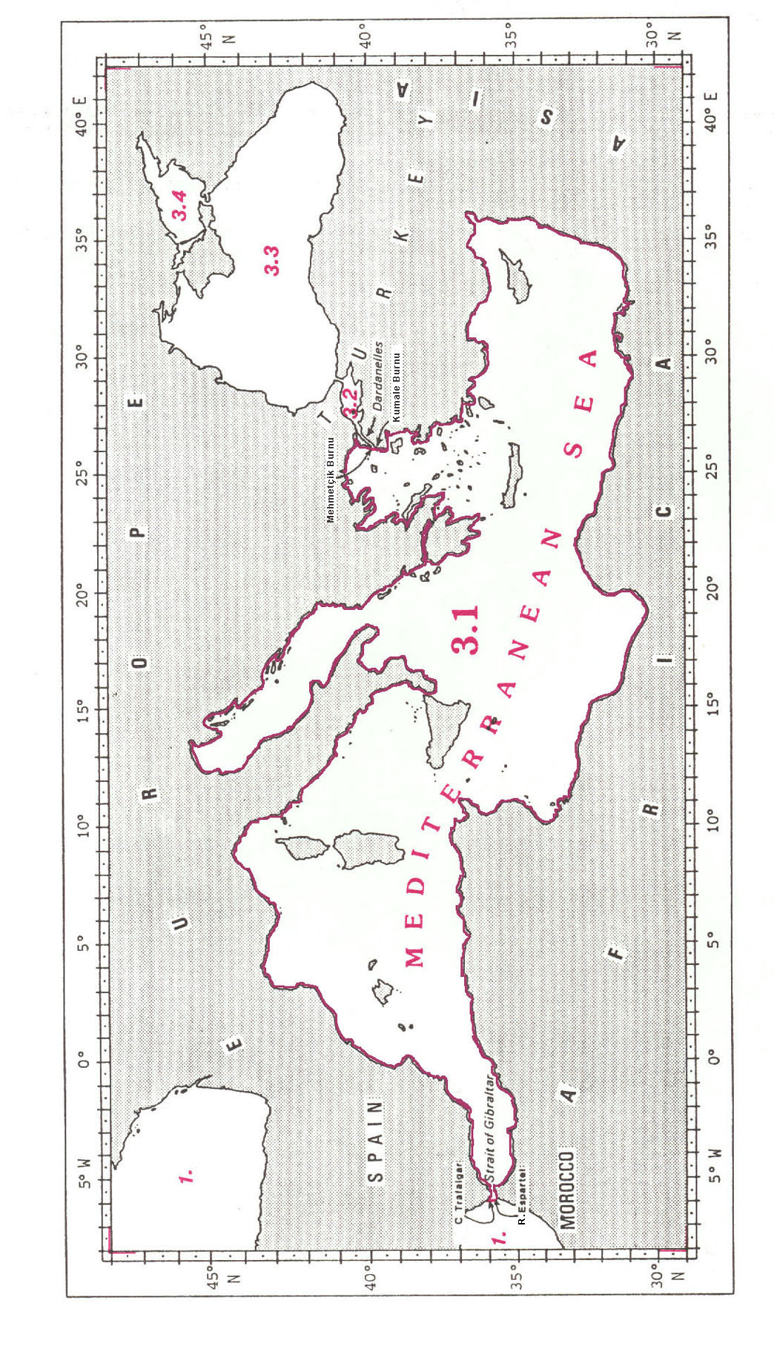
3.1 MEDITERRANEAN SEA

The Mediterranean Sea is an enclosed sea opening only, on the West, to the North Atlantic Ocean through the Strait of Gibraltar (see 3.1.1.1) and, on the Northeast, to the Sea of Marmara1 (see 3.2) through the Dardanelles2.

It is bounded by the coasts of Southern Europe, West Asia and North Africa.

The limit between the Mediterranean Sea and the North Atlantic Ocean (in the western entrance of the Strait of Gibraltar) is the following:

A line joining Cabo3 Trafalgar (36°11’N - 6°02’W), on the southern coast of Spain, southward to Ras4 Espartel (35°48’N - 5°55’W), on the northern coast of Morocco.

The limit between the Mediterranean Sea and the Sea of Marmara (in the western entrance of the Dardanelles, on the northwestern coast of Turkey) is the following:

A line joining Mehmetçik Burnu5 (40°03’N - 26°11’E) southward to Kumale Burnu (40°01’N - 26°12’E).

The Mediterranean Sea is divided into two deep basins:

the Western Basin (see 3.1.1)
the Eastern Basin (see 3.1.2)
MEDITERRANEAN SEA, WESTERN BASIN
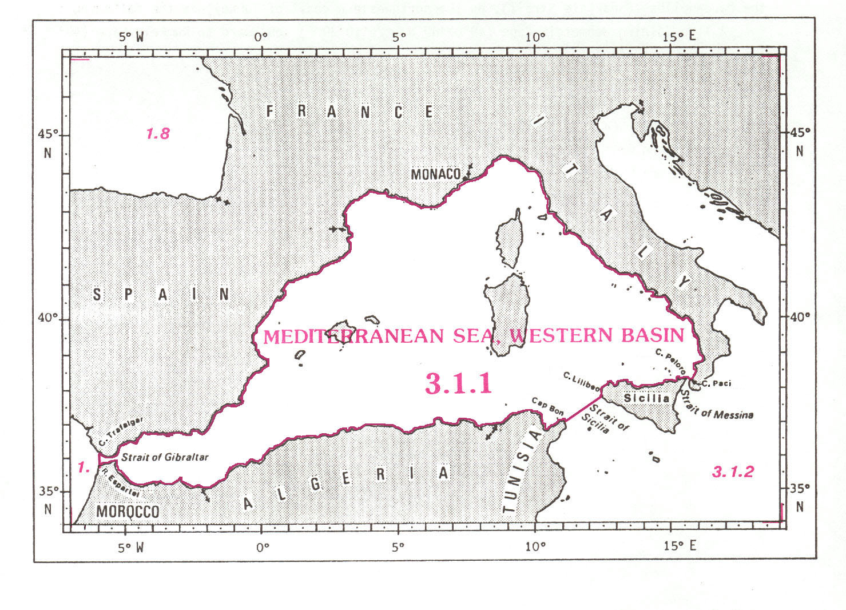
3.1.1 MEDITERRANEAN SEA, WESTERN BASIN

The limits of the Western Basin of the Mediterranean Sea, bounded by the coasts of Spain, Gibraltar, France, Monaco and Italy on the North and the East, and by the coasts of Tunisia, Algeria and Morocco on the South, are the following:

On the North and the East:
From Cabo1 Trafalgar (36°11’N - 6°02’W), on the southern coast of Spain, eastward, along the coasts of Spain, Gibraltar, France, Monaco and Italy, to Capo2 Paci (38°15’N - 15°42’E), on the southwestern coast of Italy.

On the Southeast:
A line joining Capo Paci westward to Capo Peloro (38°16’N - 15°39’E), the northeastern extremity of Sicily (the common limit with the Eastern Basin, in the Strait of Messina, see 3.1.2);
thence from Capo Peloro westward, along the northern coast of this island, to Capo Lilibeo (37°48’N - 12°26’E), the western extremity thereof;
and thence from Capo Lilibeo southwestward, a line to Cap3 Bon (37°05’N - 11°03’E), the northeastern extremity of Tunisia (the common limit with the Eastern Basin, in the Strait of Sicily, see 3.1.2).

On the South:
From Cap Bon westward, along the coasts of Tunisia, Algeria and Morocco, to Ras4 Espartel (35°48’N - 5°55’W), on the northern coast of Morocco.

On the West:
A line joining Ras Espartel northward to Cabo Trafalgar (36°11’N - 6°02’W), on the southern coast of Spain (the common limit with the North Atlantic Ocean, see 1.).
STRAIT OF GIBRALTAR and ALBORAN SEA

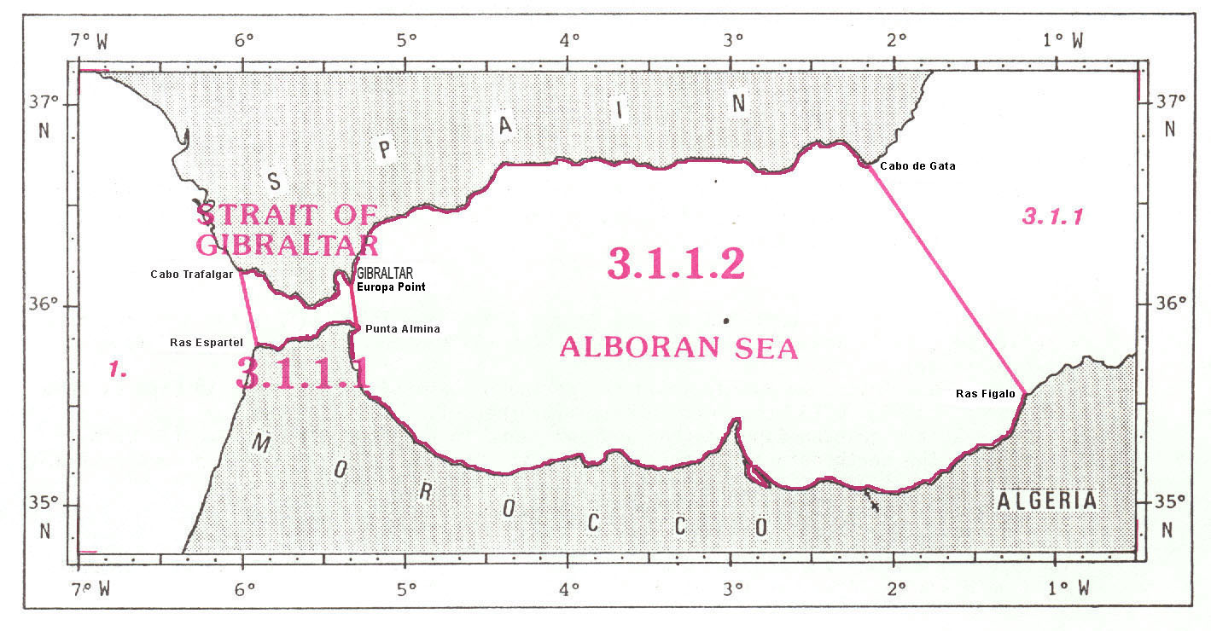

3.1.1.1 STRAIT OF GIBRALTAR

The limits of the Strait of Gibraltar, linking the North Atlantic Ocean and the Mediterranean Sea, and situated between the southern coast of Spain, Gibraltar and the northern coast of Morocco, are the following:

On the North:
From Cabo1 Trafalgar (36°11’N - 6°02’W) eastward, along the southern coast of Spain and Gibraltar, to Europa Point (36°07’N - 5°21’W).

On the East:
A line joining Europa Point southward to Punta2 Almina (35°54’N - 5°17’W), on the northern coast of Morocco.

On the South:
From Punta Almina westward, along the northern coast of Morocco, to Ras3 Espartel (35°48’N - 5°55’W).

On the West:
A line joining Ras Espartel northward to Cabo Trafalgar (36°11’N - 6°02’W), on the southern coast of Spain (the common limit with the North Atlantic Ocean, see 1.).

3.1.1.2 ALBORAN SEA

The limits of the Alboran Sea, situated between Gibraltar, the southern coast of Spain and the coasts of Algeria and Morocco, are the following:

On the North:
From Europa Point (36°07’N - 5°21’W) eastward, along the southern coast of Spain, to Cabo1 de Gata (36°43’N - 2°12’W).
On the East:
A line joining Cabo de Gata southeastward to Ras2 Figalo (35°35’N - 1°12’W), on the coast of Algeria.

On the South:
From Ras Figalo westward, along the coasts of Algeria and Morocco, to Punta3 Almina (35°54’N - 5°17’W), on the northern coast of Morocco.

On the West:
A line joining Punta Almina northward to Punta Europa (36°07’N - 5°21’W), on the southern coast of Spain (the common limit with the Strait of Gibraltar, see 3.1.1.1).

BALEARIC SEA

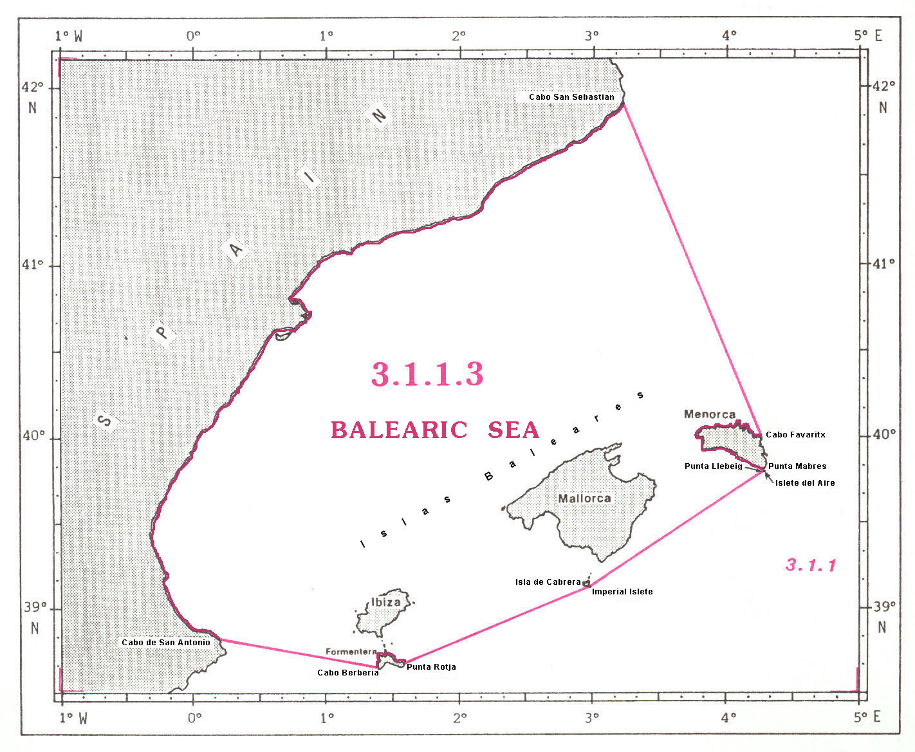

3.1.1.3 BALEARIC1 SEA

The limits of the Balearic Sea, situated between the eastern coast of Spain and the Islas2 Baleares, are the following:

On the West and the North:
From Cabo3 de San Antonio (38°48’N - 0°12’E) northeastward, along the eastern coast of Spain, to Cabo San Sebastian (41°53’N - 3°12’E).

On the East:
A line joining Cabo San Sebastian southeastward to Cabo Favaritx (40°00’N - 4°16’E), on the northeastern coast of Menorca;
thence from Cabo Favaritx southward, along the east coast of Menorca, to Punta4 Mabres (39°49’N - 4°17’E), on the southeastern coast of this island;
thence from Punta Mabres southward, a line to the eastern extremity of Islete5 del Aire (39°48’N - 4°18’E);
and thence from the eastern extremity of Islete del Aire westward, a line to Punta Llebeig (39°48’N - 4°17’E), the western extremity thereof.

On the South:
A line joining Punta Llebeig southwestward to Imperial Islete (39°08’N - 2°58’E), off the southeastern extremity of Isla de Cabrera;
thence from Imperial Islete southwestward, a line to Punta Rotja (38°39’N - 1°34’E), on the southeastern coast of Formentera;
thence from Punta Rotja westward, along the northern coast of this island, to Cabo Berberia (38°39’N - 1°23’E), the southwestern extremity thereof;
and thence from Cabo Berberia westward, a line to Cabo San Antonio (38°48’N - 0°12’E), on the eastern coast of Spain.

LIGURIAN SEA and TYRRHENIAN SEA

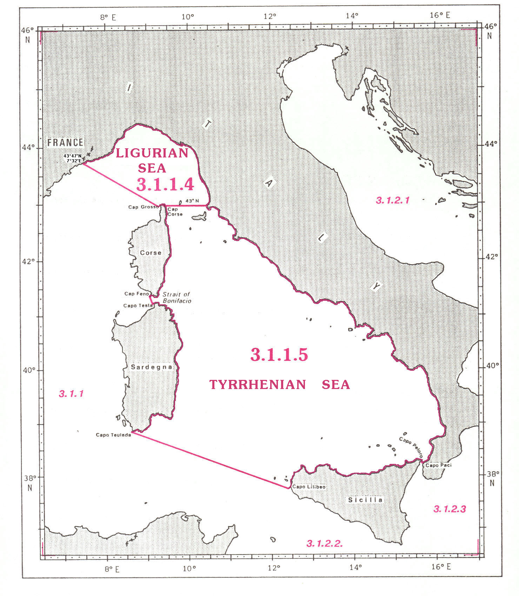
3.1.1.4 LIGURIAN1 SEA

The limits of the Ligurian Sea, situated between the northwestern coast of Italy and the northern extremity of Corse, are the following:

On the North and the East:
From the frontier between France and Italy (43°47’N - 7°32’E) eastward and southward, along the northwestern coast of Italy, to the parallel of 43°N.

On the South:
A line joining the coast of Italy westward, along the parallel of 43°N, to the northeastern coast of Cap2 Corse (43°N - 9°27’E), the northern part of Corse, in France (the common limit with the Tyrrhenian Sea, see 3.1.1.5);
and thence from the northeastern coast of Cap Corse westward, along the northern coast of this cape, to Cap Grosso (43°01’N - 9°22’E), the western extremity thereof.

On the West
A line joining Cap Grosso northwestward to the frontier between France and Italy (43°47’N - 7°32’E).

3.1.1.5 TYRRHENIAN3 SEA

The limits of the Tyrrhenian Sea, situated between the western coast of Italy, the northern coast of Sicily, in Italy, and the eastern coasts of Sardegna, in Italy, and Corse, in France,are the following :

On the North:
From the northeastern coast of Cap Corse (43°00’N - 9°27’E), the northern part of Corse, eastward, along the parallel of 43°N, to the coast of Italy (the common limit with the Ligurian Sea, see 3.1.1.4).

On the East:
From the parallel of 43°N, southeastward, along the western coast of Italy, to Capo4 Paci (38°15’N - 15°42’E).

On the South:
A line joining Capo Paci westward to Capo Peloro (38°16’N - 15°39’E), the northern extremity of Sicily (the common limit with the Ionian Sea, see 3.1.2.3).
thence from Capo Peloro westward, along the northern coast of Sicily, to Capo Lilibeo (37°48’N - 12°26’E), the western extremity of this island;
and thence from Capo Lilibeo northwestward, a line to Capo Teulada (38°52’N - 8°39’E), the southern extremity of Sardegna.

On the West:
From Capo Teulada northward, along the eastern coast of Sardegna, to the western extremity of Capo Testa (41°14’N - 9°08’E), on the northern coast of this island;
thence from the western extremity of Capo Testa northward, a line to the southwestern extremity of Capo Feno (41°23’N - 9°06’E), on the southern coast of Corse;
and thence from the southwestern extremity of Capo Feno northward, along the eastern coast of Corse, to the parallel of 43°N at position 43°00’N – 9°27’E.
MEDITERRANEAN SEA, EASTERN BASIN

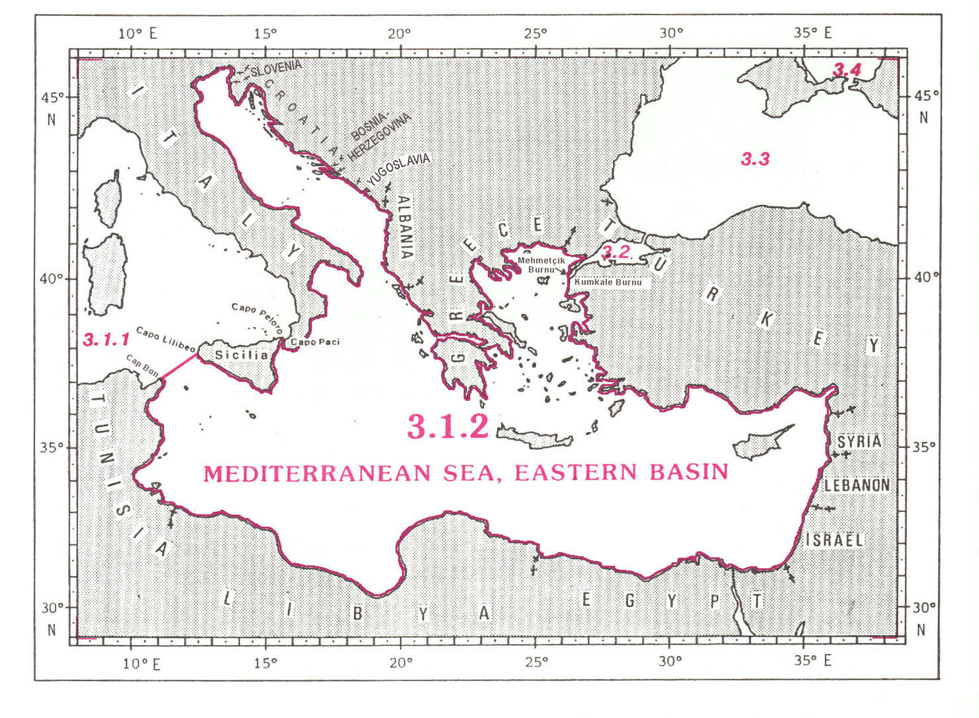

3.1.2 MEDITERRANEAN SEA, EASTERN BASIN

The limits of the Eastern Basin of the Mediterranean Sea, bounded by the coasts of Italy, Slovenia, Croatia, Bosnia-Herzegovina, Yugoslavia, Albania, Greece, Turkey, Syria, Lebanon, Israel, Egypt, Libya and Tunisia, are the following:

On the North, the East and the South:
From Capo1 Paci (38°15’N - 15°42’E), on the southwestern coast of Italy, northeastward, northwestward and southeastward, along the coasts of Italy, Slovenia, Croatia, Bosnia-Herzegovina, Yugoslavia, Albania, Greece and Turkey, to Mehmetçik Burnu2 (40°03’N - 26°11’E), on the northwestern coast of Turkey;
thence a line joining Mehmetçik Burnu southward, across the western entrance of the Dardanelle3, to Kumkale Burnu (40°01’N - 26°12’E) (the common limit with the Sea of Marmara4, see 3.2).
and thence from Kumkale Burnu, along the coasts of Turkey, Syria, Lebanon, Israel, Egypt, Libya and Tunisia, to Cap Bon5 (37°05’N - 11°03’E), the northeastern extremity of Tunisia.

On the West:
A line joining Cap Bon northeastward to Capo Lilibeo (37°48’N - 12°26’E), the western extremity of Sicily (the common limit with the Western Basin, in the Strait of Sicily, see 3.1.1);
thence from Capo Lilibeo eastward, along the southern and eastern coasts of Sicily, to Capo Peloro (38°16’N - 15°39’E), the northeastern extremity of this island;
and thence from Capo Peloro eastward, a line to Capo Paci (38°15’N - 15°42’E), on the southwestern coast of Italy (the common limit with the Western Basin, in the Strait of Messina, see 3.1.1).

ADRIATIC SEA and STRAIT OF SICILY

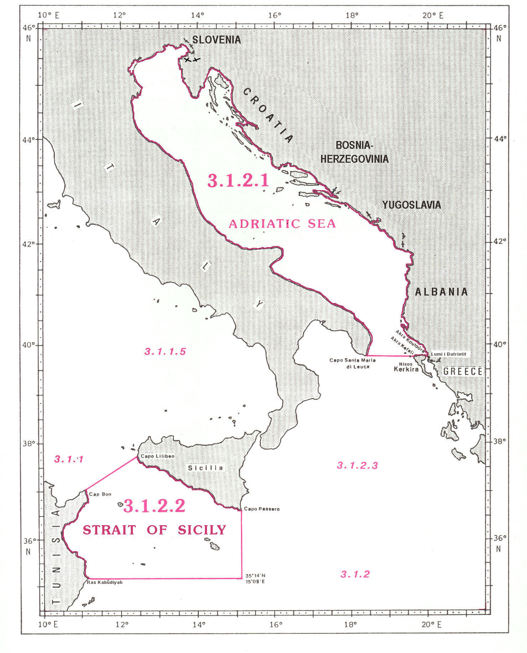
3.1.2.1 ADRIATIC SEA

The limits of the Adriatic Sea, situated in the northwestern part of the Eastern Basin, between the coasts of Italy, Yugoslavia and Albania, are the following:

On the West, the North and the East:
From Capo1 Santa Maria di Leuca (39°48’N - 18°22’), the southeastern extremity of Italy, northwestward and southeastward, along the eastern coast of Italy and the western coasts of Slovenia, Croatia, Bosnia-Herzegovina, Yugoslavia and Albania, to the mouth of Lumi2 i Butrintit (39°45’N - 19°59’E), on the coast of Albania.

On the South:
From the mouth of Lumi i Butrintit westward, a line to Akra3 Kouloúra (39°45'N – 19°57'E), on the northeastern coast of Nisos Kerkira4, in Greece;
thence from Akra Kouloúra westward, along the northern coast of Nisos Kerkira, to Akra Kefali (39°45'N – 19°38'E), the northwestern extremity of this island;
and thence from Akra Kefali westward ,a line to Capo Santa Maria di Leuca, in Italy.

3.1.2.2 STRAIT OF SICILY5

The limits of the Strait of Sicily, situated between the southern coast of Sicily, in Italy, and the eastern coast of Tunisia, are the following:

On the North:
A line joining Cap Bon6 (37°05’N - 11°03’E), the northeastern extremity of Tunisia, northeastward to Capo Lilibeo (37°48’N - 12°26’E), the western extremity of Sicily (the common limit with the Western Basin of the Mediterranean Sea, see 3.1.1);
and thence from Capo Lilibeo southeastward, along the southern coast of Sicily, to Capo Passero (36°41’N - 15°09’E), the southeastern extremity of this island.

On the East:
A line joining Capo Passero southward, along the meridian of 15°09’E, to position 35°14’N - 15°09’E, on the shelf.

On the South:
A line joining this position westward, along the parallel of 35°14’N, to Ras7 Kabúdiyah (35°14’N - 11°10’E), on the eastern coast of Tunisia.

On the West:
From Ras Kabúdiyah northward, along the eastern coast of Tunisia, to Cap Bon (37°05’N -11°03’E).
IONIAN SEA

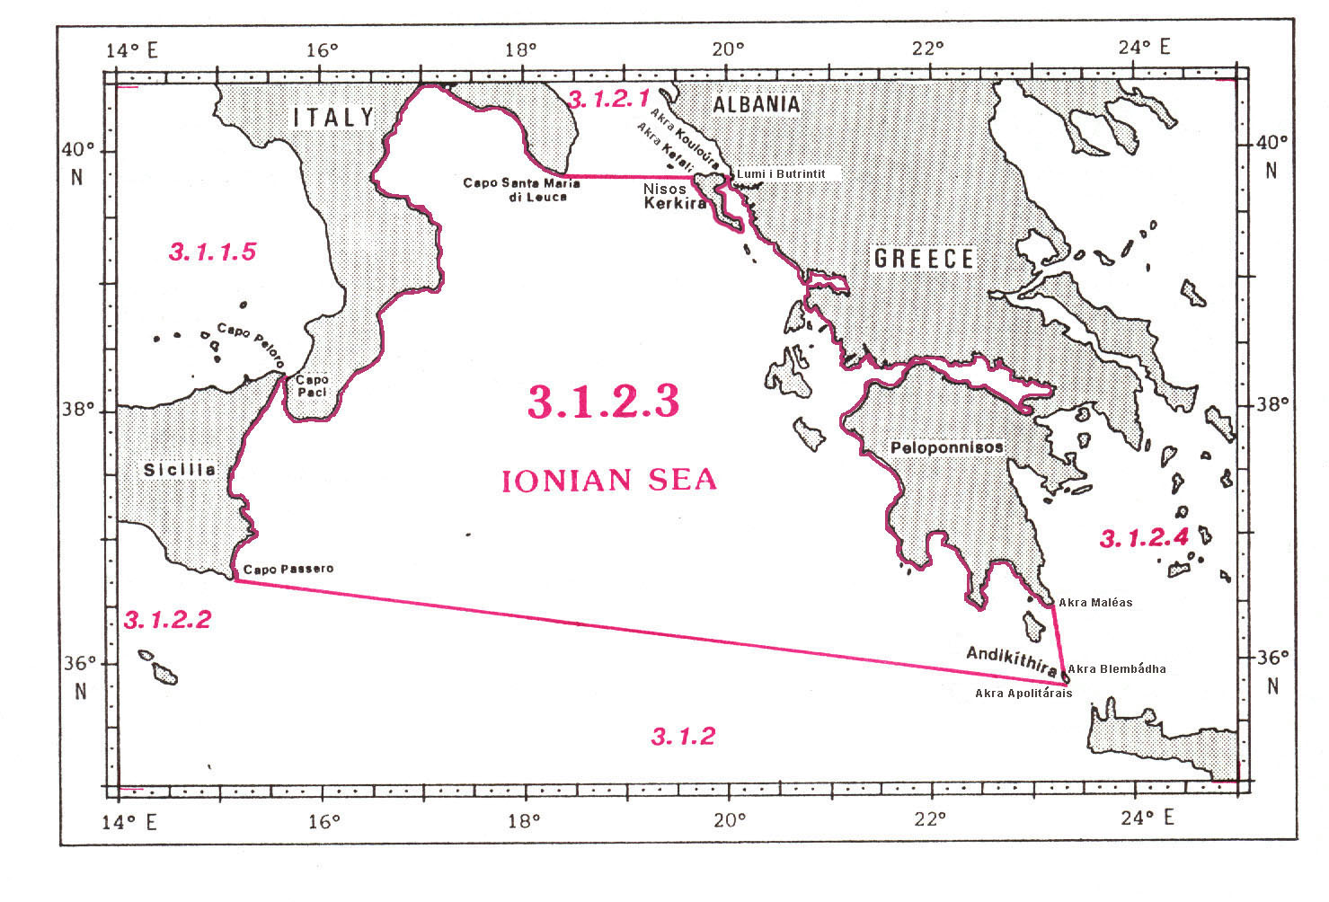

3.1.2.3 IONIAN SEA

The limits of the Ionian Sea, situated between the eastern coast of Sicily, in Italy, and the southern coast of Italy on the West, and the western coast of Greece on the East, are the following:

On the North:
A line joining Capo1 Santa Maria di Leuca (39°48’N - 18°22’E), the southeastern extremity of Italy, eastward to Akra2 Kefali (39°45’N - 19°38’E), the northwestern extremity of Nisos Kerkira3, in Greece;
thence from Akra Kefali southeastward and northward, along the western and eastern coasts of Nisos Kerkira, to Akra Kouloúra (39°45’N - 19°57’E), on the northeastern coast of this island;
and thence from Akra Kouloúra eastward, a line to the mouth of Lumi4 i Butrintit (39°45’N - 19°59’E), on the coast of Albania (the common limit with the Adriatic Sea, see 3.1.2.1).

On the East:
From the mouth of Lumi i Butrintit southeastward, along the coasts of Albania and Greece, to Akra Maléas (36°26’N - 23°12’E), the southeastern extremity of Peloponnisos;
thence from Akra Maléas southward, a line to Akra Blembádha (35°53’N - 23°19’E), the northeastern extremity of Andikythira;
and thence from Akra Blembádha southward, along the western coast of Andikythira, to Akra Apolitárais (35°50’N - 23°20’E), the southern extremity of this island (the common limit with the Aegean Sea, see 3.1.2.4).

On the South:
A line joining Akra Apolitárais westward to Capo Passero (36°40’N - 15°08’E), the southeastern extremity of Sicily.

On the West:
From Capo Passero northward, along the eastern coast of Sicily, to Capo Peloro (38°16’N - 15°39’E), the northeastern extremity of this island;
thence a line joining Capo Peloro eastward to Capo Paci (38°15’N - 15°42’E), on the southwestern coast of Italy (the common limit with the Tyrrhenian Sea, see 3.1.1.5);
and thence from Capo Paci northeastward, along the southern coast of Italy, to Capo Santa Maria di Leuca (39°48’N - 18°22’E), the southeastern extremity thereof.
AEGEAN SEA

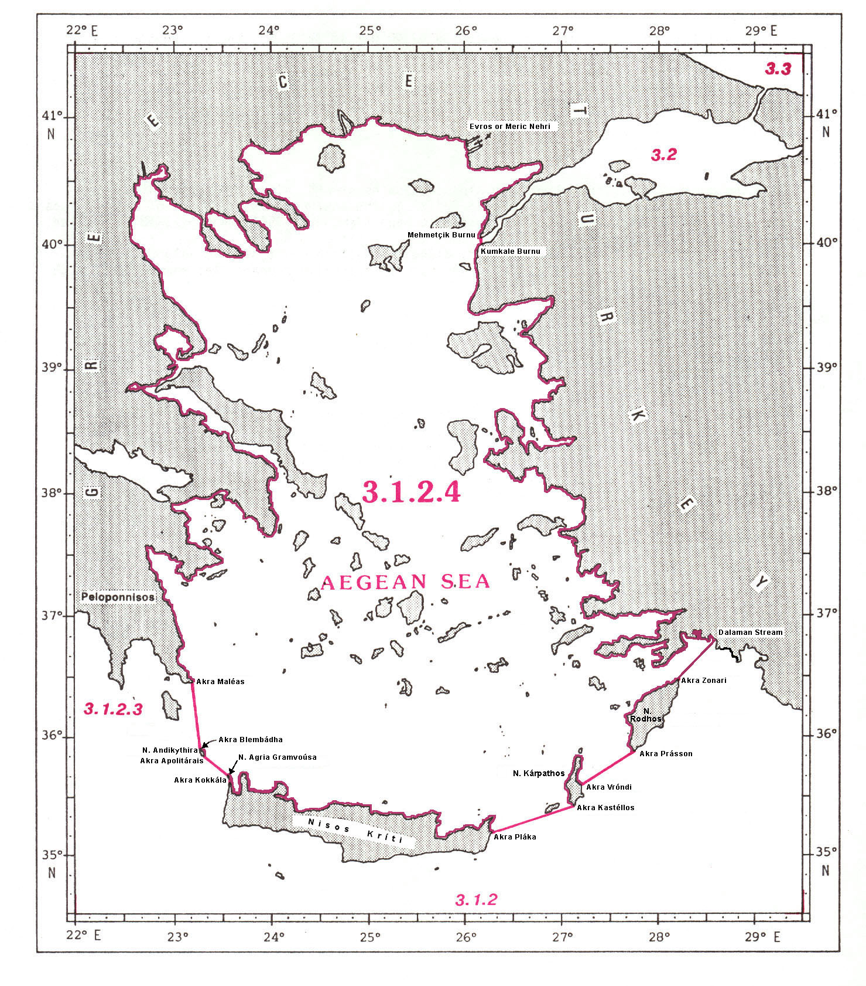
3.1.2.4 AEGEAN SEA

The limits of the Aegean Sea, situated between the coasts of Greece and Turkey, are the following:

On the West and the North:
From Akra1 Maléas (36°26’N - 23°12’E), the southeastern extremity of Peloponnisos, northward and eastward, along the coast of Greece, to the mouth of Évros or Meric Nehri2 (40°44’N - 26°02’E), the frontier between Greece and Turkey.

On the East:
From the mouth of Évros or Meric Nehri southward, along the coast of Turkey, to Mehmetçik Burnu3 (40°03’N - 26°11’E);
thence a line joining Mehmetçik Burnu, across the western entrance of the Dardanelles4, to Kumkale Burnu (40°01’N - 26°12’E) (the common limit with the Sea of Marmara5, see 3.2);
and thence from Kumkale Burnu southward, along the western coast of Turkey, to the mouth of Dalaman Stream (36°42’N - 28°44’E).

On the South:
A line joining the mouth of Dalaman Stream, on the southwestern coast of Turkey, southward to Akra Zonari (36°28’N - 28°13’E), the northern extremity of Nisos6 Rodhos, in Greece;
thence from Akra Zonari southwestward, along the western coast of Nisos Rodhos, to Akra Prásson (35°53’N - 27°45’E), the southern extremity of this island;
thence from Akra Prásson southwestward, a line to Akra Vróndi (35°33’N - 27°13’E), on the eastern coast of Nisos Kárpathos;
thence from Akra Vróndi southward, along the eastern coast of Nisos Kárpathos, to Akra Kastéllos (35°24’N - 27°08’E), the southern extremity of this island;
thence from Akra Kastéllos southwestward, a line to Akra Pláka (35°12’N - 26°19’E), on the eastern coast of Nisos Kríti;
thence from Akra Pláka westward, along the northern coast of Nisos Kríti, to Akra Kokkála (35°39’N - 23°35’E), the northern extremity of Nisos Ágria Gramvoúsa, off the northwestern extremity of Nisos Kríti;
thence from Akra Kokkála northwestward, a line to Akra Apolitárais (35°50’N - 23°20’E), the southern extremity of Nisos Andikythira;
thence from Akra Apolitárais northward, along the eastern coast of Nisos Andikythira, to Akra Blembádha (35°53’N - 23°19’E), the northeastern extremity of this island;
and thence from Akra Blembádha northward, a line to Akra Maléas (36°26’N - 23°12’E), the southeastern extremity of Peloponnisos (the common limit with the Ionian Sea, see 3.1.2.3).
SEA OF MARMARA

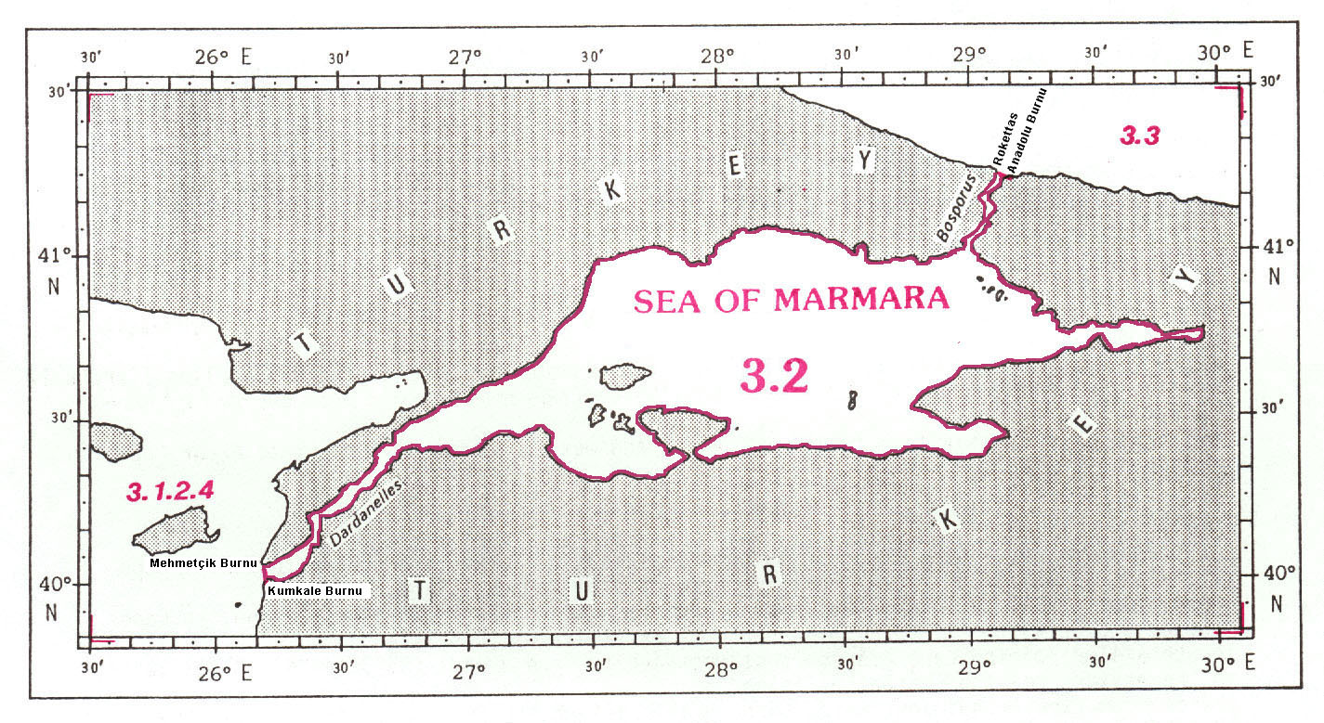

BLACK SEA and SEA OF AZOV

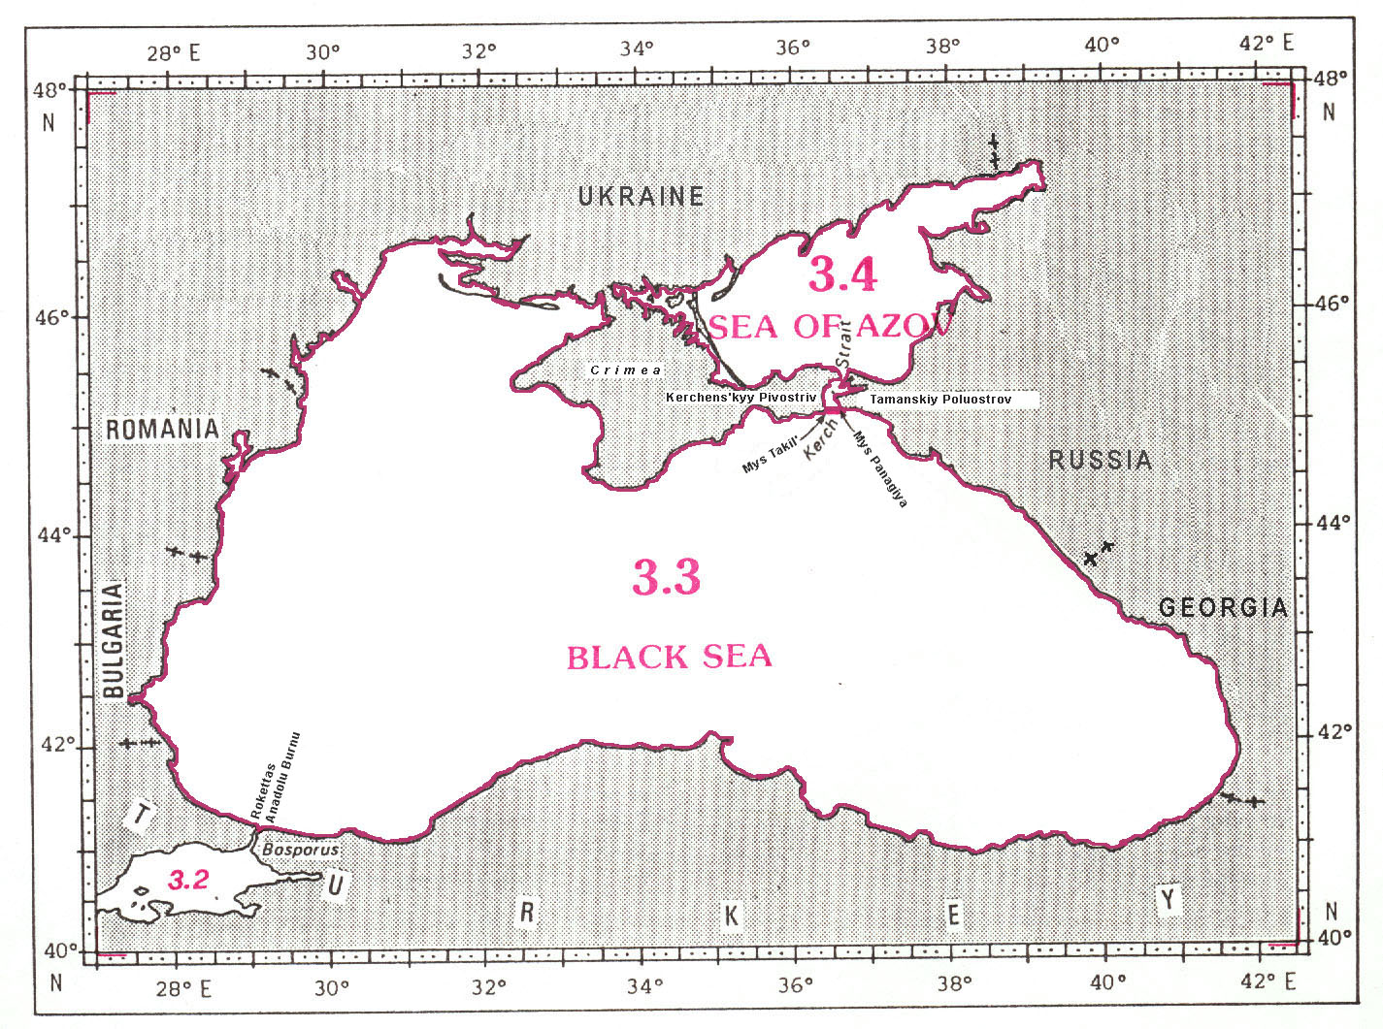
3.2 SEA OF MARMARA1

The Sea of Marmara is a small enclosed sea situated in the northwestern part of Turkey. It is connected through the Bosporus2 with the Black Sea on the Northeast, and through the Dardanelles3 with the Aegean Sea on the Southwest.

The common limit between the Sea of Marmara and the Black Sea, in the northern entrance of the Bosporus, is the following:

A line joining Rokettas (41°14’N - 29°07’E) southeastward to Anadolu Burnu4 (41°13’N - 29°09’E).

The common limit between the Sea of Marmara and the Aegean Sea, in the western entrance of the Dardanelles, is the following:

A line joining Mehmetçik Burnu (40°03’N - 26°11’E) southward to Kumkale Burnu (40°01’N - 26°12’E).

3.3 BLACK SEA

The Black Sea is an enclosed sea situated in the northeastern part of the Mediterranean Region and bounded by the coasts of Bulgaria, Romania, Russia Ukraine, Georgia and Turkey. It is connected through the Kerch Strait with the Sea of Azov on the North, and through the Bosporus with the Sea of Marmara on the Southwest.

The common limit between the Black Sea and the Sea of Azov, in the southern entrance of the Kerch Strait, is the following:

A line joining Mys5 Takil’ (45°06’N - 36°27’E), the southeastern extremity of Kerchens’kyy6 Pivostriv7 eastward to Mys Panagiya (45°08’N - 36°38’E), the southwestern extremity of Tamanskiy Poluostrov8.

The common limit between the Black Sea and the Sea of Marmara, in the northern entrance of the Bosporus, is the following:

A line joining Rokettas (41°14’N - 29°07’E) southeastward to Anadolu Burnu (41°13’N - 29°09’E).

3.4 SEA OF AZOV

The Sea of Azov, lying Northeast of the Black Sea and bounded by the coasts of Russia and Ukraine, is a shallow enclosed sea connected only with the Black Sea through the Kerch Strait on the South.

The common limit between the Sea of Azov and the Black Sea, in the southern entrance of the Kerch Strait, is the following:

A line joining Mys Takil’ (45°06’N - 36°27’E), the southeastern extremity of Kerchens’kyy Pivostriv, eastward to Mys Panagiya (45°08’N - 36°38’E), the southwestern extremity of Tamanskiy Poluostrov.

__________

Page intentionally left blank

1 Marmara Denizi (Turkish)
2 Cabo (Spanish) = Cape
3 Ras (Arabic) = Cape
1 Marma Denizi (Turkish)
2 Çanakkale Bogazi (Turkish)
3 Cabo (Spanish) = Cape
4 Ras (Arabic) = Cape
5 Burnu (Turkish) = Cape
1 Cabo (Spanish) = Cape
2 Capo (Italian) = Cape
3 Cap (French) = Cape
4 Ras (Arabic) = Cape
1 Cabo (Spanish) = Cape
2 Punta (Spanish)= Point
3 Ras (Arabic) = Point
1 Cabo (Spanish) = Cape
2 Ras (Arabic) = Cape
3 Punta (Spanish) = Point
1 International usage prefers Balearic Sea. Spanish name is "Mar Balear"
2 Islas (Spanish) = Islands
3 Cabo (Spanish) = Cape
4 Punta (Spanish) = Point
5 Islete (Spanish) = Islet
1 International usage prefers Ligurian Sea. Italian name is "Mar Ligure"
2 Cap (French) = Cape
3 International usage prefers Tyrrhenian Sea. Italian name is "Mar Tirreno"
4 Capo (Italian) = Cape
1 Capo (Italian) = Cape
2 Burnu (Turkish) = Point
3 Çanakkale Bogazi (Turkish)
4 Marmara Bogazi (Turkish)
5 Also known as Ras' at Tib (Arabic)
1 Capo (Italian) = Cape
2 Lumi (Albanian) = River
3 Akra (Greek) = Cape
4 Also known as Corfú
5 International usage prefers Strait of Sicily. Italian name is "Stretto di Sicilia"
6 Also known as Ras' at Tib (Arabic)
7 Ras (Arabic) = Cape
1 Capo (Italian) = Cape
2 Akra (Greek) = Cape
3 Also known as Corfú
4 Lumi (Albanian) = River
1 Akra (Greek) = Cape
2 Nehri (Turkish) = River
3 Burnu (Turkish) = Cape
4 Çanakkale Bogazi (Turkish)
5 Marmara Bogazi (Turkish)
6 Nisos (Greek) = Island
Marmara Denizi (Turkish)
1 Marmara Denizi (Turkish)
2 Istanbul Bogazi (Turkish)
3 Çanakkale Bogazi (Turkish)
4 Burnu (Turkish) = Cape
5 Mys (Russian) = Cape
6 Kerchen'kyy (Ukrainian) = Crimea
7 Pivostriv (Ukrainian) = Peninsula
8 Poluostrov (Russian) = Peninsula

