INTERNATIONAL HYDROGRAPHIC  ORGANIZATION | INTERGOVERNMENTAL OCEANOGRAPHIC  COMMISSION (of UNESCO)

UNDERSEA FEATURE NAME PROPOSAL
(Sea NOTE overleaf)

Note: The boxes will expand as you fill the form.
Name Proposed: | Konotori Fracture Zone | Ocean or Sea: | Northwest Pacific Ocean

Geometry that best defines the feature (Yes/No) :
Point | Line | Polygon | Multiple points | Multiple lines* | Multiple polygons* | Combination of geometries*
 | Yes
* Geometry should be clearly distinguished when providing the coordinates below.
 | Lat. (e.g. 63°32.6’N) | Long. (e.g. 046°21.3’W)
Coordinates: | 19°43.26’N  19°18.63’N  18°35.45’N  17°59.40’N  17°32.27’N | 139°50.33’E  139°33.91’E  139°20.71’E  139°02.86’E  138°42.51’E

Feature Description: | Maximum Depth : |  | Steepness :
Feature Description: | Minimum Depth : |  | Shape :
Feature Description: | Total Relief : |  | Dimension/Size : | 233 km×148 km

Associated Features: | The Konotori Fracture Zone is within the Parece Vela Fracture Zone Province.

Chart/Map References: | Shown Named on Map/Chart: | #6722
Chart/Map References: | Shown Unnamed on Map/Chart:
Chart/Map References: | Within Area of Map/Chart:

Reason for Choice of Name (if a person, state how associated with the feature to be named): | The fracture zones within the Parece Vela Fracture Zone Province have names after bird. “Konotori” is the Japanese for a stork. A bird is relevant to the name of the nearby Oki-no-Tori Shima Island, which includes a “bird” (= “tori”) within its name.

Discovery Facts: | Discovery Date: | Various surveys from October 1993 to July 2004
Discovery Facts: | Discoverer (Individual, Ship): | The Japanese survey vessels “Takuyo” and “Shoyo”

Supporting Survey Data, including Track Controls: | Date of Survey: | Oct., Nov. 1993  Oct., Nov. 1994  Jan., April, Sep.-Dec., 1995  April-July 2004
Supporting Survey Data, including Track Controls: | Survey Ship: | S/V Takuyo (1993, 1994, 1995, 2004)  S/V Shoyo (2004)
Supporting Survey Data, including Track Controls: | Sounding Equipement: | Multibeam echo sounder  SeaBeam (1993, 1994)  SeBeam 210 (1995)  SeaBeam 2112 (2004)
Supporting Survey Data, including Track Controls: | Type of Navigation: | GPS with Selective Availability (1993, 1994, 1995)  GPS without Selective Availability (after 2004)
Supporting Survey Data, including Track Controls: | Estimated Horizontal Accuracy (nm): | 0.054 nm (100 m) (1993, 1994, 1995)  0.014 nm (26 m) (2004)
Supporting Survey Data, including Track Controls: | Survey Track Spacing: | 6 nm
Supporting Survey Data, including Track Controls: | Supporting material can be submitted as Annex in analog or digital form.

Proposer(s): | Name(s): | JCUFN
Proposer(s): | Date: | Sep. 10, 2015
Proposer(s): | E-mail: | ico@jodc.go.jp
Proposer(s): | Organization and Address: | Hydrographic and Oceanographic Department, Japan Coast Guard  Aomi 2-5-18,Koto-ku, Tokyo 135-0064, Japan
Proposer(s): | Concurrer (name, e-mail, organization and address):

Remarks: | - “Parece Vela Fracture Zone Province” was accredited by SCUFN-24 at Beijing.  - Raicho, Tancho and Toki Fracture Zones were accredited by SCUFN-24 at Beijing.  - Inuwashi, Ojirowashi, Owashi and Kokugan Fracuture Zones were accredited by SCUFN-25 at Wellington.  - Relevant paper is:  Ohara et al., 2011, Tectonics of unusual crustal accretion in the Parece Vela Basin, in Y. Ogawa et al. (eds), Accretionary prisms and convergent margin tectonics in the Northwest Pacific Basin, Modern Approaches in Solid Earth Sciences, 8, Springer, doi: 10.1007/978-90-481-8885-7_7.

NOTE : This form should be forwarded, when completed :

a) If the undersea feature is located inside the external limit of the territorial sea :-
to your "National Authority for Approval of Undersea Feature Names" (see page 2-9) or, if this does not exist or is not known, either to the IHB or to the IOC (see addresses below);

b) If at least 50 % of the undersea feature is located outside the external limits of the territorial sea :-
to the IHB or to the IOC, at the following addresses :

International Hydrographic Bureau (IHB)  4, Quai Antoine 1er  B.P. 445  MC 98011 MONACO CEDEX  Principality of MONACO  Fax: +377 93 10 81 40  E-mail: info@ihb.mc | Intergovernmental Oceanographic Commission (IOC)  UNESCO  Place de Fontenoy  75700 PARIS  France  Fax: +33 1 45 68 58 12  E-mail: info@unesco.org

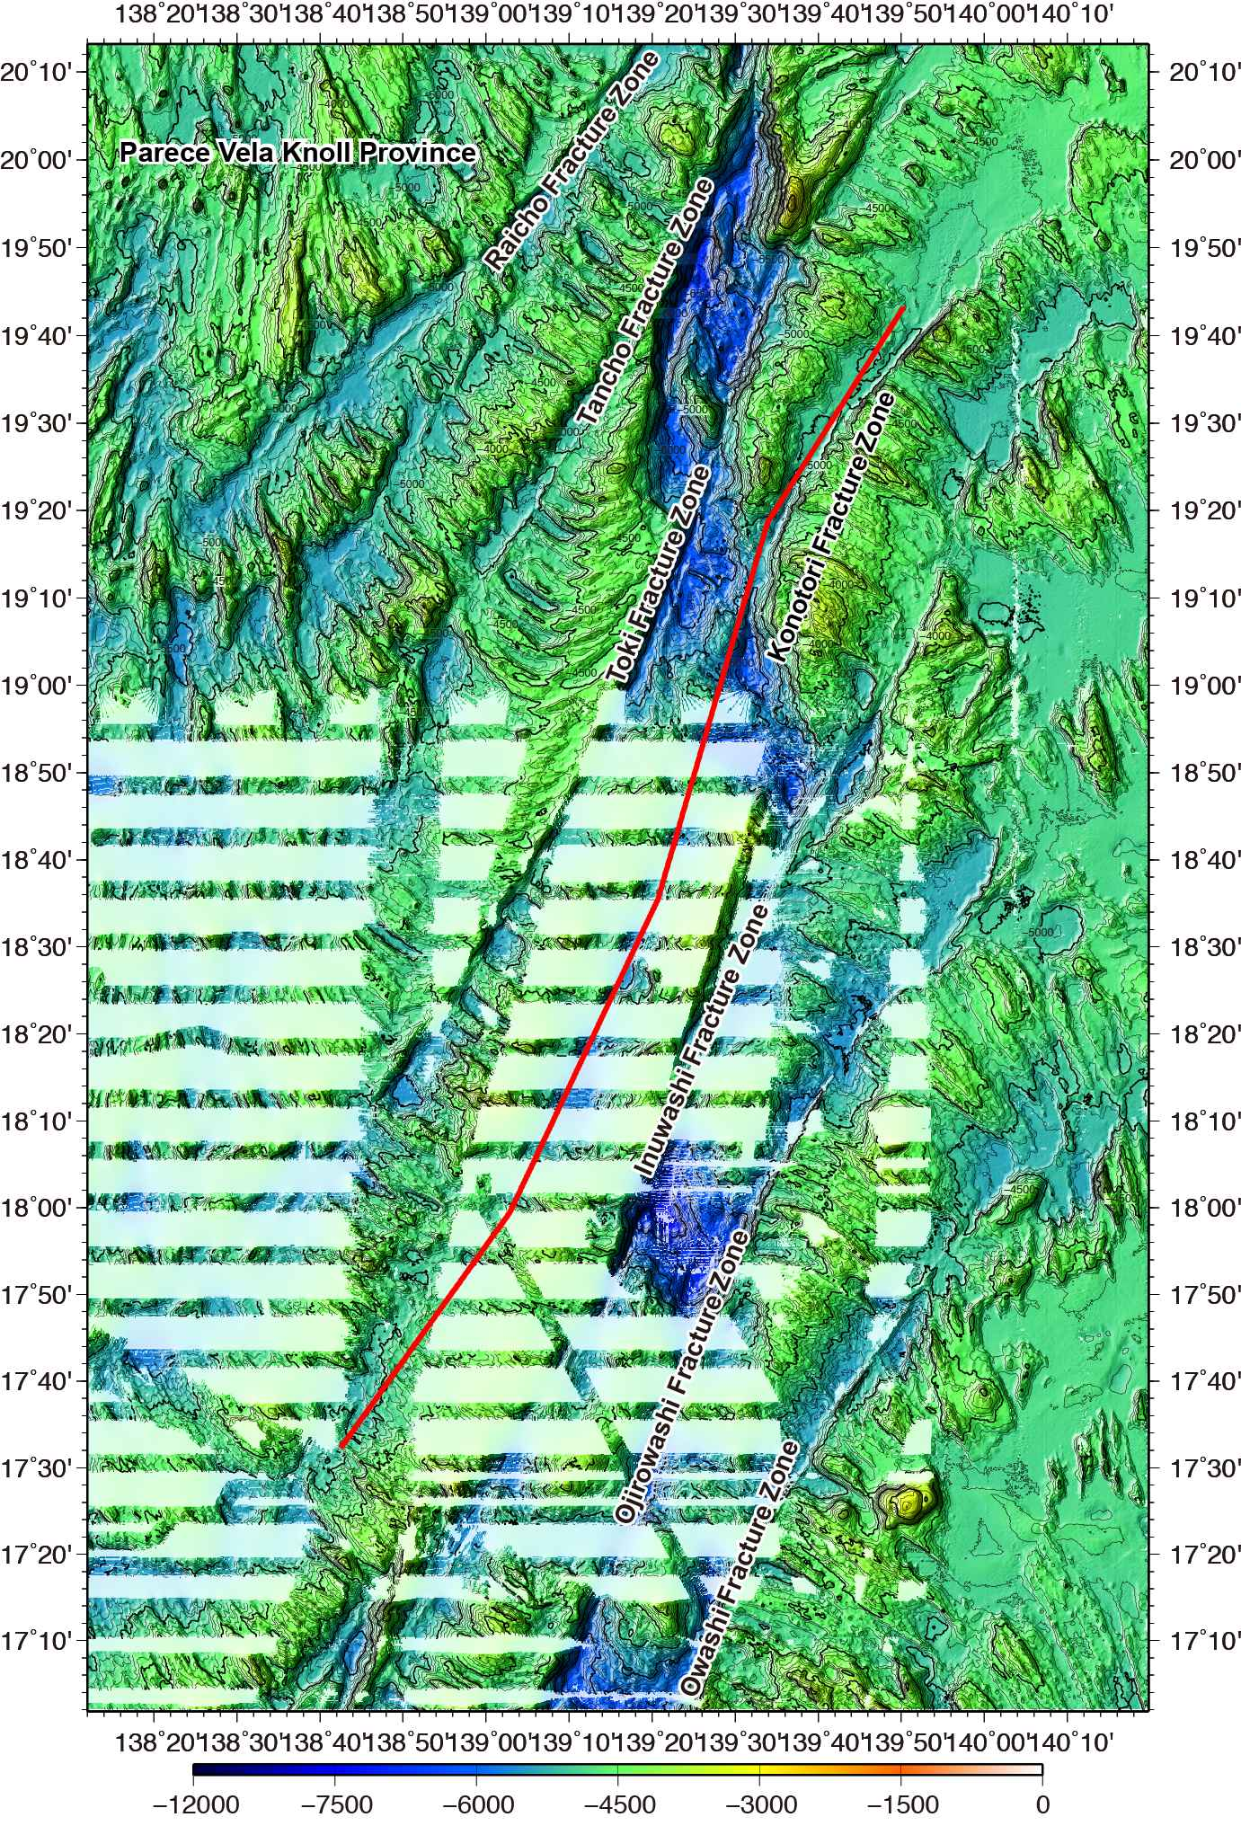

Fig. 1. Bathymetric map of the Konotori Fracture Zone. Contours are in 100 m.
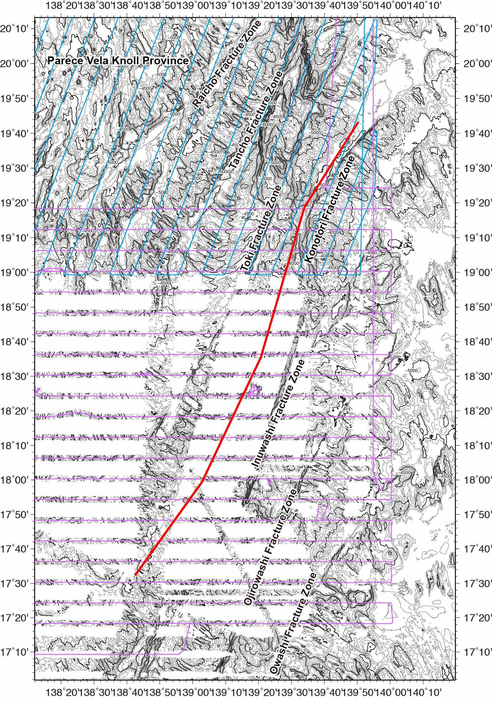

Fig. 2. Bathymetric map of the Konotori Fracture Zone, showing with track lines. Contours are in 100 m.

