INTERNATIONAL HYDROGRAPHIC  ORGANIZATION | INTERGOVERNMENTAL OCEANOGRAPHIC  COMMISSION (of UNESCO)

UNDERSEA FEATURE NAME PROPOSAL
(Sea NOTE overleaf)

Note: The boxes will expand as you fill the form.
Name Proposed: | Matsuzaki Guyot | Ocean or Sea: | Northwest Pacific Ocean

Geometry that best defines the feature (Yes/No) :
Point | Line | Polygon | Multiple points | Multiple lines* | Multiple polygons* | Combination of geometries*
 |  | Yes
* Geometry should be clearly distinguished when providing the coordinates below.
 | Lat. (e.g. 63°32.6’N) | Long. (e.g. 046°21.3’W)
Coordinates: | 19°14.54'N (summit 1)  18°50.81’N  18°59.98’N  19°10.26’N  19°20.36’N  19°32.18’N  19°43.66’N  19°45.55’N  19°39.89’N  19°35.01’N  19°27.47’N  19°13.94’N  19°09.14’N  18°50.12’N  18°44.39’N  18°44.73’N  18°50.81’N | 152°39.22'E (summit 1)  152°23.62’E  152°17.97’E  152°12.57’E  152°11.89’E  152°16.08’E  152°27.22’E  152°38.61’E  152°59.68’E  153°01.74’E  153°02.43’E  153°06.28’E  153°02.17’E  153°00.28’E  152°52.40’E  152°34.41’E  152°23.62’E

Feature Description: | Maximum Depth : | 5908 m | Steepness :
Feature Description: | Minimum Depth : | 1272 m | Shape :
Feature Description: | Total Relief : | 4636 m | Dimension/Size : | 81 km×93 km

Associated Features:

Chart/Map References: | Shown Named on Map/Chart:
Chart/Map References: | Shown Unnamed on Map/Chart:
Chart/Map References: | Within Area of Map/Chart:

Reason for Choice of Name (if a person, state how associated with the feature to be named): | The guyot is named after a chief hydrographer of Japan late Dr. Takuichi Matsuzaki. See CV for details.

Discovery Facts: | Discovery Date: | Jan. and Feb. 2000
Discovery Facts: | Discoverer (Individual, Ship): | The Japanese survey vessel “Takuyo”

Supporting Survey Data, including Track Controls: | Date of Survey: | Jan. 2002
Supporting Survey Data, including Track Controls: | Survey Ship: | The Japanese survey vessel “Takuyo”
Supporting Survey Data, including Track Controls: | Sounding Equipement: | Multibeam echo sounder  Seabeam 2112
Supporting Survey Data, including Track Controls: | Type of Navigation: | GPS without Selective Availability
Supporting Survey Data, including Track Controls: | Estimated Horizontal Accuracy (nm): | 0.014 nm (26 m)
Supporting Survey Data, including Track Controls: | Survey Track Spacing: | 3 nm
Supporting Survey Data, including Track Controls: | Supporting material can be submitted as Annex in analog or digital form.

Proposer(s): | Name(s): | JCUFN
Proposer(s): | Date: | Sep. 10, 2015
Proposer(s): | E-mail: | ico@jodc.go.jp
Proposer(s): | Organization and Address: | Hydrographic and Oceanographic Department, Japan Coast Guard  Aomi 2-5-18,Koto-ku, Tokyo 135-0064, Japan
Proposer(s): | Concurrer (name, e-mail, organization and address):

Remarks:

NOTE : This form should be forwarded, when completed :

a) If the undersea feature is located inside the external limit of the territorial sea :-
to your "National Authority for Approval of Undersea Feature Names" (see page 2-9) or, if this does not exist or is not known, either to the IHB or to the IOC (see addresses below);

b) If at least 50 % of the undersea feature is located outside the external limits of the territorial sea :-
to the IHB or to the IOC, at the following addresses :

International Hydrographic Bureau (IHB)  4, Quai Antoine 1er  B.P. 445  MC 98011 MONACO CEDEX  Principality of MONACO  Fax: +377 93 10 81 40  E-mail: info@ihb.mc | Intergovernmental Oceanographic Commission (IOC)  UNESCO  Place de Fontenoy  75700 PARIS  France  Fax: +33 1 45 68 58 12  E-mail: info@unesco.org

Personal history of late Dr. Takuichi Matsuzaki

Given name: Takuichi
Family name: Matsuzaki

1908 Born
2005 Diseased

Education
1934 B.S., Kyoto Imperial University
1965 PhD, Tohoku Univeristy

Professional carrier:
1936 Joined the Hydrographic Department of Japan
1963-1969 Chief Hydrographer of Japan
1964-1966 Chair, GEBCO Sub-Committee on Proper Geographical Names for Ocean Bottom Features

Remarks:
He was an oceanographer and geophysicist working for the Hydrographic Departmetn of Japan. He became the Chief Hydrographer since 1963 until 1969. During that period, he was the chair of the GEBCO Sub-Committee on Proper Geographical Names for Ocean Bottom Features. The sub-committee was consisted of T. Matsuzaki, A.J. Guilcher (France), L.N. Pascoe (UK), H.B. Stewart (USA), G. Udintsev (USSR), and A. Viglieri (UHB). He also played a major role in establishing the East Asia Hydrographic Commission. The inaugural meeting was held in Tokyo, chaired by Dr. Matsuzaki during October 7 to 9, 1968.

List of selected publications:
Matsuzaki, T., and Utashiro, S., Airborne and shipboard magnetic surveys in the Western Pacific Ocean and Sea of Japan, in Knopoff, L. et al. eds., The crust and upper mantle of the Pacific Area, Geophysical Monograph, AGU, vol. 12, pp. 198-211, AGU, Washington, D.C., 1968.
Matsuzaki, T., Magnetic anomalies over and around the Japan Trench off Sanriku and the Yamoto Bank in the Japan Sea, Report of Hydrographic Researches, 1, 1-26, 1966. (in Japanese with English abstract)
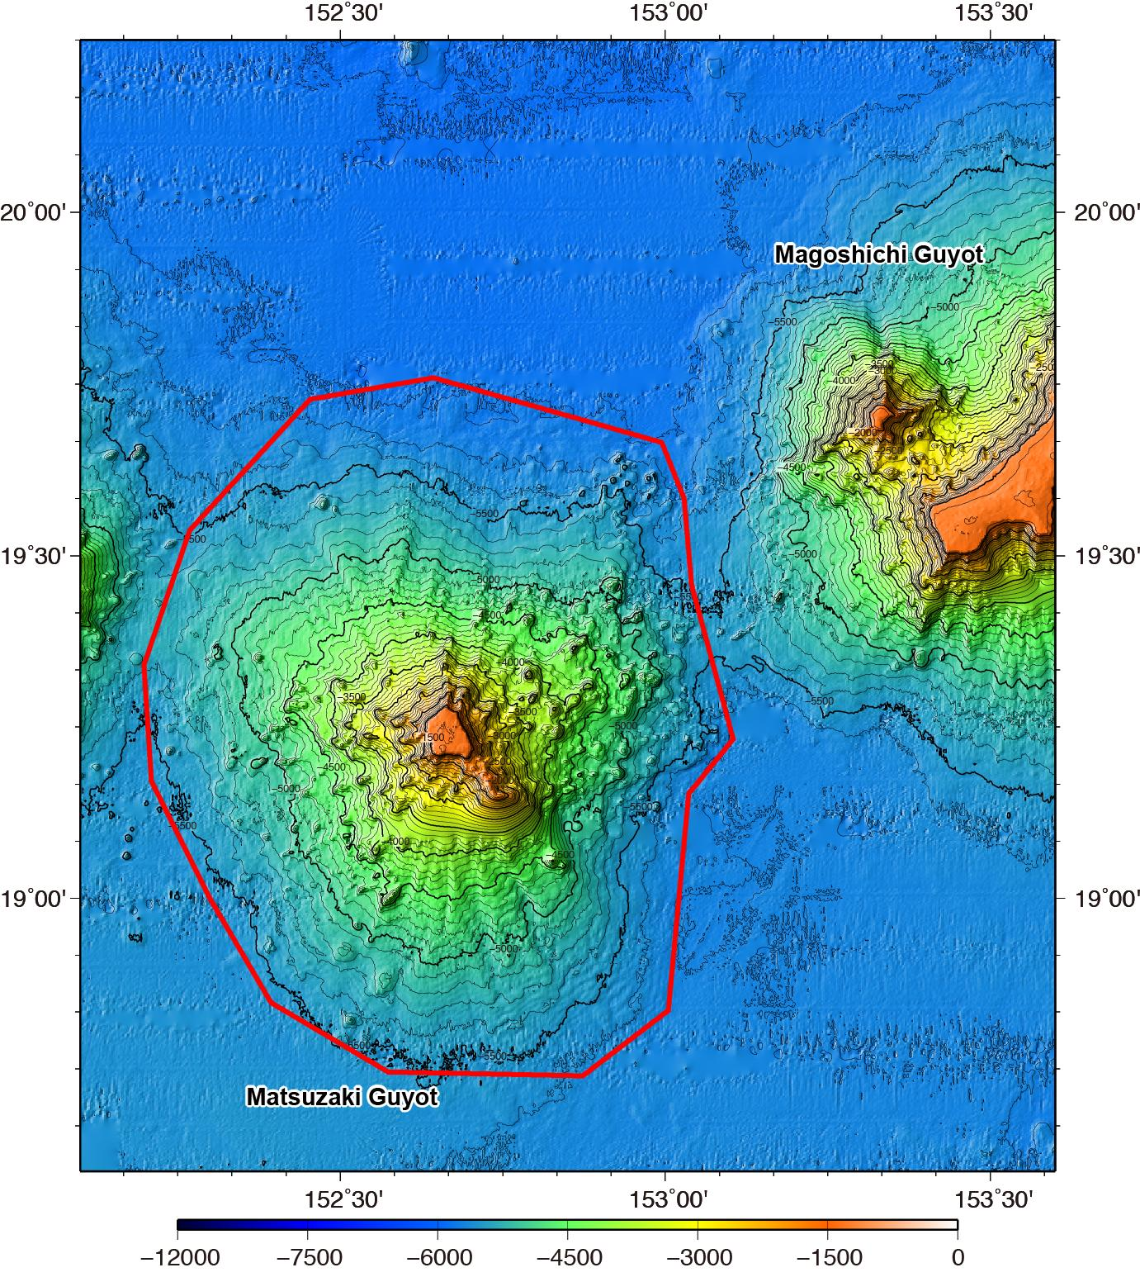

Fig. 1. Bathymetric map of the Matsuzaki Guyot. Contours are in 100 m.

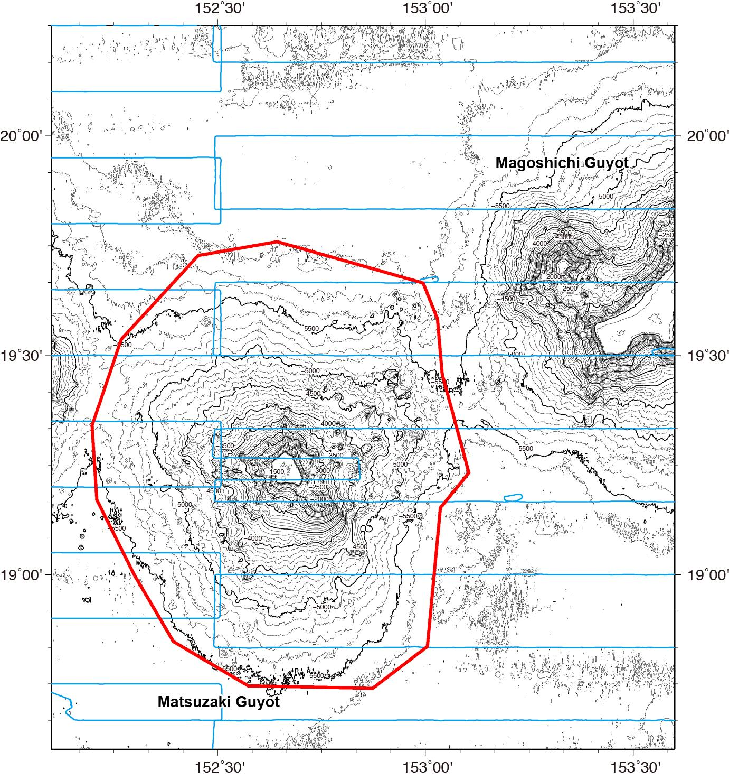

Fig. 2. Bathymetric map of the Matsuzaki Guyot, showing with track lines. Contours are in 100 m.
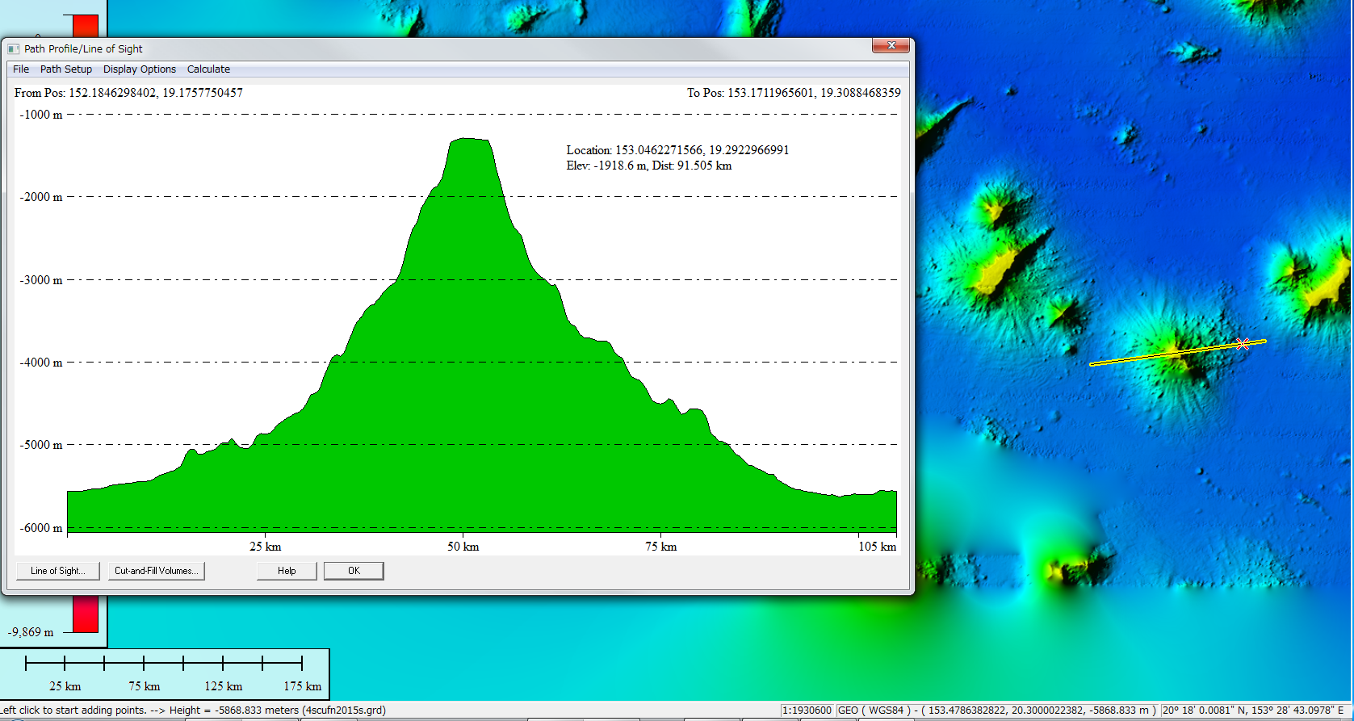

Fig. 3. Bathymetric profiles across the Matsuzaki Guyot.

