INTERNATIONAL HYDROGRAPHIC  ORGANIZATION | INTERGOVERNMENTAL OCEANOGRAPHIC  COMMISSION (of UNESCO)

UNDERSEA FEATURE NAME PROPOSAL
(Sea NOTE overleaf)

Note: The boxes will expand as you fill the form.
Name Proposed: | Magoshichi Guyot | Ocean or Sea: | Northwest Pacific Ocean

Geometry that best defines the feature (Yes/No) :
Point | Line | Polygon | Multiple points | Multiple lines* | Multiple polygons* | Combination of geometries*
 |  | Yes
* Geometry should be clearly distinguished when providing the coordinates below.
 | Lat. (e.g. 63°32.6’N) | Long. (e.g. 046°21.3’W)
Coordinates: | 19°40.97'N (summit 1)  19°12.90’N  19°16.87’N  19°30.43’N  19°35.50’N  19°50.06’N  19°56.19’N  19°56.65’N  20°03.50’N  20°04.83’N  20°00.53’N  19°55.50’N  19°47.51’N  19°41.69’N  19°29.01’N  19°19.75’N  19°15.47’N  19°15.25’N  19°16.67’N  19°12.90’N | 153°37.25'E (summit 1)  153°16.97’E  153°07.32’E  153°03.25’E  153°02.54’E  153°01.83’E  153°08.52’E  153°13.20’E  153°18.68’E  153°34.32’E  153°50.32’E  153°55.69’E  153°53.97’E  154°00.03’E  153°58.66’E  153°51.79’E  153°39.37’E  153°31.65’E  153°21.88’E  153°16.97’E

Feature Description: | Maximum Depth : | 5879 m | Steepness :
Feature Description: | Minimum Depth : | 1244 m | Shape :
Feature Description: | Total Relief : | 4635 m | Dimension/Size : | 93 km×107 km

Associated Features:

Chart/Map References: | Shown Named on Map/Chart:
Chart/Map References: | Shown Unnamed on Map/Chart:
Chart/Map References: | Within Area of Map/Chart:

Reason for Choice of Name (if a person, state how associated with the feature to be named): | The guyot is named after a legendary captain and educator late Mr. Magoshici Sato. See CV for details.

Discovery Facts: | Discovery Date: | Jan. and Feb. 2000
Discovery Facts: | Discoverer (Individual, Ship): | The Japanese survey vessel “Takuyo”

Supporting Survey Data, including Track Controls: | Date of Survey: | Jan. and Feb. 2000
Supporting Survey Data, including Track Controls: | Survey Ship: | The Japanese survey vessel “Takuyo”
Supporting Survey Data, including Track Controls: | Sounding Equipement: | Multibeam echo sounder  Seabeam 2112
Supporting Survey Data, including Track Controls: | Type of Navigation: | GPS without Selective Availability
Supporting Survey Data, including Track Controls: | Estimated Horizontal Accuracy (nm): | 0.014 nm (26 m)
Supporting Survey Data, including Track Controls: | Survey Track Spacing: | 5 nm
Supporting Survey Data, including Track Controls: | Supporting material can be submitted as Annex in analog or digital form.

Proposer(s): | Name(s): | JCUFN
Proposer(s): | Date: | Sep. 10, 2015
Proposer(s): | E-mail: | ico@jodc.go.jp
Proposer(s): | Organization and Address: | Hydrographic and Oceanographic Department, Japan Coast Guard  Aomi 2-5-18,Koto-ku, Tokyo 135-0064, Japan
Proposer(s): | Concurrer (name, e-mail, organization and address):

Remarks: | The last name, Sato, is very popular in Japan. So, employing “Sato” for an undersea feature name, we cannot indentifiy which ”Sato”. Therefore, JCUFN decided to use the first name in this case.

NOTE : This form should be forwarded, when completed :

a) If the undersea feature is located inside the external limit of the territorial sea :-
to your "National Authority for Approval of Undersea Feature Names" (see page 2-9) or, if this does not exist or is not known, either to the IHB or to the IOC (see addresses below);

b) If at least 50 % of the undersea feature is located outside the external limits of the territorial sea :-
to the IHB or to the IOC, at the following addresses :

International Hydrographic Bureau (IHB)  4, Quai Antoine 1er  B.P. 445  MC 98011 MONACO CEDEX  Principality of MONACO  Fax: +377 93 10 81 40  E-mail: info@ihb.mc | Intergovernmental Oceanographic Commission (IOC)  UNESCO  Place de Fontenoy  75700 PARIS  France  Fax: +33 1 45 68 58 12  E-mail: info@unesco.org

Personal history of late Captain and Professor Magoshichi Sato

Given name: Magoshichi
Family name: Sato

1910 Born
2006 Diseased

Professional carrier:
Before around 1943 He was a fisherman, then he worked for a fisheries guidance ship and for the Fisheries Institute.
Around 1943 Joined the Hydrographic Department of Japan, as the first captian of Survey Vessel “Dai-yon Kaiyo”
1967 Retired from the Hydrographic Department of Japan
1968-1975 Captain of the “Tokai-Daigaku Maru II”, the training vessel of Tokai Universiy
1975-1981 Professor, School of Marine Science and Technology, Tokai University

Remarks:
He was a legendary captain and professor in Japanese hydrographic and oceanographic community. He influenced numerous Japanese mariners in hydrographic and oceanographic community. He published many technical reports concerning steering of ships (written in Japanese).

List of selected publication:
Sato, M., Kinoshita, Y., Hanada, M., Araki, N., Moriya, H., and Ishii, K., Fundamental ten rules of dredging by towing, Journal of the School of Marine Science and Technology, Tokai University, 3, 149-157, 1990. (in Japanese with English abstact)
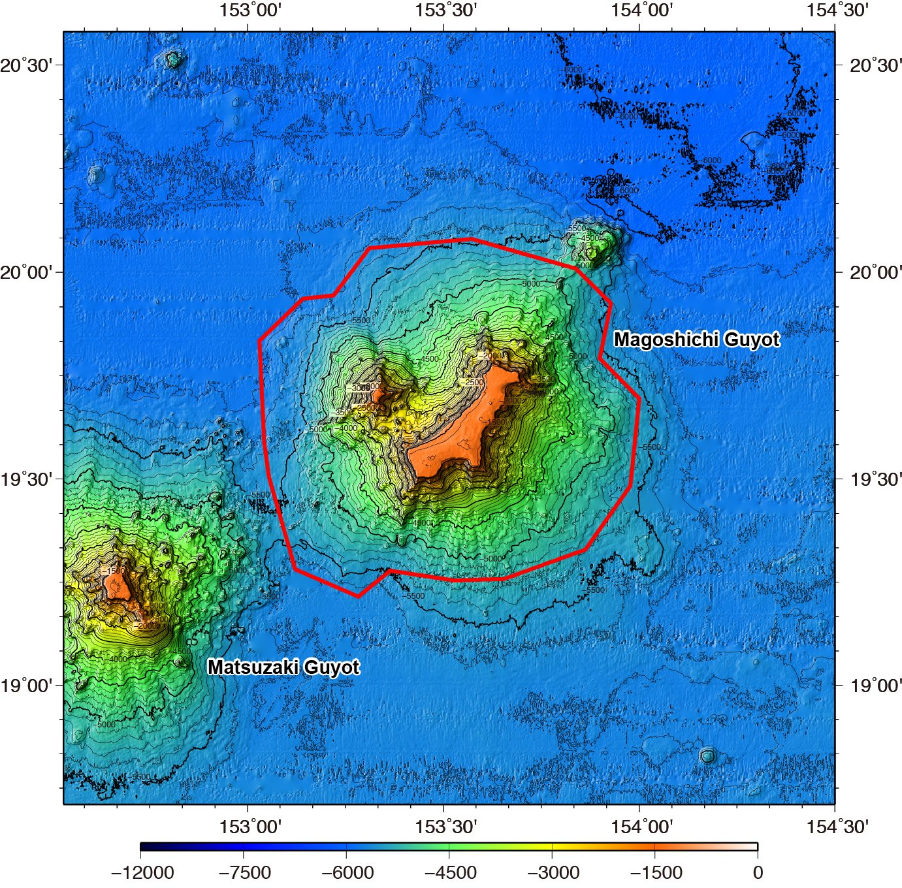

Fig. 1. Bathymetric map of the Magoshichi Guyot. Contours are in 100 m.
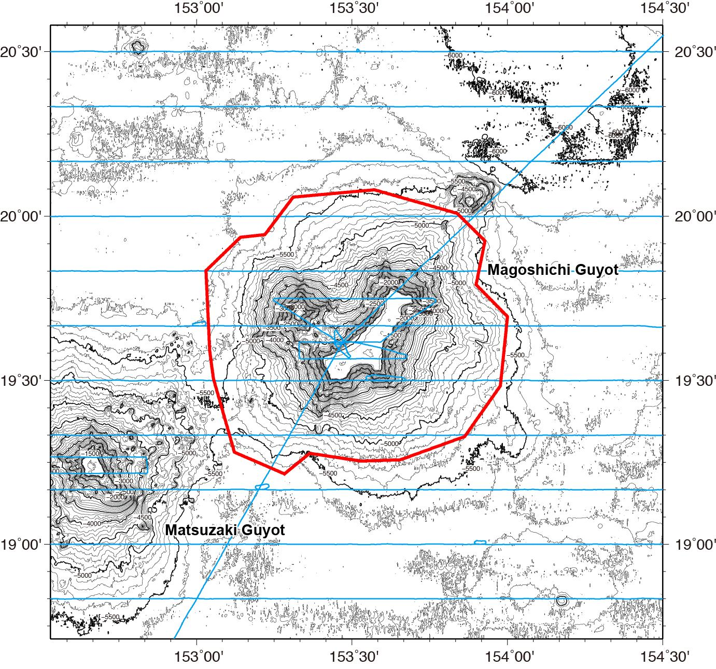

Fig. 2. Bathymetric map of the Magoshichi Guyot, showing with track lines. Contours are in 100 m.

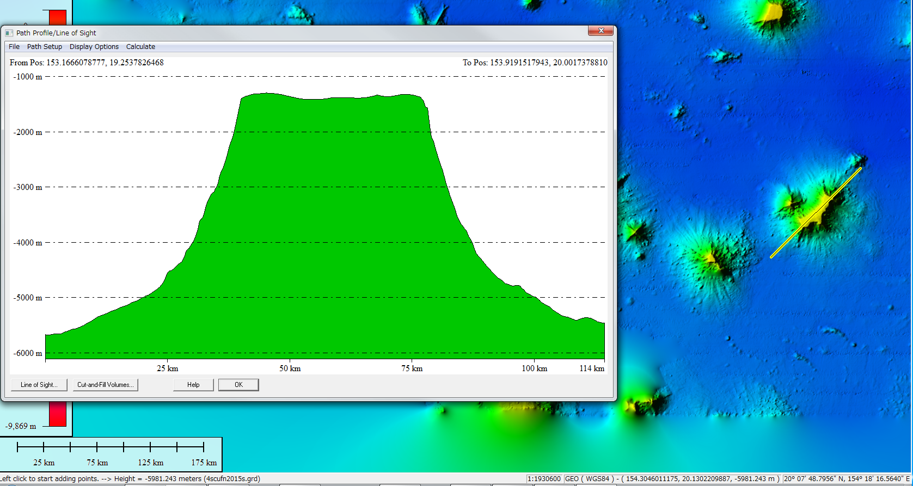

Fig. 3. Bathymetric profiles across the Magoshichi Guyot.

