INTERNATIONAL HYDROGRAPHIC  ORGANIZATION | INTERGOVERNMENTAL OCEANOGRAPHIC  COMMISSION (of UNESCO)

UNDERSEA FEATURE NAME PROPOSAL
(Sea NOTE overleaf)

Note: The boxes will expand as you fill the form.
Name Proposed: | Kawakami Seamount | Ocean or Sea: | Northwest Pacific Ocean

Geometry that best defines the feature (Yes/No) :
Point | Line | Polygon | Multiple points | Multiple lines* | Multiple polygons* | Combination of geometries*
 |  | Yes
* Geometry should be clearly distinguished when providing the coordinates below.
 | Lat. (e.g. 63°32.6’N) | Long. (e.g. 046°21.3’W)
Coordinates: | 18°31.93’N (summit 1)  18°22.96’N  18°26.32’N  18°29.89’N  18°36.60’N  18°39.00’N  18°41.50’N  18°43.95’N  18°44.49’N  18°40.53’N  18°35.38’N  18°29.25’N  18°24.31’N  18°21.46’N  18°20.97’N  18°22.96’N | 155°12.46’E (summit 1)  155°04.88’E  155°01.10’E  154°58.75’E  154°58.67’E  154°58.86’E  155°02.64’E  155°08.49’E  155°16.63’E  155°23.16’E  155°26.66’E  155°26.37’E  155°24.40’E  155°16.52’E  155°10.59’E  155°04.88’E

Feature Description: | Maximum Depth : | 5714 m | Steepness :
Feature Description: | Minimum Depth : | 1378 m | Shape :
Feature Description: | Total Relief : | 4336 m | Dimension/Size : | 44 km×57 km

Associated Features:

Chart/Map References: | Shown Named on Map/Chart:
Chart/Map References: | Shown Unnamed on Map/Chart:
Chart/Map References: | Within Area of Map/Chart:

Reason for Choice of Name (if a person, state how associated with the feature to be named): | The guyot is named after a chief hydrographer of Japan late Dr. Kiyoshi Kawakami. See CV for details.

Discovery Facts: | Discovery Date: | Jan. and Feb. 2000
Discovery Facts: | Discoverer (Individual, Ship): | The Japanese survey vessel “Takuyo”

Supporting Survey Data, including Track Controls: | Date of Survey: | Oct. and Nov. 2001
Supporting Survey Data, including Track Controls: | Survey Ship: | The Japanese survey vessel “Takuyo”
Supporting Survey Data, including Track Controls: | Sounding Equipement: | Multibeam echo sounder  Seabeam 2112
Supporting Survey Data, including Track Controls: | Type of Navigation: | GPS without Selective Availability
Supporting Survey Data, including Track Controls: | Estimated Horizontal Accuracy (nm): | 0.014 nm (26 m)
Supporting Survey Data, including Track Controls: | Survey Track Spacing: | 0.25 nm
Supporting Survey Data, including Track Controls: | Supporting material can be submitted as Annex in analog or digital form.

Proposer(s): | Name(s): | JCUFN
Proposer(s): | Date: | Sep. 10, 2015
Proposer(s): | E-mail: | ico@jodc.go.jp
Proposer(s): | Organization and Address: | Hydrographic and Oceanographic Department, Japan Coast Guard  Aomi 2-5-18,Koto-ku, Tokyo 135-0064, Japan
Proposer(s): | Concurrer (name, e-mail, organization and address):

Remarks:

NOTE : This form should be forwarded, when completed :

a) If the undersea feature is located inside the external limit of the territorial sea :-
to your "National Authority for Approval of Undersea Feature Names" (see page 2-9) or, if this does not exist or is not known, either to the IHB or to the IOC (see addresses below);

b) If at least 50 % of the undersea feature is located outside the external limits of the territorial sea :-
to the IHB or to the IOC, at the following addresses :

International Hydrographic Bureau (IHB)  4, Quai Antoine 1er  B.P. 445  MC 98011 MONACO CEDEX  Principality of MONACO  Fax: +377 93 10 81 40  E-mail: info@ihb.mc | Intergovernmental Oceanographic Commission (IOC)  UNESCO  Place de Fontenoy  75700 PARIS  France  Fax: +33 1 45 68 58 12  E-mail: info@unesco.org

Personal history of late Dr. Kiyoshi Kawakami

Given name: Kiyoshi
Family name: Kawakami

1916 Born
1982 Diseased

Education
1940 B.S., Kyoto Imperial University
1969 PhD, Tohoku Univeristy

Professional carrier:
1945 Joined the Hydrographic Department of Japan
1969-1975 Chief Hydrographer of Japan
1969-1973 2nd Chair, GEBCO Sub-Committee on Proper Geographical Names for Ocean Bottom Features
1971 Chair, East Asia Hydrographic Commission

Remarks:
He was a geomorphologist working for the Hydrographic Department of Japan. He became the Chief Hydrographer since 1969 until 1975. During that period, he was the chair of the GEBCO Sub-Committee on Proper Geographical Names for Ocean Bottom Features. He also played a major role in convening the East Asia Hydrographic Commission. Furthermore, he also played a major role in conducting the joint hydrographic survey in the Straits of Malacca and Singapore with Japan, Indonesia, Malaysia and Singapore in 1969.

Apart from the above contributions to the international community, he initiated publishing bathymetric chart series (consisting of bathymetric, geologic, gravimetric and magnetic charts) for the first time in the history of the Hydrographic Department of Japan in 1967. Before that, the department only issued nautical charts.

List of selected publications:
Kawakami, K., Joint Hydrographic Survey in the Straits of Malacca and Singapore, Journal of Geography, 82, 34-38, 1973. (in Japanese with English abstract)
Kawakami, K., and Segawa, S., Bathymetric survey between Okinawa and Guam Island, Journal of Geography, 84, 36-40, 1975.
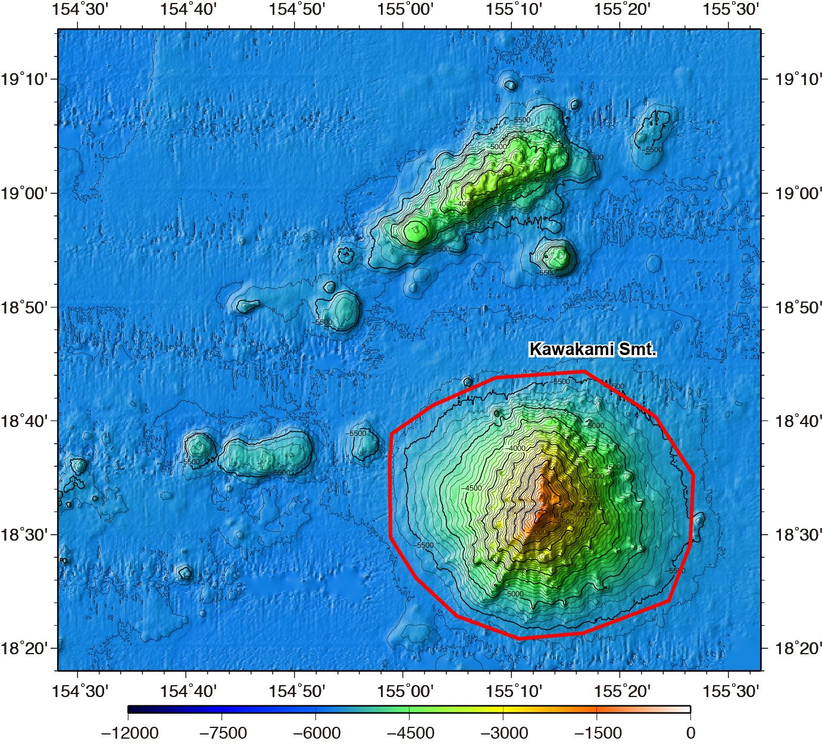

Fig. 1. Bathymetric map of the Kawakami Seamount. Contours are in 100 m.
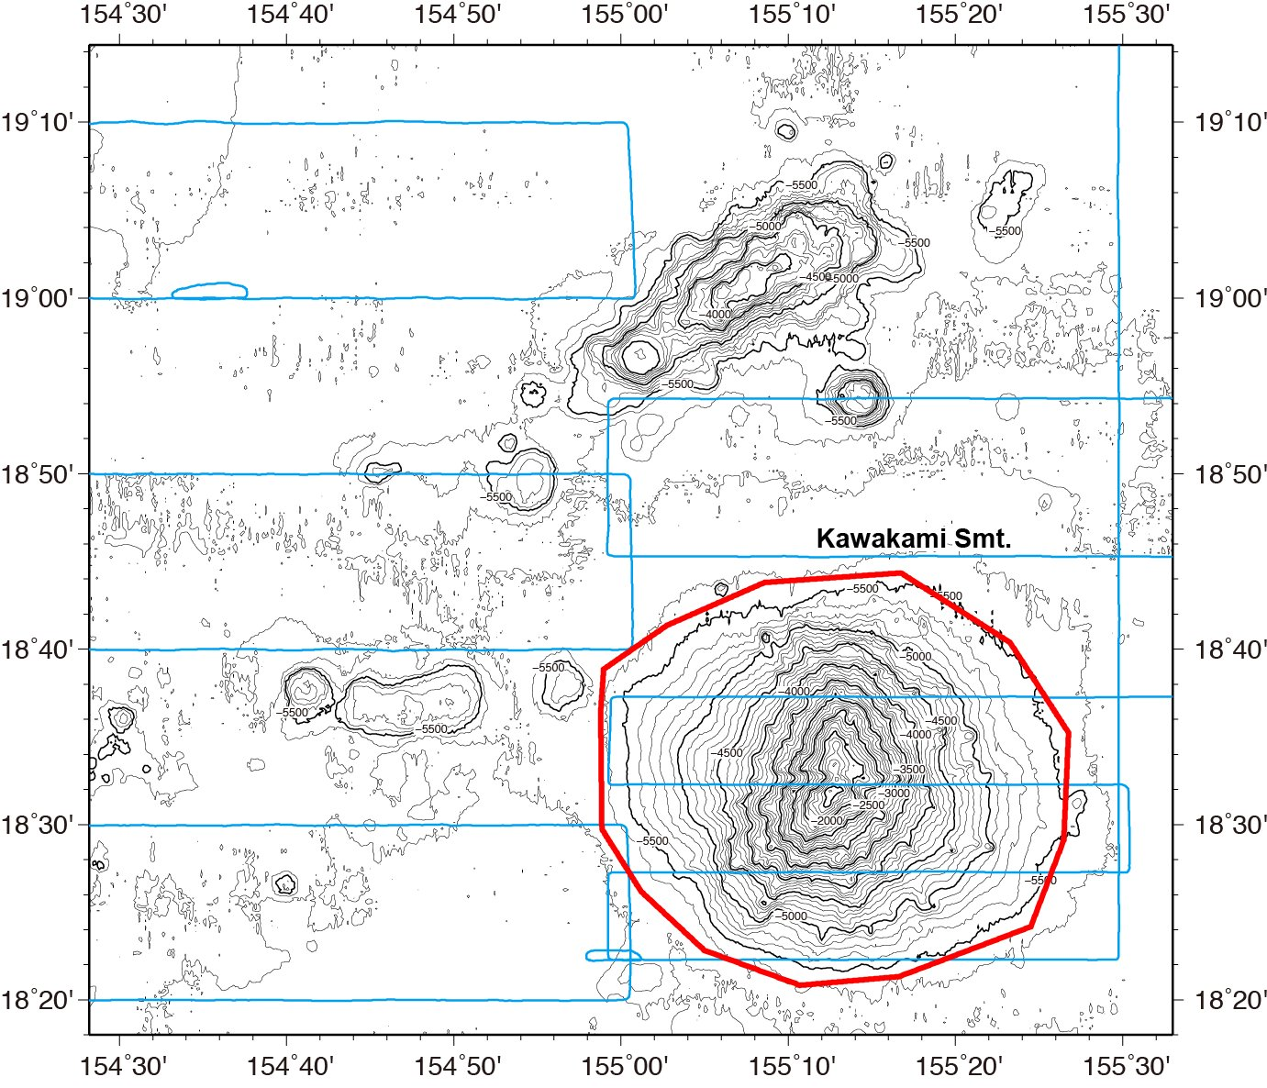

Fig. 2. Bathymetric map of the Kawakami Seamount, showing with track lines. Contours are in 100 m.
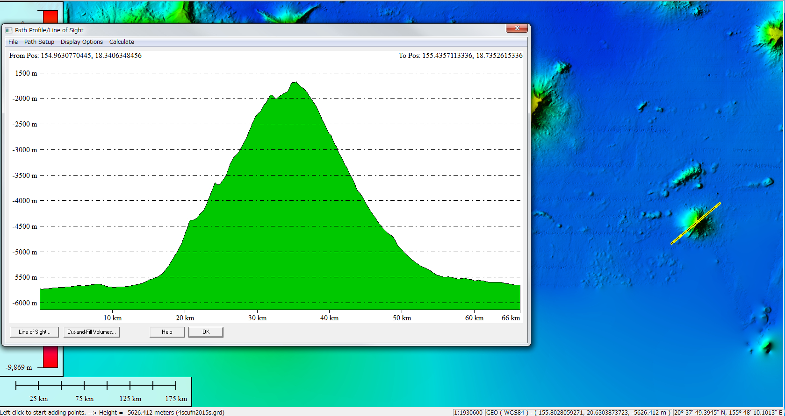

Fig. 3. Bathymetric profiles across the Kawakami Seamount.

