INTERNATIONAL HYDROGRAPHIC  ORGANIZATION | INTERGOVERNMENTAL OCEANOGRAPHIC  COMMISSION (of UNESCO)

UNDERSEA FEATURE NAME PROPOSAL
(See IHO-IOC Publication B-6 and NOTE overleaf)

Note: The boxes will expand as you fill the form.
Name Proposed: | Higashi-Mokusei Seamount | Ocean or Sea: | N/A

Geometry that best defines the feature (Yes/No) :
Point | Line | Polygon | Multiple points | Multiple lines* | Multiple polygons* | Combination of geometries*
 |  | Yes
* Geometry should be clearly distinguished when providing the coordinates below.
 | Lat. (e.g. 63°32.6’N) | Long. (e.g. 046°21.3’W)
Coordinates: | 21°13.05’N  21°17.58’N  21°21.91’N  21°23.38’N  21°22.67’N  21°20.26’N  21°17.65’N  21°13.61’N  21°13.05’N | 136°30.82’E  136°27.69’E  136°28.78’E  136°33.00’E  136°34.56’E  136°35.76’E  136°36.32’E  136°33.86’E  136°30.82’E

Feature Description: | Maximum Depth: | 4,201 m | Steepness : | N/A
Feature Description: | Minimum Depth : | 1,837 m | Shape : | Oval
Feature Description: | Total Relief : | 2,364 m | Dimension/Size : | 15 km × 15 km

Associated Features: | Mokusei Seamount

Chart/Map References: | Shown Named on Map/Chart: | 6722
Chart/Map References: | Shown Unnamed on Map/Chart:
Chart/Map References: | Within Area of Map/Chart:

Reason for Choice of Name (if a person, state how associated with the feature to be named): | This feature is located to the east of Mokusei Seamount. “Mokusei” stands for Jupiter in Japanese. “Higashi” stands for east in Japanese. The undersea features on/around the Kyushu-Palau Ridge at around this region are named after stars and planets.

Discovery Facts: | Discovery Date: | Oct. 1990
Discovery Facts: | Discoverer (Individual, Ship): | Japanese survey vessel "Takuyo"

Supporting Survey Data, including Track Controls: | Date of Survey: | Oct. - Nov. 1990  Jan. 2003
Supporting Survey Data, including Track Controls: | Survey Ship: | Japanese survey vessel "Takuyo"
Supporting Survey Data, including Track Controls: | Sounding Equipement: | Multibeam echo sounder  Seabeam 2112 (2003)  Seabeam (1990)
Supporting Survey Data, including Track Controls: | Type of Navigation: | GPS without Selective Availability (2003)  Hybrid system (Loran-C & GPS) (1990)
Supporting Survey Data, including Track Controls: | Estimated Horizontal Accuracy, in nautical miles (M): | 0.014 nm (26 m) (2003)  0.108 nm (200 m) (1990)
Supporting Survey Data, including Track Controls: | Survey Track Spacing: | 1.5 nm
Supporting Survey Data, including Track Controls: | Supporting material can be submitted as Annex in analog or digital form.

Proposer(s): | Name(s): | JCUFN
Proposer(s): | Date: | August 20, 2018
Proposer(s): | E-mail: | ico@jodc.go.jp
Proposer(s): | Organization and Address: | Hydrographic and Oceanographic Department, Japan Coast Guard Kasumigaseki 3-1-1, Chiyoda-ku, Tokyo 100-8932, Japan
Proposer(s): | Concurrer (name, e-mail, organization and address):

Remarks: | The position of the summit is located in (21°17.61’N, 136°32.34’E).

NOTE: This form should be forwarded, when completed:

a) If the undersea feature is located inside the external limit of the territorial sea:
- to your "National Authority for Approval of Undersea Feature Names" (see Publication B-6) or, if this does not exist or is not known, either to the IHO or to the IOC (see addresses below);

b) If at least 50 % of the undersea feature is located outside the external limits of the territorial sea:
- to the IHO or to the IOC, at the following addresses :

International Hydrographic Organization (IHO)  4b, Quai Antoine 1er  B.P. 445  MC 98011 MONACO CEDEX  Principality of MONACO  Fax: +377 93 10 81 40  E-mail: info@iho.int  Web: www.iho.int | Intergovernmental Oceanographic Commission (IOC)  UNESCO  Place de Fontenoy  75700 PARIS  France  Fax: +33 1 45 68 58 12  E-mail: info@unesco.org  Web: http://ioc-unesco.org/

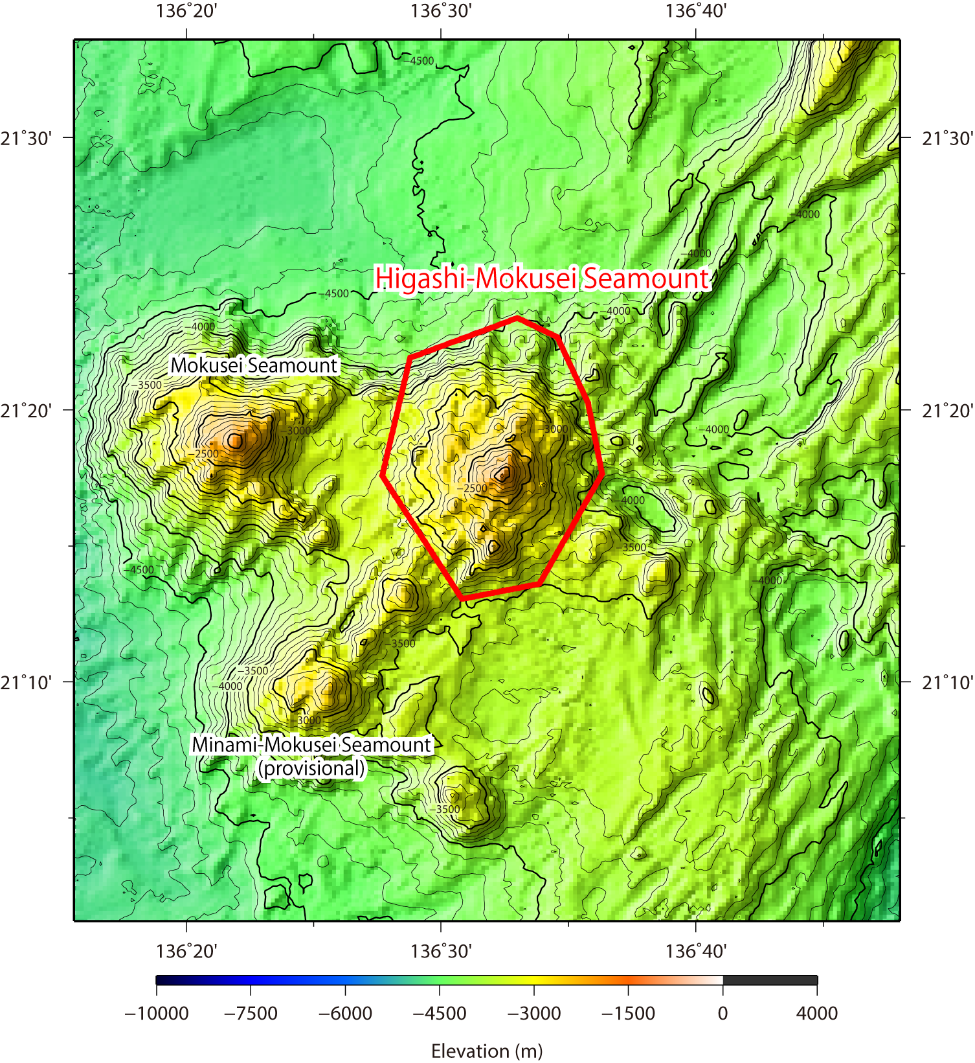
Fig. 1. Bathymetric map of the Higashi-Mokusei Seamount. Contours are in 100 m.

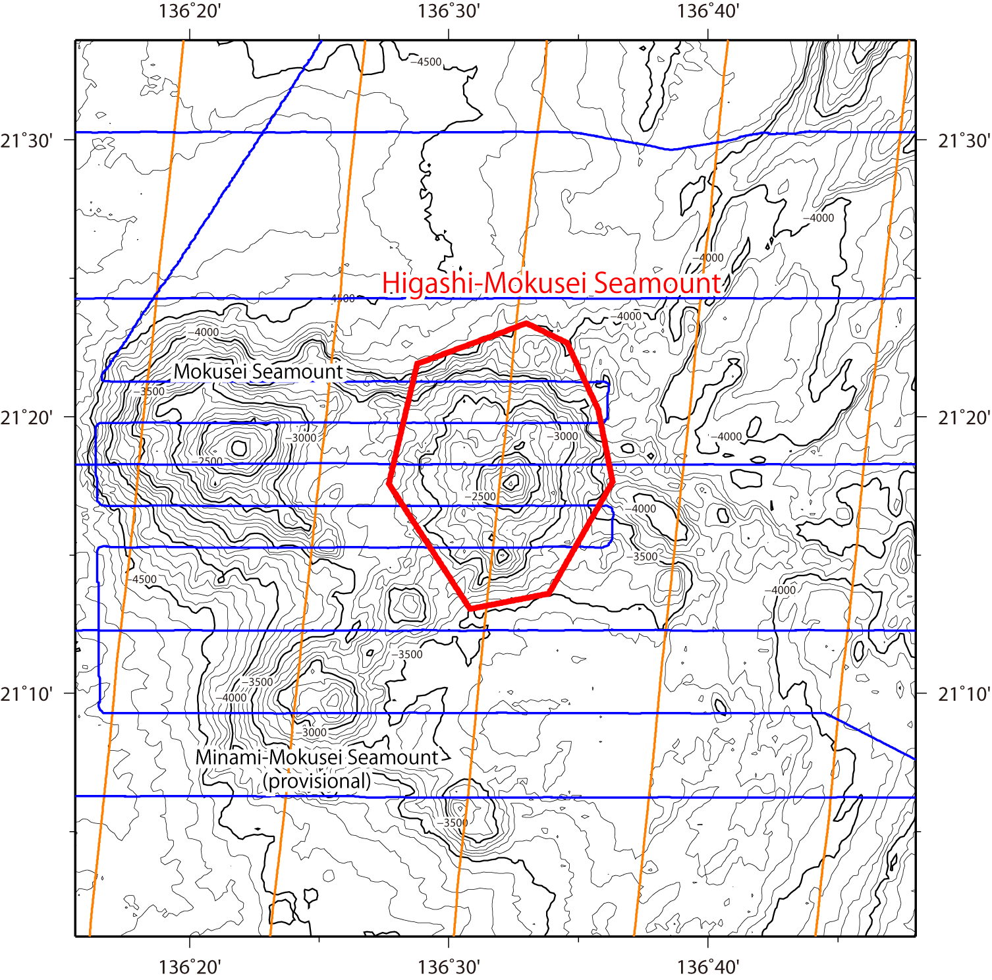
Fig. 2. Bathymetric map of the Higashi-Mokusei Seamount, showing with track lines. Contours are in 100 m.

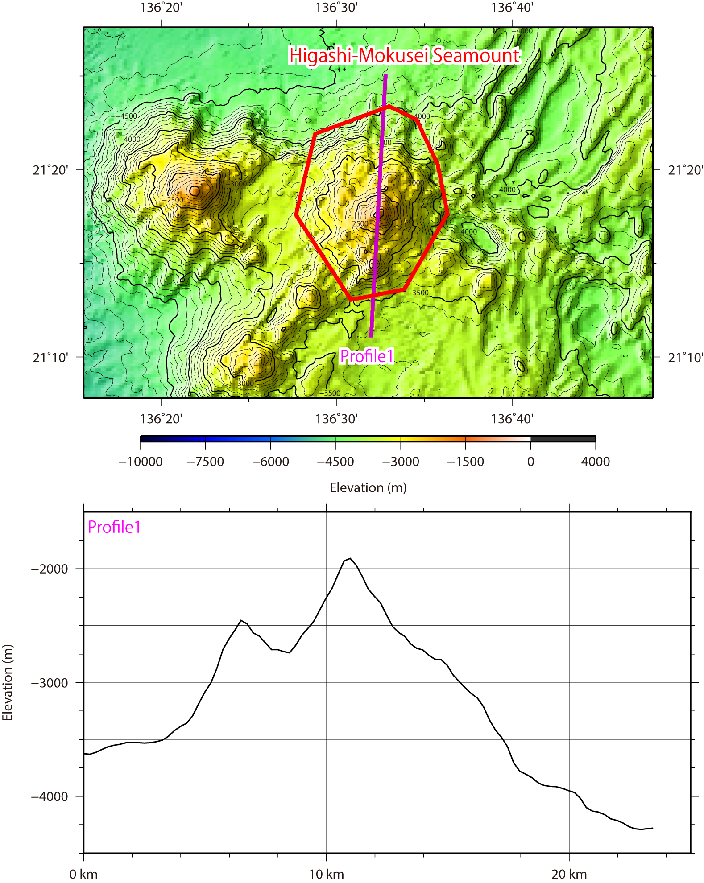
Fig. 3. Bathymetric profile across the Higashi-Mokusei Seamount.

