INTERNATIONAL HYDROGRAPHIC  ORGANIZATION | INTERGOVERNMENTAL OCEANOGRAPHIC  COMMISSION (of UNESCO)

UNDERSEA FEATURE NAME PROPOSAL
(See IHO-IOC Publication B-6 and NOTE overleaf)

Note: The boxes will expand as you fill the form.
Name Proposed: | Yagiza Seamount | Ocean or Sea: | N/A

Geometry that best defines the feature (Yes/No) :
Point | Line | Polygon | Multiple points | Multiple lines* | Multiple polygons* | Combination of geometries*
 |  | Yes
* Geometry should be clearly distinguished when providing the coordinates below.
 | Lat. (e.g. 63°32.6’N) | Long. (e.g. 046°21.3’W)
Coordinates: | 15°43.43’N  15°44.31’N  15°44.47’N  15°43.18’N  15°36.01’N  15°35.49’N  15°35.67’N  15°37.22’N  15°43.43’N | 133°02.79’E  133°03.78’E  133°07.44’E  133°08.46’E  133°08.55’E  133°07.35’E  133°04.41’E  133°03.03’E  133°02.79’E

Feature Description: | Maximum Depth: | 6,154 m | Steepness : | N/A
Feature Description: | Minimum Depth : | 5,024 m | Shape : | Rectangular
Feature Description: | Total Relief : | 1,130 m | Dimension/Size : | 10 km × 15 km

Associated Features:

Chart/Map References: | Shown Named on Map/Chart: | 6728
Chart/Map References: | Shown Unnamed on Map/Chart:
Chart/Map References: | Within Area of Map/Chart:

Reason for Choice of Name (if a person, state how associated with the feature to be named): | This feature is interpreted to be an Oceanic Core Complex (OCC) (see Remarks), and is located on the Philippine Basin, to the west of Kyushu-Palau Ridge and to the north of CBF Rise. The OCC is typically characterized with corrugated surface, which is almost normal to the regional bathymetric trend defined by the abyssal hills. The OCCs in this region are named after 12 ecliptical constellations. "Yagiza" is the Japanese that means the Capricornus. The undersea features on/around the Kyushu-Palau Ridge at around this region are named after stars and planets.

Discovery Facts: | Discovery Date: | Mar. 1997
Discovery Facts: | Discoverer (Individual, Ship): | Japanese survey vessel "Takuyo"

Supporting Survey Data, including Track Controls: | Date of Survey: | Mar. 1997  Apr. - May 2007
Supporting Survey Data, including Track Controls: | Survey Ship: | Japanese survey vessel "Shoyo" and "Takuyo"
Supporting Survey Data, including Track Controls: | Sounding Equipement: | Multibeam echo sounder  Seabeam 2112 (2007)  Seabeam 210A (1997)
Supporting Survey Data, including Track Controls: | Type of Navigation: | GPS without Selective Availability (2007)  GPS with Selective Availability (1997)
Supporting Survey Data, including Track Controls: | Estimated Horizontal Accuracy, in nautical miles (M): | 0.014 nm (26 m) (2007)  0.054 nm (100 m) (1997)
Supporting Survey Data, including Track Controls: | Survey Track Spacing: | 3 nm
Supporting Survey Data, including Track Controls: | Supporting material can be submitted as Annex in analog or digital form.

Proposer(s): | Name(s): | JCUFN
Proposer(s): | Date: | August 20, 2018
Proposer(s): | E-mail: | ico@jodc.go.jp
Proposer(s): | Organization and Address: | Hydrographic and Oceanographic Department, Japan Coast Guard Kasumigaseki 3-1-1, Chiyoda-ku, Tokyo 100-8932, Japan
Proposer(s): | Concurrer (name, e-mail, organization and address):

Remarks: | The position of the summit is located in (15°38.16’N, 133°05.40’E).  This feature is interpreted to be an Oceanic Core Complex (OCC). OCCs are domal bathymetric highs with axis-normal corrugations, interpreted as exhumed footwalls of low-angle detachment faults. Recently, many OCCs are identified in the Philippine Sea. Some of the relevant papers are:  - Blackman, D.K. J.P. Canales, and A. Harding, Geophysical signatures of oceanic core complexes, Geophysical Journal International, 178, 593-613, 2009.  - Escartin, J., and J. P. Canales, Detachments in oceanic lithosphere: deformation, magmatism, fluid flow, and ecosystems, EOS Transactions, AGU, 92, 31, DOI: 10.1029/2011EO040003., 2011.  - Ohara, Y., K. Okino, and J. Kasahara, Seismic study on oceanic core complexes in the Parece Vela back-arc basin, Island Arc, 16, 348-360, 2007.  - Ohara, Y., The Godzilla Megamullion, the largest oceanic core complex on the earth: a historical review, Island Arc, 25, 193-208, 2016.

NOTE: This form should be forwarded, when completed:

a) If the undersea feature is located inside the external limit of the territorial sea:
- to your "National Authority for Approval of Undersea Feature Names" (see Publication B-6) or, if this does not exist or is not known, either to the IHO or to the IOC (see addresses below);

b) If at least 50 % of the undersea feature is located outside the external limits of the territorial sea:
- to the IHO or to the IOC, at the following addresses :

International Hydrographic Organization (IHO)  4b, Quai Antoine 1er  B.P. 445  MC 98011 MONACO CEDEX  Principality of MONACO  Fax: +377 93 10 81 40  E-mail: info@iho.int  Web: www.iho.int | Intergovernmental Oceanographic Commission (IOC)  UNESCO  Place de Fontenoy  75700 PARIS  France  Fax: +33 1 45 68 58 12  E-mail: info@unesco.org  Web: http://ioc-unesco.org/

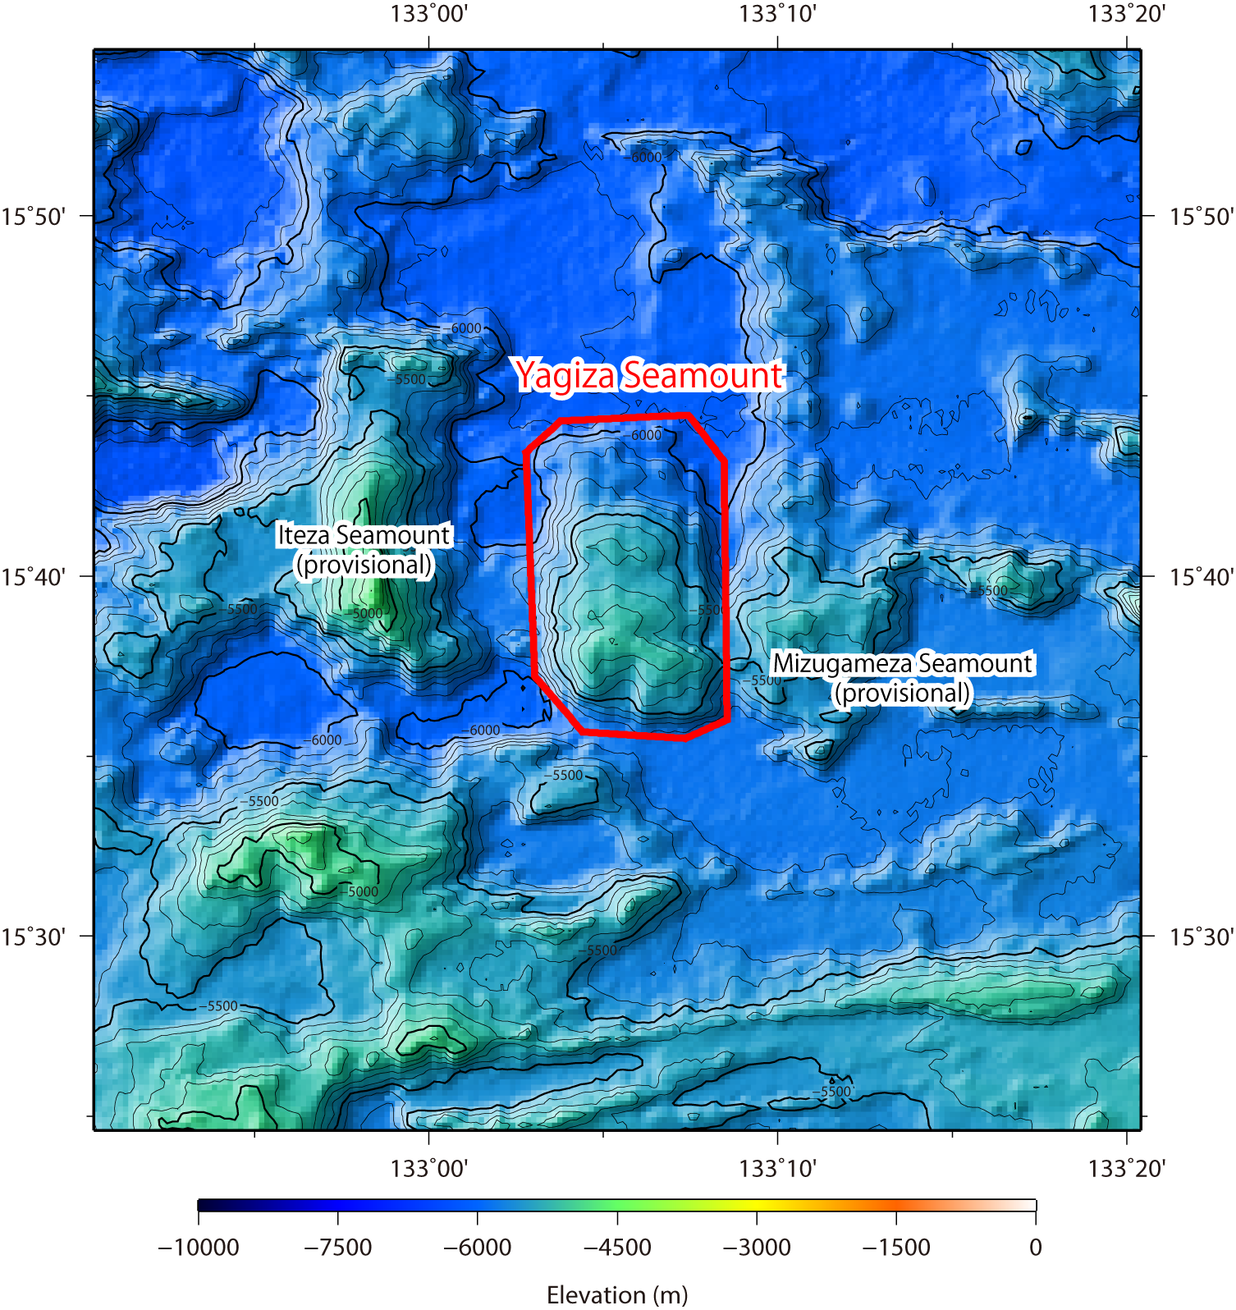
Fig. 1. Bathymetric map of the Yagiza Seamount. Contours are in 100 m.

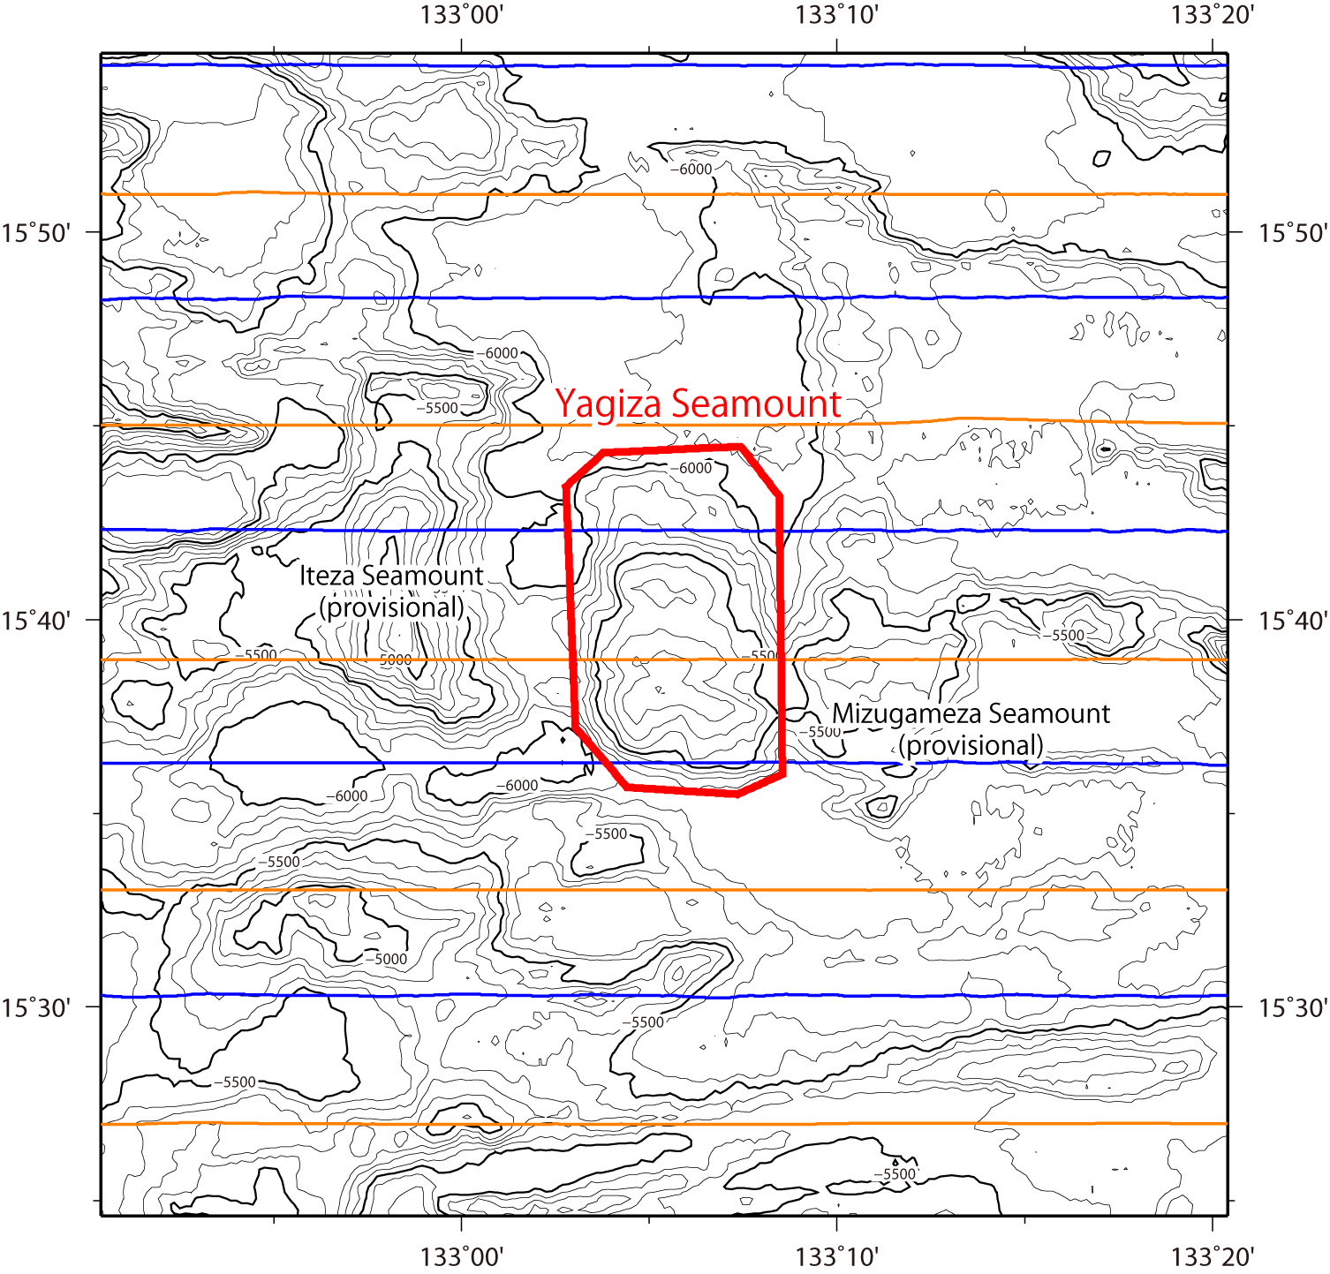
Fig. 2. Bathymetric map of the Yagiza Seamount, showing with track lines. Contours are in 100 m.

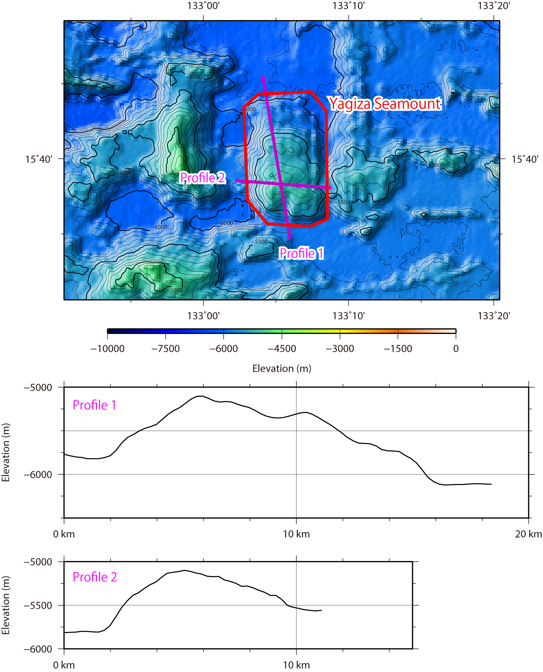
Fig. 3. Bathymetric profile across the Yagiza Seamount.

