Modification of the Feature Catalogue Model
Motivation:
The motivation for the change in the feature catalogue model was to reflect the changes in the general feature model. In addition some cleanup has been done in the model to remove redundant information. The main change is that there are now two types of associations, feature and information association and that those can have attributes.
Background:
The GFM in S-100 Version 1.0.0 does not allow to associate information types by means of association types. In addition the feature association types are not allowed to carry thematic attributes. Both are required for the modeling of nautical publications. Since workarounds were not satisfying the situation, the GFM was modified. One side effect of these changes is that the model of the feature catalogue needs to be changed as well. These modifications are proposed in this document. In addition a new version of the feature catalogue schema (xsd) will be created.
There are two other small changes to the model. The first is the addition of a numeric code for items to reflect the ISO 8211 encapsulation where codes are integer numbers. The second is the change of an alias from a simple string to a structure containing the value and optional a context of the alias.
Furthermore a pattern constraint for item codes is introduced into the model. The motivation of this is that the codes are intended to use as tag names in XML encapsulations. They must comply with the XML name constraint.
The pattern allows only codes starting with a letter from the Latin alphabet (A-Z or a-z). All other characters must be either Latin alphabet characters or digits (0-9) or the underline character (_). No other characters are allowed including all kind of white spaces.
The numeric code is also constraint to the interval 0 < numericCode < 65535.
Proposed changes (brief):
The main changes are:
- Add a new class S100_FC_Item to carry the common properties of all feature catalogue items. Those were repeated in three classes of the old model. This is only a cleanup and does not semantically changes the model.
- The class S100_FC_PropertyType was removed from the model. Derived classes are now derived from S100_FC_Item. The reason for this is that the removed class does not add any information to the model.
- The classes S100_FC_InformationRole and S100_FC_AssociationRole were replaced by only one class S100_FC_Role due to the changes in the GFM. (There is only one role type in the GFM now)
- There is a super class for S100_FC_FeatureType and S100_FC_InformationType: S100_FC_ObjectType. The reason for this is the common property ‘informationBinding’.
- A new class S100_FC_InformationAssociation was added to the model due to the change of the GFM.
- The classes S100_FC_InformationAssociation and S100_FC_FeatureAssociation are subject of inheritance now (to be in line with the GFM).
- The attribute ‘permittedValues’ of S100_FC_AttributeBinding was changed into an association. This is not a semantically change of the model.
- Adding the attribute ‘numericCode’ to S100_FC_Item.
- Adding a class S100_FC_Alias with attributes ‘value’ and ‘context’.
- Changing the attribute ‘alias’ in S100_FC_Item and S100_FC_ListedValue to a role of type S100_FC_Alias.
- Adding constraints for the attributes ‘code‘ and ‘numericCode’ of class S100_FC_Item

Proposed changes (detailed):

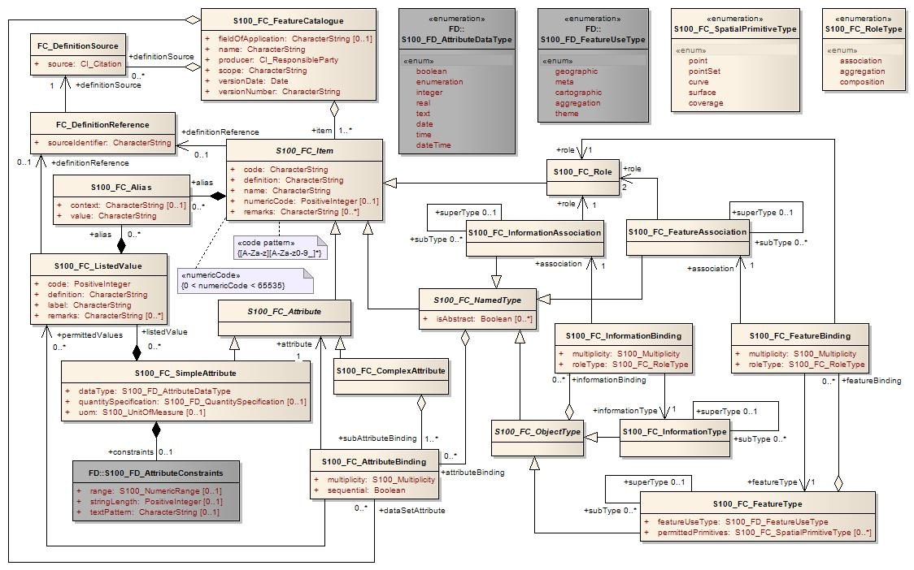
Figure 1 - The modified feature catalogue model
Elements of the model:
Role Name | Name | Description | Mult. | Type | Remarks
Class | S100_FC_FeatureCatalogue | a feature catalogue contains its identification and contact information, and definition of some number of feature types with other information necessary for those definitions | - | -
Attribute | name | name for this feature catalogue | 1 | CharacterString
Attribute | scope | subject domain(s) of feature types defined in this feature catalogue | 1 | CharacterString
Attribute | fieldOfApplication | description of kind(s) of use to which this feature catalogue may be put | 0..1 | CharacterString
Attribute | versionNumber | version number of this feature catalogue, which may include both a major version number or letter and a sequence of minor release numbers or letters, such as “3.2.4a.” The format of this attribute may differ between cataloguing authorities. | 1 | CharacterString
Attribute | versionDate | effective date of this feature catalogue | 1 | Date
Attribute | producer | name, address, country, and telecommunications address of person or organization having primary responsibility for the intellectual content of this feature catalogue | 1 | CI_ResponsibleParty
Role | item | list of items defined by this feature catalogue; items are feature types, information types, feature associations, information associations, attributes, and roles | 1..* | S100_FC_Item | aggregation
Role | definitionSource | list of sources of definitions of items, and listed values that are defined by this feature catalogue. Usually those sources are feature data dictionaries. | 0..* | FC_DefinitionSource | aggregation
Role | dataSetAttribute | Attribute bindings for the data set level to specify meta information for the data set | 0..* | S100_FC_AttributeBinding | aggregation
Table 1 - S100_FC_FeatureCatalogue

Role Name | Name | Description | Mult. | Type | Remarks
Class | FC_Definition_Source | class that specifies the source of a definition | - | -
Attribute | source | actual citation of the source, sufficient to identify the document and how to obtain it | 1 | CI_Citation
Table 2 - FC_DefinitionSource

Role Name | Name | Description | Mult. | Type | Remarks
Class | FC_DefinitionReference | class that links a data instance to the source of its definition | - | -
Attribute | sourceIdentifier | information to locate the definition in the source document. The format of this information is specific to the structure of the source document. | 1 | CharacterString
Role | definitionSource | the source of the definition | 1 | FC_DefinitionSource
Table 3 - FC_DefinitionReference

Role Name | Name | Description | Mult. | Type | Remarks
Class | S100_FC_Item | abstract base class that defines the common properties of all items in the feature catalogue; items are feature types, information types, feature associations, information associations, attributes and roles | - | - | abstract
Attribute | name | name of the item | 1 | CharacterString
Attribute | definition | definition of the named type in a natural language | 1 | CharacterString
Attribute | code | Code that uniquely identifies the named type within the feature catalogue. | 1 | CharacterString | Pattern:  [A-Za-z][A-Za-z0-9_]*
Attribute | numericCode | A numeric code, used in the ISO 8211 encoding. Only required for products with such an encoding. | 0..1 | PositiveInteger | 0 < numericCode < 65535
Attribute | remarks | further explanations about the item | 0..* | CharacterString
Role | alias | equivalent name(s) of this item | 0..* | S100_FC_Alias
Role | definitionReference | the link to the source of definition | 0..1 | FC_DefinitionReference
Table 4 - S100_FC_Item

Role Name | Name | Description | Mult. | Type | Remarks
Class | S100_FC_NamedType | abstract base class that defines the common properties for object types and associations | - | - | abstract; derived from S100_FC_Item
Attribute | isAbstract | Indicates if instances of this named type can exists in a geographic data set. Abstract types cannot be instantiated but serve as base classes for other (non-abstract) types. | 1 | Boolean
Role | attributeBinding | list of bindings to attributes which describe the characteristic of this named type | 0..* | S100_FC_AttributeBinding | aggregation
Table 5 - S100_FC_NamedType

Role Name | Name | Description | Mult. | Type | Remarks
Class | S100_FC_ObjectType | abstract base class that defines the common properties for feature types and information types | - | - | abstract; derived from S100_FC_NamedType
Role | informationBinding | list of bindings to information types that can be associated to this object type by means of an information association | 0..* | S100_FC_InformationBinding | aggregation
Table 6 - S100_FC_ObjectType

Role Name | Name | Description | Mult. | Type | Remarks
Class | S100_FC_InformationType | class that defines all properties of an information type | - | - | derived from S100_FC_ObjectType
Role | superType | Indicates the information type from which an information type is derived. The sub type will inherit all properties from its super type:  name, definition and code will usually be overridden by the sub type, although new properties may be added to the sub type. | 0..1 | S100_FC_InformationType
Role | subType | Indicates the information types which are derived from an information type. | 0..* | S100_FC_InformationType
Table 7 - S100_FC_InformationType

Role Name | Name | Description | Mult. | Type | Remarks
Class | S100_FC_FeatureType | class that defines all properties of a feature type | - | - | derived from S100_FC_ObjectType
Attribute | featureUseType | the use type of this feature type | 1 | S100_FD_FeatureUseType
Attribute | permittedPrimitives | the combination of 0 or more spatial primitives permitted for feature type | 0..* | S100_FC_SpatialPrimitiveType
Role | featureBinding | list of bindings to feature types that can be related to this feature type by means of a feature association | 0..* | S100_FC_FeatureBinding | aggregation
Role | superType | Indicates the feature type from which a feature type is derived. The sub type will inherit all properties from its super type:  name, definition and code will usually be overridden by the sub type, although new properties may be added to the sub type. | 0..1 | S100_FC_FeatureType
Role | subtype | Indicates the feature types which are derived from a feature type. | 0..* | S100_FC_FeatureType
Table 8 - S100_FC_FeatureType

Role Name | Name | Description | Mult. | Type | Remarks
Class | S100_FC_InformationAssociation | An information association describes the relationship between an object (feature or information type) and an information type.  An information association is unidirectional and has only one role for the direction to the information type. | - | - | derived from S100_FC_NamedType
Role | role | the role of the association. | 1 | S100_FC_Role
Role | superType | Indicates the information association from which an information association is derived. The sub type will inherit all properties from its super type:  name, definition and code will usually be overridden by the sub type, although new properties may be added to the sub type. | 0..1 | S100_FC_InformationAssociation
Role | subtype | Indicates the information associations which are derived from an information association. | 0..* | S100_FC_InformationAssociation
Table 9 - S100_FC_InformationAssociation
Role Name | Name | Description | Mult. | Type | Remarks
Class | S100_FC_FeatureAssociation | A feature association describes the relationship between two feature types.  A feature association is bidirectional and has a separate role for each direction. | - | - | derived from S100_FC_NamedType
Role | role | the roles of the association | 2 | S100_FC_Role
Role | superType | Indicates the feature association from which a feature association is derived. The sub type will inherit all properties from its super type:  name, definition and code will usually be overridden by the sub type, although new properties may be added to the sub type. | 0..1 | S100_FC_FeatureAssociation
Role | subtype | Indicates the feature associations which are derived from a feature association. | 0..* | S100_FC_FeatureAssociation
Table 10- S100_FC_FeatureAssociation

Role Name | Name | Description | Mult. | Type | Remarks
Class | S100_FC_Role | a role which can be used in a feature association or an information association | - | - | derived from S100_FC_Item
Table 11 - S100_FC_Role

Role Name | Name | Description | Mult. | Type | Remarks
Class | S100_FC_Attribute | Abstract base class for the two kinds of attributes: simple attributes and complex attributes. Attributes carry the characteristics of named types | - | - | abstract; derived from S100_FC_Item
Table 12 - S100_FC_Attribute

Role Name | Name | Description | Mult. | Type | Remarks
Class | S100_FC_SimpleAttribute | attribute that carries a value | - | - | derived from S100_FC_Attribute
Attribute | dataType | the data type of this attribute | 1 | S100_FD_AttributeDataType
Attribute | uom | unit of measure used for values of this feature attribute | 0..1 | S100_UnitOfMeasure
Attribute | quantitySpecification | the physical quantity | 0..1 | S100_FD_QuantitySpecification
Role | constraints | constraints which may apply to the attribute | 0..1 | S100_FD_AttributeConstraints | composition
Role | listedValues | set of listed values for an enumerated attribute domain | 0..* | S100_FC_ListedValue | composition; applies only if data type is enumeration
Table 13 - S100_FC_SimpleAttribute

Role Name | Name | Description | Mult. | Type | Remarks
Class | S100_FC_ComplexAttribute | a complex attribute consists of a list of sub-attributes which can be both simple or complex attributes | - | - | derived from S100_FC_Attribute
Role | subAttributeBinding | list of bindings to the sub-attributes | 1..* | S100_FC_AttributeBinding | aggregation
Table 14 - S100_FC_ComplexAttribute

Role Name | Name | Description | Mult. | Type | Remarks
Class | S100_FC_ListedValue | value of an enumerated attribute domain, including its codes and definition | - | -
Attribute | label | descriptive label that uniquely identifies one value in the attribute domain | 1 | CharacterString
Attribute | definition | definition of the listed value in a natural language | 1 | CharacterString
Attribute | code | Numeric code that uniquely identifies the listed value in the attribute domain. This code should be identical with the code in the feature concept dictionary, if any. | 1 | PositiveInteger
Attribute | remarks | further explanations about the listed value | 0..* | CharacterString
Role | alias | equivalent name(s) of this listed value | 0..* | S100_FC_Alias
Role | definitionReference | the link to the source of the definition | 0..1 | FC_DefinitionReference
Table 15 - S100_FC_ListedValue

Role Name | Name | Description | Mult. | Type | Remarks
Class | S100_FC_AttributeBinding | class that is used to describe the specifics of how an attribute is bound to a particular named type or a complex attribute | - | -
Attribute | multiplicity | multiplicity defining how many instances of the attribute can be part of the named type or complex attribute | 1 | S100_Multiplicity
Attribute | sequential | describes if the sequence of the attributes is meaningful or not | 1 | Boolean | Applies only to attributes which may occur more than once.
Role | permittedValues | permissible values of this attribute | 0..* | S100_FC_ListedValue | Applies only to attribute of data type enumeration.
Role | attribute | the attribute that is bound to the item or the complex attribute | 1 | S100_FC_Attribute
Table 16 - S100_FC_AttributeBinding

Role Name | Name | Description | Mult. | Type | Remarks
Class | S100_FC_InformationBinding | class describing the use of an information type by an object type | - | -
Attribute | multiplicity | defining how many instances of the target information type can be linked to one instance of the object type | 1 | S100_Multiplicity
Attribute | roleType | the nature of the association end | 1 | S100_FC_RoleType
Role | association | the association used for the binding; defining also the role | 1 | S100_FC_InformationAssociation
Role | informationType | the target information type | 1 | S100_FC_InformationType
Table 17 - S100_FC_InformationBinding

Role Name | Name | Description | Mult. | Type | Remarks
Class | S100_FC_FeatureBinding | class describing the relationship from one feature type to another feature type by means of a feature association | - | -
Attribute | multiplicity | multiplicity defining how many instances of the target feature type can be linked to one instance of the source feature type | 1 | S100_Multiplicity
Attribute | roleType | the nature of the association end | 1 | S100_FC_RoleType
Role | association | the association used for the binding | 1 | S100_FC_FeatureAssociation
Role | role | The role used for the binding. It must be part of the association used for the binding and defines the end of the association. | 1 | S100_FC_Role
Role | featureType | the target feature type | 1 | S100_FC_FeatureType
Table 18 - S100_FC_FeatureBinding

Role Name | Name | Description | Mult. | Type | Remarks
Class | S100_FC_Alias | class describing an alias, that is another name for an item | - | -
Attribute | value | The name of the alias | 1 | CharacterString
Attribute | context | The context in which the alias is used. | 0..1 | CharacterString
Table 19 - S100_FC_Alias

Role Name | Name | Description | Remarks
Enumeration | S100_FC_SpatialPrimitiveType | specifies spatial primitives permitted for use with a feature instance
Literal | point | point spatial primitive | GM_Point
Literal | pointSet | point set spatial primitive | GM_Pointset
Literal | curve | curve spatial primitive | GM_OrientableCurve
Literal | surface | surface spatial primitive | GM_Surface
Literal | coverage | coverage spatial primitive
Table 20 - S100_FC_SpatialPrimitiveType

Role Name | Name | Description | Remarks
Enumeration | S100_FC_RoleType | defines the nature of a role
Literal | association | An association is used to describe a relationship between two feature types that involves connections between their instances.
Literal | aggregation | An aggregation association is a relationship between two feature types, in which one of the feature types plays the role of a container and the other plays the role of a containee.
Literal | composition | A composition association is a strong aggregation. In a composition association, if a container object is deleted then all of its containee objects are deleted as well. With other words containee objects cannot exists without the container object.
Table 21 - S100_FC_RoleType

