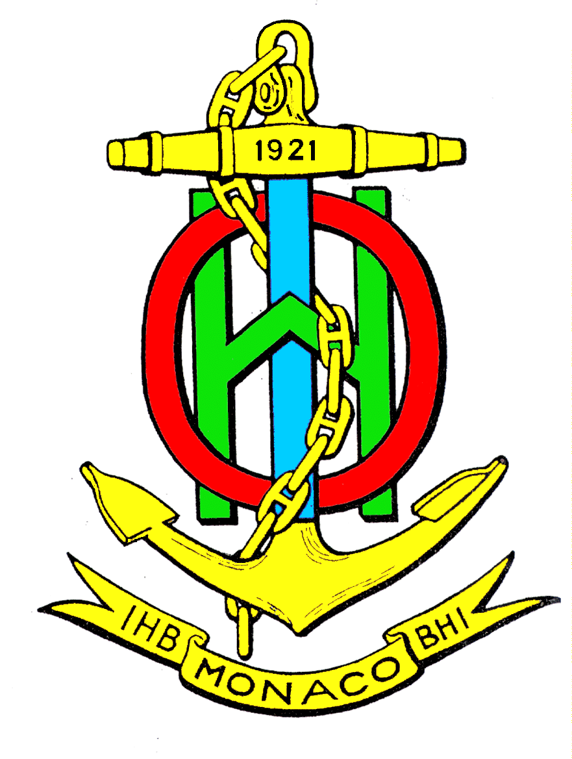
WEND-WG2-01.Registration

Worldwide ENC Database Working Group (WEND-WG)

Second Meeting; Central London, 21-22nd September 2012

Annex A: Registration

Please complete this registration form and e-mail it to helen.jones@ukho.gov.uk, with copy to jamie.mcmichael-phillips@ukho.gov.uk by 27th August 2012

Rank or Title

Surname or Family Name

First Name

Name of Accompanying Person(s)

E-mail

Telephone

Representing (Nation, RHC, other)

Arrival | date
Arrival | time
Arrival | Airport
Arrival | Flt nº
Are you continuing on to HSSC 4 at Taunton?
Departure | date
Departure | time
Departure | Airport
Departure | Flt nº
London Accommodation
(Hotel Name)

More information can be obtained from:

Helen Jones, UKHO International Partnering Team
Phone: +44 (0)1823 337900 x 3559
Fax: +44 (0)1823 723380
Email: helen.jones@ukho.gov.uk

