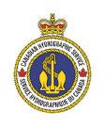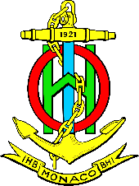

6th Meeting of the Arctic Regional Hydrographic Commission
Iqaluit (63°45'09.7"N, 068°32'40.7"W), Nunavut, Canada
3 and 6 October 2016

REGISTRATION FORM
[Please send this registration form via e-mail to the Canadian Hydrographic Service’s point of contact, Douglas.Brunt@dfo-mpo.gc.ca copy to yves.guillam@iho.int no later than 1st August 2016
Please note that you also need to register at: http://www.oceaninnovation.ca/Themes/2016/Content/Registration/
as explained in the Logistic Information]

Note: The boxes will expand as you type your answers

Organization

- Contact Details:

Rank or Title
Family Name*
First Name
Position / Job title / Role
Nationality
Telephone
E-mail
Accompanying person(s)
* Underline the name generally used in case of double surnames such as in Spanish-speaking countries

- Travel Details (for administrative purpose)

 | Airport
Your Arrival at Iqaluit | Date
 | Flight Number
 | Airline
 | Arrival Time

Your Departure from Iqaluit | Airport
 | Date
 | Flight Number
 | Airline
 | Departure Time

- Hotel Information (participants are expected to arrange their own accommodation)

Selected Hotel | Frobisher Inn | yes/no

Comments
Date

