Annex B
SWPHC CL 02-2013
26 March 2013
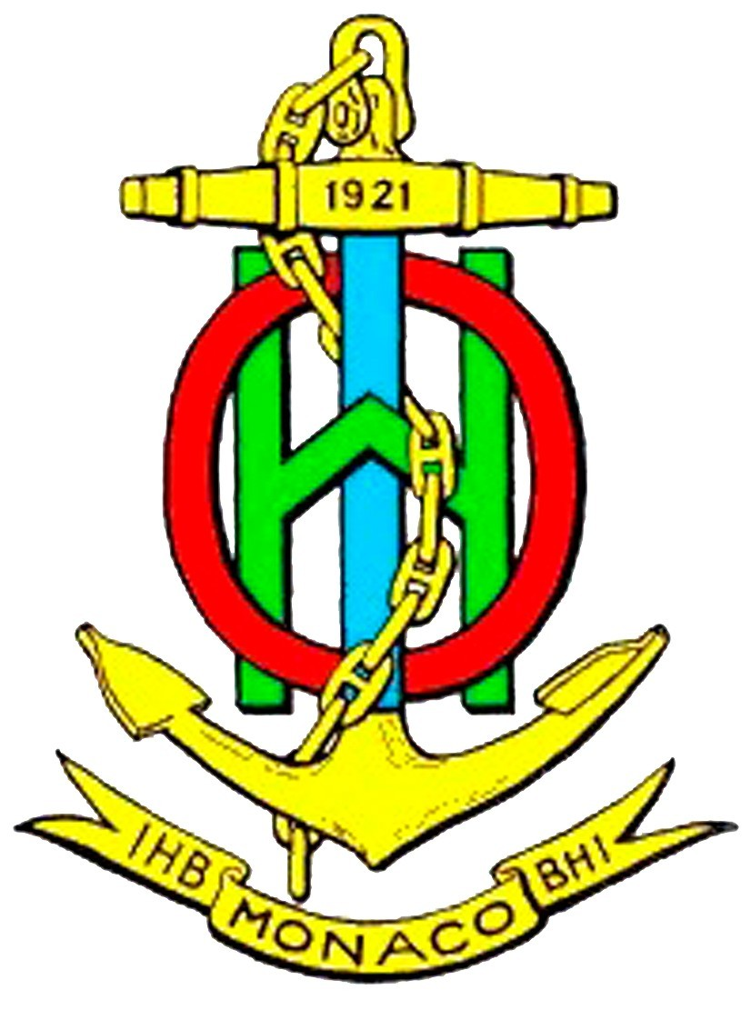

SOUTH WEST PACIFIC HYDROGRAPHIC COMMISSION (SWPHC)

12th Meeting of the South West Pacific Hydrographic Commission (SWPHC)

Port Vila, Vanuatu, 12 to 14 November 2013

REGISTRATION FORM

Please send the completed registration form to june.thompson@ukho.gov.uk copied to sluankon@vanuatu.gov.vu by 28 October 2013.

Member State / Organization

- Contact Details:

Head or Member of delegation
Rank or Title
Family Name
Given or Personal Name
Position / Job title / Role
Nationality
Telephone
Fax
E-mail
Spouse/Partner Travelling

- Travel Details.
Your arrival in Vanuatu | Date
Your arrival in Vanuatu | Flight Number
Your arrival in Vanuatu | Airline
Your arrival in Vanuatu | Arrival Time

Your departure from Vanuatu | Date
Your departure from Vanuatu | Flight Number
Your departure from Vanuatu | Airline
Your departure from Vanuatu | Departure Time

- Hotel Information (For administrative purpose only). Participants are expected to make their own accommodation arrangements –

Hotel at which booking has been made | Warwick Lagon
Hotel at which booking has been made | Melanesian/Kaivitimotel

Signature
Date

